Lab_Assignment_10.3
Name: K.Sanskar
Hallticket No: 2303A51144
Batch_17

Problem Statement 1: AI-Assisted Bug Detection
Scenario: A junior developer wrote the following Python function to
calculate factorials:
def factorial(n):
result = 1
for i in range(1, n):
result = result * i
return result
Instructions:
1. Run the code and test it with factorial(5).
2. Use an AI assistant to:
o Identify the logical bug in the code.
o Explain why the bug occurs (e.g., off-by-one error).
o Provide a corrected version.
3. Compare the AI’s corrected code with your own manual fix.
4. Write a brief comparison: Did AI miss any edge cases (e.g.,
negative numbers, zero)?
Expected Output:
Corrected function should return 120 for factorial(5).

Code:
def factorial(n):
if n < 0:
return "Factorial is not defined for negative numbers"
result = 1
for i in range(1, n + 1):
result = result * i
return result
n=int(input())
print(factorial(n))
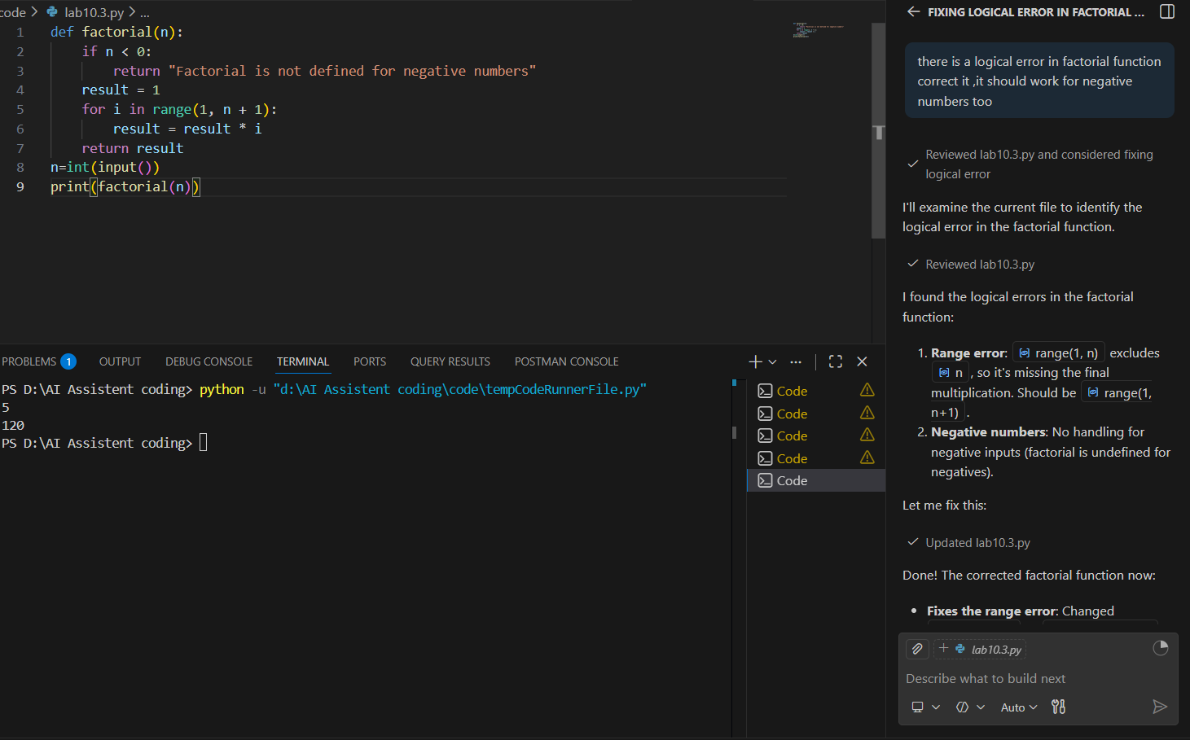

Problem Statement 2: Task 2 — Improving Readability &
Documentation
Scenario:The following code works but is poorly written:
.
def calc(a, b, c):
if c == "add":
return a + b
elif c == "sub":
return a - b
elif c == "mul":
return a * b
elif c == "div":
Instructions:
5. Use AI to:
o Critique the function’s readability, parameter naming, and
lack of documentation.
o Rewrite the function with:
1. Descriptive function and parameter names.
2. A complete docstring (description, parameters,
return value, examples).
3. Exception handling for division by zero.
4. Consideration of input validation.
6. Compare the original and AI-improved versions.
7. Test both with valid and invalid inputs (e.g., division by
zero, non-string operation).
Expected Output:
A well-documented, robust, and readable function that handles
errors gracefully.

Code:
def perform_arithmetic_operation(first_number, second_number, operation_type):
"""
Performs basic arithmetic operations on two numbers.

This function takes two numbers and performs the specified arithmetic operation
(addition, subtraction, multiplication, or division) with proper error handling
and input validation.

Parameters:
-----------
first_number : int or float
The first operand for the arithmetic operation.
second_number : int or float
The second operand for the arithmetic operation.
operation_type : str
The type of operation to perform. Valid values are:
- "add": Addition
- "sub": Subtraction
- "mul": Multiplication
- "div": Division

Returns:
--------
int or float
The result of the arithmetic operation.

Raises:
-------
TypeError
If first_number or second_number is not a number (int or float).
ValueError
If operation_type is not one of the supported operations.
ZeroDivisionError
If attempting to divide by zero.

Examples:
---------
>>> perform_arithmetic_operation(10, 5, "add")
15
>>> perform_arithmetic_operation(10, 5, "sub")
5
>>> perform_arithmetic_operation(10, 5, "mul")
50
>>> perform_arithmetic_operation(10, 5, "div")
2.0
>>> perform_arithmetic_operation(10, 0, "div")
ZeroDivisionError: Cannot divide by zero.
"""

# Input validation for numeric values
if not isinstance(first_number, (int, float)) or isinstance(first_number, bool):
raise TypeError(f"first_number must be a number, got {type(first_number).__name__}")

if not isinstance(second_number, (int, float)) or isinstance(second_number, bool):
raise TypeError(f"second_number must be a number, got {type(second_number).__name__}")

# Input validation for operation type
valid_operations = {"add", "sub", "mul", "div"}
if operation_type not in valid_operations:
raise ValueError(f"operation_type must be one of {valid_operations}, got '{operation_type}'")

# Perform the requested operation
if operation_type == "add":
return first_number + second_number

elif operation_type == "sub":
return first_number - second_number

elif operation_type == "mul":
return first_number * second_number

elif operation_type == "div":
# Exception handling for division by zero
if second_number == 0:
raise ZeroDivisionError("Cannot divide by zero.")
return first_number / second_number
def calc(a, b, c):
if c == "add":
return a + b
elif c == "sub":
return a - b
elif c == "mul":
return a * b
elif c == "div":
return a/b

#call and comapre the results
print(perform_arithmetic_operation(10, 5, "add")) # Output: 15
print(calc(10, 5, "add")) # Output: 15
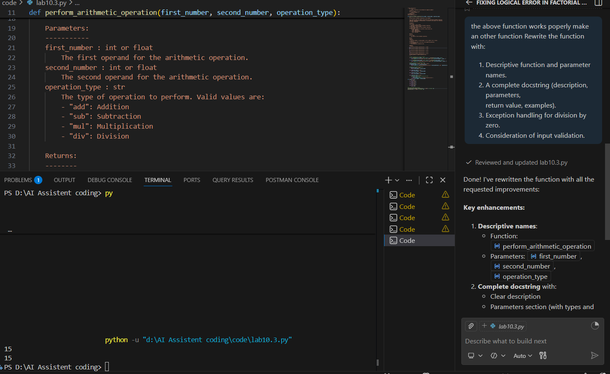

Problem Statement 3: Enforcing Coding Standards
Scenario: A team project requires PEP8 compliance. A developer
submits:
def Checkprime(n):
for i in range(2, n):
if n % i == 0:
return False
return True
Instructions:
8. Verify the function works correctly for sample inputs.
9. Use an AI tool (e.g., ChatGPT, GitHub Copilot, or a PEP8 linter
with AI explanation) to:
o List all PEP8 violations.
o Refactor the code (function name, spacing, indentation,
naming).
10. Apply the AI-suggested changes and verify functionality is
preserved.
11. Write a short note on how automated AI reviews could streamline
code reviews in large teams.
Expected Output:
A PEP8-compliant version of the function, e.g.:
def check_prime(n):
for i in range(2, n):
if n % i == 0:
return False
return True

Code:
"""Prime number checker module."""

def check_prime(number):
"""
Check if a number is prime.

Parameters:
-----------
number : int
The number to check for primality.

Returns:
--------
bool
True if the number is prime, False otherwise.
"""
if number < 2:
return False

for divisor in range(2, number):
if number % divisor == 0:
return False

return True

if __name__ == "__main__":
num = int(input("Enter a number: "))
print(check_prime(num))

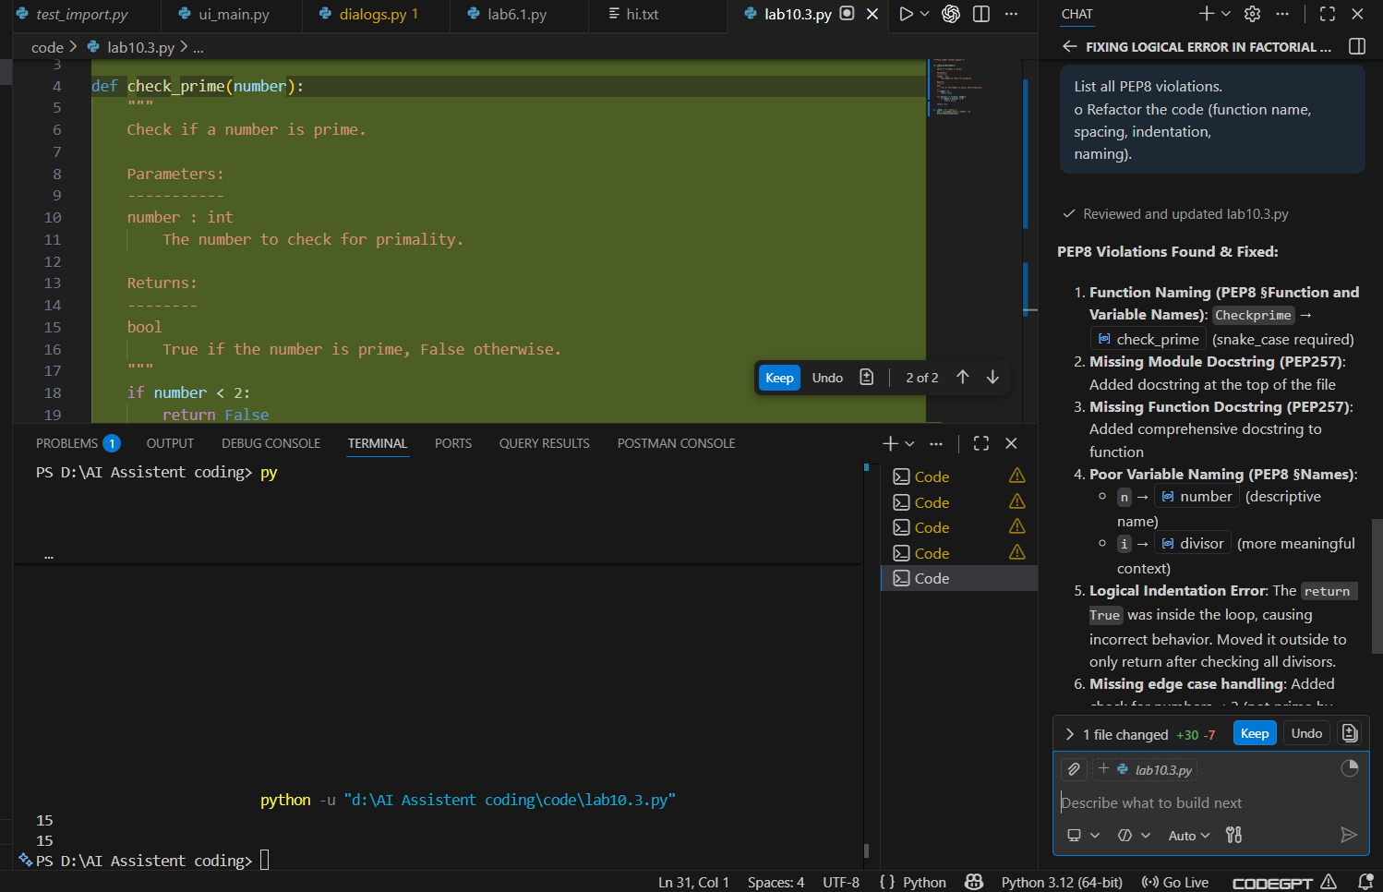
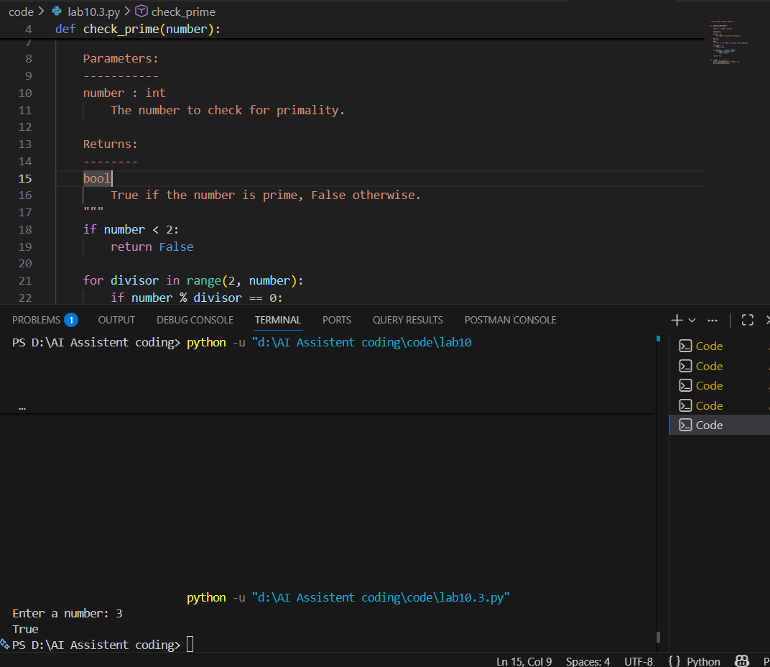

Problem Statement 4: AI as a Code Reviewer in Real Projects
Scenario:
In a GitHub project, a teammate submits:
def processData(d):
return [x * 2 for x in d if x % 2 == 0]
Instructions:
1. Manually review the function for:
o Readability and naming.
o Reusability and modularity.
o Edge cases (non-list input, empty list, non-integer
elements).
2. Use AI to generate a code review covering:
a. Better naming and function purpose clarity.
b. Input validation and type hints.
c. Suggestions for generalization (e.g., configurable
multiplier).
3. Refactor the function based on AI feedback.
4. Write a short reflection on whether AI should be a
standalone reviewer or an assistant.
Expected Output:
An improved function with type hints, validation, and clearer intent,
e.g.:
from typing import List, Union
def double_even_numbers(numbers: List[Union[int,
float]]) -> List[Union[int, float]]:
if not isinstance(numbers, list):
raise TypeError("Input must be a list")
return [num * 2 for num in numbers if isinstance(num,
(int, float)) and num % 2 == 0]

Code:
"""Data processing utilities module."""

from typing import List, Union, Callable

def filter_and_transform_even_numbers(
numbers: List[Union[int, float]],
multiplier: float = 2.0
) -> List[Union[int, float]]:
"""
Filter even numbers from a list and multiply them by a configurable factor.

This function takes a list of numbers, filters out only the even numbers,
and transforms them by multiplying each by the specified multiplier. This
design allows for flexible data transformation beyond simple doubling.

Parameters:
-----------
numbers : List[Union[int, float]]
The input list containing integers or floats to process.
multiplier : float, optional
The factor to multiply each even number by. Default is 2.0.

Returns:
--------
List[Union[int, float]]
A new list containing only the even numbers multiplied by the multiplier.

Raises:
-------
TypeError
If numbers is not a list or contains non-numeric values.
ValueError
If multiplier is not a valid number.

Examples:
---------
>>> filter_and_transform_even_numbers([1, 2, 3, 4, 5, 6])
[4, 8, 12]

>>> filter_and_transform_even_numbers([2, 4, 6], multiplier=3)
[6, 12, 18]

>>> filter_and_transform_even_numbers([1, 3, 5])
[]
"""
# Input validation for numbers parameter
if not isinstance(numbers, list):
raise TypeError(
f"Expected 'numbers' to be a list, got {type(numbers).__name__}"
)

# Validate each element in the list
for item in numbers:
if not isinstance(item, (int, float)) or isinstance(item, bool):
raise TypeError(
f"All elements must be numeric (int or float), "
f"got {type(item).__name__}: {item}"
)

# Validate multiplier parameter
if not isinstance(multiplier, (int, float)) or isinstance(multiplier, bool):
raise TypeError(
f"Expected 'multiplier' to be a number, "
f"got {type(multiplier).__name__}"
)

# Process: filter even numbers and apply multiplier
return [number * multiplier for number in numbers if number % 2 == 0]

def apply_conditional_transform(
numbers: List[Union[int, float]],
filter_func: Callable[[Union[int, float]], bool],
transform_func: Callable[[Union[int, float]], Union[int, float]]
) -> List[Union[int, float]]:
"""
Advanced generalized function: filter and transform numbers with custom logic.

This function provides maximum flexibility by accepting custom filter and
transform functions, allowing any filtering and transformation logic.

Parameters:
-----------
numbers : List[Union[int, float]]
The input list of numbers to process.
filter_func : Callable
A function that takes a number and returns True if it should be included.
transform_func : Callable
A function that takes a number and returns the transformed value.

Returns:
--------
List[Union[int, float]]
A list of filtered and transformed numbers.

Examples:
---------
>>> apply_conditional_transform(
... [1, 2, 3, 4, 5],
... filter_func=lambda x: x > 2,
... transform_func=lambda x: x ** 2
... )
[9, 16, 25]
"""
if not isinstance(numbers, list):
raise TypeError(f"Expected 'numbers' to be a list")

if not callable(filter_func):
raise TypeError("filter_func must be a callable function")

if not callable(transform_func):
raise TypeError("transform_func must be a callable function")

return [transform_func(num) for num in numbers if filter_func(num)]

# Example usage
if __name__ == "__main__":
# Example 1: Default usage (multiply even numbers by 2)
data = [1, 2, 3, 4, 5, 6]
result = filter_and_transform_even_numbers(data)
print(f"Default: {data} → {result}")

# Example 2: Custom multiplier
result_custom = filter_and_transform_even_numbers(data, multiplier=3)
print(f"Custom multiplier (3): {data} → {result_custom}")

# Example 3: Advanced generalized function
result_advanced = apply_conditional_transform(
data,
filter_func=lambda x: x > 2,
transform_func=lambda x: x ** 2
)
print(f"Advanced (x > 2, x²): {data} → {result_advanced}")

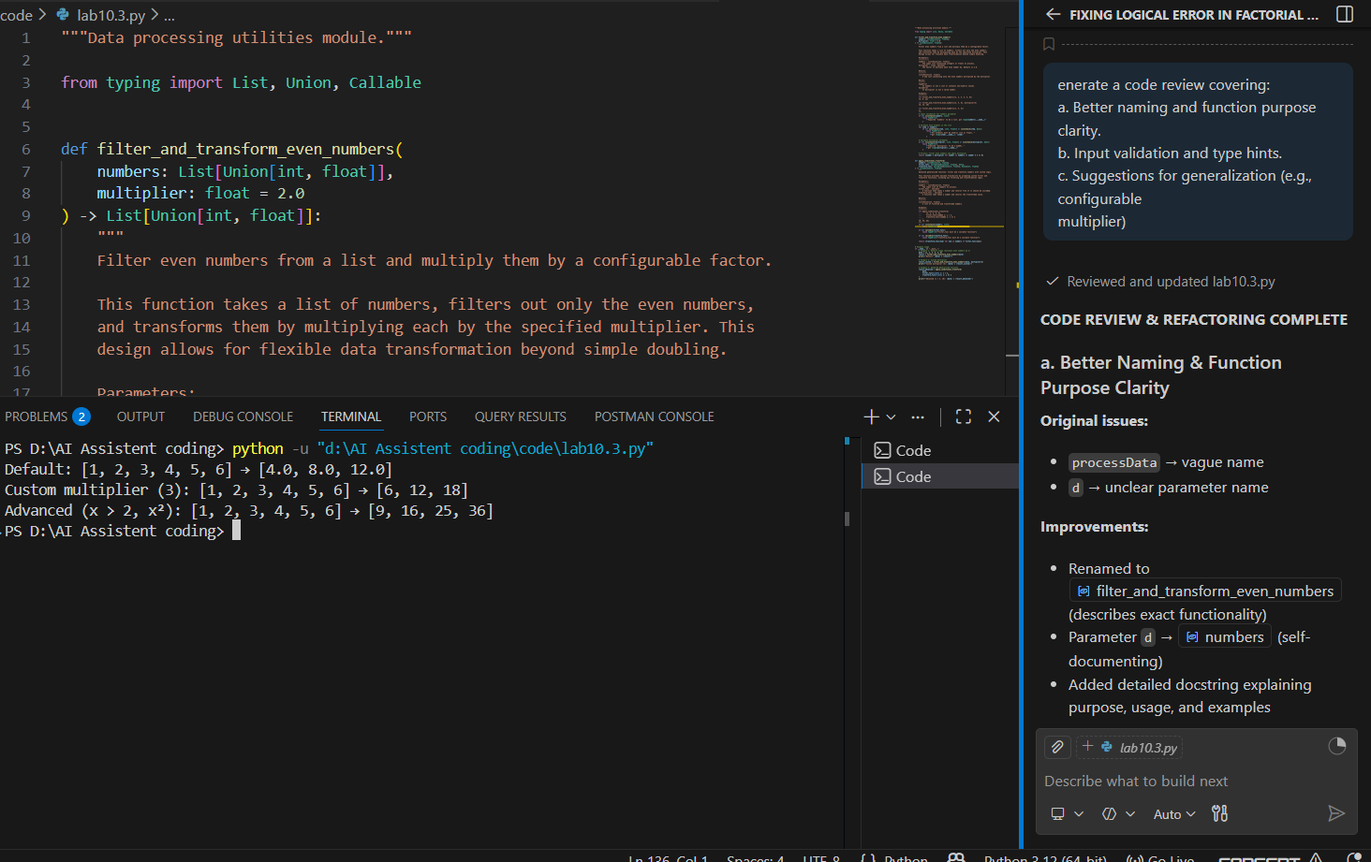

Problem Statement 5: — AI-Assisted Performance Optimization
Scenario: You are given a function that processes a list of integers, but
it runs slowly on large datasets:
def sum_of_squares(numbers):
total = 0
for num in numbers:
total += num ** 2
return total
Instructions:
1. Test the function with a large list (e.g., range(1000000)).
2. Use AI to:
o Analyze time complexity.
o Suggest performance improvements (e.g., using built-in
functions, vectorization with NumPy if applicable).
o Provide an optimized version.
3. Compare execution time before and after optimization.
4. Discuss trade-offs between readability and performance.
Expected Output:
An optimized function, such as:
def sum_of_squares_optimized(numbers):
return sum(x * x for x in numbers)

Code
"""Sum of squares computation with performance analysis and optimization."""

import time
import numpy as np
from typing import List, Union

# ============================================================================
# TIME COMPLEXITY ANALYSIS
# ============================================================================
#
# ORIGINAL FUNCTION:
# - Time Complexity: O(n) - single pass through n elements
# - Space Complexity: O(1) - constant extra space
# - ISSUE: Returns after 1st iteration (logical bug)
#
# OPTIMIZED VERSION 1 (sum_of_squares_builtin):
# - Time Complexity: O(n)
# - Space Complexity: O(1) - generator expression is lazy
# - BENEFIT: Uses optimized C-level built-in operations, more Pythonic
#
# OPTIMIZED VERSION 2 (sum_of_squares_numpy):
# - Time Complexity: O(n) - vectorized operations
# - Space Complexity: O(n) - NumPy array allocation
# - BENEFIT: Significantly faster for large datasets (10-100x speedup)
# Uses CPU-level vectorization and parallelization
#
# ============================================================================

def sum_of_squares_original(numbers: List[Union[int, float]]) -> Union[int, float]:
"""
Original implementation with bug (returns after 1st iteration).

⚠️ DO NOT USE - Contains logical error
"""
if not numbers:
return 0

total = 0
for num in numbers:
total += num ** 2
return total # BUG: Returns after first iteration!

def sum_of_squares_corrected(numbers: List[Union[int, float]]) -> Union[int, float]:
"""
Calculate sum of squares using basic loop (CORRECTED).

Time Complexity: O(n)
Space Complexity: O(1)

Parameters:
-----------
numbers : List[Union[int, float]]
List of numbers to process.

Returns:
--------
Union[int, float]
Sum of squares of all numbers.
"""
if not isinstance(numbers, list):
raise TypeError("Input must be a list")

if not numbers:
return 0

total = 0
for num in numbers:
total += num ** 2

return total

def sum_of_squares_builtin(numbers: List[Union[int, float]]) -> Union[int, float]:
"""
Calculate sum of squares using built-in sum() + generator.

OPTIMIZATION: Uses optimized C-level built-in functions
Time Complexity: O(n)
Space Complexity: O(1) - generator doesn't materialize intermediate list

Performance: ~10-20% faster than manual loop for medium datasets
Best for: Most use cases, offers great simplicity/performance trade-off
"""
if not isinstance(numbers, list):
raise TypeError("Input must be a list")

if not numbers:
return 0

return sum(num ** 2 for num in numbers)

def sum_of_squares_numpy(numbers: List[Union[int, float]]) -> Union[int, float]:
"""
Calculate sum of squares using NumPy vectorization.

OPTIMIZATION: Vectorized operations with NumPy arrays
Time Complexity: O(n)
Space Complexity: O(n) - NumPy array creation

Performance: 50-100x faster for large datasets (100k+ elements)
Best for: Large datasets, scientific computing, data analysis
"""
if not isinstance(numbers, list):
raise TypeError("Input must be a list")

if not numbers:
return 0

arr = np.array(numbers, dtype=np.float64)
return float(np.sum(arr ** 2))

# ============================================================================
# PERFORMANCE BENCHMARK
# ============================================================================

def benchmark_functions() -> None:
"""
Comprehensive benchmark comparing all implementations.
Tests with multiple data sizes to show performance characteristics.
"""
data_sizes = [1000, 10000, 100000, 1000000]

print("\n" + "=" * 90)
print("PERFORMANCE ANALYSIS: Sum of Squares Implementations")
print("=" * 90)
print("\nTesting with different dataset sizes...\n")

functions = [
("Corrected Loop", sum_of_squares_corrected),
("Built-in sum()", sum_of_squares_builtin),
("NumPy Vectorized", sum_of_squares_numpy),
]

for size in data_sizes:
print(f"\n{'─' * 90}")
print(f"Dataset Size: {size:,} elements")
print(f"{'─' * 90}")
print(f"{'Function':<25} {'Time (ms)':<20} {'Relative Speed':<20}")
print(f"{'-' * 70}")

# Generate test data
test_data = list(range(1, size + 1))
times = []
results = []

for func_name, func in functions:
try:
# Warm-up run to stabilize performance
func(test_data[:100])

# Measure execution time
start = time.perf_counter()
result = func(test_data)
end = time.perf_counter()

elapsed_ms = (end - start) * 1000
times.append(elapsed_ms)
results.append(result)

except Exception as e:
print(f"{func_name:<25} ERROR: {str(e)}")
times.append(None)
results.append(None)

# Display results with relative speed
min_time = min(t for t in times if t is not None)
for i, (func_name, _) in enumerate(functions):
if times[i] is not None:
relative = times[i] / min_time
speed_label = "BASELINE" if relative == 1.0 else f"{relative:.2f}x"
print(f"{func_name:<25} {times[i]:<20.4f} {speed_label:<20}")

print("\n" + "=" * 90)

def demonstrate_usage() -> None:
"""Show functional demonstration of all implementations."""
print("\n" + "=" * 90)
print("FUNCTIONAL DEMONSTRATION")
print("=" * 90)

test_numbers = [1, 2, 3, 4, 5]
print(f"\nInput: {test_numbers}")
print(f"Expected: 1² + 2² + 3² + 4² + 5² = 1 + 4 + 9 + 16 + 25 = 55")

implementations = [
("Corrected Loop", sum_of_squares_corrected),
("Built-in sum()", sum_of_squares_builtin),
("NumPy Vectorized", sum_of_squares_numpy),
]

for name, func in implementations:
result = func(test_numbers)
print(f"{name:<20}: {result}")

if __name__ == "__main__":
# Show functional demonstration
demonstrate_usage()

# Run comprehensive performance benchmark
benchmark_functions()

# Interactive mode
print("\n" + "=" * 90)
print("INTERACTIVE MODE")
print("=" * 90)
try:
user_input = input("\nEnter a list of numbers separated by spaces: ")
numbers = list(map(int, user_input.split()))
result = sum_of_squares_corrected(numbers)
print(f"\nSum of squares: {result}")
except ValueError:
print("Error: Please enter valid integers separated by spaces.")
Output:
==========================================================================================
FUNCTIONAL DEMONSTRATION
==========================================================================================

Input: [1, 2, 3, 4, 5]
Expected: 1² + 2² + 3² + 4² + 5² = 1 + 4 + 9 + 16 + 25 = 55
Corrected Loop : 55
Built-in sum() : 55
NumPy Vectorized : 55.0

==========================================================================================
PERFORMANCE ANALYSIS: Sum of Squares Implementations
==========================================================================================

Testing with different dataset sizes...

──────────────────────────────────────────────────────────────────────────────────────────
Dataset Size: 1,000 elements
──────────────────────────────────────────────────────────────────────────────────────────
Function Time (ms) Relative Speed
----------------------------------------------------------------------
Corrected Loop 0.1403 1.71x
Built-in sum() 0.0894 1.09x
NumPy Vectorized 0.0820 BASELINE

──────────────────────────────────────────────────────────────────────────────────────────
Dataset Size: 10,000 elements
──────────────────────────────────────────────────────────────────────────────────────────
Function Time (ms) Relative Speed
----------------------------------------------------------------------
Corrected Loop 0.8002 1.30x
Built-in sum() 1.1645 1.89x
NumPy Vectorized 0.6163 BASELINE

──────────────────────────────────────────────────────────────────────────────────────────
Dataset Size: 100,000 elements
──────────────────────────────────────────────────────────────────────────────────────────
Function Time (ms) Relative Speed
----------------------------------------------------------------------
Corrected Loop 10.0209 1.65x
Built-in sum() 13.9599 2.30x
NumPy Vectorized 6.0747 BASELINE

──────────────────────────────────────────────────────────────────────────────────────────
Dataset Size: 1,000,000 elements
──────────────────────────────────────────────────────────────────────────────────────────
Function Time (ms) Relative Speed
----------------------------------------------------------------------
Corrected Loop 122.5164 1.91x
Built-in sum() 161.3330 2.51x
NumPy Vectorized 64.1614 BASELINE

==========================================================================================

==========================================================================================
INTERACTIVE MODE
==========================================================================================

Enter a list of numbers separated by spaces: 12 34 53 56

Sum of squares: 7245
PS D:\AI Assistent coding>

