` **MYSQL**

**Submitted By : Omkar N Gadre**

**Date : 9 Apr 2023**

**Roll No. 2334027**

**$sudo apt-get install mariadb**

**$sudo apt-get install mariadb-server**

**$sudo mysql -u root -p**

**>SHOW DATABASES ;**

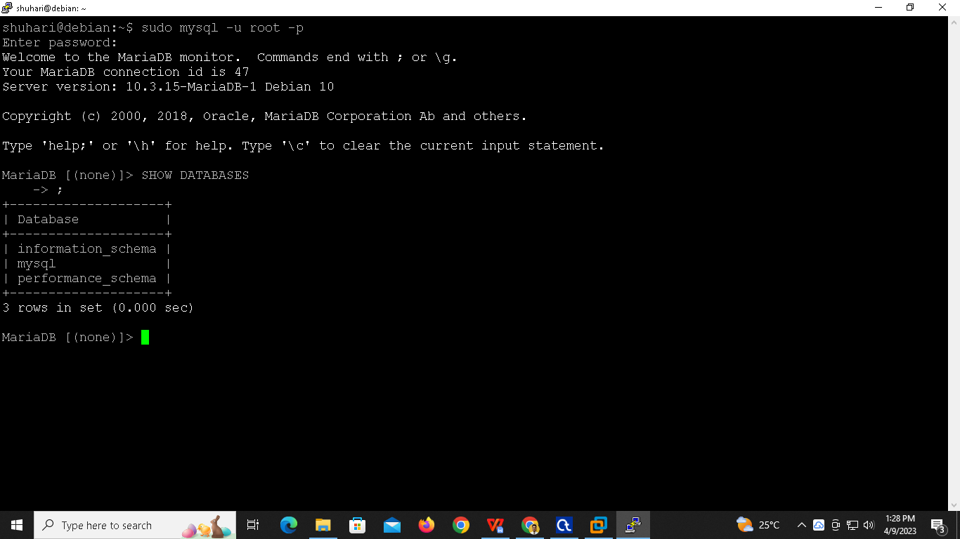

**>CREATE DATABASE IF NOT EXISTS OMKAR;**

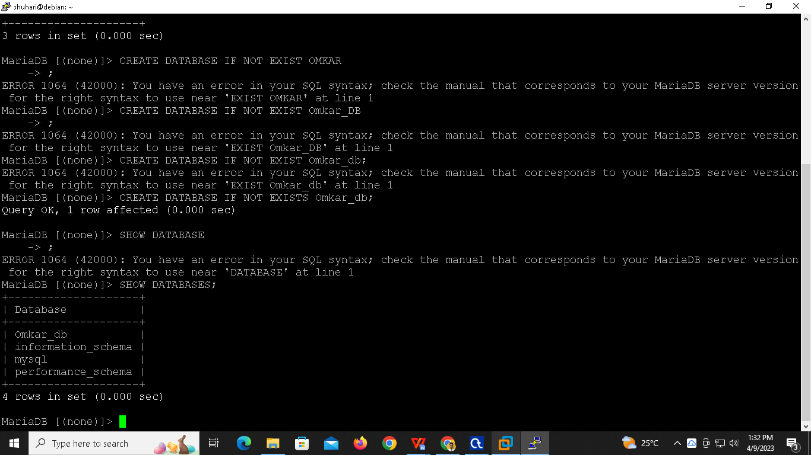

**>USE Omkar_db**

**>SHOW TABLES:**

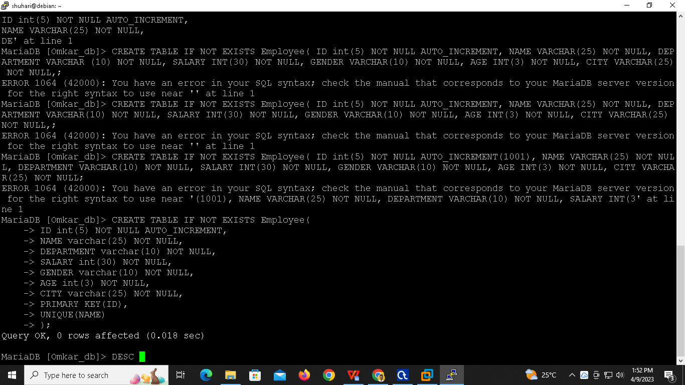

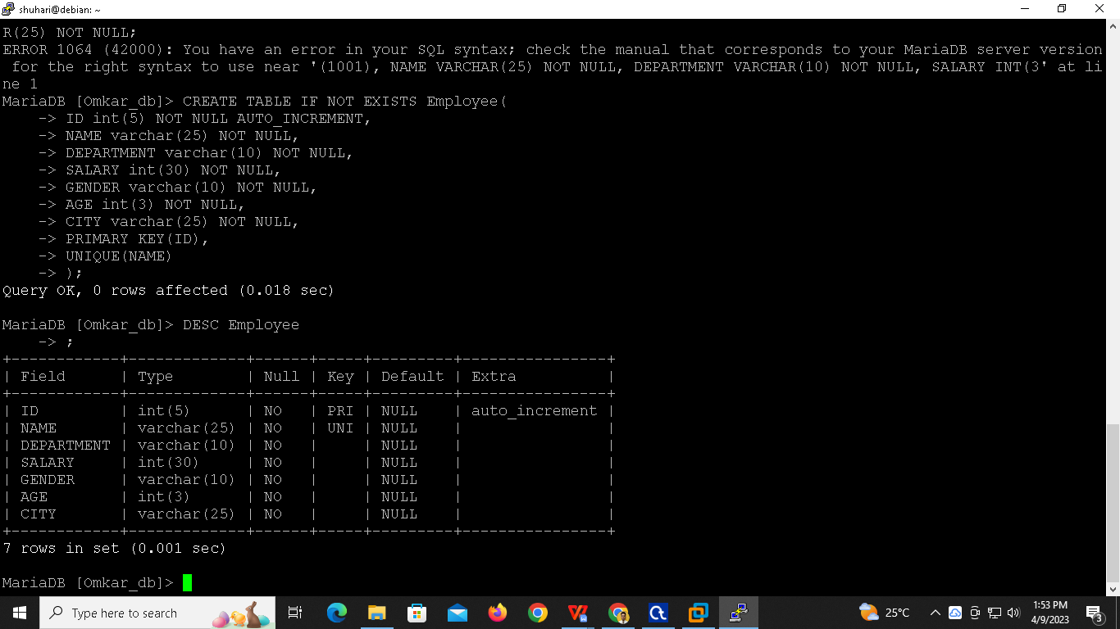

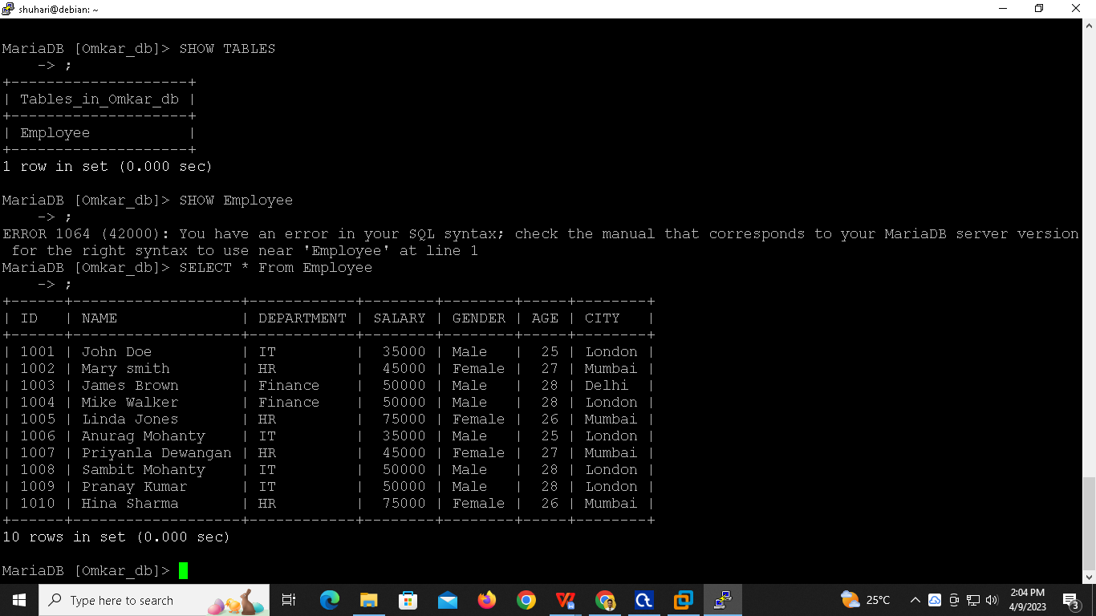

**1)Write an SQL query to print details of the Workers whose SALARY lies between 10000 and 50000.**

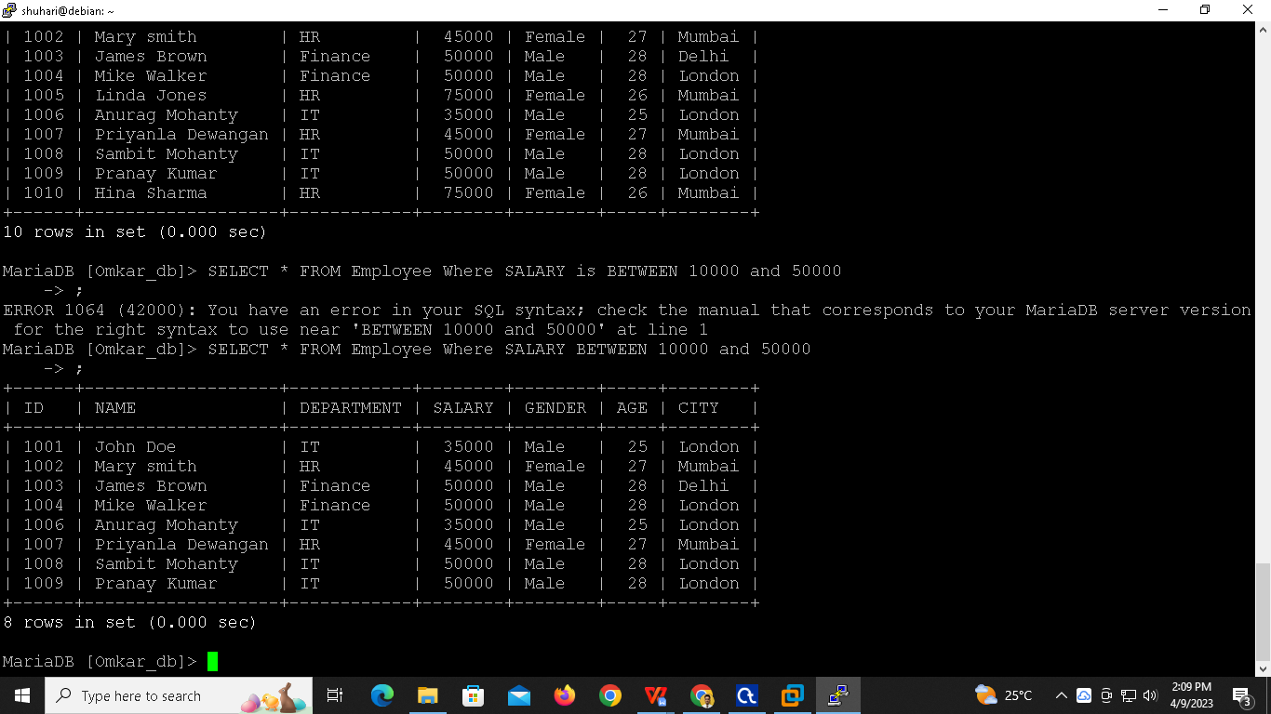

**2)Write an SQL query to fetch the count of employees working in the department ‘IT’.**

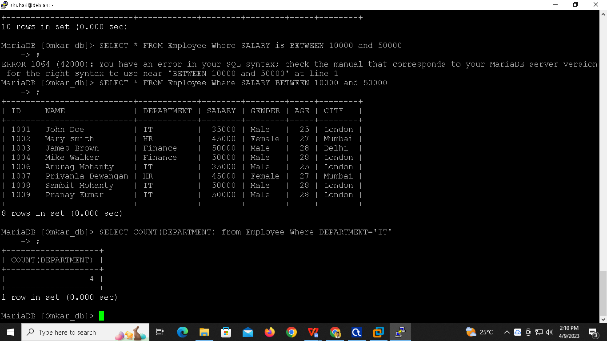

1. **Write an SQL query to print details for Workers with the first name as “Anurag” and “Hina”.**



