Name:

Date of Birth:

School:

***Questions 1 to 4 are to be filled in by all applicants to the UNCA, in addition to the questions specific to journalists, cartoonists or photographers, depending upon which of the three you wish to apply for.***

1. Please detail your past experience with Model United Nations conferences. Begin by listing the conferences you have attended, the committees you were a part of, and the awards you have received, if any.
2. What is it about this committee that appeals to you, and why would you like to apply for it? What do you hope to gain from the experience?
3. What, in your opinion, can you contribute to the United Nations Correspondents Association?
4. What, according to you, is the role and significance of the Press in democratic societies?

***For Journalists:***

Please write a 250-300 word opinion editorial on any of the following themes. You can choose to agree or disagree with the same.

* Whether countries worldwide should draw inspiration from France, the Netherlands and Belgium, and ban the burqa
* Jus ad Bellum in a world of colossal nuclear arsenals
* Populism as a threat to democracy
* Decriminalisation of euthanasia and assisted suicide

***For Cartoonists:***

Please send across two political cartoons on current issues at [unca2018@sanskritimun.in](mailto:unca2018@sanskritimun.in).

***For Photographers:***

1. Give this photograph a suitable caption in 30 words or less.

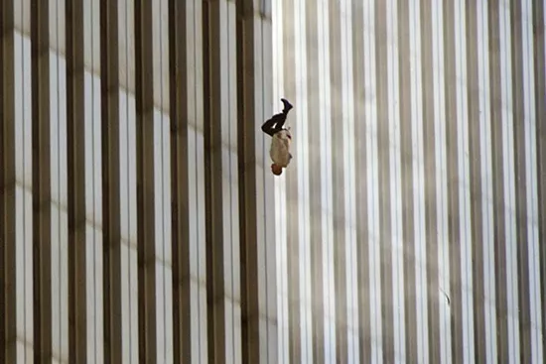

1. Please submit 5 photographs to photography2018@sanskritimun.in

Suggested categories:

* Motion Photography
* Portraits
* MUN photography (if any)