Loaded 8447 epochs (windows), each with shape (29, 1000).

C:\Users\sansk\miniconda3\Lib\site-packages\numpy\lib\function_base.py:2897: RuntimeWarning: invalid value encountered in divide

c /= stddev[:, None]

C:\Users\sansk\miniconda3\Lib\site-packages\numpy\lib\function_base.py:2898: RuntimeWarning: invalid value encountered in divide

c /= stddev[None, :]

Epoch 1: Loss 0.7932

Epoch 2: Loss 0.7276

Epoch 3: Loss 0.7125

Epoch 4: Loss 0.6777

Epoch 5: Loss 0.6483

Epoch 6: Loss 0.6294

Epoch 7: Loss 0.6215

Epoch 8: Loss 0.6177

Epoch 9: Loss 0.6399

Epoch 10: Loss 0.6321

Epoch 11: Loss 0.5886

Epoch 12: Loss 0.5893

Epoch 13: Loss 0.5941

Epoch 14: Loss 0.5617

Epoch 15: Loss 0.5357

Epoch 16: Loss 0.5253

Epoch 17: Loss 0.5049

Epoch 18: Loss 0.4910

Epoch 19: Loss 0.4606

Epoch 20: Loss 0.4661

Test Accuracy: 0.5817

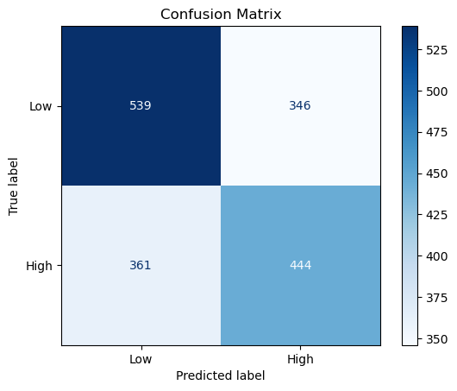

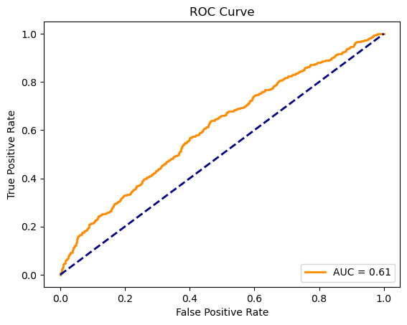

precision recall f1-score support

Low 0.60 0.61 0.60 885

High 0.56 0.55 0.56 805

accuracy 0.58 1690

macro avg 0.58 0.58 0.58 1690

weighted avg 0.58 0.58 0.58 1690