Loaded 7243 epochs (windows), each with shape (29, 1000).

C:\Users\sansk\miniconda3\Lib\site-packages\numpy\lib\function_base.py:2897: RuntimeWarning: invalid value encountered in divide

c /= stddev[:, None]

C:\Users\sansk\miniconda3\Lib\site-packages\numpy\lib\function_base.py:2898: RuntimeWarning: invalid value encountered in divide

c /= stddev[None, :]

Epoch 1: Loss 0.8496

Epoch 2: Loss 0.7327

Epoch 3: Loss 0.7235

Epoch 4: Loss 0.6924

Epoch 5: Loss 0.6781

Epoch 6: Loss 0.6702

Epoch 7: Loss 0.6574

Epoch 8: Loss 0.6513

Epoch 9: Loss 0.6331

Epoch 10: Loss 0.6355

Epoch 11: Loss 0.6348

Epoch 12: Loss 0.6386

Epoch 13: Loss 0.6165

Epoch 14: Loss 0.5937

Epoch 15: Loss 0.6683

Epoch 16: Loss 0.6200

Epoch 17: Loss 0.6092

Epoch 18: Loss 0.5872

Epoch 19: Loss 0.6489

Epoch 20: Loss 0.5865

Test Accuracy: 0.5383

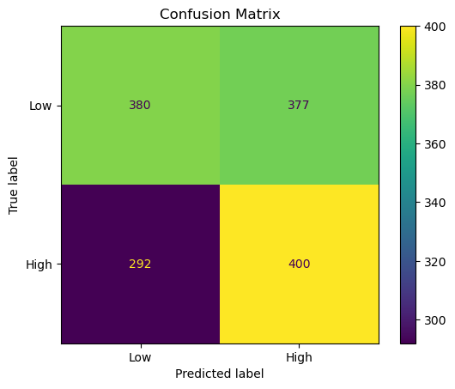

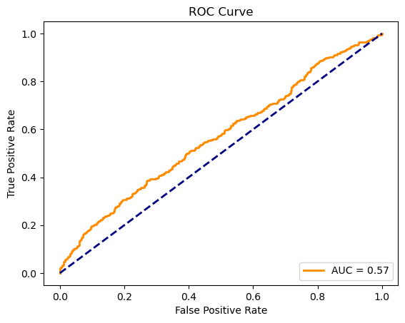

precision recall f1-score support

Low 0.57 0.50 0.53 757

High 0.51 0.58 0.54 692

accuracy 0.54 1449

macro avg 0.54 0.54 0.54 1449

weighted avg 0.54 0.54 0.54 1449