Loaded data shape: (8447, 1000, 28) (epochs, time_points, channels)

EEGNet input shape: (8447, 28, 1000, 1)

Epoch 1/100

**212/212** ━━━━━━━━━━━━━━━━━━━━ **60s** 262ms/step - accuracy: 0.4711 - loss: 0.6726 - val_accuracy: 0.4751 - val_loss: 0.6069

Epoch 2/100

**212/212** ━━━━━━━━━━━━━━━━━━━━ **59s** 277ms/step - accuracy: 0.4829 - loss: 0.5803 - val_accuracy: 0.4787 - val_loss: 0.5496

Epoch 3/100

**212/212** ━━━━━━━━━━━━━━━━━━━━ **75s** 245ms/step - accuracy: 0.4937 - loss: 0.5610 - val_accuracy: 0.5361 - val_loss: 0.5248

Epoch 4/100

**212/212** ━━━━━━━━━━━━━━━━━━━━ **82s** 245ms/step - accuracy: 0.5374 - loss: 0.5295 - val_accuracy: 0.6189 - val_loss: 0.5162

Epoch 5/100

**212/212** ━━━━━━━━━━━━━━━━━━━━ **52s** 243ms/step - accuracy: 0.5483 - loss: 0.5198 - val_accuracy: 0.7065 - val_loss: 0.5299

Epoch 6/100

**212/212** ━━━━━━━━━━━━━━━━━━━━ **52s** 247ms/step - accuracy: 0.5611 - loss: 0.5097 - val_accuracy: 0.7562 - val_loss: 0.5251

Epoch 7/100

**212/212** ━━━━━━━━━━━━━━━━━━━━ **52s** 245ms/step - accuracy: 0.5787 - loss: 0.5041 - val_accuracy: 0.7917 - val_loss: 0.5230

Epoch 8/100

**212/212** ━━━━━━━━━━━━━━━━━━━━ **52s** 246ms/step - accuracy: 0.5915 - loss: 0.4934 - val_accuracy: 0.8544 - val_loss: 0.5526

Epoch 9/100

**212/212** ━━━━━━━━━━━━━━━━━━━━ **52s** 245ms/step - accuracy: 0.6026 - loss: 0.4857 - val_accuracy: 0.8172 - val_loss: 0.5253

Epoch 10/100

**212/212** ━━━━━━━━━━━━━━━━━━━━ **53s** 252ms/step - accuracy: 0.6096 - loss: 0.4817 - val_accuracy: 0.8568 - val_loss: 0.5518

Epoch 11/100

**212/212** ━━━━━━━━━━━━━━━━━━━━ **57s** 267ms/step - accuracy: 0.5947 - loss: 0.4819 - val_accuracy: 0.8698 - val_loss: 0.5540

Epoch 12/100

**212/212** ━━━━━━━━━━━━━━━━━━━━ **31s** 148ms/step - accuracy: 0.5956 - loss: 0.4855 - val_accuracy: 0.8976 - val_loss: 0.5595

Epoch 13/100

**212/212** ━━━━━━━━━━━━━━━━━━━━ **23s** 110ms/step - accuracy: 0.6277 - loss: 0.4670 - val_accuracy: 0.9160 - val_loss: 0.6140

Epoch 14/100

**212/212** ━━━━━━━━━━━━━━━━━━━━ **22s** 103ms/step - accuracy: 0.6163 - loss: 0.4748 - val_accuracy: 0.9320 - val_loss: 0.6226

Test Accuracy: 61.89%

Test Loss: 0.5162

**53/53** ━━━━━━━━━━━━━━━━━━━━ **1s** 22ms/step

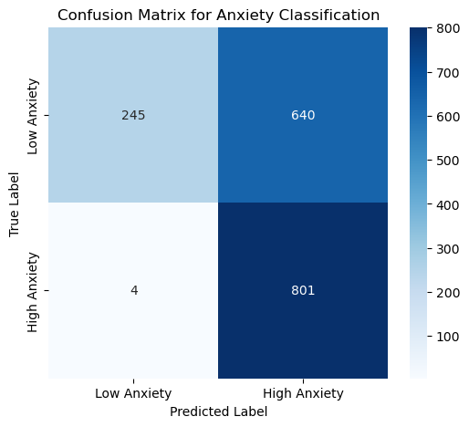

Classification Report:

precision recall f1-score support

Low Anxiety 0.98 0.28 0.43 885

High Anxiety 0.56 1.00 0.71 805

accuracy 0.62 1690

macro avg 0.77 0.64 0.57 1690

weighted avg 0.78 0.62 0.57 1690