Loaded data shape: (7243, 1000, 28) (epochs, time_points, channels)

EEGNet input shape: (7243, 28, 1000, 1)

Epoch 1/100

**182/182** ━━━━━━━━━━━━━━━━━━━━ **21s** 98ms/step - accuracy: 0.4991 - loss: 0.6506 - val_accuracy: 0.4783 - val_loss: 0.6587

Epoch 2/100

**182/182** ━━━━━━━━━━━━━━━━━━━━ **17s** 95ms/step - accuracy: 0.4809 - loss: 0.5824 - val_accuracy: 0.4769 - val_loss: 0.5859

Epoch 3/100

**182/182** ━━━━━━━━━━━━━━━━━━━━ **17s** 93ms/step - accuracy: 0.4784 - loss: 0.5686 - val_accuracy: 0.4921 - val_loss: 0.5413

Epoch 4/100

**182/182** ━━━━━━━━━━━━━━━━━━━━ **17s** 92ms/step - accuracy: 0.5095 - loss: 0.5465 - val_accuracy: 0.5217 - val_loss: 0.5067

Epoch 5/100

**182/182** ━━━━━━━━━━━━━━━━━━━━ **17s** 91ms/step - accuracy: 0.5503 - loss: 0.5177 - val_accuracy: 0.7288 - val_loss: 0.5210

Epoch 6/100

**182/182** ━━━━━━━━━━━━━━━━━━━━ **17s** 93ms/step - accuracy: 0.5805 - loss: 0.5014 - val_accuracy: 0.7612 - val_loss: 0.5148

Epoch 7/100

**182/182** ━━━━━━━━━━━━━━━━━━━━ **17s** 92ms/step - accuracy: 0.5755 - loss: 0.5053 - val_accuracy: 0.8309 - val_loss: 0.5291

Epoch 8/100

**182/182** ━━━━━━━━━━━━━━━━━━━━ **17s** 91ms/step - accuracy: 0.5926 - loss: 0.4919 - val_accuracy: 0.8109 - val_loss: 0.5308

Epoch 9/100

**182/182** ━━━━━━━━━━━━━━━━━━━━ **18s** 97ms/step - accuracy: 0.6001 - loss: 0.4935 - val_accuracy: 0.8627 - val_loss: 0.5379

Epoch 10/100

**182/182** ━━━━━━━━━━━━━━━━━━━━ **41s** 225ms/step - accuracy: 0.6114 - loss: 0.4875 - val_accuracy: 0.8634 - val_loss: 0.5238

Epoch 11/100

**182/182** ━━━━━━━━━━━━━━━━━━━━ **43s** 235ms/step - accuracy: 0.6132 - loss: 0.4751 - val_accuracy: 0.9351 - val_loss: 0.5667

Epoch 12/100

**182/182** ━━━━━━━━━━━━━━━━━━━━ **43s** 237ms/step - accuracy: 0.6124 - loss: 0.4725 - val_accuracy: 0.8944 - val_loss: 0.5808

Epoch 13/100

**182/182** ━━━━━━━━━━━━━━━━━━━━ **42s** 230ms/step - accuracy: 0.6237 - loss: 0.4715 - val_accuracy: 0.9068 - val_loss: 0.5530

Epoch 14/100

**182/182** ━━━━━━━━━━━━━━━━━━━━ **43s** 237ms/step - accuracy: 0.6256 - loss: 0.4620 - val_accuracy: 0.9255 - val_loss: 0.5651

Test Accuracy: 52.17%

Test Loss: 0.5067

**46/46** ━━━━━━━━━━━━━━━━━━━━ **3s** 50ms/step

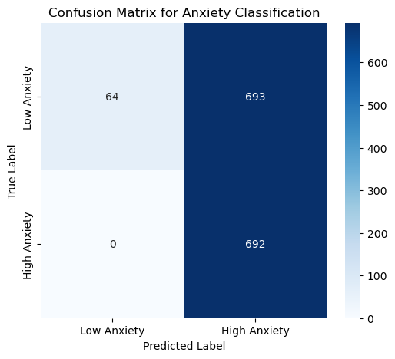

Classification Report:

precision recall f1-score support

Low Anxiety 1.00 0.08 0.16 757

High Anxiety 0.50 1.00 0.67 692

accuracy 0.52 1449

macro avg 0.75 0.54 0.41 1449

weighted avg 0.76 0.52 0.40 1449