Loaded 8447 epochs (sliding window, all files).

C:\Users\sansk\miniconda3\Lib\site-packages\numpy\lib\function_base.py:2897: RuntimeWarning: invalid value encountered in divide

c /= stddev[:, None]

C:\Users\sansk\miniconda3\Lib\site-packages\numpy\lib\function_base.py:2898: RuntimeWarning: invalid value encountered in divide

c /= stddev[None, :]

Epoch 1: Loss 1.1560

Epoch 2: Loss 0.9269

Epoch 3: Loss 0.7866

Epoch 4: Loss 0.7259

Epoch 5: Loss 0.7985

Epoch 6: Loss 0.7571

Epoch 7: Loss 0.7258

Epoch 8: Loss 0.7235

Epoch 9: Loss 0.7145

Epoch 10: Loss 0.7050

Epoch 11: Loss 0.7079

Epoch 12: Loss 0.7025

Epoch 13: Loss 0.7211

Epoch 14: Loss 0.7087

Epoch 15: Loss 0.7161

Epoch 16: Loss 0.7261

Epoch 17: Loss 0.7150

Epoch 18: Loss 0.7186

Epoch 19: Loss 0.7591

Epoch 20: Loss 0.7229

Test Accuracy: 0.5462

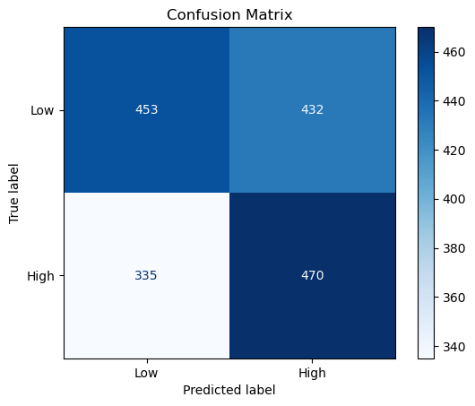

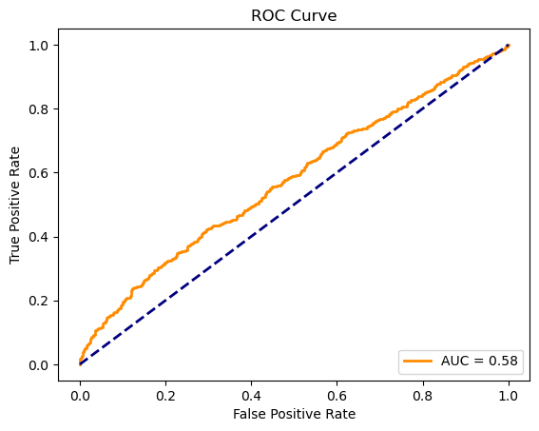

precision recall f1-score support

Low 0.57 0.51 0.54 885

High 0.52 0.58 0.55 805

accuracy 0.55 1690

macro avg 0.55 0.55 0.55 1690

weighted avg 0.55 0.55 0.55 1690