Loaded 7243 epochs (sliding window, all files).

C:\Users\sansk\miniconda3\Lib\site-packages\numpy\lib\function_base.py:2897: RuntimeWarning: invalid value encountered in divide

c /= stddev[:, None]

C:\Users\sansk\miniconda3\Lib\site-packages\numpy\lib\function_base.py:2898: RuntimeWarning: invalid value encountered in divide

c /= stddev[None, :]

Epoch 1: Loss 1.8483

Epoch 2: Loss 1.2032

Epoch 3: Loss 0.8523

Epoch 4: Loss 0.7170

Epoch 5: Loss 0.6928

Epoch 6: Loss 0.7128

Epoch 7: Loss 0.7976

Epoch 8: Loss 0.7213

Epoch 9: Loss 0.6877

Epoch 10: Loss 0.7836

Epoch 11: Loss 0.7450

Epoch 12: Loss 0.7545

Epoch 13: Loss 0.7401

Epoch 14: Loss 0.7407

Epoch 15: Loss 0.7319

Epoch 16: Loss 0.7544

Epoch 17: Loss 0.7529

Epoch 18: Loss 0.7101

Epoch 19: Loss 0.6868

Epoch 20: Loss 0.6990

Test Accuracy: 0.5562

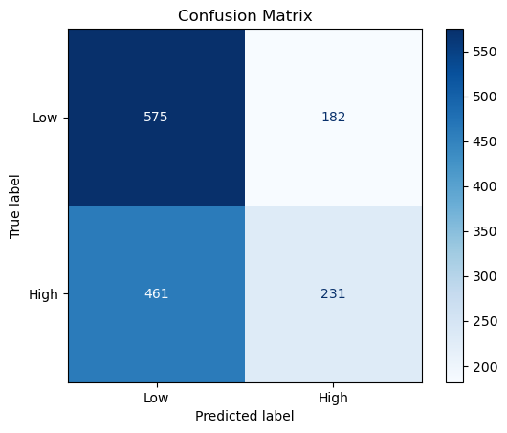

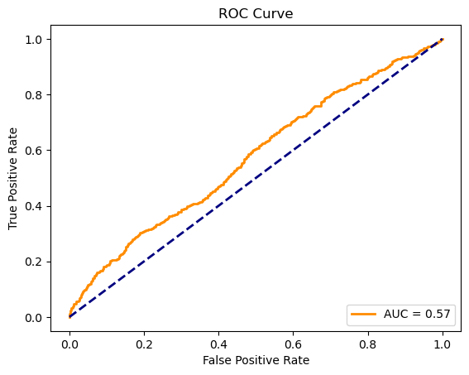

precision recall f1-score support

Low 0.56 0.76 0.64 757

High 0.56 0.33 0.42 692

accuracy 0.56 1449

macro avg 0.56 0.55 0.53 1449

weighted avg 0.56 0.56 0.53 1449