Loaded 8447 epochs (sliding window, all files).

C:\Users\sansk\miniconda3\Lib\site-packages\numpy\lib\function_base.py:2897: RuntimeWarning: invalid value encountered in divide

c /= stddev[:, None]

C:\Users\sansk\miniconda3\Lib\site-packages\numpy\lib\function_base.py:2898: RuntimeWarning: invalid value encountered in divide

c /= stddev[None, :]

Epoch 1: Loss 0.8501

Epoch 2: Loss 0.7614

Epoch 3: Loss 0.7166

Epoch 4: Loss 0.6630

Epoch 5: Loss 0.6666

Epoch 6: Loss 0.6619

Epoch 7: Loss 0.6328

Epoch 8: Loss 0.6211

Epoch 9: Loss 0.6026

Epoch 10: Loss 0.5859

Epoch 11: Loss 0.5690

Epoch 12: Loss 0.5712

Epoch 13: Loss 0.5771

Epoch 14: Loss 0.5355

Epoch 15: Loss 0.5006

Epoch 16: Loss 0.4890

Epoch 17: Loss 0.5074

Epoch 18: Loss 0.5172

Epoch 19: Loss 0.4802

Epoch 20: Loss 0.4412

Test Accuracy: 0.5751

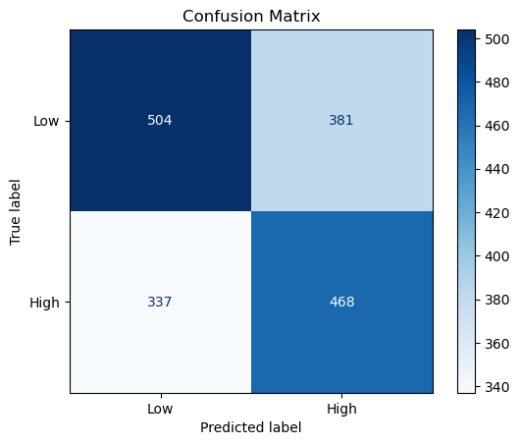

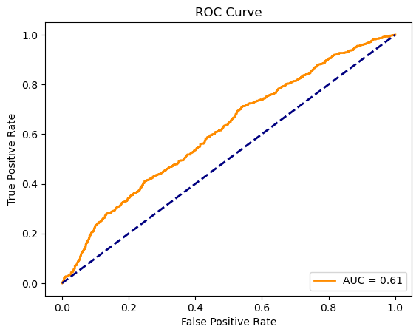

precision recall f1-score support

Low 0.60 0.57 0.58 885

High 0.55 0.58 0.57 805

accuracy 0.58 1690

macro avg 0.58 0.58 0.57 1690

weighted avg 0.58 0.58 0.58 1690