Loaded 7243 epochs (sliding window, all files).

C:\Users\sansk\miniconda3\Lib\site-packages\numpy\lib\function_base.py:2897: RuntimeWarning: invalid value encountered in divide

c /= stddev[:, None]

C:\Users\sansk\miniconda3\Lib\site-packages\numpy\lib\function_base.py:2898: RuntimeWarning: invalid value encountered in divide

c /= stddev[None, :]

Epoch 1: Loss 0.8632

Epoch 2: Loss 0.7581

Epoch 3: Loss 0.7309

Epoch 4: Loss 0.7323

Epoch 5: Loss 0.6691

Epoch 6: Loss 0.6440

Epoch 7: Loss 0.6344

Epoch 8: Loss 0.6343

Epoch 9: Loss 0.6773

Epoch 10: Loss 0.6547

Epoch 11: Loss 0.6414

Epoch 12: Loss 0.6432

Epoch 13: Loss 0.6197

Epoch 14: Loss 0.6533

Epoch 15: Loss 0.6292

Epoch 16: Loss 0.6287

Epoch 17: Loss 0.6368

Epoch 18: Loss 0.6003

Epoch 19: Loss 0.5755

Epoch 20: Loss 0.5546

Test Accuracy: 0.5611

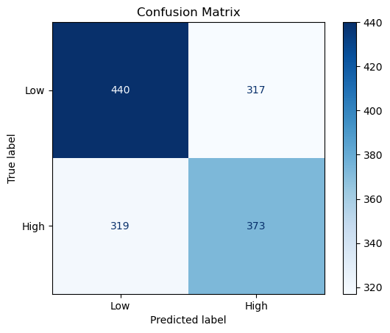

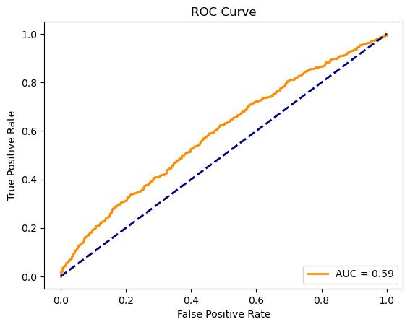

precision recall f1-score support

Low 0.58 0.58 0.58 757

High 0.54 0.54 0.54 692

accuracy 0.56 1449

macro avg 0.56 0.56 0.56 1449

weighted avg 0.56 0.56 0.56 1449