Loaded 7243 epochs (sliding window, all files).

C:\Users\sansk\miniconda3\Lib\site-packages\numpy\lib\function_base.py:2897: RuntimeWarning: invalid value encountered in divide

c /= stddev[:, None]

C:\Users\sansk\miniconda3\Lib\site-packages\numpy\lib\function_base.py:2898: RuntimeWarning: invalid value encountered in divide

c /= stddev[None, :]

C:\Users\sansk\miniconda3\Lib\site-packages\torch_geometric\warnings.py:11: UserWarning: The usage of `scatter(reduce='max')` can be accelerated via the 'torch-scatter' package, but it was not found

warnings.warn(message)

Epoch 1: Loss 2.2001

Epoch 2: Loss 1.6418

Epoch 3: Loss 1.1182

Epoch 4: Loss 0.8610

Epoch 5: Loss 0.8758

Epoch 6: Loss 1.0147

Epoch 7: Loss 0.7455

Epoch 8: Loss 0.8671

Epoch 9: Loss 0.7311

Epoch 10: Loss 0.8459

Epoch 11: Loss 0.7435

Epoch 12: Loss 0.7148

Epoch 13: Loss 0.6277

Epoch 14: Loss 0.6851

Epoch 15: Loss 0.6418

Epoch 16: Loss 0.5709

Epoch 17: Loss 0.5657

Epoch 18: Loss 0.5094

Epoch 19: Loss 0.4731

Epoch 20: Loss 0.4298

Test Accuracy: 0.5908

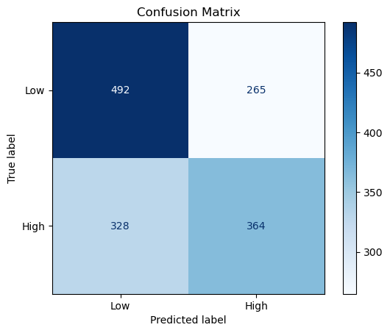

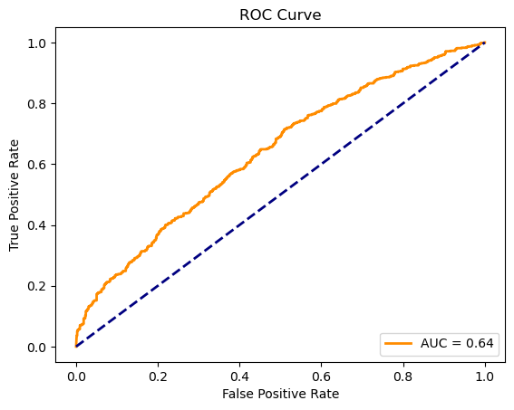

precision recall f1-score support

Low 0.60 0.65 0.62 757

High 0.58 0.53 0.55 692

accuracy 0.59 1449

macro avg 0.59 0.59 0.59 1449

weighted avg 0.59 0.59 0.59 1449