Loaded 8447 epochs (sliding window, all files).

C:\Users\sansk\miniconda3\Lib\site-packages\numpy\lib\function_base.py:2897: RuntimeWarning: invalid value encountered in divide

c /= stddev[:, None]

C:\Users\sansk\miniconda3\Lib\site-packages\numpy\lib\function_base.py:2898: RuntimeWarning: invalid value encountered in divide

c /= stddev[None, :]

C:\Users\sansk\miniconda3\Lib\site-packages\torch_geometric\deprecation.py:26: UserWarning: 'nn.glob.global_sort_pool' is deprecated, use 'nn.aggr.SortAggr' instead

warnings.warn(out)

Epoch 1: Loss 1.0448

Epoch 2: Loss 0.7411

Epoch 3: Loss 0.7378

Epoch 4: Loss 0.6895

Epoch 5: Loss 0.6834

Epoch 6: Loss 0.6666

Epoch 7: Loss 0.6409

Epoch 8: Loss 0.6260

Epoch 9: Loss 0.6175

Epoch 10: Loss 0.6129

Epoch 11: Loss 0.5832

Epoch 12: Loss 0.6034

Epoch 13: Loss 0.5684

Epoch 14: Loss 0.5455

Epoch 15: Loss 0.5441

Epoch 16: Loss 0.5314

Epoch 17: Loss 0.5019

Epoch 18: Loss 0.4854

Epoch 19: Loss 0.4631

Epoch 20: Loss 0.4791

Test Accuracy: 0.5604

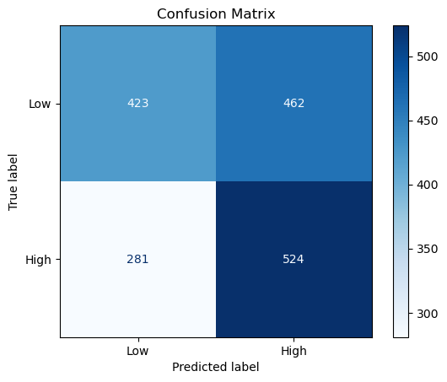

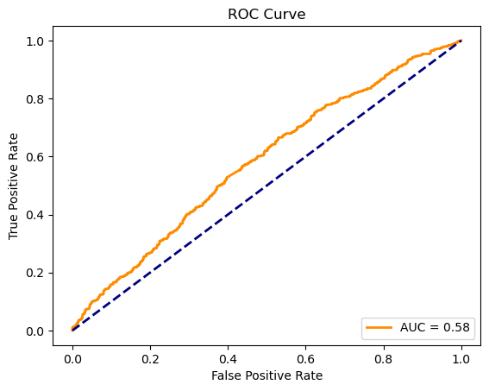

precision recall f1-score support

Low 0.60 0.48 0.53 885

High 0.53 0.65 0.59 805

accuracy 0.56 1690

macro avg 0.57 0.56 0.56 1690

weighted avg 0.57 0.56 0.56 1690