Loaded 7243 epochs (sliding window, all files).

C:\Users\sansk\miniconda3\Lib\site-packages\numpy\lib\function_base.py:2897: RuntimeWarning: invalid value encountered in divide

c /= stddev[:, None]

C:\Users\sansk\miniconda3\Lib\site-packages\numpy\lib\function_base.py:2898: RuntimeWarning: invalid value encountered in divide

c /= stddev[None, :]

C:\Users\sansk\miniconda3\Lib\site-packages\torch_geometric\deprecation.py:26: UserWarning: 'nn.glob.global_sort_pool' is deprecated, use 'nn.aggr.SortAggr' instead

warnings.warn(out)

Epoch 1: Loss 1.7514

Epoch 2: Loss 1.4872

Epoch 3: Loss 1.6843

Epoch 4: Loss 1.2716

Epoch 5: Loss 1.2241

Epoch 6: Loss 0.9033

Epoch 7: Loss 1.0614

Epoch 8: Loss 1.2369

Epoch 9: Loss 0.9880

Epoch 10: Loss 0.8603

Epoch 11: Loss 0.7916

Epoch 12: Loss 0.7891

Epoch 13: Loss 0.8312

Epoch 14: Loss 0.6971

Epoch 15: Loss 0.6787

Epoch 16: Loss 0.7023

Epoch 17: Loss 0.6794

Epoch 18: Loss 0.6644

Epoch 19: Loss 0.6400

Epoch 20: Loss 0.6491

Test Accuracy: 0.5355

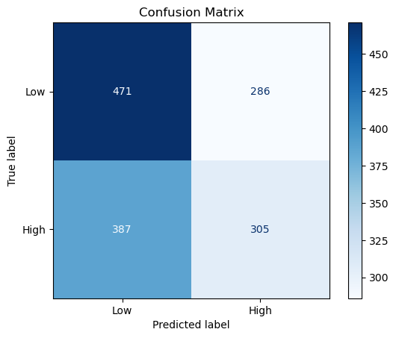

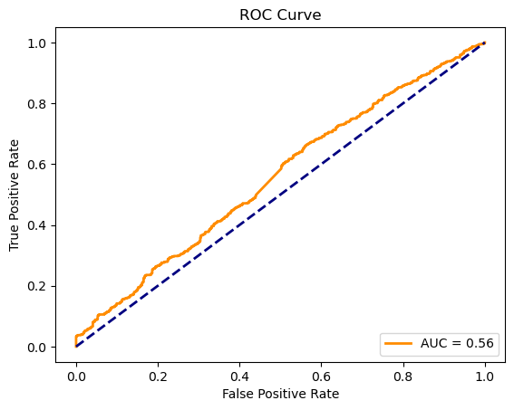

precision recall f1-score support

Low 0.55 0.62 0.58 757

High 0.52 0.44 0.48 692

accuracy 0.54 1449

macro avg 0.53 0.53 0.53 1449

weighted avg 0.53 0.54 0.53 1449