Loaded 8447 epochs (sliding window, all files).

C:\Users\sansk\miniconda3\Lib\site-packages\numpy\lib\function_base.py:2897: RuntimeWarning: invalid value encountered in divide

c /= stddev[:, None]

C:\Users\sansk\miniconda3\Lib\site-packages\numpy\lib\function_base.py:2898: RuntimeWarning: invalid value encountered in divide

c /= stddev[None, :]

Epoch 1: Loss 0.9221

Epoch 2: Loss 0.6933

Epoch 3: Loss 0.6636

Epoch 4: Loss 0.6824

Epoch 5: Loss 0.6411

Epoch 6: Loss 0.6356

Epoch 7: Loss 0.6283

Epoch 8: Loss 0.6274

Epoch 9: Loss 0.6281

Epoch 10: Loss 0.6027

Epoch 11: Loss 0.5974

Epoch 12: Loss 0.5793

Epoch 13: Loss 0.5553

Epoch 14: Loss 0.5797

Epoch 15: Loss 0.5364

Epoch 16: Loss 0.5199

Epoch 17: Loss 0.4942

Epoch 18: Loss 0.4782

Epoch 19: Loss 0.4410

Epoch 20: Loss 0.4163

Test Accuracy: 0.5633

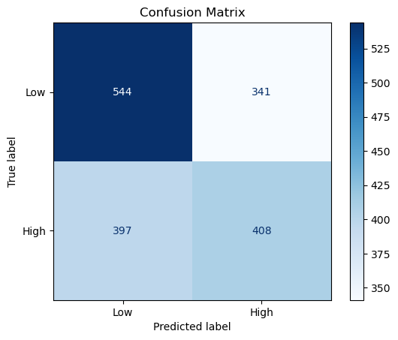

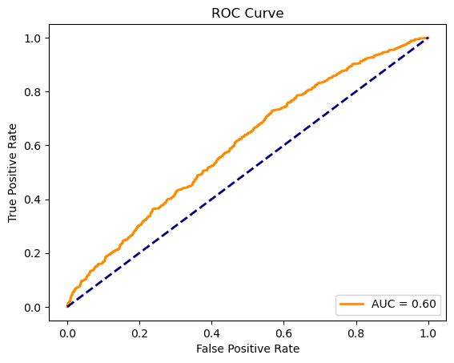

precision recall f1-score support

Low 0.58 0.61 0.60 885

High 0.54 0.51 0.53 805

accuracy 0.56 1690

macro avg 0.56 0.56 0.56 1690

weighted avg 0.56 0.56 0.56 1690