Loaded 7243 epochs (sliding window, all files).

C:\Users\sansk\miniconda3\Lib\site-packages\numpy\lib\function_base.py:2897: RuntimeWarning: invalid value encountered in divide

c /= stddev[:, None]

C:\Users\sansk\miniconda3\Lib\site-packages\numpy\lib\function_base.py:2898: RuntimeWarning: invalid value encountered in divide

c /= stddev[None, :]

Epoch 1: Loss 1.1747

Epoch 2: Loss 0.8160

Epoch 3: Loss 0.6797

Epoch 4: Loss 0.6592

Epoch 5: Loss 0.6365

Epoch 6: Loss 0.6250

Epoch 7: Loss 0.6271

Epoch 8: Loss 0.6121

Epoch 9: Loss 0.6043

Epoch 10: Loss 0.6147

Epoch 11: Loss 0.6037

Epoch 12: Loss 0.6006

Epoch 13: Loss 0.5852

Epoch 14: Loss 0.6200

Epoch 15: Loss 0.6243

Epoch 16: Loss 0.6093

Epoch 17: Loss 0.5652

Epoch 18: Loss 0.5748

Epoch 19: Loss 0.5447

Epoch 20: Loss 0.5246

Test Accuracy: 0.5742

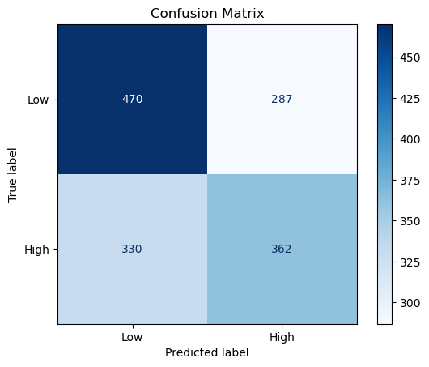

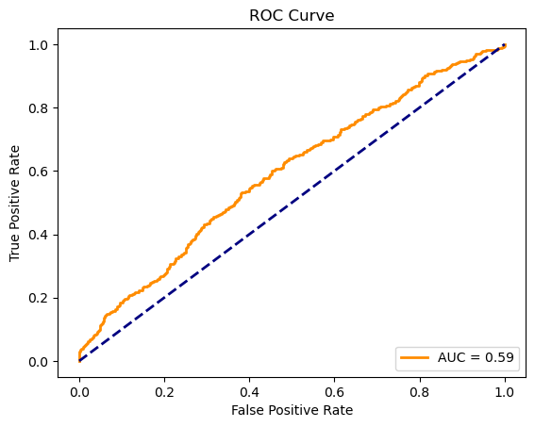

precision recall f1-score support

Low 0.59 0.62 0.60 757

High 0.56 0.52 0.54 692

accuracy 0.57 1449

macro avg 0.57 0.57 0.57 1449

weighted avg 0.57 0.57 0.57 1449