Loaded 8447 epochs with anxiety stages.

C:\Users\sansk\miniconda3\Lib\site-packages\numpy\lib\function_base.py:2897: RuntimeWarning: invalid value encountered in divide

c /= stddev[:, None]

C:\Users\sansk\miniconda3\Lib\site-packages\numpy\lib\function_base.py:2898: RuntimeWarning: invalid value encountered in divide

c /= stddev[None, :]

C:\Users\sansk\miniconda3\Lib\site-packages\torch_geometric\deprecation.py:26: UserWarning: 'data.DataLoader' is deprecated, use 'loader.DataLoader' instead

warnings.warn(out)

Epoch 1/20 - Loss: 1.6962

Epoch 2/20 - Loss: 1.2053

Epoch 3/20 - Loss: 0.9580

Epoch 4/20 - Loss: 0.8104

Epoch 5/20 - Loss: 0.6953

Epoch 6/20 - Loss: 0.6141

Epoch 7/20 - Loss: 0.5306

Epoch 8/20 - Loss: 0.4707

Epoch 9/20 - Loss: 0.4270

Epoch 10/20 - Loss: 0.3863

Epoch 11/20 - Loss: 0.3633

Epoch 12/20 - Loss: 0.3279

Epoch 13/20 - Loss: 0.2979

Epoch 14/20 - Loss: 0.3055

Epoch 15/20 - Loss: 0.2581

Epoch 16/20 - Loss: 0.2504

Epoch 17/20 - Loss: 0.2546

Epoch 18/20 - Loss: 0.2292

Epoch 19/20 - Loss: 0.2385

Epoch 20/20 - Loss: 0.1966

Test Accuracy: 0.8592

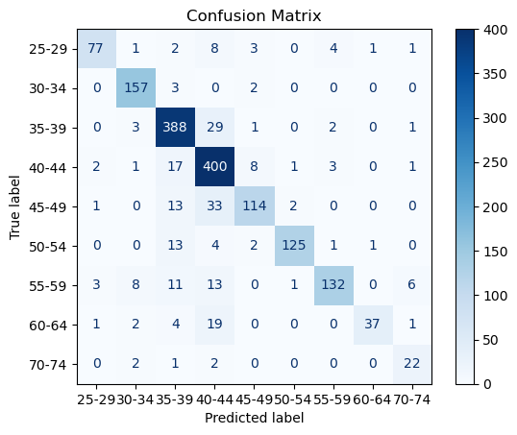

precision recall f1-score support

25-29 0.92 0.79 0.85 97

30-34 0.90 0.97 0.93 162

35-39 0.86 0.92 0.89 424

40-44 0.79 0.92 0.85 433

45-49 0.88 0.70 0.78 163

50-54 0.97 0.86 0.91 146

55-59 0.93 0.76 0.84 174

60-64 0.95 0.58 0.72 64

70-74 0.69 0.81 0.75 27

accuracy 0.86 1690

macro avg 0.88 0.81 0.83 1690

weighted avg 0.87 0.86 0.86 1690