Loaded 7243 epochs with anxiety stages.

C:\Users\sansk\miniconda3\Lib\site-packages\numpy\lib\function_base.py:2897: RuntimeWarning: invalid value encountered in divide

c /= stddev[:, None]

C:\Users\sansk\miniconda3\Lib\site-packages\numpy\lib\function_base.py:2898: RuntimeWarning: invalid value encountered in divide

c /= stddev[None, :]

C:\Users\sansk\miniconda3\Lib\site-packages\torch_geometric\deprecation.py:26: UserWarning: 'data.DataLoader' is deprecated, use 'loader.DataLoader' instead

warnings.warn(out)

Epoch 1/20 - Loss: 1.7171

Epoch 2/20 - Loss: 1.2561

Epoch 3/20 - Loss: 0.9741

Epoch 4/20 - Loss: 0.8049

Epoch 5/20 - Loss: 0.6618

Epoch 6/20 - Loss: 0.5823

Epoch 7/20 - Loss: 0.5011

Epoch 8/20 - Loss: 0.4581

Epoch 9/20 - Loss: 0.4020

Epoch 10/20 - Loss: 0.3966

Epoch 11/20 - Loss: 0.3659

Epoch 12/20 - Loss: 0.3095

Epoch 13/20 - Loss: 0.2665

Epoch 14/20 - Loss: 0.2827

Epoch 15/20 - Loss: 0.2544

Epoch 16/20 - Loss: 0.2311

Epoch 17/20 - Loss: 0.2237

Epoch 18/20 - Loss: 0.2012

Epoch 19/20 - Loss: 0.1983

Epoch 20/20 - Loss: 0.2183

Test Accuracy: 0.8309

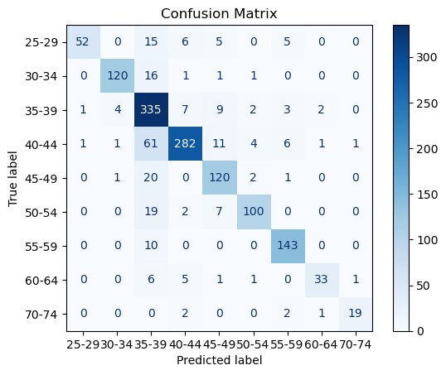

precision recall f1-score support

25-29 0.96 0.63 0.76 83

30-34 0.95 0.86 0.91 139

35-39 0.70 0.92 0.79 363

40-44 0.92 0.77 0.84 368

45-49 0.78 0.83 0.81 144

50-54 0.91 0.78 0.84 128

55-59 0.89 0.93 0.91 153

60-64 0.89 0.70 0.79 47

70-74 0.90 0.79 0.84 24

accuracy 0.83 1449

macro avg 0.88 0.80 0.83 1449

weighted avg 0.85 0.83 0.83 1449