Processing sub-001_task-P300_run-1_eeg.set-epo.fif

Reading C:\Users\sansk\processed_data\sub-001_task-P300_run-1_eeg.set-epo.fif ...

Found the data of interest:

t = -199.22 ... 800.78 ms

0 CTF compensation matrices available

Not setting metadata

862 matching events found

No baseline correction applied

0 projection items activated

Processing sub-001_task-P300_run-2_eeg.set-epo.fif

Reading C:\Users\sansk\processed_data\sub-001_task-P300_run-2_eeg.set-epo.fif ...

Found the data of interest:

t = -199.22 ... 800.78 ms

0 CTF compensation matrices available

Not setting metadata

861 matching events found

No baseline correction applied

0 projection items activated

Processing sub-001_task-P300_run-3_eeg.set-epo.fif

Reading C:\Users\sansk\processed_data\sub-001_task-P300_run-3_eeg.set-epo.fif ...

Found the data of interest:

t = -199.22 ... 800.78 ms

0 CTF compensation matrices available

Not setting metadata

859 matching events found

No baseline correction applied

0 projection items activated

Processing sub-002_task-P300_run-1_eeg.set-epo.fif

Reading C:\Users\sansk\processed_data\sub-002_task-P300_run-1_eeg.set-epo.fif ...

Found the data of interest:

t = -199.22 ... 800.78 ms

0 CTF compensation matrices available

Not setting metadata

811 matching events found

No baseline correction applied

0 projection items activated

Processing sub-002_task-P300_run-2_eeg.set-epo.fif

Reading C:\Users\sansk\processed_data\sub-002_task-P300_run-2_eeg.set-epo.fif ...

Found the data of interest:

t = -199.22 ... 800.78 ms

0 CTF compensation matrices available

Not setting metadata

806 matching events found

No baseline correction applied

0 projection items activated

Processing sub-002_task-P300_run-3_eeg.set-epo.fif

Reading C:\Users\sansk\processed_data\sub-002_task-P300_run-3_eeg.set-epo.fif ...

Found the data of interest:

t = -199.22 ... 800.78 ms

0 CTF compensation matrices available

Not setting metadata

799 matching events found

No baseline correction applied

0 projection items activated

Processing sub-003_task-P300_run-1_eeg.set-epo.fif

Reading C:\Users\sansk\processed_data\sub-003_task-P300_run-1_eeg.set-epo.fif ...

Found the data of interest:

t = -199.22 ... 800.78 ms

0 CTF compensation matrices available

Not setting metadata

860 matching events found

No baseline correction applied

0 projection items activated

Processing sub-003_task-P300_run-2_eeg.set-epo.fif

Reading C:\Users\sansk\processed_data\sub-003_task-P300_run-2_eeg.set-epo.fif ...

Found the data of interest:

t = -199.22 ... 800.78 ms

0 CTF compensation matrices available

Not setting metadata

859 matching events found

No baseline correction applied

0 projection items activated

Processing sub-003_task-P300_run-3_eeg.set-epo.fif

Reading C:\Users\sansk\processed_data\sub-003_task-P300_run-3_eeg.set-epo.fif ...

Found the data of interest:

t = -199.22 ... 800.78 ms

0 CTF compensation matrices available

Not setting metadata

861 matching events found

No baseline correction applied

0 projection items activated

Processing sub-004_task-P300_run-1_eeg.set-epo.fif

Reading C:\Users\sansk\processed_data\sub-004_task-P300_run-1_eeg.set-epo.fif ...

Found the data of interest:

t = -199.22 ... 800.78 ms

0 CTF compensation matrices available

Not setting metadata

859 matching events found

No baseline correction applied

0 projection items activated

Processing sub-004_task-P300_run-2_eeg.set-epo.fif

Reading C:\Users\sansk\processed_data\sub-004_task-P300_run-2_eeg.set-epo.fif ...

Found the data of interest:

t = -199.22 ... 800.78 ms

0 CTF compensation matrices available

Not setting metadata

856 matching events found

No baseline correction applied

0 projection items activated

Processing sub-004_task-P300_run-3_eeg.set-epo.fif

Reading C:\Users\sansk\processed_data\sub-004_task-P300_run-3_eeg.set-epo.fif ...

Found the data of interest:

t = -199.22 ... 800.78 ms

0 CTF compensation matrices available

Not setting metadata

860 matching events found

No baseline correction applied

0 projection items activated

Processing sub-005_task-P300_run-1_eeg.set-epo.fif

Reading C:\Users\sansk\processed_data\sub-005_task-P300_run-1_eeg.set-epo.fif ...

Found the data of interest:

t = -199.22 ... 800.78 ms

0 CTF compensation matrices available

Not setting metadata

859 matching events found

No baseline correction applied

0 projection items activated

Processing sub-005_task-P300_run-2_eeg.set-epo.fif

Reading C:\Users\sansk\processed_data\sub-005_task-P300_run-2_eeg.set-epo.fif ...

Found the data of interest:

t = -199.22 ... 800.78 ms

0 CTF compensation matrices available

Not setting metadata

861 matching events found

No baseline correction applied

0 projection items activated

Processing sub-005_task-P300_run-3_eeg.set-epo.fif

Reading C:\Users\sansk\processed_data\sub-005_task-P300_run-3_eeg.set-epo.fif ...

Found the data of interest:

t = -199.22 ... 800.78 ms

0 CTF compensation matrices available

Not setting metadata

855 matching events found

No baseline correction applied

0 projection items activated

Processing sub-006_task-P300_run-1_eeg.set-epo.fif

Reading C:\Users\sansk\processed_data\sub-006_task-P300_run-1_eeg.set-epo.fif ...

Found the data of interest:

t = -199.22 ... 800.78 ms

0 CTF compensation matrices available

Not setting metadata

855 matching events found

No baseline correction applied

0 projection items activated

Processing sub-006_task-P300_run-2_eeg.set-epo.fif

Reading C:\Users\sansk\processed_data\sub-006_task-P300_run-2_eeg.set-epo.fif ...

Found the data of interest:

t = -199.22 ... 800.78 ms

0 CTF compensation matrices available

Not setting metadata

835 matching events found

No baseline correction applied

0 projection items activated

Processing sub-006_task-P300_run-3_eeg.set-epo.fif

Reading C:\Users\sansk\processed_data\sub-006_task-P300_run-3_eeg.set-epo.fif ...

Found the data of interest:

t = -199.22 ... 800.78 ms

0 CTF compensation matrices available

Not setting metadata

859 matching events found

No baseline correction applied

0 projection items activated

Processing sub-007_task-P300_run-1_eeg.set-epo.fif

Reading C:\Users\sansk\processed_data\sub-007_task-P300_run-1_eeg.set-epo.fif ...

Found the data of interest:

t = -199.22 ... 800.78 ms

0 CTF compensation matrices available

Not setting metadata

862 matching events found

No baseline correction applied

0 projection items activated

Processing sub-007_task-P300_run-2_eeg.set-epo.fif

Reading C:\Users\sansk\processed_data\sub-007_task-P300_run-2_eeg.set-epo.fif ...

Found the data of interest:

t = -199.22 ... 800.78 ms

0 CTF compensation matrices available

Not setting metadata

848 matching events found

No baseline correction applied

0 projection items activated

Processing sub-007_task-P300_run-3_eeg.set-epo.fif

Reading C:\Users\sansk\processed_data\sub-007_task-P300_run-3_eeg.set-epo.fif ...

Found the data of interest:

t = -199.22 ... 800.78 ms

0 CTF compensation matrices available

Not setting metadata

856 matching events found

No baseline correction applied

0 projection items activated

Processing sub-008_task-P300_run-1_eeg.set-epo.fif

Reading C:\Users\sansk\processed_data\sub-008_task-P300_run-1_eeg.set-epo.fif ...

Found the data of interest:

t = -199.22 ... 800.78 ms

0 CTF compensation matrices available

Not setting metadata

819 matching events found

No baseline correction applied

0 projection items activated

Processing sub-008_task-P300_run-2_eeg.set-epo.fif

Reading C:\Users\sansk\processed_data\sub-008_task-P300_run-2_eeg.set-epo.fif ...

Found the data of interest:

t = -199.22 ... 800.78 ms

0 CTF compensation matrices available

Not setting metadata

824 matching events found

No baseline correction applied

0 projection items activated

Processing sub-008_task-P300_run-3_eeg.set-epo.fif

Reading C:\Users\sansk\processed_data\sub-008_task-P300_run-3_eeg.set-epo.fif ...

Found the data of interest:

t = -199.22 ... 800.78 ms

0 CTF compensation matrices available

Not setting metadata

796 matching events found

No baseline correction applied

0 projection items activated

Processing sub-009_task-P300_run-1_eeg.set-epo.fif

Reading C:\Users\sansk\processed_data\sub-009_task-P300_run-1_eeg.set-epo.fif ...

Found the data of interest:

t = -199.22 ... 800.78 ms

0 CTF compensation matrices available

Not setting metadata

862 matching events found

No baseline correction applied

0 projection items activated

Processing sub-009_task-P300_run-2_eeg.set-epo.fif

Reading C:\Users\sansk\processed_data\sub-009_task-P300_run-2_eeg.set-epo.fif ...

Found the data of interest:

t = -199.22 ... 800.78 ms

0 CTF compensation matrices available

Not setting metadata

859 matching events found

No baseline correction applied

0 projection items activated

Processing sub-009_task-P300_run-3_eeg.set-epo.fif

Reading C:\Users\sansk\processed_data\sub-009_task-P300_run-3_eeg.set-epo.fif ...

Found the data of interest:

t = -199.22 ... 800.78 ms

0 CTF compensation matrices available

Not setting metadata

860 matching events found

No baseline correction applied

0 projection items activated

Processing sub-010_task-P300_run-1_eeg.set-epo.fif

Reading C:\Users\sansk\processed_data\sub-010_task-P300_run-1_eeg.set-epo.fif ...

Found the data of interest:

t = -199.22 ... 800.78 ms

0 CTF compensation matrices available

Not setting metadata

866 matching events found

No baseline correction applied

0 projection items activated

Processing sub-010_task-P300_run-2_eeg.set-epo.fif

Reading C:\Users\sansk\processed_data\sub-010_task-P300_run-2_eeg.set-epo.fif ...

Found the data of interest:

t = -199.22 ... 800.78 ms

0 CTF compensation matrices available

Not setting metadata

861 matching events found

No baseline correction applied

0 projection items activated

Processing sub-010_task-P300_run-3_eeg.set-epo.fif

Reading C:\Users\sansk\processed_data\sub-010_task-P300_run-3_eeg.set-epo.fif ...

Found the data of interest:

t = -199.22 ... 800.78 ms

0 CTF compensation matrices available

Not setting metadata

857 matching events found

No baseline correction applied

0 projection items activated

Processing sub-011_task-P300_run-1_eeg.set-epo.fif

Reading C:\Users\sansk\processed_data\sub-011_task-P300_run-1_eeg.set-epo.fif ...

Found the data of interest:

t = -199.22 ... 800.78 ms

0 CTF compensation matrices available

Not setting metadata

860 matching events found

No baseline correction applied

0 projection items activated

Processing sub-011_task-P300_run-2_eeg.set-epo.fif

Reading C:\Users\sansk\processed_data\sub-011_task-P300_run-2_eeg.set-epo.fif ...

Found the data of interest:

t = -199.22 ... 800.78 ms

0 CTF compensation matrices available

Not setting metadata

857 matching events found

No baseline correction applied

0 projection items activated

Processing sub-011_task-P300_run-3_eeg.set-epo.fif

Reading C:\Users\sansk\processed_data\sub-011_task-P300_run-3_eeg.set-epo.fif ...

Found the data of interest:

t = -199.22 ... 800.78 ms

0 CTF compensation matrices available

Not setting metadata

854 matching events found

No baseline correction applied

0 projection items activated

Processing sub-012_task-P300_run-1_eeg.set-epo.fif

Reading C:\Users\sansk\processed_data\sub-012_task-P300_run-1_eeg.set-epo.fif ...

Found the data of interest:

t = -199.22 ... 800.78 ms

0 CTF compensation matrices available

Not setting metadata

100 matching events found

No baseline correction applied

0 projection items activated

Processing sub-012_task-P300_run-2_eeg.set-epo.fif

Reading C:\Users\sansk\processed_data\sub-012_task-P300_run-2_eeg.set-epo.fif ...

Found the data of interest:

t = -199.22 ... 800.78 ms

0 CTF compensation matrices available

Not setting metadata

785 matching events found

No baseline correction applied

0 projection items activated

Processing sub-012_task-P300_run-3_eeg.set-epo.fif

Reading C:\Users\sansk\processed_data\sub-012_task-P300_run-3_eeg.set-epo.fif ...

Found the data of interest:

t = -199.22 ... 800.78 ms

0 CTF compensation matrices available

Not setting metadata

861 matching events found

No baseline correction applied

0 projection items activated

Processing sub-013_task-P300_run-1_eeg.set-epo.fif

Reading C:\Users\sansk\processed_data\sub-013_task-P300_run-1_eeg.set-epo.fif ...

Found the data of interest:

t = -199.22 ... 800.78 ms

0 CTF compensation matrices available

Not setting metadata

851 matching events found

No baseline correction applied

0 projection items activated

Processing sub-013_task-P300_run-2_eeg.set-epo.fif

Reading C:\Users\sansk\processed_data\sub-013_task-P300_run-2_eeg.set-epo.fif ...

Found the data of interest:

t = -199.22 ... 800.78 ms

0 CTF compensation matrices available

Not setting metadata

861 matching events found

No baseline correction applied

0 projection items activated

Processing sub-013_task-P300_run-3_eeg.set-epo.fif

Reading C:\Users\sansk\processed_data\sub-013_task-P300_run-3_eeg.set-epo.fif ...

Found the data of interest:

t = -199.22 ... 800.78 ms

0 CTF compensation matrices available

Not setting metadata

860 matching events found

No baseline correction applied

0 projection items activated

Data shape: (24164, 1, 79, 257), Labels shape: (24164,)

--- Fold 1/5 ---

Train class 0: 15933, class 1: 3398 | Test class 0: 3984, class 1: 849

First 5 trials' means: [-0.05561629 -0.05560151 -0.05560195 -0.05559734 -0.05559145]

First 5 trials' stds : [0.45557523 0.45557576 0.45557508 0.45557418 0.45557374]

Overall mean across trials: -0.055422507

Overall std across trials : 0.45570552

Interpretation:

- If overall mean is close to 0 and overall std is close to 1, your data is likely normalized and scaled.

- If not, consider applying normalization (e.g., z-scoring) before model input.

True label counts: [3984 849], Predicted label counts: [4799 34]

Fold 1 - Acc: 0.831, AUC: 0.750, Precision: 0.971, Recall: 0.039, F1: 0.075

--- Fold 2/5 ---

Train class 0: 15933, class 1: 3398 | Test class 0: 3984, class 1: 849

First 5 trials' means: [-0.05561629 -0.05560151 -0.05560195 -0.05559734 -0.05559145]

First 5 trials' stds : [0.45557523 0.45557576 0.45557508 0.45557418 0.45557374]

Overall mean across trials: -0.055422507

Overall std across trials : 0.45570552

Interpretation:

- If overall mean is close to 0 and overall std is close to 1, your data is likely normalized and scaled.

- If not, consider applying normalization (e.g., z-scoring) before model input.

True label counts: [3984 849], Predicted label counts: [4342 491]

Fold 2 - Acc: 0.855, AUC: 0.748, Precision: 0.650, Recall: 0.376, F1: 0.476

--- Fold 3/5 ---

Train class 0: 15934, class 1: 3397 | Test class 0: 3983, class 1: 850

First 5 trials' means: [-0.05561629 -0.05560151 -0.05560195 -0.05559734 -0.05559145]

First 5 trials' stds : [0.45557523 0.45557576 0.45557508 0.45557418 0.45557374]

Overall mean across trials: -0.055422507

Overall std across trials : 0.45570552

Interpretation:

- If overall mean is close to 0 and overall std is close to 1, your data is likely normalized and scaled.

- If not, consider applying normalization (e.g., z-scoring) before model input.

True label counts: [3983 850], Predicted label counts: [4787 46]

Fold 3 - Acc: 0.830, AUC: 0.702, Precision: 0.783, Recall: 0.042, F1: 0.080

--- Fold 4/5 ---

Train class 0: 15934, class 1: 3397 | Test class 0: 3983, class 1: 850

First 5 trials' means: [-0.05561629 -0.05560151 -0.05560195 -0.05559734 -0.05559145]

First 5 trials' stds : [0.45557523 0.45557576 0.45557508 0.45557418 0.45557374]

Overall mean across trials: -0.055422507

Overall std across trials : 0.45570552

Interpretation:

- If overall mean is close to 0 and overall std is close to 1, your data is likely normalized and scaled.

- If not, consider applying normalization (e.g., z-scoring) before model input.

True label counts: [3983 850], Predicted label counts: [4645 188]

Fold 4 - Acc: 0.823, AUC: 0.671, Precision: 0.484, Recall: 0.107, F1: 0.175

--- Fold 5/5 ---

Train class 0: 15934, class 1: 3398 | Test class 0: 3983, class 1: 849

First 5 trials' means: [-0.05561629 -0.05560151 -0.05560195 -0.05559734 -0.05559145]

First 5 trials' stds : [0.45557523 0.45557576 0.45557508 0.45557418 0.45557374]

Overall mean across trials: -0.055422507

Overall std across trials : 0.45570552

Interpretation:

- If overall mean is close to 0 and overall std is close to 1, your data is likely normalized and scaled.

- If not, consider applying normalization (e.g., z-scoring) before model input.

True label counts: [3983 849], Predicted label counts: [4832]

Fold 5 - Acc: 0.824, AUC: 0.749, Precision: 0.000, Recall: 0.000, F1: 0.000

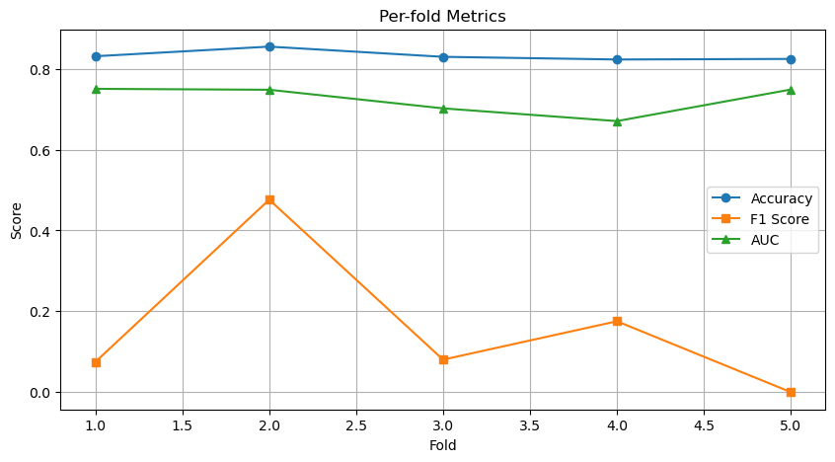

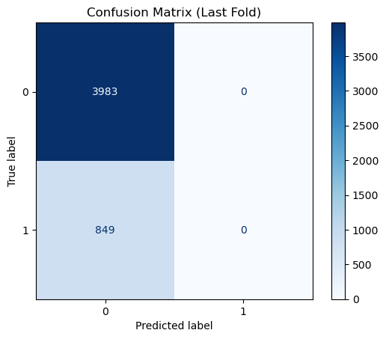

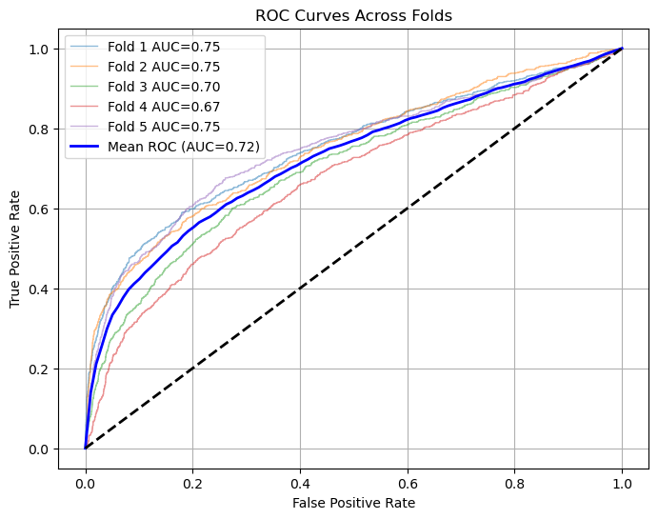

=== K-Fold Results ===

ACC: 0.832 ± 0.012

AUC: 0.724 ± 0.032

PRECISION: 0.577 ± 0.330

RECALL: 0.113 ± 0.136

F1: 0.161 ± 0.167