Processing sub-001_task-P300_run-1_eeg.set-epo.fif

Reading C:\Users\sansk\processed_data\sub-001_task-P300_run-1_eeg.set-epo.fif ...

Found the data of interest:

t = -199.22 ... 800.78 ms

0 CTF compensation matrices available

Not setting metadata

862 matching events found

No baseline correction applied

0 projection items activated

Processing sub-001_task-P300_run-2_eeg.set-epo.fif

Reading C:\Users\sansk\processed_data\sub-001_task-P300_run-2_eeg.set-epo.fif ...

Found the data of interest:

t = -199.22 ... 800.78 ms

0 CTF compensation matrices available

Not setting metadata

861 matching events found

No baseline correction applied

0 projection items activated

Processing sub-001_task-P300_run-3_eeg.set-epo.fif

Reading C:\Users\sansk\processed_data\sub-001_task-P300_run-3_eeg.set-epo.fif ...

Found the data of interest:

t = -199.22 ... 800.78 ms

0 CTF compensation matrices available

Not setting metadata

859 matching events found

No baseline correction applied

0 projection items activated

Processing sub-002_task-P300_run-1_eeg.set-epo.fif

Reading C:\Users\sansk\processed_data\sub-002_task-P300_run-1_eeg.set-epo.fif ...

Found the data of interest:

t = -199.22 ... 800.78 ms

0 CTF compensation matrices available

Not setting metadata

811 matching events found

No baseline correction applied

0 projection items activated

Processing sub-002_task-P300_run-2_eeg.set-epo.fif

Reading C:\Users\sansk\processed_data\sub-002_task-P300_run-2_eeg.set-epo.fif ...

Found the data of interest:

t = -199.22 ... 800.78 ms

0 CTF compensation matrices available

Not setting metadata

806 matching events found

No baseline correction applied

0 projection items activated

Processing sub-002_task-P300_run-3_eeg.set-epo.fif

Reading C:\Users\sansk\processed_data\sub-002_task-P300_run-3_eeg.set-epo.fif ...

Found the data of interest:

t = -199.22 ... 800.78 ms

0 CTF compensation matrices available

Not setting metadata

799 matching events found

No baseline correction applied

0 projection items activated

Processing sub-003_task-P300_run-1_eeg.set-epo.fif

Reading C:\Users\sansk\processed_data\sub-003_task-P300_run-1_eeg.set-epo.fif ...

Found the data of interest:

t = -199.22 ... 800.78 ms

0 CTF compensation matrices available

Not setting metadata

860 matching events found

No baseline correction applied

0 projection items activated

Processing sub-003_task-P300_run-2_eeg.set-epo.fif

Reading C:\Users\sansk\processed_data\sub-003_task-P300_run-2_eeg.set-epo.fif ...

Found the data of interest:

t = -199.22 ... 800.78 ms

0 CTF compensation matrices available

Not setting metadata

859 matching events found

No baseline correction applied

0 projection items activated

Processing sub-003_task-P300_run-3_eeg.set-epo.fif

Reading C:\Users\sansk\processed_data\sub-003_task-P300_run-3_eeg.set-epo.fif ...

Found the data of interest:

t = -199.22 ... 800.78 ms

0 CTF compensation matrices available

Not setting metadata

861 matching events found

No baseline correction applied

0 projection items activated

Processing sub-004_task-P300_run-1_eeg.set-epo.fif

Reading C:\Users\sansk\processed_data\sub-004_task-P300_run-1_eeg.set-epo.fif ...

Found the data of interest:

t = -199.22 ... 800.78 ms

0 CTF compensation matrices available

Not setting metadata

859 matching events found

No baseline correction applied

0 projection items activated

Processing sub-004_task-P300_run-2_eeg.set-epo.fif

Reading C:\Users\sansk\processed_data\sub-004_task-P300_run-2_eeg.set-epo.fif ...

Found the data of interest:

t = -199.22 ... 800.78 ms

0 CTF compensation matrices available

Not setting metadata

856 matching events found

No baseline correction applied

0 projection items activated

Processing sub-004_task-P300_run-3_eeg.set-epo.fif

Reading C:\Users\sansk\processed_data\sub-004_task-P300_run-3_eeg.set-epo.fif ...

Found the data of interest:

t = -199.22 ... 800.78 ms

0 CTF compensation matrices available

Not setting metadata

860 matching events found

No baseline correction applied

0 projection items activated

Processing sub-005_task-P300_run-1_eeg.set-epo.fif

Reading C:\Users\sansk\processed_data\sub-005_task-P300_run-1_eeg.set-epo.fif ...

Found the data of interest:

t = -199.22 ... 800.78 ms

0 CTF compensation matrices available

Not setting metadata

859 matching events found

No baseline correction applied

0 projection items activated

Processing sub-005_task-P300_run-2_eeg.set-epo.fif

Reading C:\Users\sansk\processed_data\sub-005_task-P300_run-2_eeg.set-epo.fif ...

Found the data of interest:

t = -199.22 ... 800.78 ms

0 CTF compensation matrices available

Not setting metadata

861 matching events found

No baseline correction applied

0 projection items activated

Processing sub-005_task-P300_run-3_eeg.set-epo.fif

Reading C:\Users\sansk\processed_data\sub-005_task-P300_run-3_eeg.set-epo.fif ...

Found the data of interest:

t = -199.22 ... 800.78 ms

0 CTF compensation matrices available

Not setting metadata

855 matching events found

No baseline correction applied

0 projection items activated

Processing sub-006_task-P300_run-1_eeg.set-epo.fif

Reading C:\Users\sansk\processed_data\sub-006_task-P300_run-1_eeg.set-epo.fif ...

Found the data of interest:

t = -199.22 ... 800.78 ms

0 CTF compensation matrices available

Not setting metadata

855 matching events found

No baseline correction applied

0 projection items activated

Processing sub-006_task-P300_run-2_eeg.set-epo.fif

Reading C:\Users\sansk\processed_data\sub-006_task-P300_run-2_eeg.set-epo.fif ...

Found the data of interest:

t = -199.22 ... 800.78 ms

0 CTF compensation matrices available

Not setting metadata

835 matching events found

No baseline correction applied

0 projection items activated

Processing sub-006_task-P300_run-3_eeg.set-epo.fif

Reading C:\Users\sansk\processed_data\sub-006_task-P300_run-3_eeg.set-epo.fif ...

Found the data of interest:

t = -199.22 ... 800.78 ms

0 CTF compensation matrices available

Not setting metadata

859 matching events found

No baseline correction applied

0 projection items activated

Processing sub-007_task-P300_run-1_eeg.set-epo.fif

Reading C:\Users\sansk\processed_data\sub-007_task-P300_run-1_eeg.set-epo.fif ...

Found the data of interest:

t = -199.22 ... 800.78 ms

0 CTF compensation matrices available

Not setting metadata

862 matching events found

No baseline correction applied

0 projection items activated

Processing sub-007_task-P300_run-2_eeg.set-epo.fif

Reading C:\Users\sansk\processed_data\sub-007_task-P300_run-2_eeg.set-epo.fif ...

Found the data of interest:

t = -199.22 ... 800.78 ms

0 CTF compensation matrices available

Not setting metadata

848 matching events found

No baseline correction applied

0 projection items activated

Processing sub-007_task-P300_run-3_eeg.set-epo.fif

Reading C:\Users\sansk\processed_data\sub-007_task-P300_run-3_eeg.set-epo.fif ...

Found the data of interest:

t = -199.22 ... 800.78 ms

0 CTF compensation matrices available

Not setting metadata

856 matching events found

No baseline correction applied

0 projection items activated

Processing sub-008_task-P300_run-1_eeg.set-epo.fif

Reading C:\Users\sansk\processed_data\sub-008_task-P300_run-1_eeg.set-epo.fif ...

Found the data of interest:

t = -199.22 ... 800.78 ms

0 CTF compensation matrices available

Not setting metadata

819 matching events found

No baseline correction applied

0 projection items activated

Processing sub-008_task-P300_run-2_eeg.set-epo.fif

Reading C:\Users\sansk\processed_data\sub-008_task-P300_run-2_eeg.set-epo.fif ...

Found the data of interest:

t = -199.22 ... 800.78 ms

0 CTF compensation matrices available

Not setting metadata

824 matching events found

No baseline correction applied

0 projection items activated

Processing sub-008_task-P300_run-3_eeg.set-epo.fif

Reading C:\Users\sansk\processed_data\sub-008_task-P300_run-3_eeg.set-epo.fif ...

Found the data of interest:

t = -199.22 ... 800.78 ms

0 CTF compensation matrices available

Not setting metadata

796 matching events found

No baseline correction applied

0 projection items activated

Processing sub-009_task-P300_run-1_eeg.set-epo.fif

Reading C:\Users\sansk\processed_data\sub-009_task-P300_run-1_eeg.set-epo.fif ...

Found the data of interest:

t = -199.22 ... 800.78 ms

0 CTF compensation matrices available

Not setting metadata

862 matching events found

No baseline correction applied

0 projection items activated

Processing sub-009_task-P300_run-2_eeg.set-epo.fif

Reading C:\Users\sansk\processed_data\sub-009_task-P300_run-2_eeg.set-epo.fif ...

Found the data of interest:

t = -199.22 ... 800.78 ms

0 CTF compensation matrices available

Not setting metadata

859 matching events found

No baseline correction applied

0 projection items activated

Processing sub-009_task-P300_run-3_eeg.set-epo.fif

Reading C:\Users\sansk\processed_data\sub-009_task-P300_run-3_eeg.set-epo.fif ...

Found the data of interest:

t = -199.22 ... 800.78 ms

0 CTF compensation matrices available

Not setting metadata

860 matching events found

No baseline correction applied

0 projection items activated

Processing sub-010_task-P300_run-1_eeg.set-epo.fif

Reading C:\Users\sansk\processed_data\sub-010_task-P300_run-1_eeg.set-epo.fif ...

Found the data of interest:

t = -199.22 ... 800.78 ms

0 CTF compensation matrices available

Not setting metadata

866 matching events found

No baseline correction applied

0 projection items activated

Processing sub-010_task-P300_run-2_eeg.set-epo.fif

Reading C:\Users\sansk\processed_data\sub-010_task-P300_run-2_eeg.set-epo.fif ...

Found the data of interest:

t = -199.22 ... 800.78 ms

0 CTF compensation matrices available

Not setting metadata

861 matching events found

No baseline correction applied

0 projection items activated

Processing sub-010_task-P300_run-3_eeg.set-epo.fif

Reading C:\Users\sansk\processed_data\sub-010_task-P300_run-3_eeg.set-epo.fif ...

Found the data of interest:

t = -199.22 ... 800.78 ms

0 CTF compensation matrices available

Not setting metadata

857 matching events found

No baseline correction applied

0 projection items activated

Processing sub-011_task-P300_run-1_eeg.set-epo.fif

Reading C:\Users\sansk\processed_data\sub-011_task-P300_run-1_eeg.set-epo.fif ...

Found the data of interest:

t = -199.22 ... 800.78 ms

0 CTF compensation matrices available

Not setting metadata

860 matching events found

No baseline correction applied

0 projection items activated

Processing sub-011_task-P300_run-2_eeg.set-epo.fif

Reading C:\Users\sansk\processed_data\sub-011_task-P300_run-2_eeg.set-epo.fif ...

Found the data of interest:

t = -199.22 ... 800.78 ms

0 CTF compensation matrices available

Not setting metadata

857 matching events found

No baseline correction applied

0 projection items activated

Processing sub-011_task-P300_run-3_eeg.set-epo.fif

Reading C:\Users\sansk\processed_data\sub-011_task-P300_run-3_eeg.set-epo.fif ...

Found the data of interest:

t = -199.22 ... 800.78 ms

0 CTF compensation matrices available

Not setting metadata

854 matching events found

No baseline correction applied

0 projection items activated

Processing sub-012_task-P300_run-1_eeg.set-epo.fif

Reading C:\Users\sansk\processed_data\sub-012_task-P300_run-1_eeg.set-epo.fif ...

Found the data of interest:

t = -199.22 ... 800.78 ms

0 CTF compensation matrices available

Not setting metadata

100 matching events found

No baseline correction applied

0 projection items activated

Processing sub-012_task-P300_run-2_eeg.set-epo.fif

Reading C:\Users\sansk\processed_data\sub-012_task-P300_run-2_eeg.set-epo.fif ...

Found the data of interest:

t = -199.22 ... 800.78 ms

0 CTF compensation matrices available

Not setting metadata

785 matching events found

No baseline correction applied

0 projection items activated

Processing sub-012_task-P300_run-3_eeg.set-epo.fif

Reading C:\Users\sansk\processed_data\sub-012_task-P300_run-3_eeg.set-epo.fif ...

Found the data of interest:

t = -199.22 ... 800.78 ms

0 CTF compensation matrices available

Not setting metadata

861 matching events found

No baseline correction applied

0 projection items activated

Processing sub-013_task-P300_run-1_eeg.set-epo.fif

Reading C:\Users\sansk\processed_data\sub-013_task-P300_run-1_eeg.set-epo.fif ...

Found the data of interest:

t = -199.22 ... 800.78 ms

0 CTF compensation matrices available

Not setting metadata

851 matching events found

No baseline correction applied

0 projection items activated

Processing sub-013_task-P300_run-2_eeg.set-epo.fif

Reading C:\Users\sansk\processed_data\sub-013_task-P300_run-2_eeg.set-epo.fif ...

Found the data of interest:

t = -199.22 ... 800.78 ms

0 CTF compensation matrices available

Not setting metadata

861 matching events found

No baseline correction applied

0 projection items activated

Processing sub-013_task-P300_run-3_eeg.set-epo.fif

Reading C:\Users\sansk\processed_data\sub-013_task-P300_run-3_eeg.set-epo.fif ...

Found the data of interest:

t = -199.22 ... 800.78 ms

0 CTF compensation matrices available

Not setting metadata

860 matching events found

No baseline correction applied

0 projection items activated

Data shape: (24164, 1, 79, 257), Labels shape: (24164,)

--- Checking normalization before model input ---

First 5 trials' means: [-0.05561629 -0.05560151 -0.05560195 -0.05559734 -0.05559145]

First 5 trials' stds : [0.45557523 0.45557576 0.45557508 0.45557418 0.45557374]

Overall mean across trials: -0.055422507

Overall std across trials : 0.45570552

- If overall mean is close to 0 and std close to 1, data is normalized.

Applying z-score normalization trialwise...

First 5 trials' means: [-6.0124274e-09 -2.4049710e-08 1.8037282e-08 -1.2024855e-08

0.0000000e+00]

First 5 trials' stds : [0.99999994 1. 1. 0.99999994 1. ]

Overall mean across trials: 3.732263e-12

Overall std across trials : 1.0

- If overall mean is close to 0 and std close to 1, data is normalized.

--- Fold 1/5 ---

Train class 0: 15933, class 1: 3398 | Test class 0: 3984, class 1: 849

True label counts: [3984 849], Predicted label counts: [4833]

Fold 1 - Acc: 0.824, AUC: 0.476, Precision: 0.000, Recall: 0.000, F1: 0.000

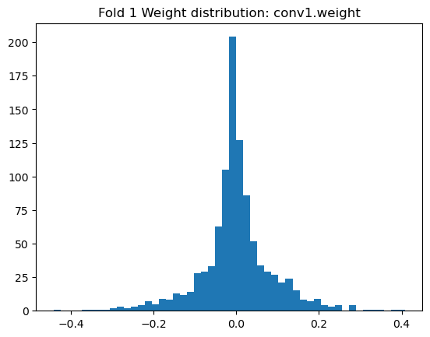

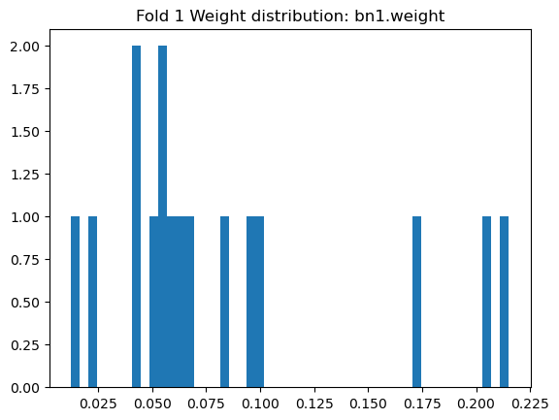

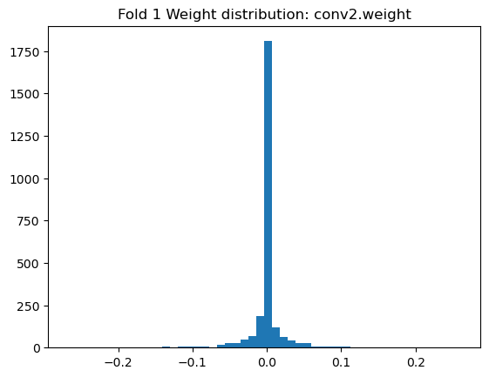

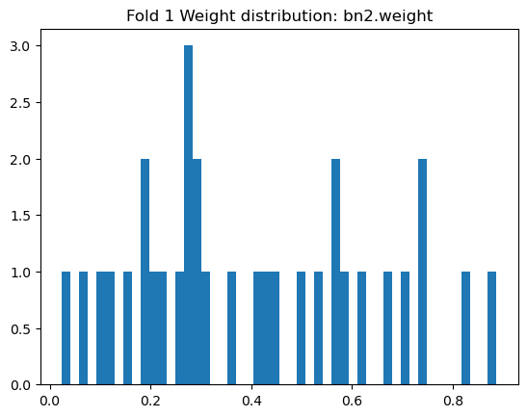

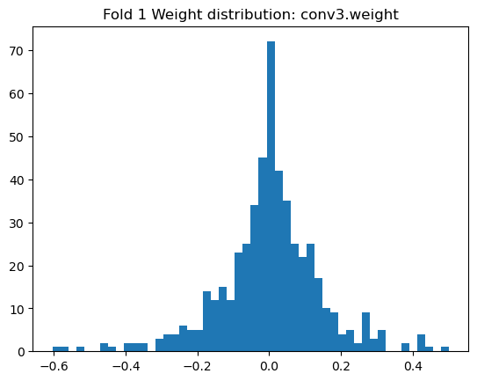

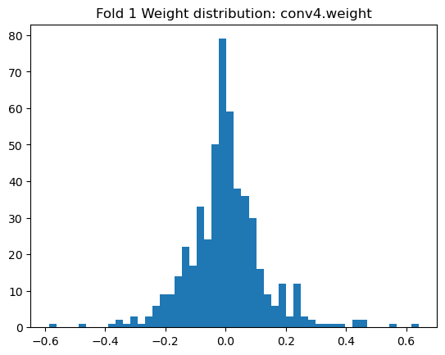

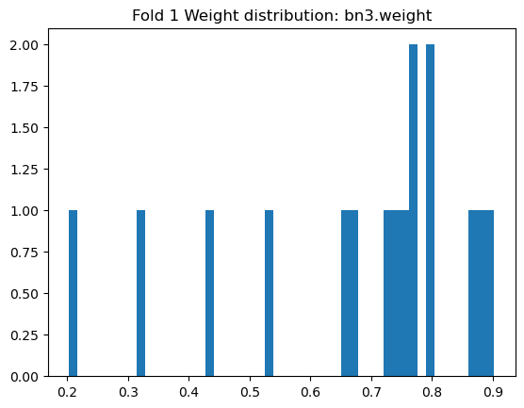

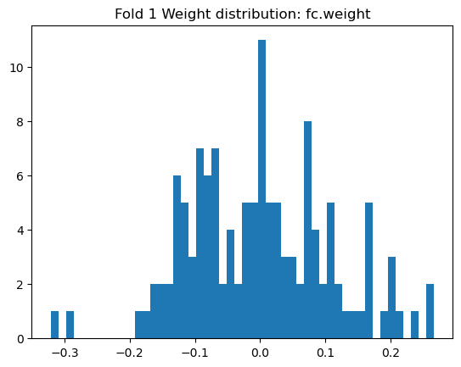

--- Fold 2/5 ---

Train class 0: 15933, class 1: 3398 | Test class 0: 3984, class 1: 849

True label counts: [3984 849], Predicted label counts: [4833]

Fold 2 - Acc: 0.824, AUC: 0.491, Precision: 0.000, Recall: 0.000, F1: 0.000

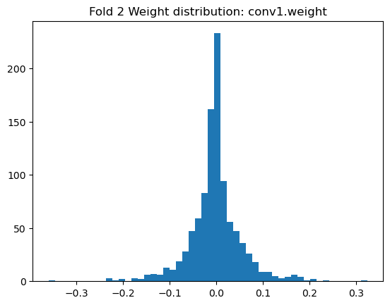

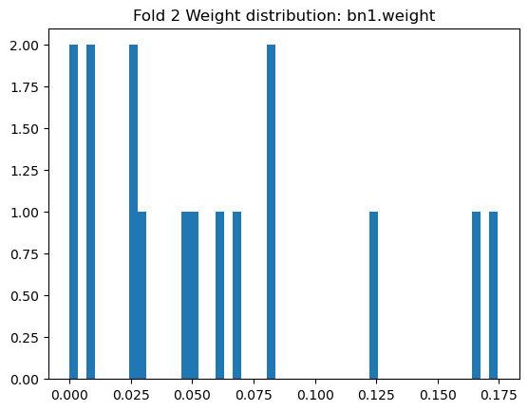

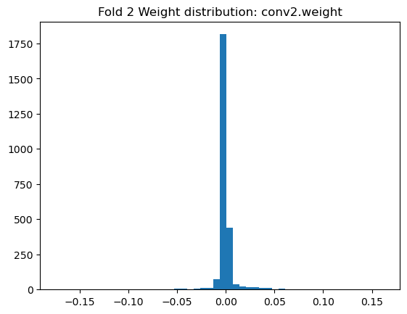

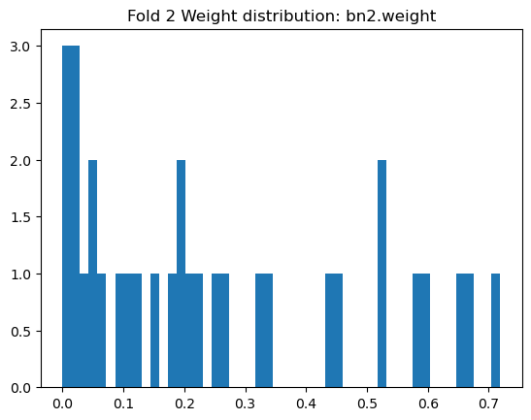

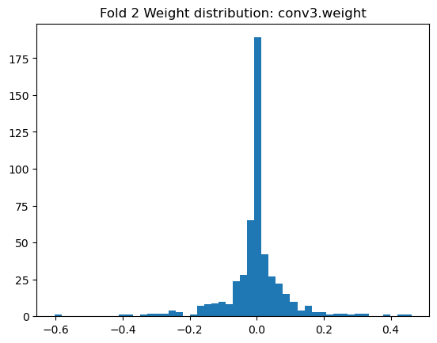

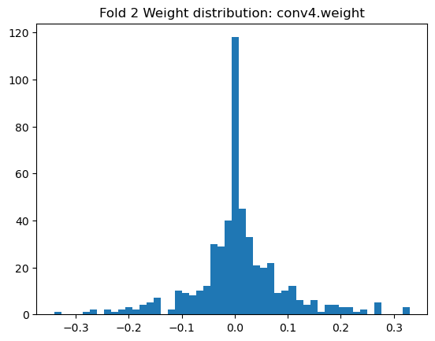

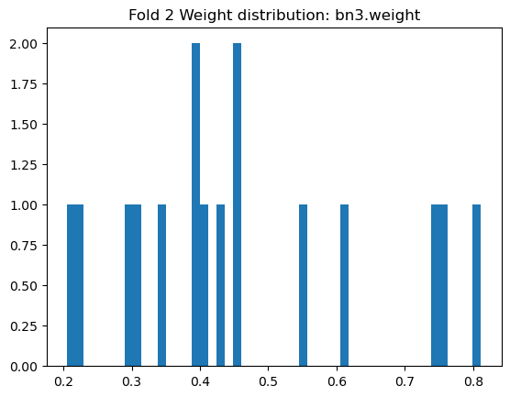

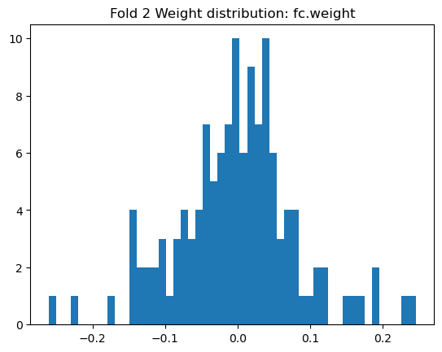

--- Fold 3/5 ---

Train class 0: 15934, class 1: 3397 | Test class 0: 3983, class 1: 850

True label counts: [3983 850], Predicted label counts: [4833]

Fold 3 - Acc: 0.824, AUC: 0.507, Precision: 0.000, Recall: 0.000, F1: 0.000

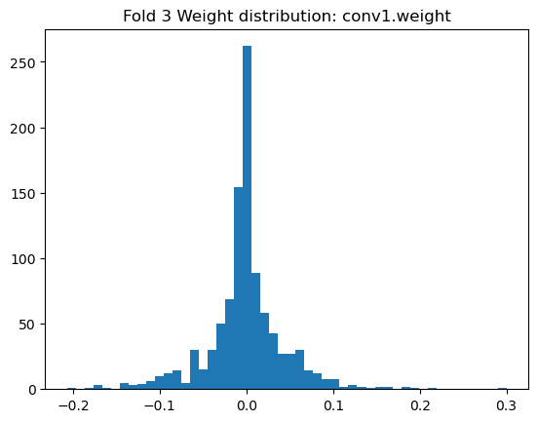

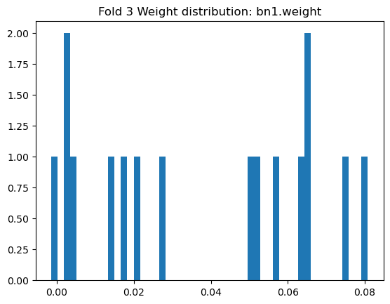

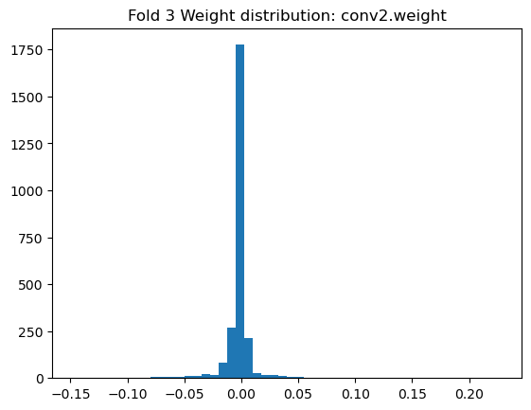

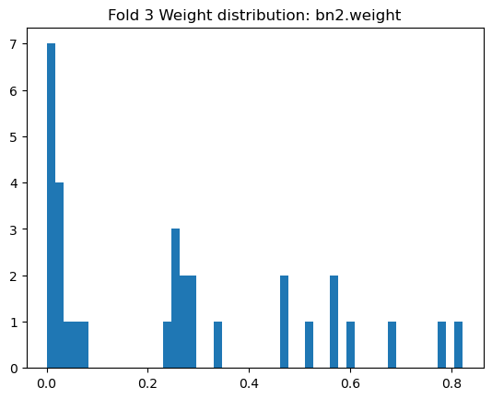

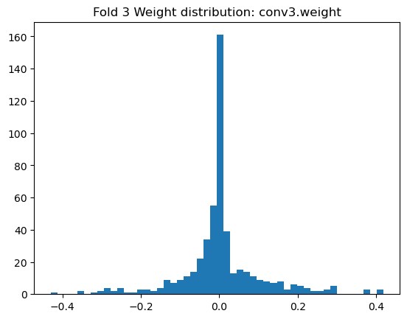

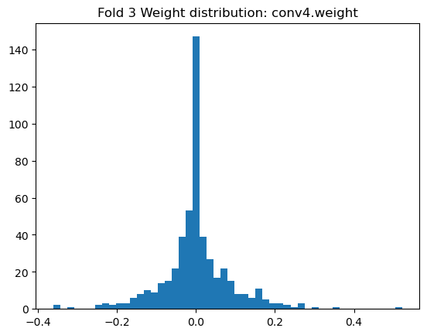

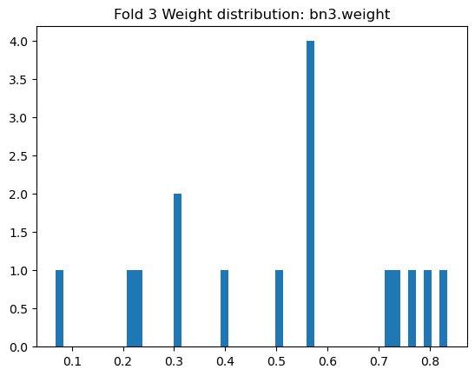

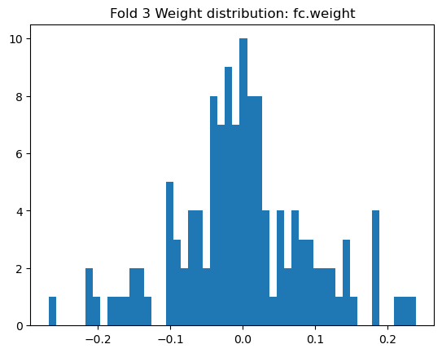

--- Fold 4/5 ---

Train class 0: 15934, class 1: 3397 | Test class 0: 3983, class 1: 850

True label counts: [3983 850], Predicted label counts: [4833]

Fold 4 - Acc: 0.824, AUC: 0.507, Precision: 0.000, Recall: 0.000, F1: 0.000

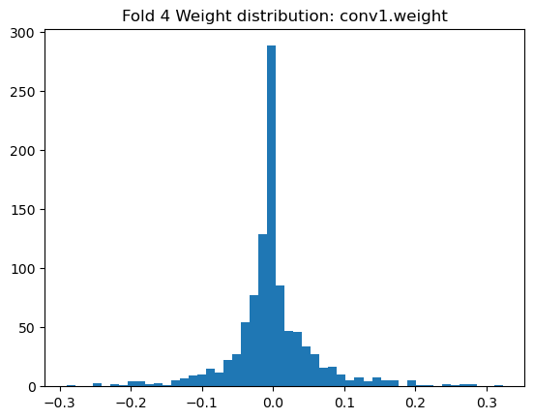

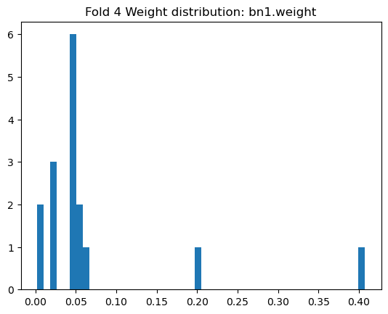

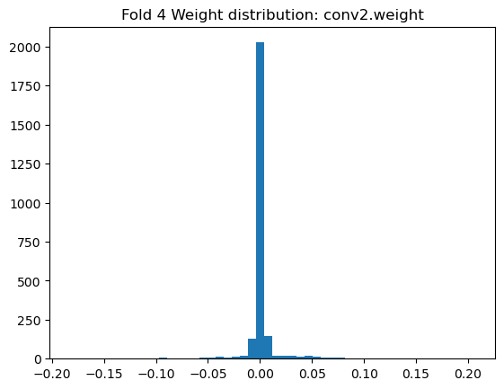

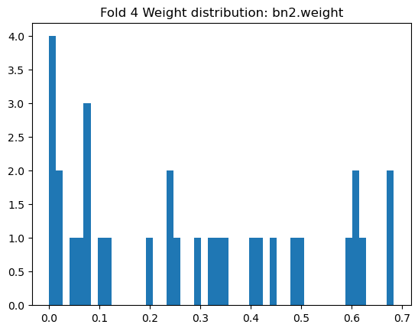

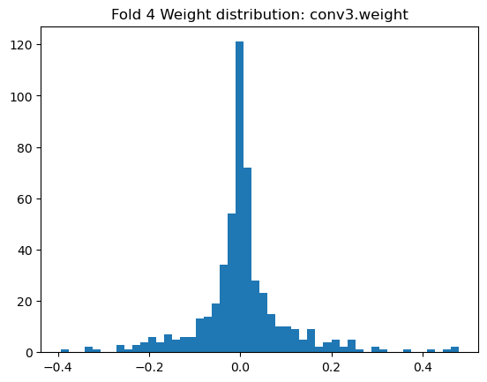

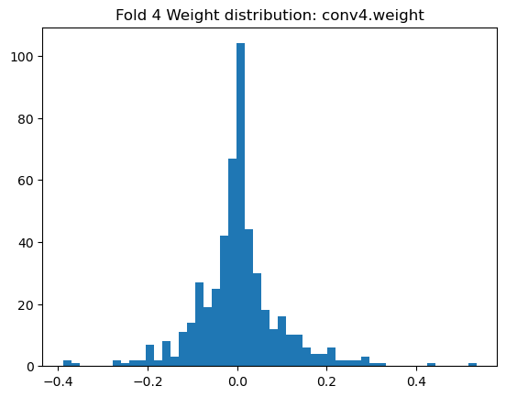

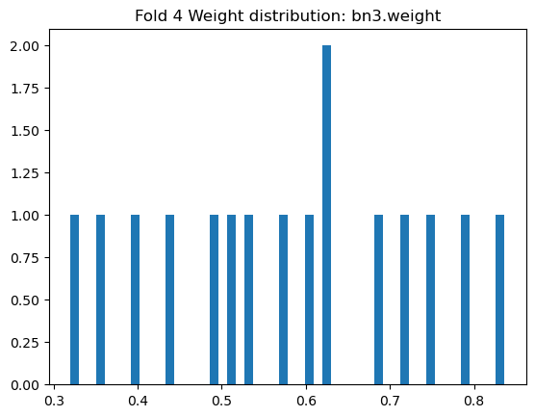

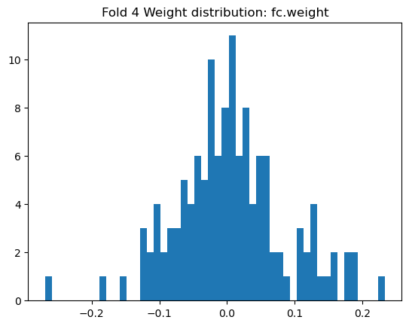

--- Fold 5/5 ---

Train class 0: 15934, class 1: 3398 | Test class 0: 3983, class 1: 849

True label counts: [3983 849], Predicted label counts: [4832]

Fold 5 - Acc: 0.824, AUC: 0.496, Precision: 0.000, Recall: 0.000, F1: 0.000

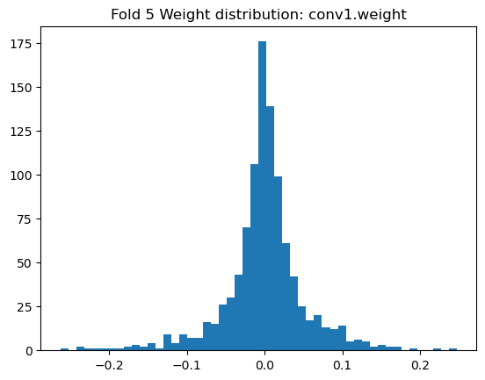

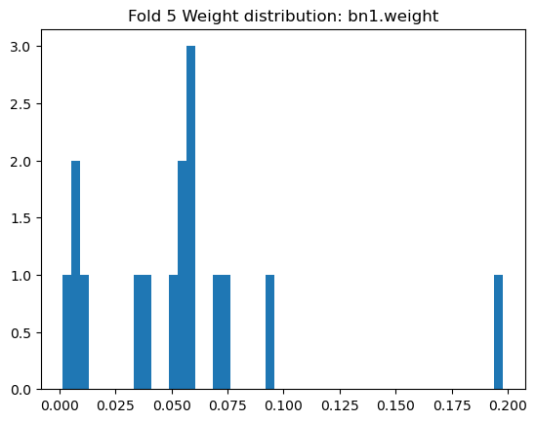

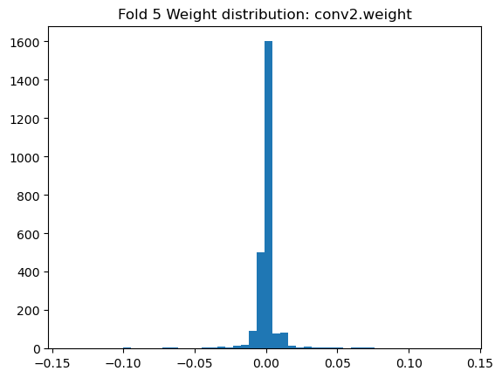

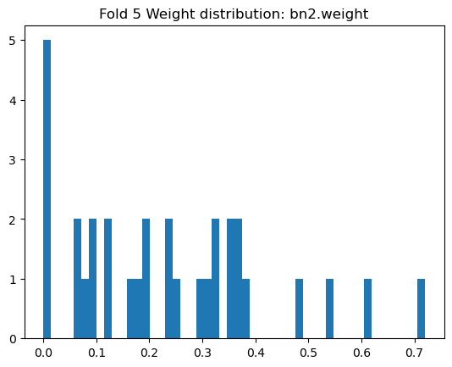

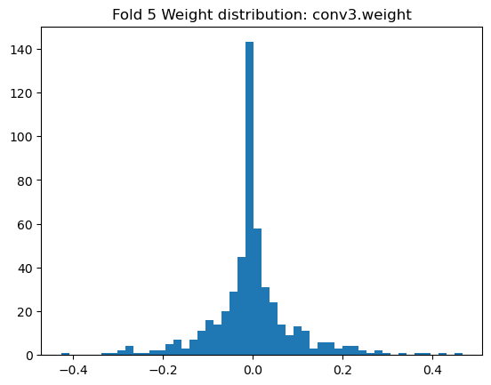

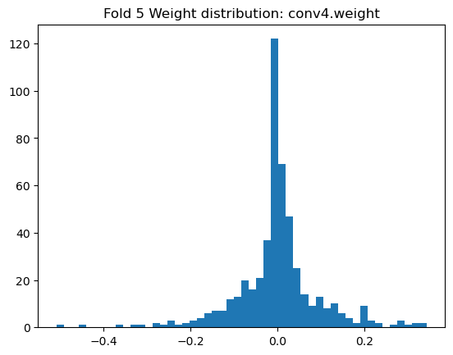

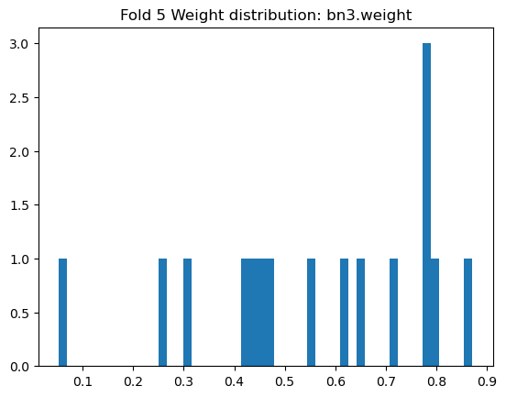

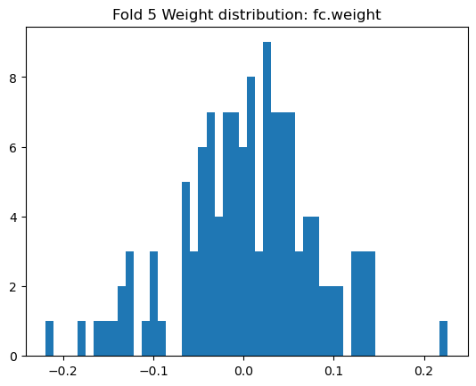

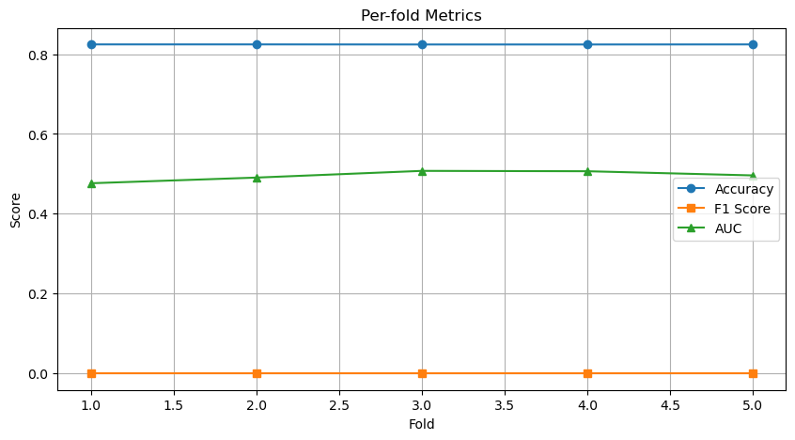

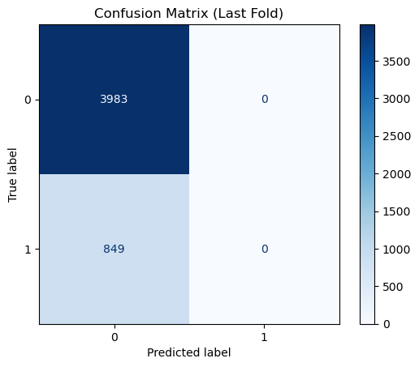

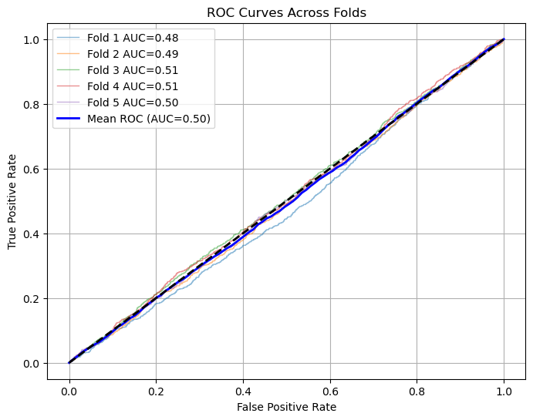

=== K-Fold Results ===

ACC: 0.824 ± 0.000

AUC: 0.495 ± 0.011

PRECISION: 0.000 ± 0.000

RECALL: 0.000 ± 0.000

F1: 0.000 ± 0.000

