Processing sub-001_task-P300_run-1_eeg.set-epo.fif

Reading C:\Users\sansk\processed_data\sub-001_task-P300_run-1_eeg.set-epo.fif ...

Found the data of interest:

t = -199.22 ... 800.78 ms

0 CTF compensation matrices available

Not setting metadata

862 matching events found

No baseline correction applied

0 projection items activated

Processing sub-001_task-P300_run-2_eeg.set-epo.fif

Reading C:\Users\sansk\processed_data\sub-001_task-P300_run-2_eeg.set-epo.fif ...

Found the data of interest:

t = -199.22 ... 800.78 ms

0 CTF compensation matrices available

Not setting metadata

861 matching events found

No baseline correction applied

0 projection items activated

Processing sub-001_task-P300_run-3_eeg.set-epo.fif

Reading C:\Users\sansk\processed_data\sub-001_task-P300_run-3_eeg.set-epo.fif ...

Found the data of interest:

t = -199.22 ... 800.78 ms

0 CTF compensation matrices available

Not setting metadata

859 matching events found

No baseline correction applied

0 projection items activated

Processing sub-002_task-P300_run-1_eeg.set-epo.fif

Reading C:\Users\sansk\processed_data\sub-002_task-P300_run-1_eeg.set-epo.fif ...

Found the data of interest:

t = -199.22 ... 800.78 ms

0 CTF compensation matrices available

Not setting metadata

811 matching events found

No baseline correction applied

0 projection items activated

Processing sub-002_task-P300_run-2_eeg.set-epo.fif

Reading C:\Users\sansk\processed_data\sub-002_task-P300_run-2_eeg.set-epo.fif ...

Found the data of interest:

t = -199.22 ... 800.78 ms

0 CTF compensation matrices available

Not setting metadata

806 matching events found

No baseline correction applied

0 projection items activated

Processing sub-002_task-P300_run-3_eeg.set-epo.fif

Reading C:\Users\sansk\processed_data\sub-002_task-P300_run-3_eeg.set-epo.fif ...

Found the data of interest:

t = -199.22 ... 800.78 ms

0 CTF compensation matrices available

Not setting metadata

799 matching events found

No baseline correction applied

0 projection items activated

Processing sub-003_task-P300_run-1_eeg.set-epo.fif

Reading C:\Users\sansk\processed_data\sub-003_task-P300_run-1_eeg.set-epo.fif ...

Found the data of interest:

t = -199.22 ... 800.78 ms

0 CTF compensation matrices available

Not setting metadata

860 matching events found

No baseline correction applied

0 projection items activated

Processing sub-003_task-P300_run-2_eeg.set-epo.fif

Reading C:\Users\sansk\processed_data\sub-003_task-P300_run-2_eeg.set-epo.fif ...

Found the data of interest:

t = -199.22 ... 800.78 ms

0 CTF compensation matrices available

Not setting metadata

859 matching events found

No baseline correction applied

0 projection items activated

Processing sub-003_task-P300_run-3_eeg.set-epo.fif

Reading C:\Users\sansk\processed_data\sub-003_task-P300_run-3_eeg.set-epo.fif ...

Found the data of interest:

t = -199.22 ... 800.78 ms

0 CTF compensation matrices available

Not setting metadata

861 matching events found

No baseline correction applied

0 projection items activated

Processing sub-004_task-P300_run-1_eeg.set-epo.fif

Reading C:\Users\sansk\processed_data\sub-004_task-P300_run-1_eeg.set-epo.fif ...

Found the data of interest:

t = -199.22 ... 800.78 ms

0 CTF compensation matrices available

Not setting metadata

859 matching events found

No baseline correction applied

0 projection items activated

Processing sub-004_task-P300_run-2_eeg.set-epo.fif

Reading C:\Users\sansk\processed_data\sub-004_task-P300_run-2_eeg.set-epo.fif ...

Found the data of interest:

t = -199.22 ... 800.78 ms

0 CTF compensation matrices available

Not setting metadata

856 matching events found

No baseline correction applied

0 projection items activated

Processing sub-004_task-P300_run-3_eeg.set-epo.fif

Reading C:\Users\sansk\processed_data\sub-004_task-P300_run-3_eeg.set-epo.fif ...

Found the data of interest:

t = -199.22 ... 800.78 ms

0 CTF compensation matrices available

Not setting metadata

860 matching events found

No baseline correction applied

0 projection items activated

Processing sub-005_task-P300_run-1_eeg.set-epo.fif

Reading C:\Users\sansk\processed_data\sub-005_task-P300_run-1_eeg.set-epo.fif ...

Found the data of interest:

t = -199.22 ... 800.78 ms

0 CTF compensation matrices available

Not setting metadata

859 matching events found

No baseline correction applied

0 projection items activated

Processing sub-005_task-P300_run-2_eeg.set-epo.fif

Reading C:\Users\sansk\processed_data\sub-005_task-P300_run-2_eeg.set-epo.fif ...

Found the data of interest:

t = -199.22 ... 800.78 ms

0 CTF compensation matrices available

Not setting metadata

861 matching events found

No baseline correction applied

0 projection items activated

Processing sub-005_task-P300_run-3_eeg.set-epo.fif

Reading C:\Users\sansk\processed_data\sub-005_task-P300_run-3_eeg.set-epo.fif ...

Found the data of interest:

t = -199.22 ... 800.78 ms

0 CTF compensation matrices available

Not setting metadata

855 matching events found

No baseline correction applied

0 projection items activated

Processing sub-006_task-P300_run-1_eeg.set-epo.fif

Reading C:\Users\sansk\processed_data\sub-006_task-P300_run-1_eeg.set-epo.fif ...

Found the data of interest:

t = -199.22 ... 800.78 ms

0 CTF compensation matrices available

Not setting metadata

855 matching events found

No baseline correction applied

0 projection items activated

Processing sub-006_task-P300_run-2_eeg.set-epo.fif

Reading C:\Users\sansk\processed_data\sub-006_task-P300_run-2_eeg.set-epo.fif ...

Found the data of interest:

t = -199.22 ... 800.78 ms

0 CTF compensation matrices available

Not setting metadata

835 matching events found

No baseline correction applied

0 projection items activated

Processing sub-006_task-P300_run-3_eeg.set-epo.fif

Reading C:\Users\sansk\processed_data\sub-006_task-P300_run-3_eeg.set-epo.fif ...

Found the data of interest:

t = -199.22 ... 800.78 ms

0 CTF compensation matrices available

Not setting metadata

859 matching events found

No baseline correction applied

0 projection items activated

Processing sub-007_task-P300_run-1_eeg.set-epo.fif

Reading C:\Users\sansk\processed_data\sub-007_task-P300_run-1_eeg.set-epo.fif ...

Found the data of interest:

t = -199.22 ... 800.78 ms

0 CTF compensation matrices available

Not setting metadata

862 matching events found

No baseline correction applied

0 projection items activated

Processing sub-007_task-P300_run-2_eeg.set-epo.fif

Reading C:\Users\sansk\processed_data\sub-007_task-P300_run-2_eeg.set-epo.fif ...

Found the data of interest:

t = -199.22 ... 800.78 ms

0 CTF compensation matrices available

Not setting metadata

848 matching events found

No baseline correction applied

0 projection items activated

Processing sub-007_task-P300_run-3_eeg.set-epo.fif

Reading C:\Users\sansk\processed_data\sub-007_task-P300_run-3_eeg.set-epo.fif ...

Found the data of interest:

t = -199.22 ... 800.78 ms

0 CTF compensation matrices available

Not setting metadata

856 matching events found

No baseline correction applied

0 projection items activated

Processing sub-008_task-P300_run-1_eeg.set-epo.fif

Reading C:\Users\sansk\processed_data\sub-008_task-P300_run-1_eeg.set-epo.fif ...

Found the data of interest:

t = -199.22 ... 800.78 ms

0 CTF compensation matrices available

Not setting metadata

819 matching events found

No baseline correction applied

0 projection items activated

Processing sub-008_task-P300_run-2_eeg.set-epo.fif

Reading C:\Users\sansk\processed_data\sub-008_task-P300_run-2_eeg.set-epo.fif ...

Found the data of interest:

t = -199.22 ... 800.78 ms

0 CTF compensation matrices available

Not setting metadata

824 matching events found

No baseline correction applied

0 projection items activated

Processing sub-008_task-P300_run-3_eeg.set-epo.fif

Reading C:\Users\sansk\processed_data\sub-008_task-P300_run-3_eeg.set-epo.fif ...

Found the data of interest:

t = -199.22 ... 800.78 ms

0 CTF compensation matrices available

Not setting metadata

796 matching events found

No baseline correction applied

0 projection items activated

Processing sub-009_task-P300_run-1_eeg.set-epo.fif

Reading C:\Users\sansk\processed_data\sub-009_task-P300_run-1_eeg.set-epo.fif ...

Found the data of interest:

t = -199.22 ... 800.78 ms

0 CTF compensation matrices available

Not setting metadata

862 matching events found

No baseline correction applied

0 projection items activated

Processing sub-009_task-P300_run-2_eeg.set-epo.fif

Reading C:\Users\sansk\processed_data\sub-009_task-P300_run-2_eeg.set-epo.fif ...

Found the data of interest:

t = -199.22 ... 800.78 ms

0 CTF compensation matrices available

Not setting metadata

859 matching events found

No baseline correction applied

0 projection items activated

Processing sub-009_task-P300_run-3_eeg.set-epo.fif

Reading C:\Users\sansk\processed_data\sub-009_task-P300_run-3_eeg.set-epo.fif ...

Found the data of interest:

t = -199.22 ... 800.78 ms

0 CTF compensation matrices available

Not setting metadata

860 matching events found

No baseline correction applied

0 projection items activated

Processing sub-010_task-P300_run-1_eeg.set-epo.fif

Reading C:\Users\sansk\processed_data\sub-010_task-P300_run-1_eeg.set-epo.fif ...

Found the data of interest:

t = -199.22 ... 800.78 ms

0 CTF compensation matrices available

Not setting metadata

866 matching events found

No baseline correction applied

0 projection items activated

Processing sub-010_task-P300_run-2_eeg.set-epo.fif

Reading C:\Users\sansk\processed_data\sub-010_task-P300_run-2_eeg.set-epo.fif ...

Found the data of interest:

t = -199.22 ... 800.78 ms

0 CTF compensation matrices available

Not setting metadata

861 matching events found

No baseline correction applied

0 projection items activated

Processing sub-010_task-P300_run-3_eeg.set-epo.fif

Reading C:\Users\sansk\processed_data\sub-010_task-P300_run-3_eeg.set-epo.fif ...

Found the data of interest:

t = -199.22 ... 800.78 ms

0 CTF compensation matrices available

Not setting metadata

857 matching events found

No baseline correction applied

0 projection items activated

Processing sub-011_task-P300_run-1_eeg.set-epo.fif

Reading C:\Users\sansk\processed_data\sub-011_task-P300_run-1_eeg.set-epo.fif ...

Found the data of interest:

t = -199.22 ... 800.78 ms

0 CTF compensation matrices available

Not setting metadata

860 matching events found

No baseline correction applied

0 projection items activated

Processing sub-011_task-P300_run-2_eeg.set-epo.fif

Reading C:\Users\sansk\processed_data\sub-011_task-P300_run-2_eeg.set-epo.fif ...

Found the data of interest:

t = -199.22 ... 800.78 ms

0 CTF compensation matrices available

Not setting metadata

857 matching events found

No baseline correction applied

0 projection items activated

Processing sub-011_task-P300_run-3_eeg.set-epo.fif

Reading C:\Users\sansk\processed_data\sub-011_task-P300_run-3_eeg.set-epo.fif ...

Found the data of interest:

t = -199.22 ... 800.78 ms

0 CTF compensation matrices available

Not setting metadata

854 matching events found

No baseline correction applied

0 projection items activated

Processing sub-012_task-P300_run-1_eeg.set-epo.fif

Reading C:\Users\sansk\processed_data\sub-012_task-P300_run-1_eeg.set-epo.fif ...

Found the data of interest:

t = -199.22 ... 800.78 ms

0 CTF compensation matrices available

Not setting metadata

100 matching events found

No baseline correction applied

0 projection items activated

Processing sub-012_task-P300_run-2_eeg.set-epo.fif

Reading C:\Users\sansk\processed_data\sub-012_task-P300_run-2_eeg.set-epo.fif ...

Found the data of interest:

t = -199.22 ... 800.78 ms

0 CTF compensation matrices available

Not setting metadata

785 matching events found

No baseline correction applied

0 projection items activated

Processing sub-012_task-P300_run-3_eeg.set-epo.fif

Reading C:\Users\sansk\processed_data\sub-012_task-P300_run-3_eeg.set-epo.fif ...

Found the data of interest:

t = -199.22 ... 800.78 ms

0 CTF compensation matrices available

Not setting metadata

861 matching events found

No baseline correction applied

0 projection items activated

Processing sub-013_task-P300_run-1_eeg.set-epo.fif

Reading C:\Users\sansk\processed_data\sub-013_task-P300_run-1_eeg.set-epo.fif ...

Found the data of interest:

t = -199.22 ... 800.78 ms

0 CTF compensation matrices available

Not setting metadata

851 matching events found

No baseline correction applied

0 projection items activated

Processing sub-013_task-P300_run-2_eeg.set-epo.fif

Reading C:\Users\sansk\processed_data\sub-013_task-P300_run-2_eeg.set-epo.fif ...

Found the data of interest:

t = -199.22 ... 800.78 ms

0 CTF compensation matrices available

Not setting metadata

861 matching events found

No baseline correction applied

0 projection items activated

Processing sub-013_task-P300_run-3_eeg.set-epo.fif

Reading C:\Users\sansk\processed_data\sub-013_task-P300_run-3_eeg.set-epo.fif ...

Found the data of interest:

t = -199.22 ... 800.78 ms

0 CTF compensation matrices available

Not setting metadata

860 matching events found

No baseline correction applied

0 projection items activated

Data shape: (24164, 1, 79, 257), Labels shape: (24164,)

--- Fold 1/5 ---

Train class 0: 15933, class 1: 3398 | Test class 0: 3984, class 1: 849

True label counts: [3984 849], Predicted label counts: [4804 29]

Fold 1 - Acc: 0.820, AUC: 0.534, Precision: 0.103, Recall: 0.004, F1: 0.007

--- Fold 2/5 ---

Train class 0: 15933, class 1: 3398 | Test class 0: 3984, class 1: 849

True label counts: [3984 849], Predicted label counts: [ 0 4833]

Fold 2 - Acc: 0.176, AUC: 0.625, Precision: 0.176, Recall: 1.000, F1: 0.299

--- Fold 3/5 ---

Train class 0: 15934, class 1: 3397 | Test class 0: 3983, class 1: 850

True label counts: [3983 850], Predicted label counts: [4829 4]

Fold 3 - Acc: 0.824, AUC: 0.561, Precision: 0.500, Recall: 0.002, F1: 0.005

--- Fold 4/5 ---

Train class 0: 15934, class 1: 3397 | Test class 0: 3983, class 1: 850

True label counts: [3983 850], Predicted label counts: [3735 1098]

Fold 4 - Acc: 0.792, AUC: 0.759, Precision: 0.429, Recall: 0.554, F1: 0.484

--- Fold 5/5 ---

Train class 0: 15934, class 1: 3398 | Test class 0: 3983, class 1: 849

True label counts: [3983 849], Predicted label counts: [ 142 4690]

Fold 5 - Acc: 0.199, AUC: 0.540, Precision: 0.178, Recall: 0.982, F1: 0.301

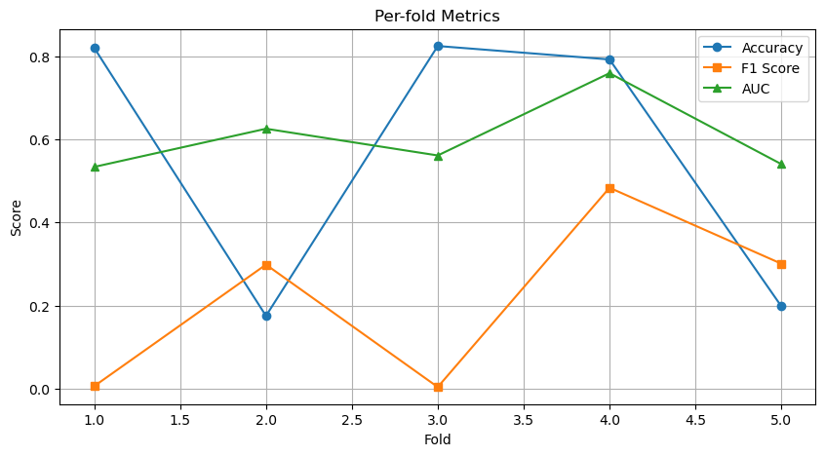

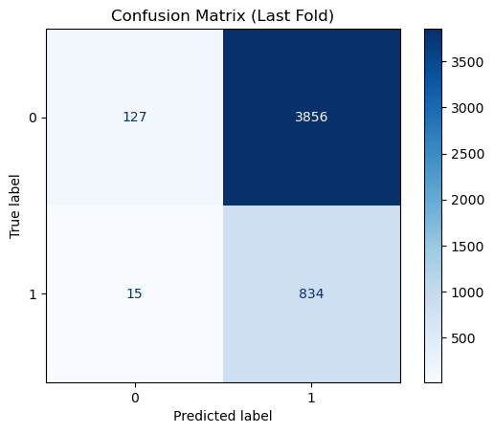

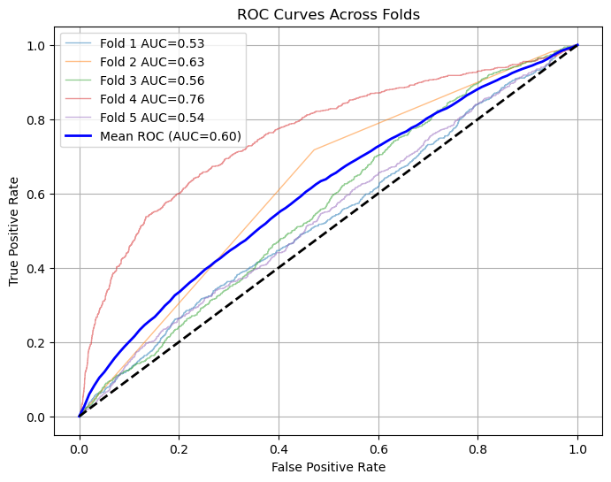

=== K-Fold Results ===

ACC: 0.562 ± 0.306

AUC: 0.604 ± 0.084

PRECISION: 0.277 ± 0.157

RECALL: 0.508 ± 0.443

F1: 0.219 ± 0.187