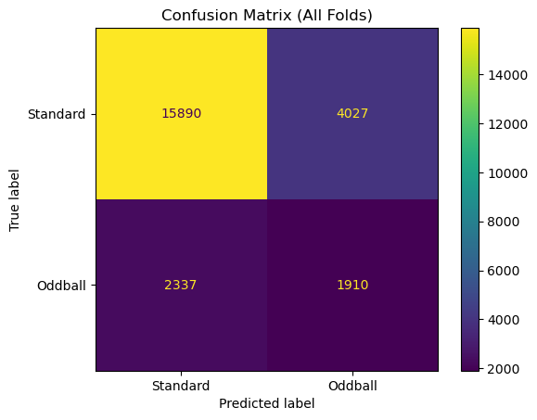

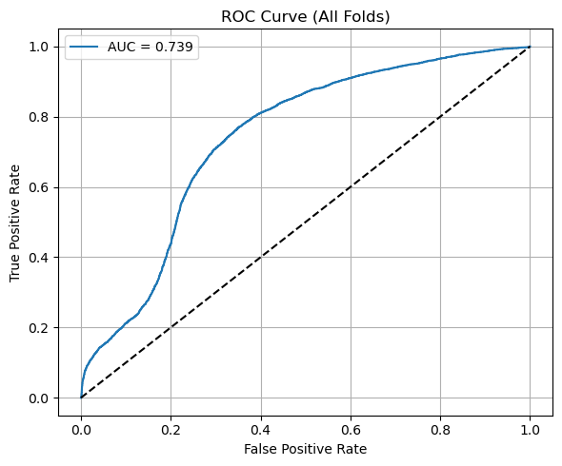

**=== Fold-by-Fold Analysis ===**

**Fold 1:**

**Accuracy: 0.8736**

**AUC: 0.8454**

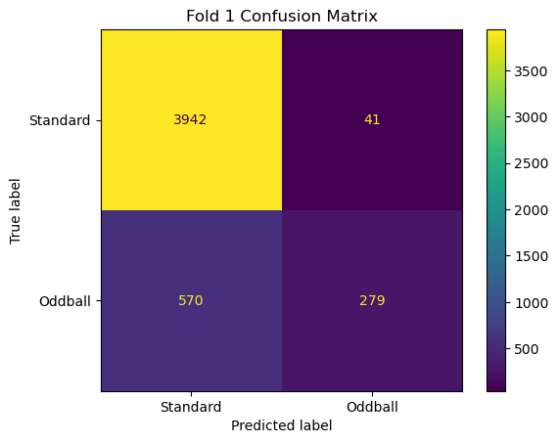

**Fold 2:**

**Accuracy: 0.8843**

**AUC: 0.8654**

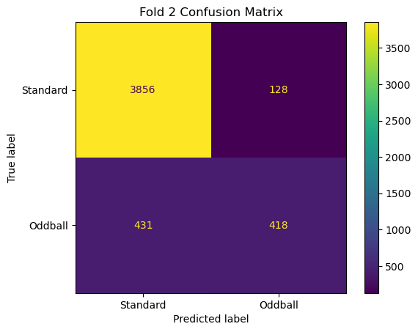

**Fold 3:**

**Accuracy: 0.8403**

**AUC: 0.8413**

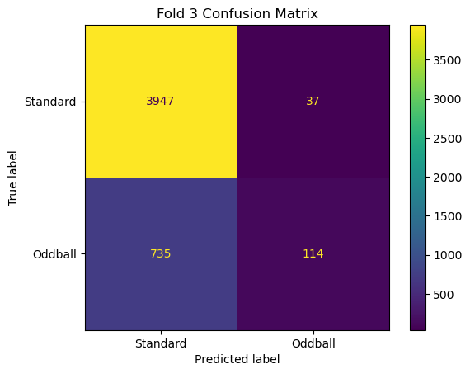

**Fold 4:**

**Accuracy: 0.2181**

**AUC: 0.7646**

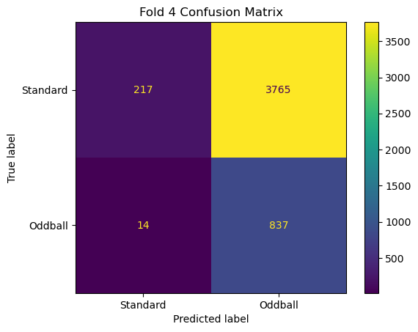

**Fold 5:**

**Accuracy: 0.8670**

**AUC: 0.8567**

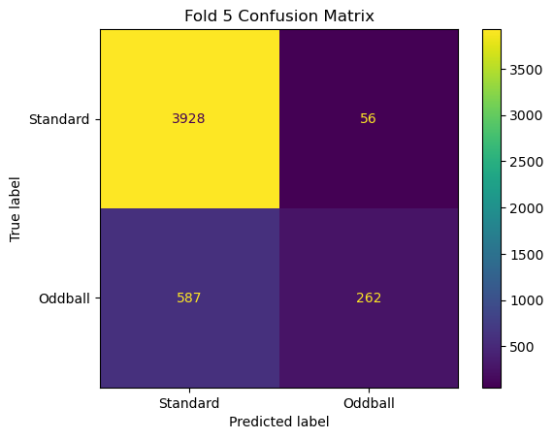

**=== Cross-Validation Summary ===**

**Average Accuracy: 0.7366 (±0.2597)**

**Average AUC: 0.8347 (±0.0360)**