Standard class undersampled from 19917 to 4247

Balanced dataset: 4247 standard, 4247 oddball

Using device: cuda

--- Fold 1/5 ---

Epoch 1/10 - Train Loss: 0.6533, Val Loss: 0.6341, Train Acc: 0.6533, Val Acc: 0.6633

Epoch 2/10 - Train Loss: 0.5633, Val Loss: 0.5827, Train Acc: 0.7174, Val Acc: 0.6963

Epoch 3/10 - Train Loss: 0.5160, Val Loss: 0.5399, Train Acc: 0.7585, Val Acc: 0.7357

Epoch 4/10 - Train Loss: 0.4773, Val Loss: 0.5188, Train Acc: 0.7860, Val Acc: 0.7557

Epoch 5/10 - Train Loss: 0.4506, Val Loss: 0.5405, Train Acc: 0.8007, Val Acc: 0.7398

Epoch 6/10 - Train Loss: 0.4311, Val Loss: 0.5773, Train Acc: 0.8106, Val Acc: 0.7122

Epoch 7/10 - Train Loss: 0.4164, Val Loss: 0.5359, Train Acc: 0.8168, Val Acc: 0.7528

Epoch 8/10 - Train Loss: 0.4007, Val Loss: 0.5702, Train Acc: 0.8221, Val Acc: 0.7375

Epoch 9/10 - Train Loss: 0.3925, Val Loss: 0.5324, Train Acc: 0.8286, Val Acc: 0.7504

Epoch 10/10 - Train Loss: 0.3839, Val Loss: 0.5668, Train Acc: 0.8361, Val Acc: 0.7393

Fold 1 Mean Val Accuracy: 0.7283

--- Fold 2/5 ---

Epoch 1/10 - Train Loss: 0.6436, Val Loss: 0.6233, Train Acc: 0.6534, Val Acc: 0.7175

Epoch 2/10 - Train Loss: 0.5667, Val Loss: 0.5611, Train Acc: 0.7204, Val Acc: 0.7481

Epoch 3/10 - Train Loss: 0.5254, Val Loss: 0.5354, Train Acc: 0.7492, Val Acc: 0.7663

Epoch 4/10 - Train Loss: 0.4971, Val Loss: 0.5256, Train Acc: 0.7681, Val Acc: 0.7816

Epoch 5/10 - Train Loss: 0.4681, Val Loss: 0.5098, Train Acc: 0.7888, Val Acc: 0.7557

Epoch 6/10 - Train Loss: 0.4488, Val Loss: 0.4724, Train Acc: 0.8022, Val Acc: 0.7934

Epoch 7/10 - Train Loss: 0.4322, Val Loss: 0.4745, Train Acc: 0.8099, Val Acc: 0.7858

Epoch 8/10 - Train Loss: 0.4156, Val Loss: 0.4596, Train Acc: 0.8191, Val Acc: 0.7881

Epoch 9/10 - Train Loss: 0.4018, Val Loss: 0.5035, Train Acc: 0.8269, Val Acc: 0.7710

Epoch 10/10 - Train Loss: 0.3953, Val Loss: 0.4841, Train Acc: 0.8250, Val Acc: 0.8016

Fold 2 Mean Val Accuracy: 0.7709

--- Fold 3/5 ---

Epoch 1/10 - Train Loss: 0.6491, Val Loss: 0.6384, Train Acc: 0.6517, Val Acc: 0.6969

Epoch 2/10 - Train Loss: 0.5755, Val Loss: 0.5750, Train Acc: 0.7116, Val Acc: 0.7157

Epoch 3/10 - Train Loss: 0.5266, Val Loss: 0.5523, Train Acc: 0.7544, Val Acc: 0.7434

Epoch 4/10 - Train Loss: 0.4931, Val Loss: 0.5521, Train Acc: 0.7790, Val Acc: 0.7416

Epoch 5/10 - Train Loss: 0.4648, Val Loss: 0.4973, Train Acc: 0.7938, Val Acc: 0.7816

Epoch 6/10 - Train Loss: 0.4425, Val Loss: 0.4931, Train Acc: 0.8084, Val Acc: 0.7787

Epoch 7/10 - Train Loss: 0.4211, Val Loss: 0.4940, Train Acc: 0.8130, Val Acc: 0.7769

Epoch 8/10 - Train Loss: 0.4048, Val Loss: 0.5099, Train Acc: 0.8235, Val Acc: 0.7546

Epoch 9/10 - Train Loss: 0.3948, Val Loss: 0.4990, Train Acc: 0.8268, Val Acc: 0.7805

Epoch 10/10 - Train Loss: 0.3806, Val Loss: 0.4852, Train Acc: 0.8350, Val Acc: 0.7852

Fold 3 Mean Val Accuracy: 0.7555

--- Fold 4/5 ---

Epoch 1/10 - Train Loss: 0.6450, Val Loss: 0.6417, Train Acc: 0.6453, Val Acc: 0.7057

Epoch 2/10 - Train Loss: 0.5608, Val Loss: 0.5823, Train Acc: 0.7236, Val Acc: 0.7363

Epoch 3/10 - Train Loss: 0.5094, Val Loss: 0.5542, Train Acc: 0.7685, Val Acc: 0.7493

Epoch 4/10 - Train Loss: 0.4768, Val Loss: 0.5692, Train Acc: 0.7907, Val Acc: 0.7334

Epoch 5/10 - Train Loss: 0.4558, Val Loss: 0.5108, Train Acc: 0.7987, Val Acc: 0.7775

Epoch 6/10 - Train Loss: 0.4310, Val Loss: 0.5618, Train Acc: 0.8153, Val Acc: 0.7387

Epoch 7/10 - Train Loss: 0.4175, Val Loss: 0.5219, Train Acc: 0.8215, Val Acc: 0.7781

Epoch 8/10 - Train Loss: 0.4054, Val Loss: 0.5112, Train Acc: 0.8259, Val Acc: 0.7852

Epoch 9/10 - Train Loss: 0.3931, Val Loss: 0.5966, Train Acc: 0.8346, Val Acc: 0.7228

Epoch 10/10 - Train Loss: 0.3812, Val Loss: 0.6299, Train Acc: 0.8372, Val Acc: 0.7110

Fold 4 Mean Val Accuracy: 0.7438

--- Fold 5/5 ---

Epoch 1/10 - Train Loss: 0.6502, Val Loss: 0.6308, Train Acc: 0.6455, Val Acc: 0.6996

Epoch 2/10 - Train Loss: 0.5676, Val Loss: 0.5674, Train Acc: 0.7104, Val Acc: 0.7468

Epoch 3/10 - Train Loss: 0.5164, Val Loss: 0.5920, Train Acc: 0.7562, Val Acc: 0.7503

Epoch 4/10 - Train Loss: 0.4799, Val Loss: 0.5257, Train Acc: 0.7821, Val Acc: 0.7674

Epoch 5/10 - Train Loss: 0.4502, Val Loss: 0.5024, Train Acc: 0.8012, Val Acc: 0.7909

Epoch 6/10 - Train Loss: 0.4310, Val Loss: 0.5077, Train Acc: 0.8103, Val Acc: 0.7774

Epoch 7/10 - Train Loss: 0.4127, Val Loss: 0.5323, Train Acc: 0.8199, Val Acc: 0.7562

Epoch 8/10 - Train Loss: 0.4012, Val Loss: 0.5316, Train Acc: 0.8230, Val Acc: 0.7426

Epoch 9/10 - Train Loss: 0.3867, Val Loss: 0.5628, Train Acc: 0.8320, Val Acc: 0.7503

Epoch 10/10 - Train Loss: 0.3790, Val Loss: 0.7035, Train Acc: 0.8345, Val Acc: 0.6955

Fold 5 Mean Val Accuracy: 0.7477

Average Cross-Validation Accuracy: 0.7492 (±0.0140)

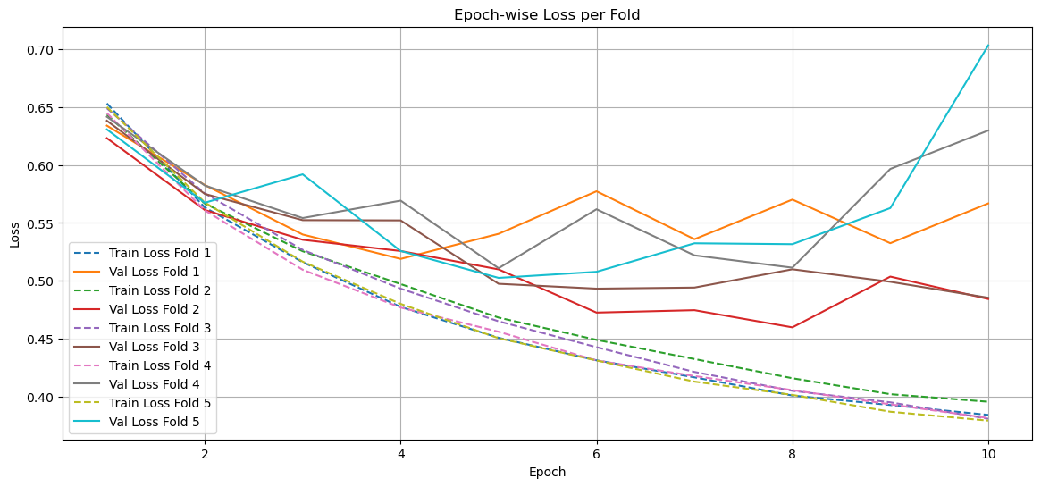

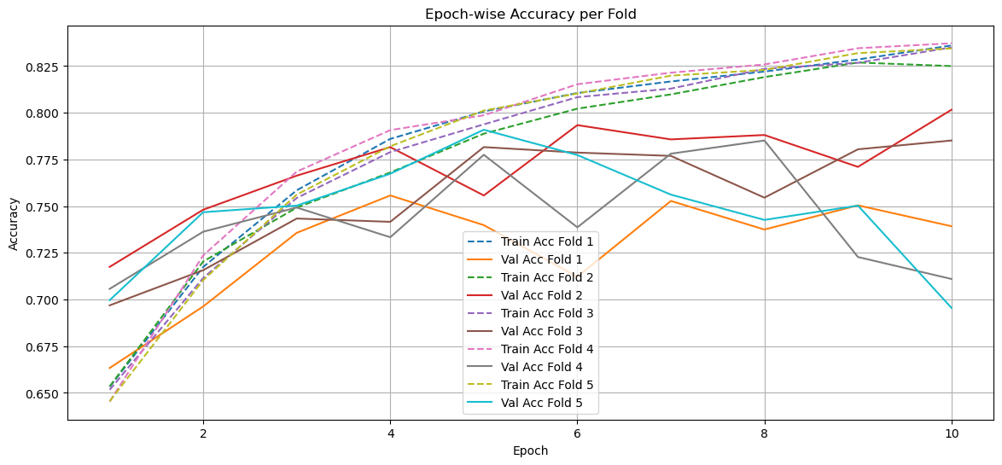

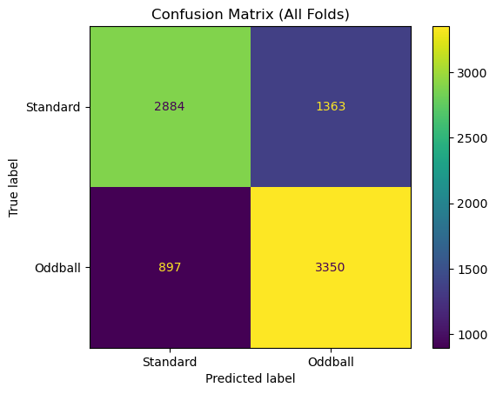

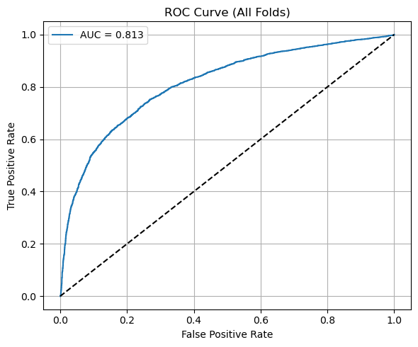

Final data shape: (8494, 1, 64, 257)

Number of EEG channels: 64