Using device: cuda

--- Fold 1/5 ---

Fold 1 Accuracy: 0.6758

--- Fold 2/5 ---

Fold 2 Accuracy: 0.8291

--- Fold 3/5 ---

Fold 3 Accuracy: 0.8703

--- Fold 4/5 ---

Fold 4 Accuracy: 0.8229

--- Fold 5/5 ---

Fold 5 Accuracy: 0.7823

Average Cross-Validation Accuracy: 0.7961 (±0.0663)

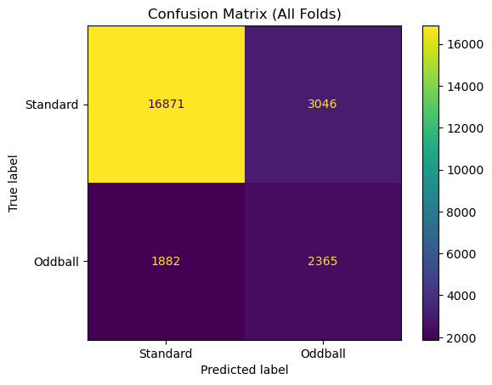

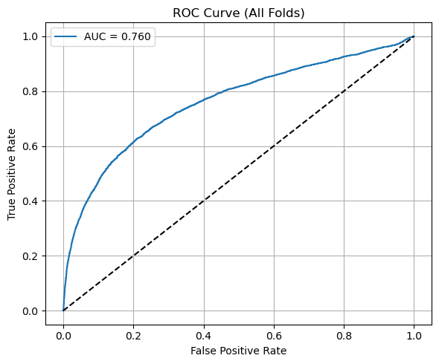

=== Fold-by-Fold Detailed Analysis ===

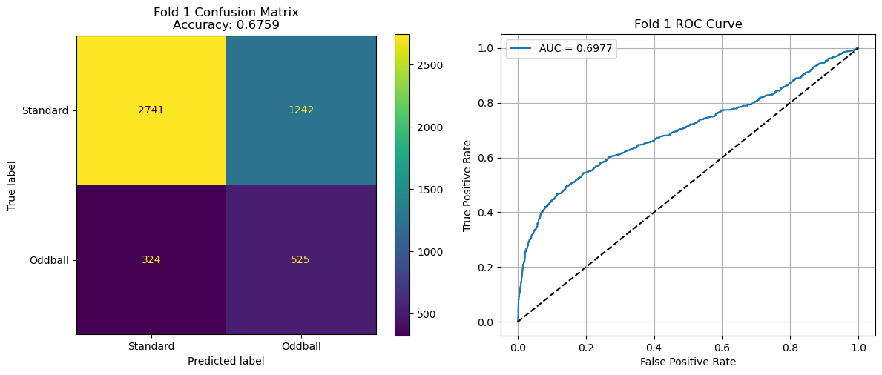

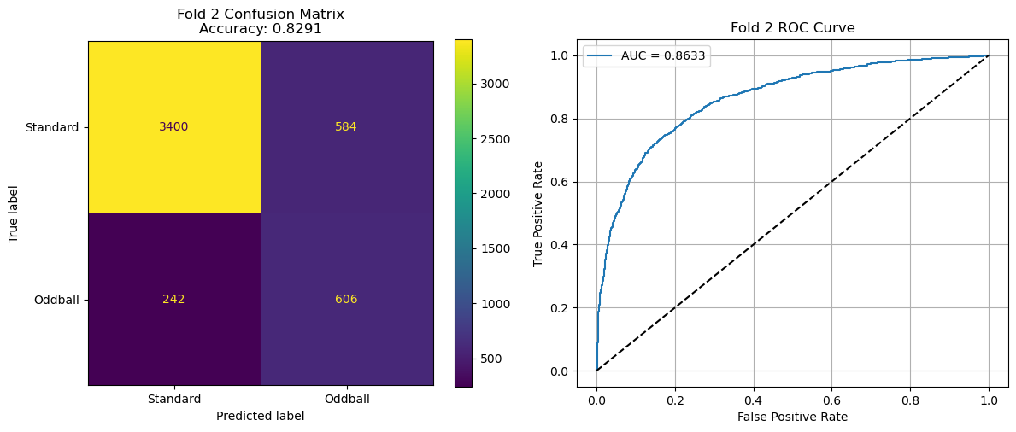

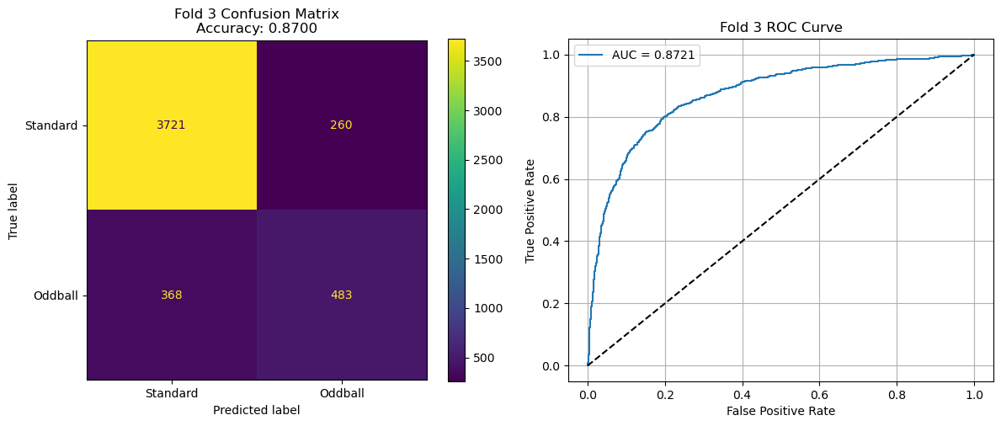

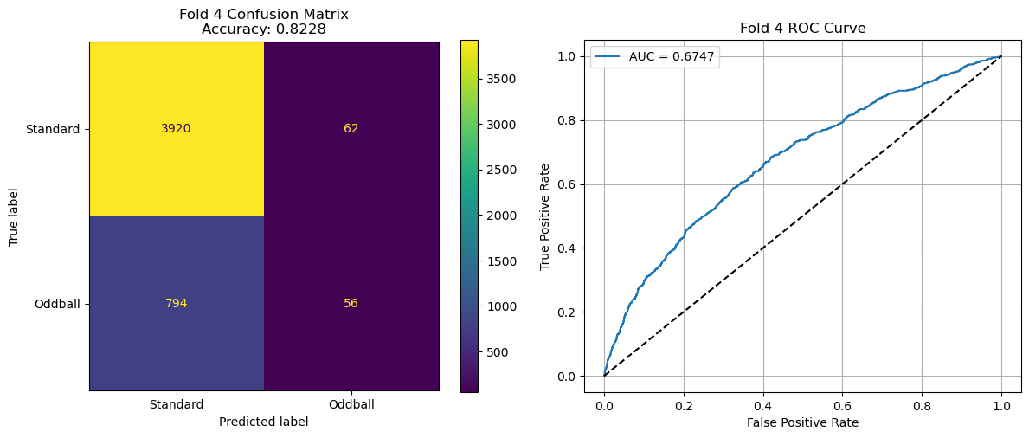

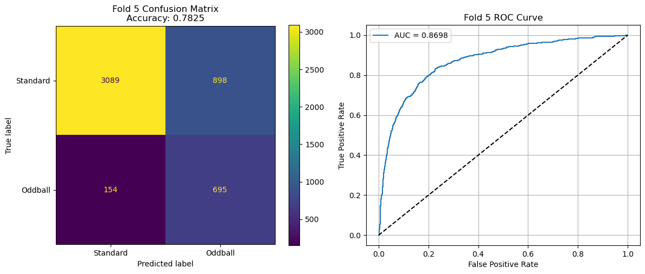

=== Cross-Validation Performance Summary ===

Fold | Accuracy | AUC

-----------------------------------

Fold 1 | 0.6759 | 0.6977

Fold 2 | 0.8291 | 0.8633

Fold 3 | 0.8700 | 0.8721

Fold 4 | 0.8228 | 0.6747

Fold 5 | 0.7825 | 0.8698

-----------------------------------

Mean | 0.7961 | 0.7955

Std | ±0.0662 | ±0.0896

=== Overall Performance ===

