Balanced dataset:

Standard trials: 4247

Oddball trials: 4247

Using device: cuda

--- Fold 1/5 ---

Fold 1 Accuracy: 0.5403

--- Fold 2/5 ---

Fold 2 Accuracy: 0.7228

--- Fold 3/5 ---

Fold 3 Accuracy: 0.7987

--- Fold 4/5 ---

Fold 4 Accuracy: 0.5397

--- Fold 5/5 ---

Fold 5 Accuracy: 0.7786

Average Cross-Validation Accuracy: 0.6760 (±0.1138)

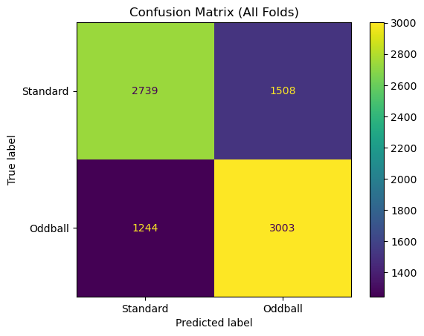

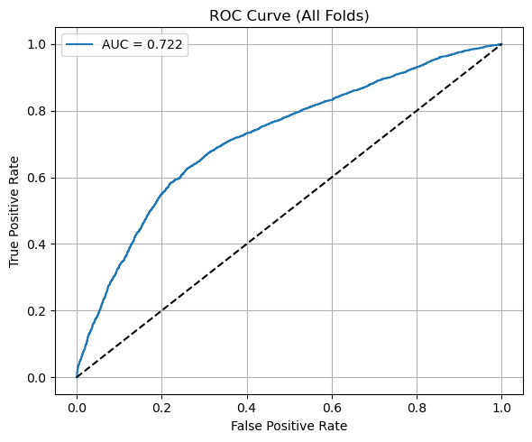

=== Fold-by-Fold Detailed Analysis ===

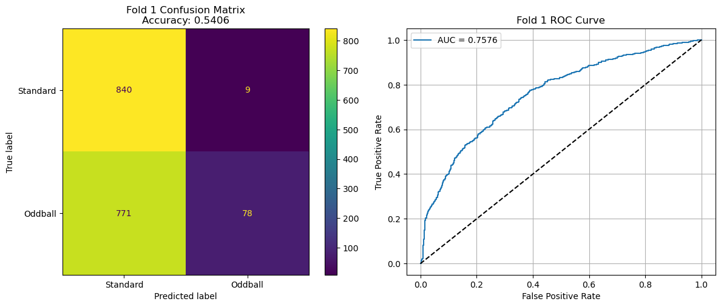

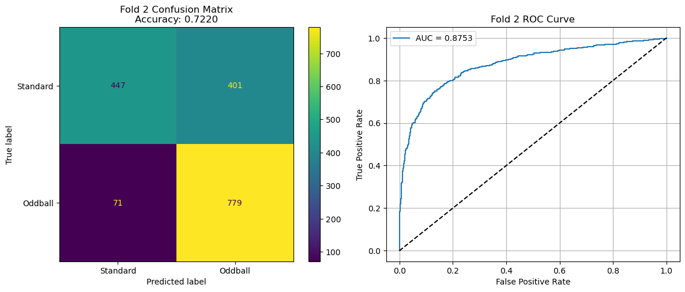

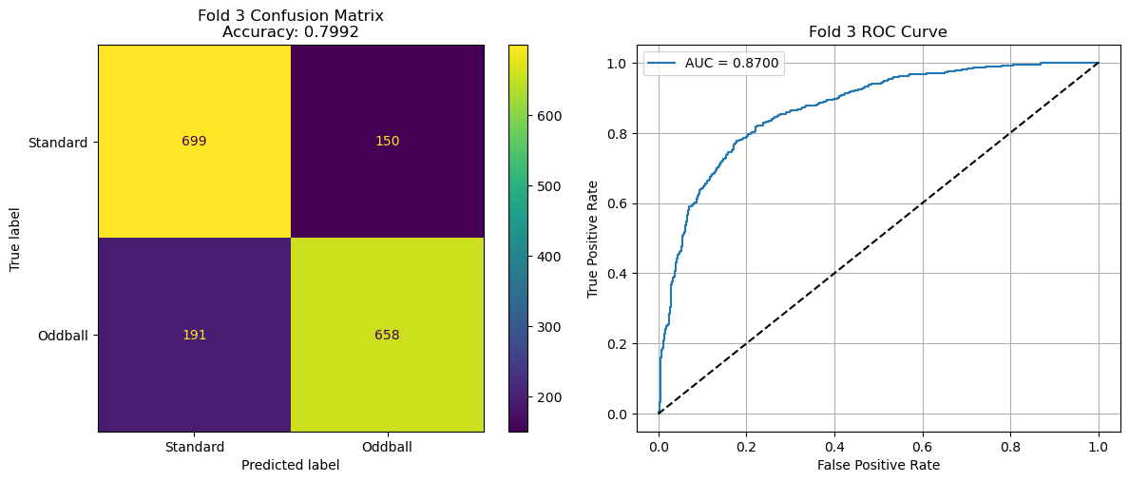

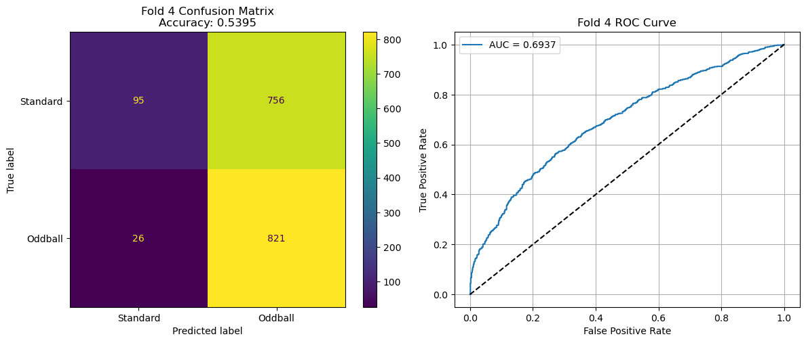

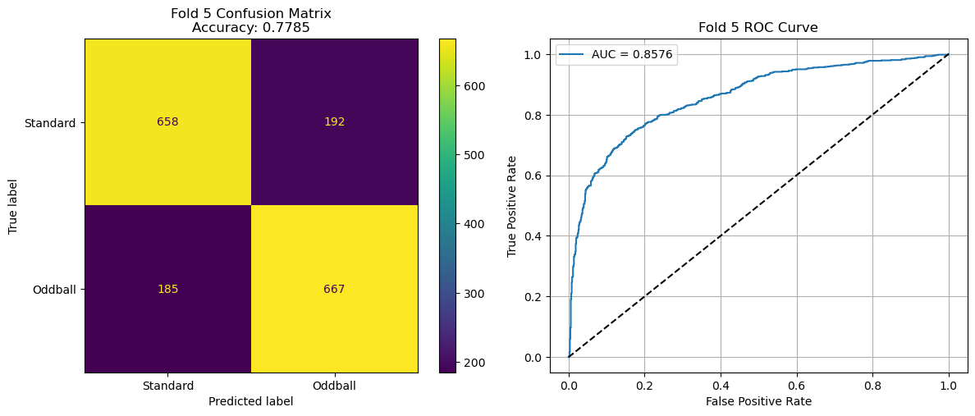

=== Cross-Validation Performance Summary ===

Fold | Accuracy | AUC

-----------------------------------

Fold 1 | 0.5406 | 0.7576

Fold 2 | 0.7220 | 0.8753

Fold 3 | 0.7992 | 0.8700

Fold 4 | 0.5395 | 0.6937

Fold 5 | 0.7785 | 0.8576

-----------------------------------

Mean | 0.6760 | 0.8109

Std | ±0.1138 | ±0.0727

=== Overall Performance ===

