Fold 1/5 Test Accuracy: 0.8182

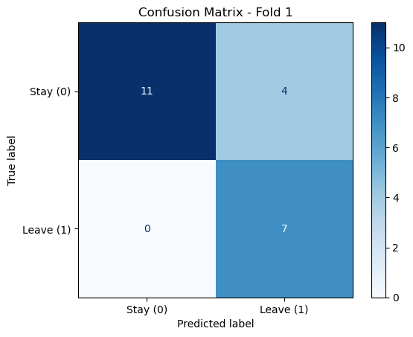

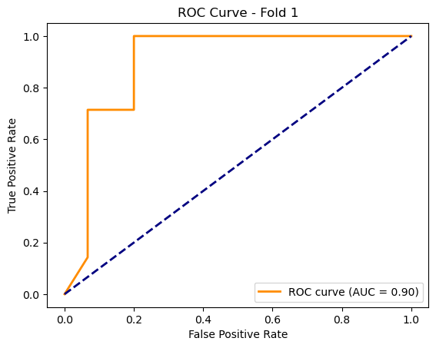

C:\Users\sansk\miniconda3\Lib\site-packages\torch_geometric\deprecation.py:26: UserWarning: 'data.DataLoader' is deprecated, use 'loader.DataLoader' instead

warnings.warn(out)

Fold 2/5 Test Accuracy: 0.7727

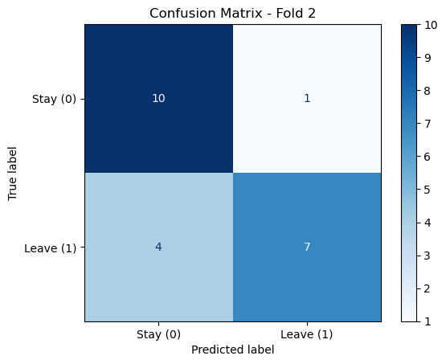

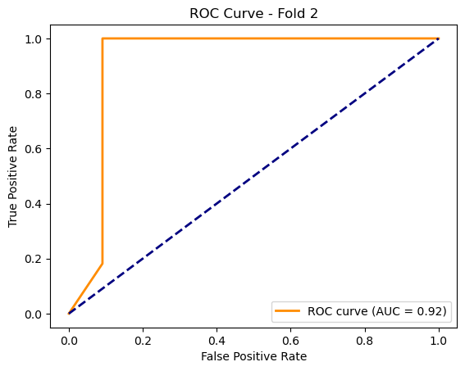

C:\Users\sansk\miniconda3\Lib\site-packages\torch_geometric\deprecation.py:26: UserWarning: 'data.DataLoader' is deprecated, use 'loader.DataLoader' instead

warnings.warn(out)

Fold 3/5 Test Accuracy: 0.9524

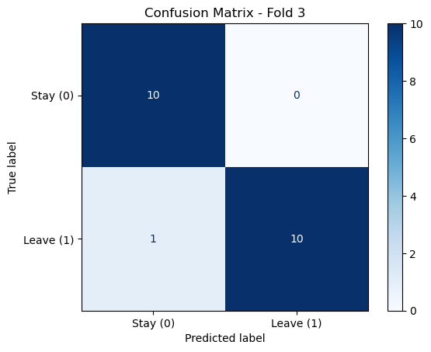

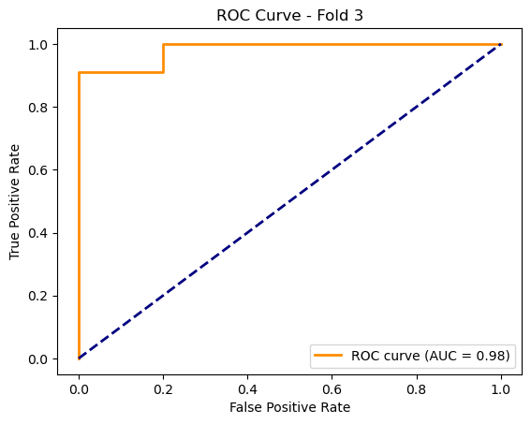

C:\Users\sansk\miniconda3\Lib\site-packages\torch_geometric\deprecation.py:26: UserWarning: 'data.DataLoader' is deprecated, use 'loader.DataLoader' instead

warnings.warn(out)

Fold 4/5 Test Accuracy: 0.8095

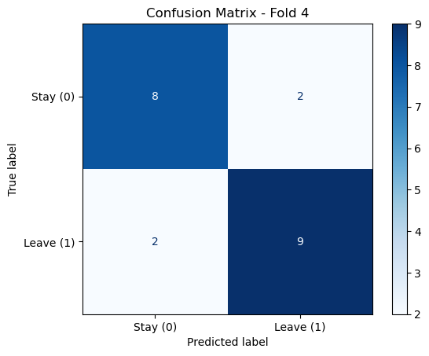

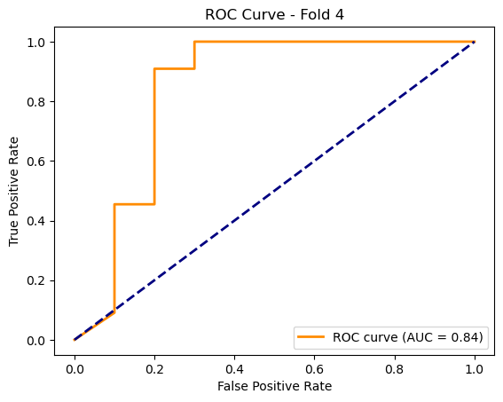

C:\Users\sansk\miniconda3\Lib\site-packages\torch_geometric\deprecation.py:26: UserWarning: 'data.DataLoader' is deprecated, use 'loader.DataLoader' instead

warnings.warn(out)

Fold 5/5 Test Accuracy: 0.8571

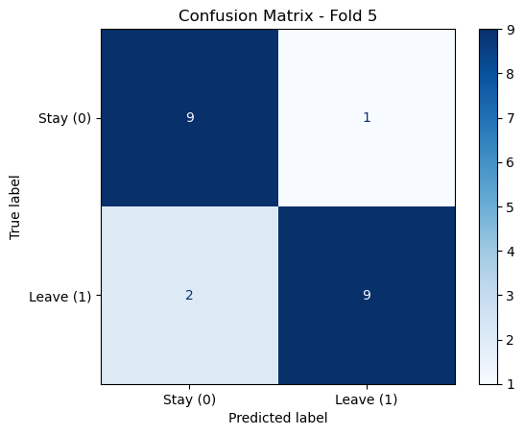

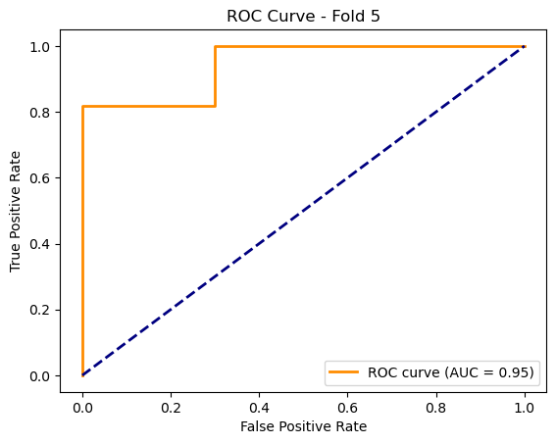

Average Test Accuracy across all folds: 0.8420