=== Processing Split 1/10 ===

Epoch 1/20 | Loss: 0.8787

Epoch 2/20 | Loss: 0.5306

Epoch 3/20 | Loss: 0.6402

Epoch 4/20 | Loss: 1.0953

Epoch 5/20 | Loss: 0.5566

Epoch 6/20 | Loss: 0.5100

Epoch 7/20 | Loss: 0.1927

Epoch 8/20 | Loss: nan

Epoch 9/20 | Loss: nan

Epoch 10/20 | Loss: nan

Epoch 11/20 | Loss: nan

Epoch 12/20 | Loss: nan

Epoch 13/20 | Loss: nan

Epoch 14/20 | Loss: nan

Epoch 15/20 | Loss: nan

Epoch 16/20 | Loss: nan

Epoch 17/20 | Loss: nan

Epoch 18/20 | Loss: nan

Epoch 19/20 | Loss: nan

Epoch 20/20 | Loss: nan

Accuracy: 0.8333

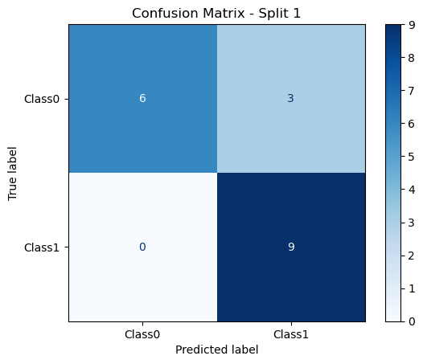

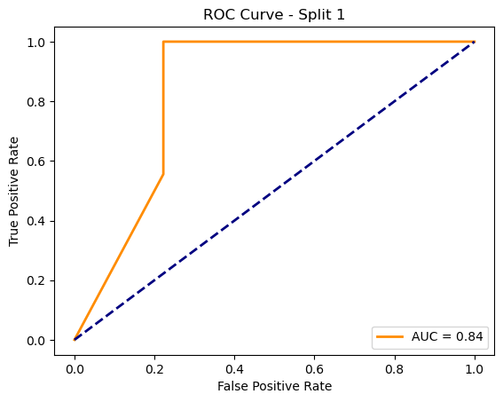

=== Processing Split 2/10 ===

C:\Users\sansk\miniconda3\Lib\site-packages\torch_geometric\deprecation.py:26: UserWarning: 'data.DataLoader' is deprecated, use 'loader.DataLoader' instead

warnings.warn(out)

Epoch 1/20 | Loss: 0.7622

Epoch 2/20 | Loss: 0.7414

Epoch 3/20 | Loss: 0.0645

Epoch 4/20 | Loss: 0.0169

Epoch 5/20 | Loss: 0.0118

Epoch 6/20 | Loss: 0.0087

Epoch 7/20 | Loss: 0.0074

Epoch 8/20 | Loss: 0.0060

Epoch 9/20 | Loss: 0.0048

Epoch 10/20 | Loss: 0.0039

Epoch 11/20 | Loss: 0.0033

Epoch 12/20 | Loss: 0.0028

Epoch 13/20 | Loss: 0.0024

Epoch 14/20 | Loss: 0.0021

Epoch 15/20 | Loss: 0.0019

Epoch 16/20 | Loss: 0.0017

Epoch 17/20 | Loss: 0.0015

Epoch 18/20 | Loss: 0.0013

Epoch 19/20 | Loss: 0.0012

Epoch 20/20 | Loss: 0.0011

Accuracy: 0.8125

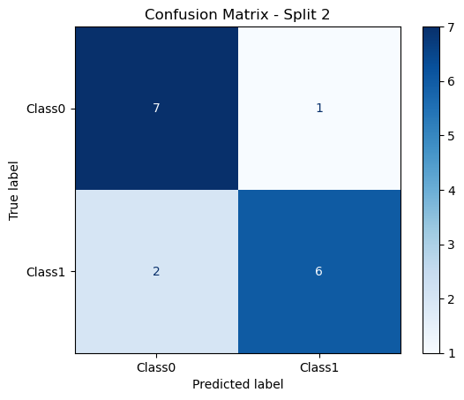

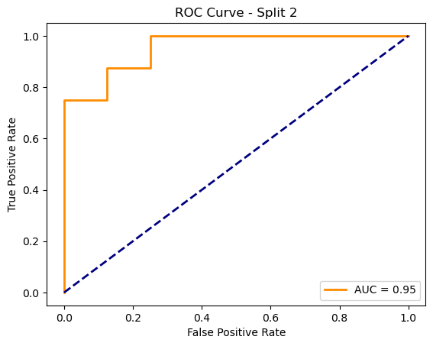

=== Processing Split 3/10 ===

C:\Users\sansk\miniconda3\Lib\site-packages\torch_geometric\deprecation.py:26: UserWarning: 'data.DataLoader' is deprecated, use 'loader.DataLoader' instead

warnings.warn(out)

Epoch 1/20 | Loss: 0.6165

Epoch 2/20 | Loss: 0.6218

Epoch 3/20 | Loss: 1.2492

Epoch 4/20 | Loss: nan

Epoch 5/20 | Loss: nan

Epoch 6/20 | Loss: nan

Epoch 7/20 | Loss: nan

Epoch 8/20 | Loss: nan

Epoch 9/20 | Loss: nan

Epoch 10/20 | Loss: nan

Epoch 11/20 | Loss: nan

Epoch 12/20 | Loss: nan

Epoch 13/20 | Loss: nan

Epoch 14/20 | Loss: nan

Epoch 15/20 | Loss: nan

Epoch 16/20 | Loss: nan

Epoch 17/20 | Loss: nan

Epoch 18/20 | Loss: nan

Epoch 19/20 | Loss: nan

Epoch 20/20 | Loss: nan

Accuracy: 0.8500

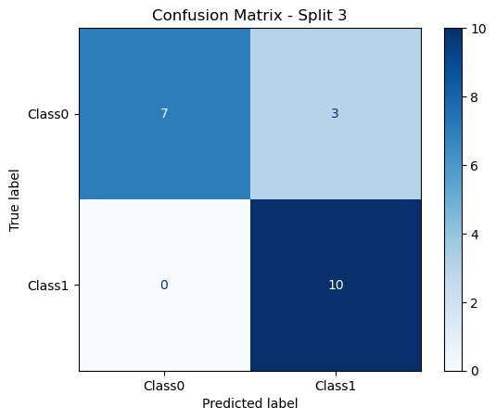

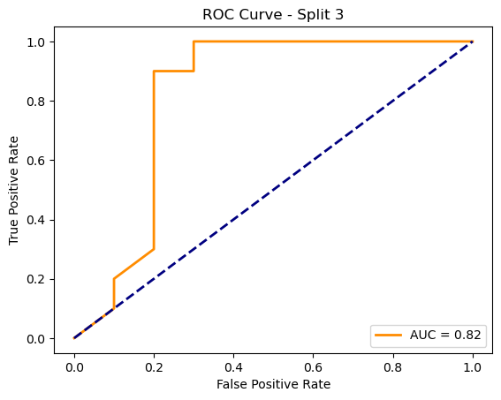

=== Processing Split 4/10 ===

C:\Users\sansk\miniconda3\Lib\site-packages\torch_geometric\deprecation.py:26: UserWarning: 'data.DataLoader' is deprecated, use 'loader.DataLoader' instead

warnings.warn(out)

Epoch 1/20 | Loss: 2.4178

Epoch 2/20 | Loss: 2.9251

Epoch 3/20 | Loss: nan

Epoch 4/20 | Loss: nan

Epoch 5/20 | Loss: nan

Epoch 6/20 | Loss: nan

Epoch 7/20 | Loss: nan

Epoch 8/20 | Loss: nan

Epoch 9/20 | Loss: nan

Epoch 10/20 | Loss: nan

Epoch 11/20 | Loss: nan

Epoch 12/20 | Loss: nan

Epoch 13/20 | Loss: nan

Epoch 14/20 | Loss: nan

Epoch 15/20 | Loss: nan

Epoch 16/20 | Loss: nan

Epoch 17/20 | Loss: nan

Epoch 18/20 | Loss: nan

Epoch 19/20 | Loss: nan

Epoch 20/20 | Loss: nan

Accuracy: 0.8889

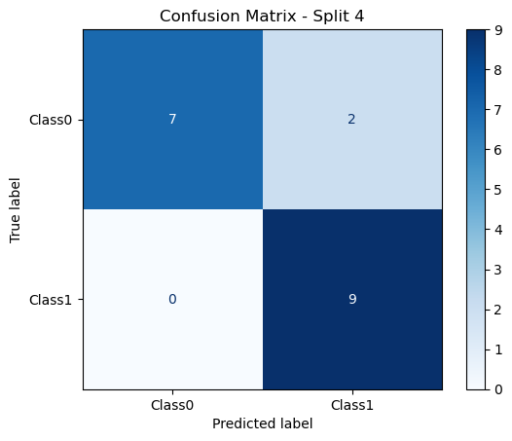

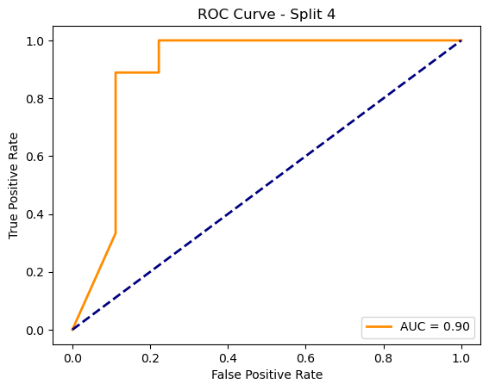

=== Processing Split 5/10 ===

C:\Users\sansk\miniconda3\Lib\site-packages\torch_geometric\deprecation.py:26: UserWarning: 'data.DataLoader' is deprecated, use 'loader.DataLoader' instead

warnings.warn(out)

Epoch 1/20 | Loss: 0.4924

Epoch 2/20 | Loss: 0.3847

Epoch 3/20 | Loss: 0.6696

Epoch 4/20 | Loss: 0.2438

Epoch 5/20 | Loss: nan

Epoch 6/20 | Loss: nan

Epoch 7/20 | Loss: nan

Epoch 8/20 | Loss: nan

Epoch 9/20 | Loss: nan

Epoch 10/20 | Loss: nan

Epoch 11/20 | Loss: nan

Epoch 12/20 | Loss: nan

Epoch 13/20 | Loss: nan

Epoch 14/20 | Loss: nan

Epoch 15/20 | Loss: nan

Epoch 16/20 | Loss: nan

Epoch 17/20 | Loss: nan

Epoch 18/20 | Loss: nan

Epoch 19/20 | Loss: nan

Epoch 20/20 | Loss: nan

Accuracy: 0.7500

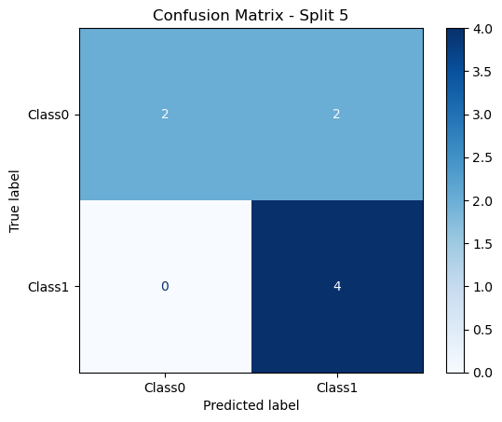

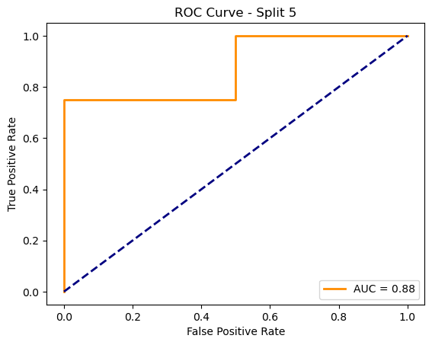

=== Processing Split 6/10 ===

C:\Users\sansk\miniconda3\Lib\site-packages\torch_geometric\deprecation.py:26: UserWarning: 'data.DataLoader' is deprecated, use 'loader.DataLoader' instead

warnings.warn(out)

Epoch 1/20 | Loss: 0.7678

Epoch 2/20 | Loss: 0.4919

Epoch 3/20 | Loss: 0.1365

Epoch 4/20 | Loss: nan

Epoch 5/20 | Loss: 0.5436

Epoch 6/20 | Loss: 0.0512

Epoch 7/20 | Loss: 0.0215

Epoch 8/20 | Loss: 0.0153

Epoch 9/20 | Loss: 0.0120

Epoch 10/20 | Loss: 0.0098

Epoch 11/20 | Loss: 0.0080

Epoch 12/20 | Loss: 0.0068

Epoch 13/20 | Loss: 0.0057

Epoch 14/20 | Loss: 0.0066

Epoch 15/20 | Loss: nan

Epoch 16/20 | Loss: 0.0047

Epoch 17/20 | Loss: 0.0038

Epoch 18/20 | Loss: 0.0033

Epoch 19/20 | Loss: 0.0028

Epoch 20/20 | Loss: 0.0025

Accuracy: 0.8500

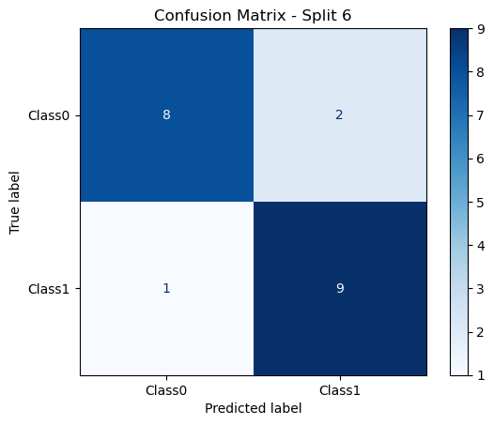

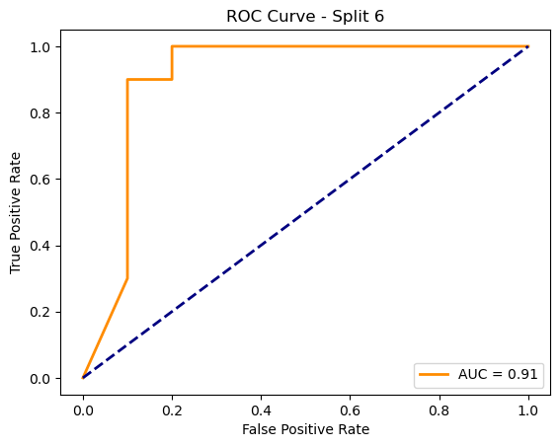

=== Processing Split 7/10 ===

C:\Users\sansk\miniconda3\Lib\site-packages\torch_geometric\deprecation.py:26: UserWarning: 'data.DataLoader' is deprecated, use 'loader.DataLoader' instead

warnings.warn(out)

Epoch 1/20 | Loss: 0.9660

Epoch 2/20 | Loss: 0.1581

Epoch 3/20 | Loss: 0.1437

Epoch 4/20 | Loss: 0.3223

Epoch 5/20 | Loss: 0.0310

Epoch 6/20 | Loss: 0.0175

Epoch 7/20 | Loss: 0.0110

Epoch 8/20 | Loss: 0.0076

Epoch 9/20 | Loss: 0.0056

Epoch 10/20 | Loss: 0.0043

Epoch 11/20 | Loss: 0.0034

Epoch 12/20 | Loss: 0.0028

Epoch 13/20 | Loss: 0.0023

Epoch 14/20 | Loss: 0.0019

Epoch 15/20 | Loss: 0.0016

Epoch 16/20 | Loss: 0.0014

Epoch 17/20 | Loss: 0.0012

Epoch 18/20 | Loss: 0.0011

Epoch 19/20 | Loss: 0.0009

Epoch 20/20 | Loss: 0.0008

Accuracy: 0.7500

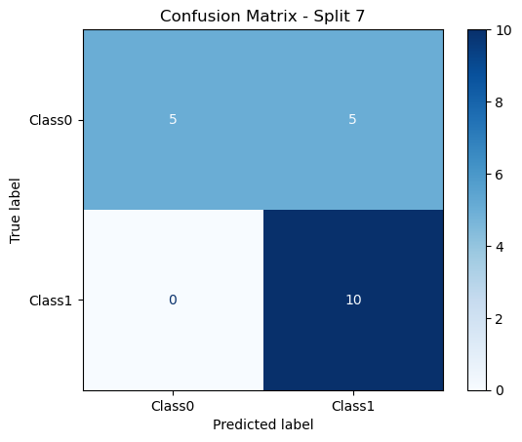

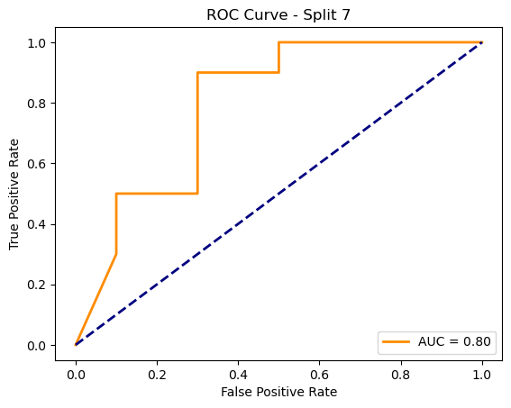

=== Processing Split 8/10 ===

C:\Users\sansk\miniconda3\Lib\site-packages\torch_geometric\deprecation.py:26: UserWarning: 'data.DataLoader' is deprecated, use 'loader.DataLoader' instead

warnings.warn(out)

Epoch 1/20 | Loss: 0.6249

Epoch 2/20 | Loss: 0.1622

Epoch 3/20 | Loss: 0.0292

Epoch 4/20 | Loss: 0.0116

Epoch 5/20 | Loss: 0.1615

Epoch 6/20 | Loss: 0.3053

Epoch 7/20 | Loss: 0.4851

Epoch 8/20 | Loss: 0.5856

Epoch 9/20 | Loss: nan

Epoch 10/20 | Loss: nan

Epoch 11/20 | Loss: nan

Epoch 12/20 | Loss: nan

Epoch 13/20 | Loss: nan

Epoch 14/20 | Loss: nan

Epoch 15/20 | Loss: nan

Epoch 16/20 | Loss: nan

Epoch 17/20 | Loss: nan

Epoch 18/20 | Loss: nan

Epoch 19/20 | Loss: nan

Epoch 20/20 | Loss: nan

Accuracy: 0.9500

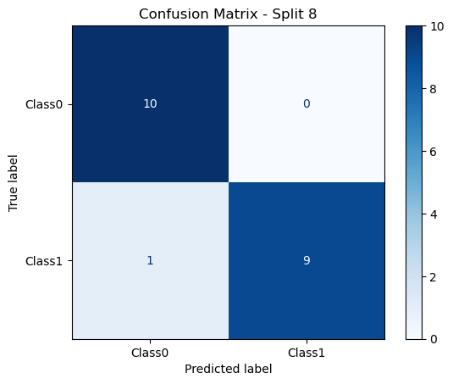

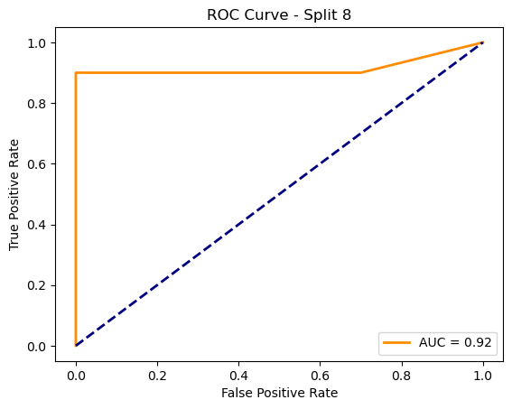

=== Processing Split 9/10 ===

C:\Users\sansk\miniconda3\Lib\site-packages\torch_geometric\deprecation.py:26: UserWarning: 'data.DataLoader' is deprecated, use 'loader.DataLoader' instead

warnings.warn(out)

Epoch 1/20 | Loss: 0.8908

Epoch 2/20 | Loss: 0.3795

Epoch 3/20 | Loss: 0.2799

Epoch 4/20 | Loss: 0.0239

Epoch 5/20 | Loss: 0.0169

Epoch 6/20 | Loss: 0.0120

Epoch 7/20 | Loss: 0.0092

Epoch 8/20 | Loss: 0.0072

Epoch 9/20 | Loss: 0.0058

Epoch 10/20 | Loss: 0.0047

Epoch 11/20 | Loss: 0.0038

Epoch 12/20 | Loss: 0.0031

Epoch 13/20 | Loss: 0.0026

Epoch 14/20 | Loss: 0.0021

Epoch 15/20 | Loss: 0.0018

Epoch 16/20 | Loss: 0.0015

Epoch 17/20 | Loss: 0.0013

Epoch 18/20 | Loss: 0.0011

Epoch 19/20 | Loss: 0.0009

Epoch 20/20 | Loss: 0.0008

Accuracy: 0.9000

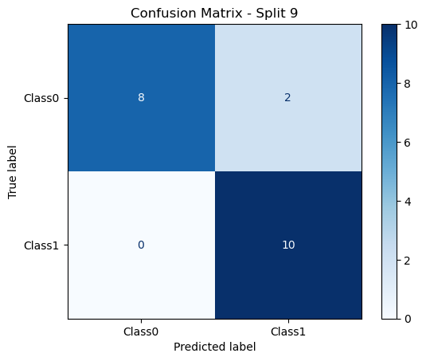

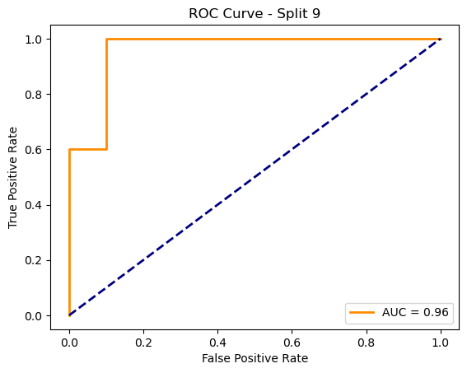

=== Processing Split 10/10 ===

C:\Users\sansk\miniconda3\Lib\site-packages\torch_geometric\deprecation.py:26: UserWarning: 'data.DataLoader' is deprecated, use 'loader.DataLoader' instead

warnings.warn(out)

Epoch 1/20 | Loss: 0.9764

Epoch 2/20 | Loss: 0.6700

Epoch 3/20 | Loss: nan

Epoch 4/20 | Loss: nan

Epoch 5/20 | Loss: nan

Epoch 6/20 | Loss: nan

Epoch 7/20 | Loss: nan

Epoch 8/20 | Loss: nan

Epoch 9/20 | Loss: nan

Epoch 10/20 | Loss: nan

Epoch 11/20 | Loss: nan

Epoch 12/20 | Loss: nan

Epoch 13/20 | Loss: nan

Epoch 14/20 | Loss: nan

Epoch 15/20 | Loss: nan

Epoch 16/20 | Loss: nan

Epoch 17/20 | Loss: nan

Epoch 18/20 | Loss: nan

Epoch 19/20 | Loss: nan

Epoch 20/20 | Loss: nan

Accuracy: 0.8500

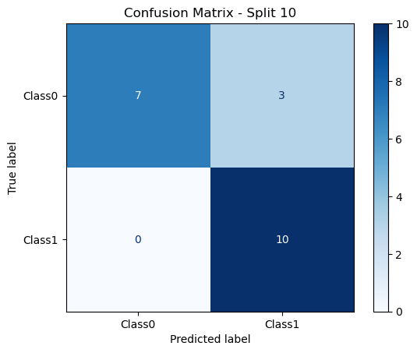

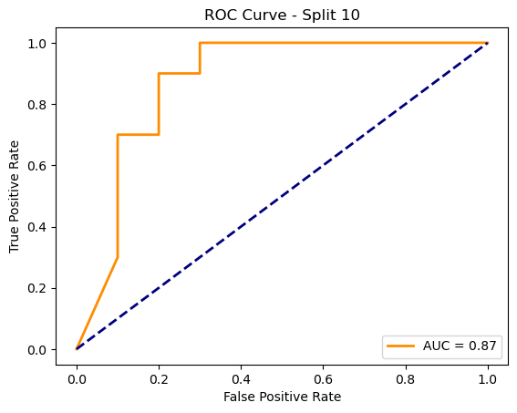

Average Test Accuracy: 0.8435 ± 0.0594