Loading ENV1 data...

ENV1: Loaded 106 trials (Stay: 53, Leave: 53)

==================================================

Training GNN for ENV1

==================================================

=== ENV1 Split 1/5 ===

C:\Users\sansk\miniconda3\Lib\site-packages\torch_geometric\deprecation.py:26: UserWarning: 'data.DataLoader' is deprecated, use 'loader.DataLoader' instead

warnings.warn(out)

C:\Users\sansk\miniconda3\Lib\site-packages\torch\nn\modules\module.py:1150: UserWarning: expandable_segments not supported on this platform (Triggered internally at .[.\c10/cuda/CUDAAllocatorConfig.h:30](http://localhost:8888/lab/tree/c10/cuda/CUDAAllocatorConfig.h#line=29).)

return t.to(device, dtype if t.is_floating_point() or t.is_complex() else None, non_blocking)

Epoch 1/20 | Loss: 2.6890

Epoch 2/20 | Loss: 1.5320

Epoch 3/20 | Loss: 2.4588

Epoch 4/20 | Loss: 1.5249

Epoch 5/20 | Loss: 0.5551

Epoch 6/20 | Loss: 0.2715

Epoch 7/20 | Loss: 0.2194

Epoch 8/20 | Loss: 0.1816

Epoch 9/20 | Loss: 0.1552

Epoch 10/20 | Loss: 0.1304

Epoch 11/20 | Loss: 0.1097

Epoch 12/20 | Loss: 0.0912

Epoch 13/20 | Loss: 0.0754

Epoch 14/20 | Loss: 0.0645

Epoch 15/20 | Loss: 0.0548

Epoch 16/20 | Loss: 0.0485

Epoch 17/20 | Loss: 0.0384

Epoch 18/20 | Loss: 0.0325

Epoch 19/20 | Loss: 0.0284

Epoch 20/20 | Loss: 0.0244

Split 1 Accuracy: 0.5909

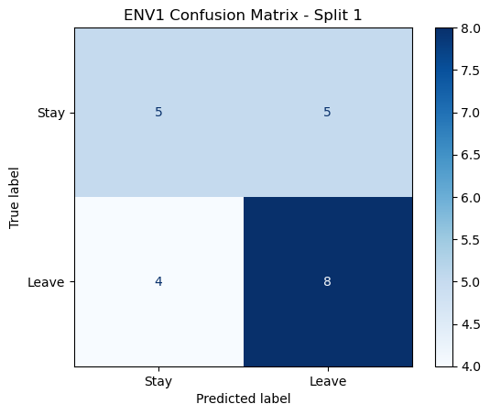

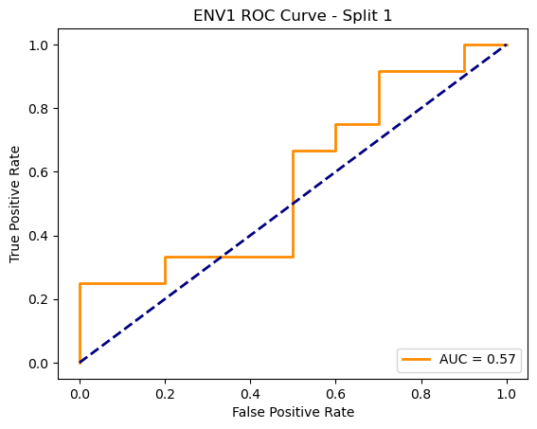

=== ENV1 Split 2/5 ===

C:\Users\sansk\miniconda3\Lib\site-packages\torch_geometric\deprecation.py:26: UserWarning: 'data.DataLoader' is deprecated, use 'loader.DataLoader' instead

warnings.warn(out)

Epoch 1/20 | Loss: 5.4488

Epoch 2/20 | Loss: 1.3329

Epoch 3/20 | Loss: 2.2299

Epoch 4/20 | Loss: 1.4180

Epoch 5/20 | Loss: 0.4072

Epoch 6/20 | Loss: 1.1379

Epoch 7/20 | Loss: 1.0570

Epoch 8/20 | Loss: 1.7362

Epoch 9/20 | Loss: 0.6225

Epoch 10/20 | Loss: 0.3715

Epoch 11/20 | Loss: 0.2767

Epoch 12/20 | Loss: 0.2249

Epoch 13/20 | Loss: 0.1973

Epoch 14/20 | Loss: 0.1720

Epoch 15/20 | Loss: 0.1505

Epoch 16/20 | Loss: 0.1288

Epoch 17/20 | Loss: 0.1149

Epoch 18/20 | Loss: 0.1019

Epoch 19/20 | Loss: 0.0903

Epoch 20/20 | Loss: 0.0811

Split 2 Accuracy: 0.4286

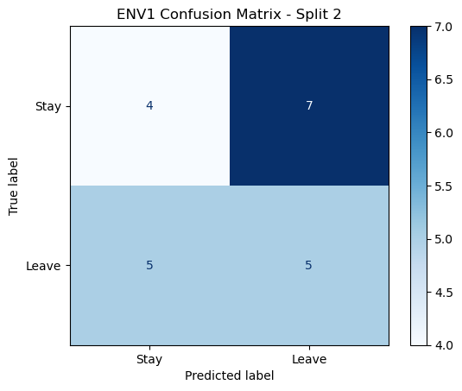

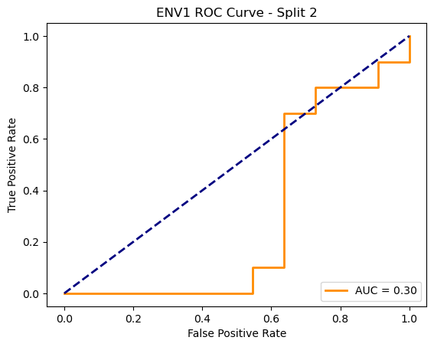

=== ENV1 Split 3/5 ===

C:\Users\sansk\miniconda3\Lib\site-packages\torch_geometric\deprecation.py:26: UserWarning: 'data.DataLoader' is deprecated, use 'loader.DataLoader' instead

warnings.warn(out)

Epoch 1/20 | Loss: 2.6499

Epoch 2/20 | Loss: 2.1217

Epoch 3/20 | Loss: 1.3889

Epoch 4/20 | Loss: 0.4293

Epoch 5/20 | Loss: 0.3013

Epoch 6/20 | Loss: 0.2463

Epoch 7/20 | Loss: 0.2071

Epoch 8/20 | Loss: 0.1870

Epoch 9/20 | Loss: 0.1519

Epoch 10/20 | Loss: 0.1328

Epoch 11/20 | Loss: 0.1070

Epoch 12/20 | Loss: 0.0905

Epoch 13/20 | Loss: 0.0776

Epoch 14/20 | Loss: 0.0840

Epoch 15/20 | Loss: 0.0627

Epoch 16/20 | Loss: 0.0526

Epoch 17/20 | Loss: 0.0440

Epoch 18/20 | Loss: 0.0364

Epoch 19/20 | Loss: 0.0318

Epoch 20/20 | Loss: 0.0270

Split 3 Accuracy: 0.6190

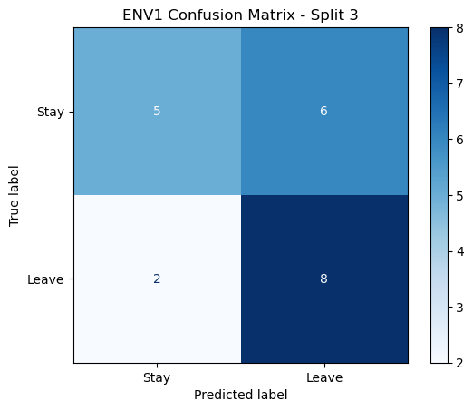

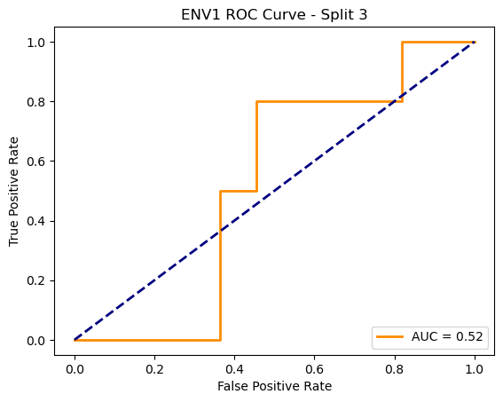

=== ENV1 Split 4/5 ===

C:\Users\sansk\miniconda3\Lib\site-packages\torch_geometric\deprecation.py:26: UserWarning: 'data.DataLoader' is deprecated, use 'loader.DataLoader' instead

warnings.warn(out)

Epoch 1/20 | Loss: 8.2037

Epoch 2/20 | Loss: 2.6596

Epoch 3/20 | Loss: 2.8716

Epoch 4/20 | Loss: 3.9486

Epoch 5/20 | Loss: 0.4401

Epoch 6/20 | Loss: 0.3141

Epoch 7/20 | Loss: 0.2750

Epoch 8/20 | Loss: 0.2396

Epoch 9/20 | Loss: 0.2139

Epoch 10/20 | Loss: 0.1886

Epoch 11/20 | Loss: 0.1644

Epoch 12/20 | Loss: 0.1449

Epoch 13/20 | Loss: 0.1267

Epoch 14/20 | Loss: 0.1087

Epoch 15/20 | Loss: 0.0926

Epoch 16/20 | Loss: 0.0802

Epoch 17/20 | Loss: 0.0662

Epoch 18/20 | Loss: 0.0565

Epoch 19/20 | Loss: 0.0477

Epoch 20/20 | Loss: 0.0406

Split 4 Accuracy: 0.4286

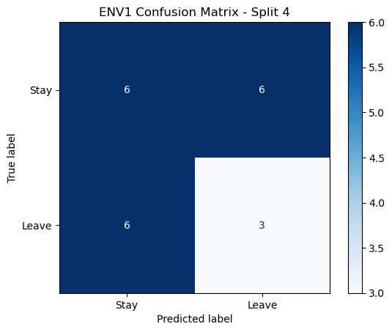

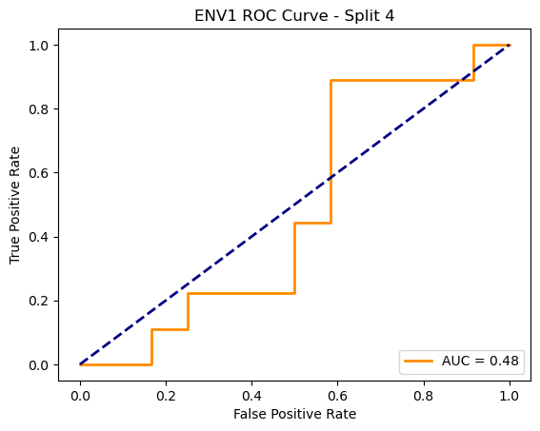

=== ENV1 Split 5/5 ===

C:\Users\sansk\miniconda3\Lib\site-packages\torch_geometric\deprecation.py:26: UserWarning: 'data.DataLoader' is deprecated, use 'loader.DataLoader' instead

warnings.warn(out)

Epoch 1/20 | Loss: 4.2646

Epoch 2/20 | Loss: 0.8300

Epoch 3/20 | Loss: 0.3384

Epoch 4/20 | Loss: 0.2664

Epoch 5/20 | Loss: 0.2137

Epoch 6/20 | Loss: 0.1771

Epoch 7/20 | Loss: 0.1681

Epoch 8/20 | Loss: 0.1195

Epoch 9/20 | Loss: 0.0989

Epoch 10/20 | Loss: 0.3456

Epoch 11/20 | Loss: 0.1868

Epoch 12/20 | Loss: 0.1646

Epoch 13/20 | Loss: 0.4118

Epoch 14/20 | Loss: 1.4399

Epoch 15/20 | Loss: 0.3848

Epoch 16/20 | Loss: 0.0830

Epoch 17/20 | Loss: 0.0577

Epoch 18/20 | Loss: 0.0466

Epoch 19/20 | Loss: 0.0395

Epoch 20/20 | Loss: 0.0345

Split 5 Accuracy: 0.4286

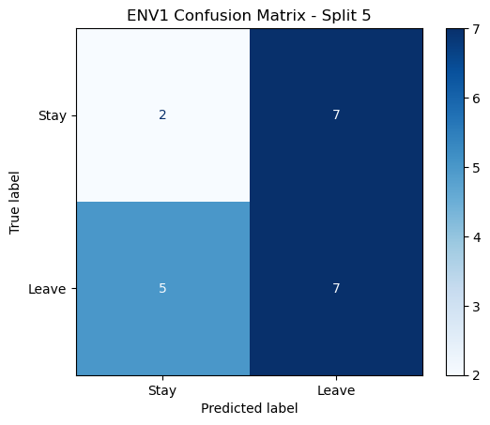

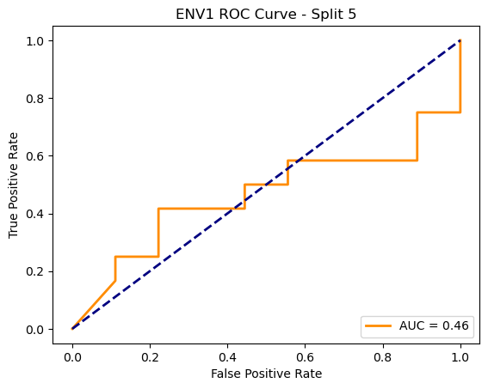

ENV1 Average Accuracy: 0.4991 ± 0.0869

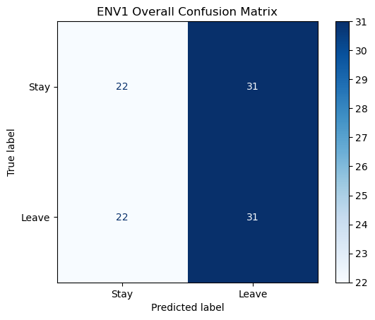

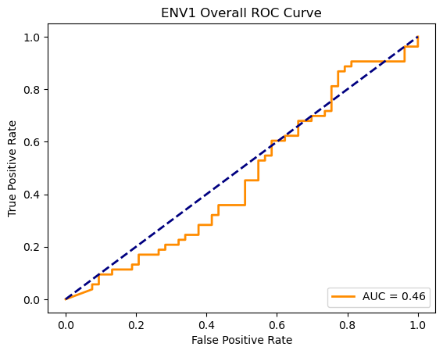

Loading ENV2 data...

ENV2: Loaded 106 trials (Stay: 53, Leave: 53)

==================================================

Training GNN for ENV2

==================================================

=== ENV2 Split 1/5 ===

C:\Users\sansk\miniconda3\Lib\site-packages\torch_geometric\deprecation.py:26: UserWarning: 'data.DataLoader' is deprecated, use 'loader.DataLoader' instead

warnings.warn(out)

Epoch 1/20 | Loss: 1.3936

Epoch 2/20 | Loss: 0.8058

Epoch 3/20 | Loss: 1.6775

Epoch 4/20 | Loss: 0.9748

Epoch 5/20 | Loss: 1.1543

Epoch 6/20 | Loss: 0.6140

Epoch 7/20 | Loss: 0.3846

Epoch 8/20 | Loss: 0.2506

Epoch 9/20 | Loss: 0.1672

Epoch 10/20 | Loss: 0.1345

Epoch 11/20 | Loss: 0.1059

Epoch 12/20 | Loss: 0.0783

Epoch 13/20 | Loss: 0.0644

Epoch 14/20 | Loss: 0.0542

Epoch 15/20 | Loss: 0.0463

Epoch 16/20 | Loss: 0.0389

Epoch 17/20 | Loss: 0.0328

Epoch 18/20 | Loss: 0.0280

Epoch 19/20 | Loss: 0.0238

Epoch 20/20 | Loss: 0.0206

Split 1 Accuracy: 0.5909

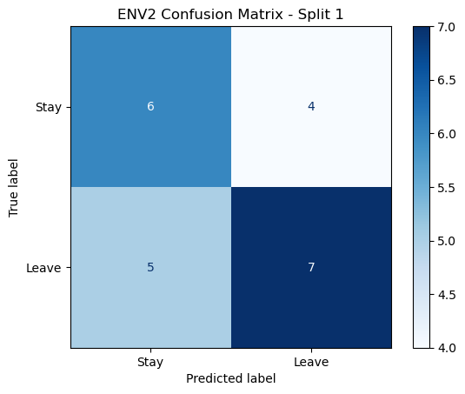

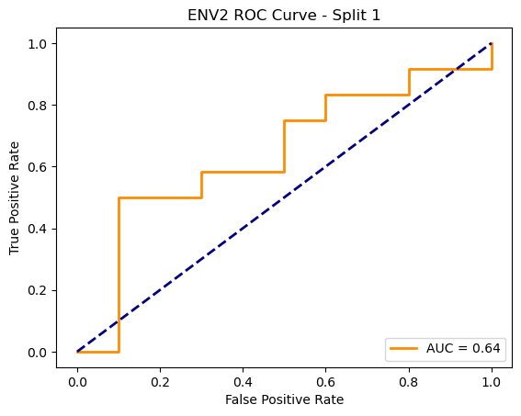

=== ENV2 Split 2/5 ===

C:\Users\sansk\miniconda3\Lib\site-packages\torch_geometric\deprecation.py:26: UserWarning: 'data.DataLoader' is deprecated, use 'loader.DataLoader' instead

warnings.warn(out)

Epoch 1/20 | Loss: 2.4928

Epoch 2/20 | Loss: 2.0866

Epoch 3/20 | Loss: 0.5079

Epoch 4/20 | Loss: 0.3418

Epoch 5/20 | Loss: 0.4182

Epoch 6/20 | Loss: 0.9766

Epoch 7/20 | Loss: 1.0550

Epoch 8/20 | Loss: 0.2413

Epoch 9/20 | Loss: 0.1322

Epoch 10/20 | Loss: 0.0907

Epoch 11/20 | Loss: 2.7303

Epoch 12/20 | Loss: 2.4038

Epoch 13/20 | Loss: 0.2351

Epoch 14/20 | Loss: 0.2408

Epoch 15/20 | Loss: 0.1181

Epoch 16/20 | Loss: 0.0636

Epoch 17/20 | Loss: 0.0505

Epoch 18/20 | Loss: 0.0442

Epoch 19/20 | Loss: 0.0378

Epoch 20/20 | Loss: 0.0324

Split 2 Accuracy: 0.5238

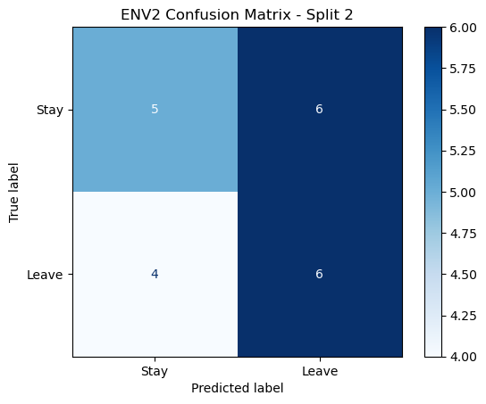

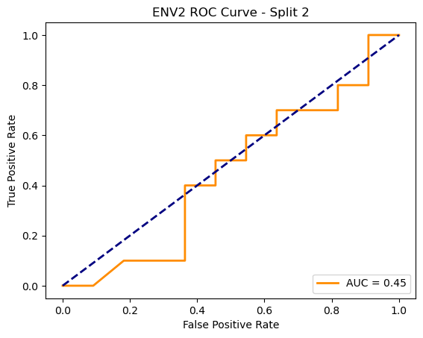

=== ENV2 Split 3/5 ===

C:\Users\sansk\miniconda3\Lib\site-packages\torch_geometric\deprecation.py:26: UserWarning: 'data.DataLoader' is deprecated, use 'loader.DataLoader' instead

warnings.warn(out)

Epoch 1/20 | Loss: 2.4329

Epoch 2/20 | Loss: 1.4390

Epoch 3/20 | Loss: 0.4499

Epoch 4/20 | Loss: 2.3720

Epoch 5/20 | Loss: 1.3433

Epoch 6/20 | Loss: 1.4273

Epoch 7/20 | Loss: 0.2466

Epoch 8/20 | Loss: 0.1747

Epoch 9/20 | Loss: 0.1239

Epoch 10/20 | Loss: 0.0979

Epoch 11/20 | Loss: 0.0809

Epoch 12/20 | Loss: 0.0655

Epoch 13/20 | Loss: 0.0551

Epoch 14/20 | Loss: 0.0444

Epoch 15/20 | Loss: 0.0370

Epoch 16/20 | Loss: 0.0302

Epoch 17/20 | Loss: 0.0261

Epoch 18/20 | Loss: 0.0215

Epoch 19/20 | Loss: 0.0185

Epoch 20/20 | Loss: 0.0154

Split 3 Accuracy: 0.3810

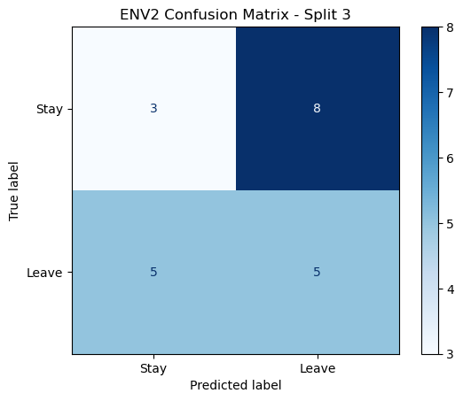

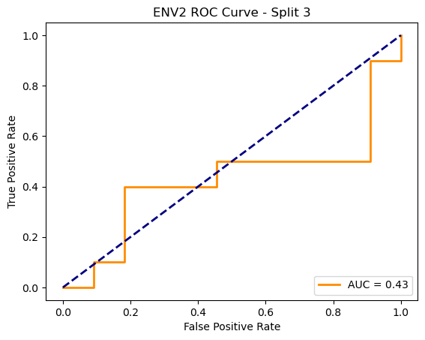

=== ENV2 Split 4/5 ===

C:\Users\sansk\miniconda3\Lib\site-packages\torch_geometric\deprecation.py:26: UserWarning: 'data.DataLoader' is deprecated, use 'loader.DataLoader' instead

warnings.warn(out)

Epoch 1/20 | Loss: 2.1645

Epoch 2/20 | Loss: 5.2666

Epoch 3/20 | Loss: 4.1203

Epoch 4/20 | Loss: 0.3940

Epoch 5/20 | Loss: 0.2730

Epoch 6/20 | Loss: 0.2032

Epoch 7/20 | Loss: 0.1719

Epoch 8/20 | Loss: 0.1353

Epoch 9/20 | Loss: 0.1120

Epoch 10/20 | Loss: 0.0901

Epoch 11/20 | Loss: 0.0743

Epoch 12/20 | Loss: 0.0608

Epoch 13/20 | Loss: 0.0493

Epoch 14/20 | Loss: 0.0397

Epoch 15/20 | Loss: 0.0327

Epoch 16/20 | Loss: 0.0293

Epoch 17/20 | Loss: 0.0234

Epoch 18/20 | Loss: 0.0198

Epoch 19/20 | Loss: 0.0173

Epoch 20/20 | Loss: 0.0150

Split 4 Accuracy: 0.4762

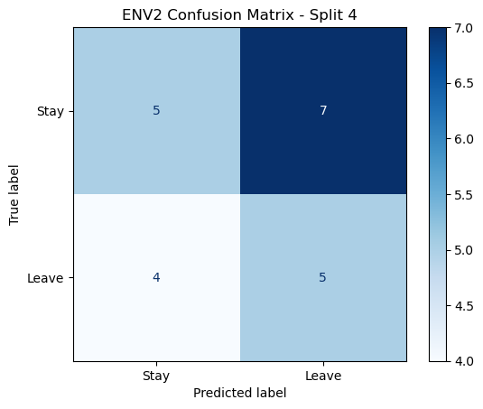

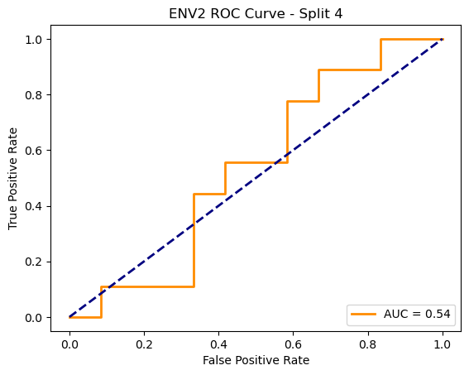

=== ENV2 Split 5/5 ===

C:\Users\sansk\miniconda3\Lib\site-packages\torch_geometric\deprecation.py:26: UserWarning: 'data.DataLoader' is deprecated, use 'loader.DataLoader' instead

warnings.warn(out)

Epoch 1/20 | Loss: 1.8034

Epoch 2/20 | Loss: 0.8971

Epoch 3/20 | Loss: 0.4450

Epoch 4/20 | Loss: 0.2368

Epoch 5/20 | Loss: 0.1718

Epoch 6/20 | Loss: 0.1325

Epoch 7/20 | Loss: 0.0962

Epoch 8/20 | Loss: 0.0659

Epoch 9/20 | Loss: 0.0504

Epoch 10/20 | Loss: 0.0382

Epoch 11/20 | Loss: 0.0290

Epoch 12/20 | Loss: 0.0223

Epoch 13/20 | Loss: 0.0178

Epoch 14/20 | Loss: 0.0145

Epoch 15/20 | Loss: 0.0115

Epoch 16/20 | Loss: 0.0094

Epoch 17/20 | Loss: 0.0078

Epoch 18/20 | Loss: 0.0067

Epoch 19/20 | Loss: 0.0057

Epoch 20/20 | Loss: 0.0048

Split 5 Accuracy: 0.3810

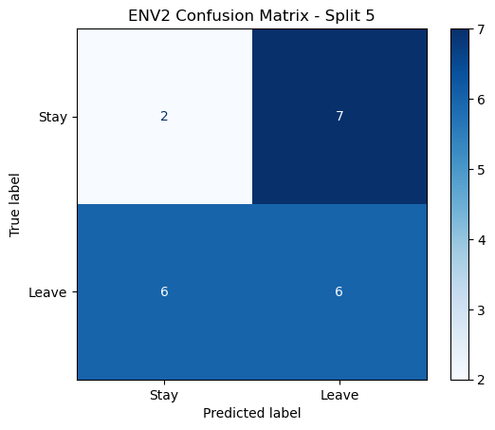

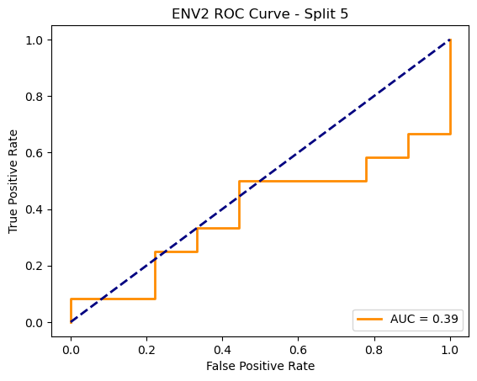

ENV2 Average Accuracy: 0.4706 ± 0.0817

