Loading ENV1 data...

ENV1: Loaded 106 trials (Stay: 53, Leave: 53)

Running GNN with corr connectivity for ENV1...

==================================================

Training GNN for ENV1 with corr connectivity

==================================================

=== ENV1 Split 1/5 ===

After oversampling, class counts: Counter({0: 43, 1: 43})

C:\Users\sansk\miniconda3\Lib\site-packages\torch_geometric\deprecation.py:26: UserWarning: 'data.DataLoader' is deprecated, use 'loader.DataLoader' instead

warnings.warn(out)

Epoch 1/100 | Loss: 0.7115

Epoch 2/100 | Loss: 0.7152

Epoch 3/100 | Loss: 0.7636

Epoch 4/100 | Loss: 0.7511

Epoch 5/100 | Loss: 0.6501

Epoch 6/100 | Loss: 0.6807

Epoch 7/100 | Loss: 0.7822

Epoch 8/100 | Loss: 0.7110

Epoch 9/100 | Loss: 0.6751

Epoch 10/100 | Loss: 0.6996

Epoch 11/100 | Loss: 0.6584

Epoch 12/100 | Loss: 0.7645

Epoch 13/100 | Loss: 0.7123

Epoch 14/100 | Loss: 0.6683

Epoch 15/100 | Loss: 0.7506

Epoch 16/100 | Loss: 0.6588

Epoch 17/100 | Loss: 0.7269

Epoch 18/100 | Loss: 0.6803

Epoch 19/100 | Loss: 0.6826

Epoch 20/100 | Loss: 0.6257

Epoch 21/100 | Loss: 0.7250

Epoch 22/100 | Loss: 0.6830

Epoch 23/100 | Loss: 0.6695

Epoch 24/100 | Loss: 0.6672

Epoch 25/100 | Loss: 0.6771

Epoch 26/100 | Loss: 0.6517

Epoch 27/100 | Loss: 0.6809

Epoch 28/100 | Loss: 0.6383

Epoch 29/100 | Loss: 0.6823

Epoch 30/100 | Loss: 0.6809

Epoch 31/100 | Loss: 0.6947

Epoch 32/100 | Loss: 0.6570

Epoch 33/100 | Loss: 0.6341

Epoch 34/100 | Loss: 0.6852

Epoch 35/100 | Loss: 0.6603

Epoch 36/100 | Loss: 0.7201

Epoch 37/100 | Loss: 0.7047

Epoch 38/100 | Loss: 0.7235

Epoch 39/100 | Loss: 0.7481

Epoch 40/100 | Loss: 0.6954

Epoch 41/100 | Loss: 0.6444

Epoch 42/100 | Loss: 0.6287

Epoch 43/100 | Loss: 0.7082

Epoch 44/100 | Loss: 0.6863

Epoch 45/100 | Loss: 0.6298

Epoch 46/100 | Loss: 0.6394

Epoch 47/100 | Loss: 0.6717

Epoch 48/100 | Loss: 0.6443

Epoch 49/100 | Loss: 0.6457

Epoch 50/100 | Loss: 0.6463

Epoch 51/100 | Loss: 0.5780

Epoch 52/100 | Loss: 0.6631

Epoch 53/100 | Loss: 0.6527

Epoch 54/100 | Loss: 0.6078

Epoch 55/100 | Loss: 0.6480

Epoch 56/100 | Loss: 0.6490

Epoch 57/100 | Loss: 0.6753

Epoch 58/100 | Loss: 0.6343

Epoch 59/100 | Loss: 0.6524

Epoch 60/100 | Loss: 0.5971

Epoch 61/100 | Loss: 0.6174

Epoch 62/100 | Loss: 0.7231

Epoch 63/100 | Loss: 0.6805

Epoch 64/100 | Loss: 0.6296

Epoch 65/100 | Loss: 0.6024

Epoch 66/100 | Loss: 0.6456

Epoch 67/100 | Loss: 0.6446

Epoch 68/100 | Loss: 0.6762

Epoch 69/100 | Loss: 0.6700

Epoch 70/100 | Loss: 0.7173

Epoch 71/100 | Loss: 0.6185

Epoch 72/100 | Loss: 0.7073

Epoch 73/100 | Loss: 0.5981

Epoch 74/100 | Loss: 0.6478

Epoch 75/100 | Loss: 0.7222

Epoch 76/100 | Loss: 0.6035

Epoch 77/100 | Loss: 0.6196

Epoch 78/100 | Loss: 0.6046

Epoch 79/100 | Loss: 0.6524

Epoch 80/100 | Loss: 0.5850

Epoch 81/100 | Loss: 0.6430

Epoch 82/100 | Loss: 0.5964

Epoch 83/100 | Loss: 0.6328

Epoch 84/100 | Loss: 0.6226

Epoch 85/100 | Loss: 0.6164

Epoch 86/100 | Loss: 0.6046

Epoch 87/100 | Loss: 0.6758

Epoch 88/100 | Loss: 0.6418

Epoch 89/100 | Loss: 0.5437

Epoch 90/100 | Loss: 0.5590

Epoch 91/100 | Loss: 0.5995

Epoch 92/100 | Loss: 0.6164

Epoch 93/100 | Loss: 0.6017

Epoch 94/100 | Loss: 0.5625

Epoch 95/100 | Loss: 0.6110

Epoch 96/100 | Loss: 0.5876

Epoch 97/100 | Loss: 0.6218

Epoch 98/100 | Loss: 0.6603

Epoch 99/100 | Loss: 0.5843

Epoch 100/100 | Loss: 0.6117

Split 1 Accuracy: 0.4091

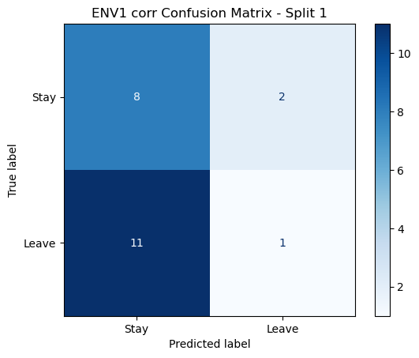

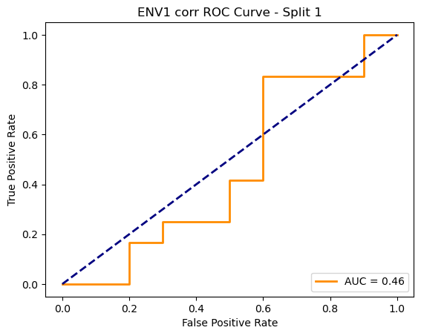

=== ENV1 Split 2/5 ===

After oversampling, class counts: Counter({1: 43, 0: 43})

C:\Users\sansk\miniconda3\Lib\site-packages\torch_geometric\deprecation.py:26: UserWarning: 'data.DataLoader' is deprecated, use 'loader.DataLoader' instead

warnings.warn(out)

Epoch 1/100 | Loss: 0.6675

Epoch 2/100 | Loss: 0.7131

Epoch 3/100 | Loss: 0.7249

Epoch 4/100 | Loss: 0.7145

Epoch 5/100 | Loss: 0.7635

Epoch 6/100 | Loss: 0.7065

Epoch 7/100 | Loss: 0.7529

Epoch 8/100 | Loss: 0.7309

Epoch 9/100 | Loss: 0.7241

Epoch 10/100 | Loss: 0.7023

Epoch 11/100 | Loss: 0.7066

Epoch 12/100 | Loss: 0.6532

Epoch 13/100 | Loss: 0.6970

Epoch 14/100 | Loss: 0.7161

Epoch 15/100 | Loss: 0.6820

Epoch 16/100 | Loss: 0.6958

Epoch 17/100 | Loss: 0.6972

Epoch 18/100 | Loss: 0.7052

Epoch 19/100 | Loss: 0.7141

Epoch 20/100 | Loss: 0.6657

Epoch 21/100 | Loss: 0.7007

Epoch 22/100 | Loss: 0.6978

Epoch 23/100 | Loss: 0.6437

Epoch 24/100 | Loss: 0.7511

Epoch 25/100 | Loss: 0.6570

Epoch 26/100 | Loss: 0.6711

Epoch 27/100 | Loss: 0.6350

Epoch 28/100 | Loss: 0.6145

Epoch 29/100 | Loss: 0.7178

Epoch 30/100 | Loss: 0.6383

Epoch 31/100 | Loss: 0.6940

Epoch 32/100 | Loss: 0.6772

Epoch 33/100 | Loss: 0.6872

Epoch 34/100 | Loss: 0.6182

Epoch 35/100 | Loss: 0.6233

Epoch 36/100 | Loss: 0.6237

Epoch 37/100 | Loss: 0.6885

Epoch 38/100 | Loss: 0.6320

Epoch 39/100 | Loss: 0.6516

Epoch 40/100 | Loss: 0.6879

Epoch 41/100 | Loss: 0.7072

Epoch 42/100 | Loss: 0.6201

Epoch 43/100 | Loss: 0.6162

Epoch 44/100 | Loss: 0.6294

Epoch 45/100 | Loss: 0.7150

Epoch 46/100 | Loss: 0.7187

Epoch 47/100 | Loss: 0.6406

Epoch 48/100 | Loss: 0.6245

Epoch 49/100 | Loss: 0.5952

Epoch 50/100 | Loss: 0.6688

Epoch 51/100 | Loss: 0.5713

Epoch 52/100 | Loss: 0.6211

Epoch 53/100 | Loss: 0.6128

Epoch 54/100 | Loss: 0.6349

Epoch 55/100 | Loss: 0.6588

Epoch 56/100 | Loss: 0.6726

Epoch 57/100 | Loss: 0.6857

Epoch 58/100 | Loss: 0.6458

Epoch 59/100 | Loss: 0.5833

Epoch 60/100 | Loss: 0.6472

Epoch 61/100 | Loss: 0.6370

Epoch 62/100 | Loss: 0.5855

Epoch 63/100 | Loss: 0.5967

Epoch 64/100 | Loss: 0.5786

Epoch 65/100 | Loss: 0.6308

Epoch 66/100 | Loss: 0.6977

Epoch 67/100 | Loss: 0.5256

Epoch 68/100 | Loss: 0.6959

Epoch 69/100 | Loss: 0.6432

Epoch 70/100 | Loss: 0.5791

Epoch 71/100 | Loss: 0.6054

Epoch 72/100 | Loss: 0.5757

Epoch 73/100 | Loss: 0.6412

Epoch 74/100 | Loss: 0.5904

Epoch 75/100 | Loss: 0.6028

Epoch 76/100 | Loss: 0.6444

Epoch 77/100 | Loss: 0.6422

Epoch 78/100 | Loss: 0.5936

Epoch 79/100 | Loss: 0.6578

Epoch 80/100 | Loss: 0.6090

Epoch 81/100 | Loss: 0.6394

Epoch 82/100 | Loss: 0.5914

Epoch 83/100 | Loss: 0.6040

Epoch 84/100 | Loss: 0.6036

Epoch 85/100 | Loss: 0.5385

Epoch 86/100 | Loss: 0.6142

Epoch 87/100 | Loss: 0.5716

Epoch 88/100 | Loss: 0.5510

Epoch 89/100 | Loss: 0.6581

Epoch 90/100 | Loss: 0.5875

Epoch 91/100 | Loss: 0.5609

Epoch 92/100 | Loss: 0.6737

Epoch 93/100 | Loss: 0.5823

Epoch 94/100 | Loss: 0.6234

Epoch 95/100 | Loss: 0.6095

Epoch 96/100 | Loss: 0.5665

Epoch 97/100 | Loss: 0.5356

Epoch 98/100 | Loss: 0.5794

Epoch 99/100 | Loss: 0.5588

Epoch 100/100 | Loss: 0.5190

Split 2 Accuracy: 0.4762

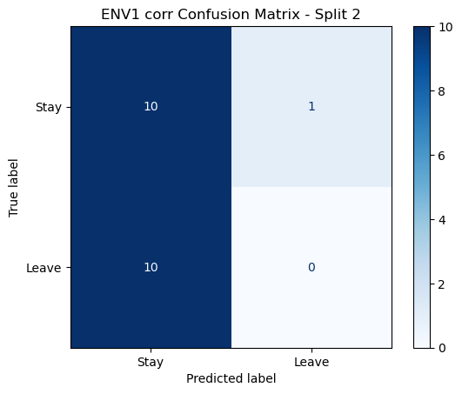

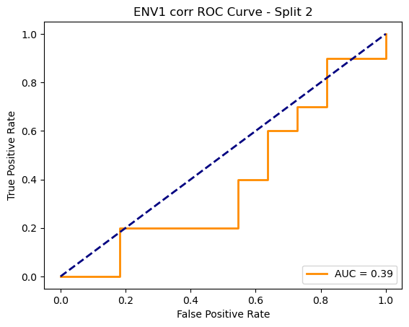

=== ENV1 Split 3/5 ===

After oversampling, class counts: Counter({1: 43, 0: 43})

C:\Users\sansk\miniconda3\Lib\site-packages\torch_geometric\deprecation.py:26: UserWarning: 'data.DataLoader' is deprecated, use 'loader.DataLoader' instead

warnings.warn(out)

Epoch 1/100 | Loss: 0.7639

Epoch 2/100 | Loss: 0.7410

Epoch 3/100 | Loss: 0.7708

Epoch 4/100 | Loss: 0.7365

Epoch 5/100 | Loss: 0.7472

Epoch 6/100 | Loss: 0.6792

Epoch 7/100 | Loss: 0.7212

Epoch 8/100 | Loss: 0.7704

Epoch 9/100 | Loss: 0.7537

Epoch 10/100 | Loss: 0.6678

Epoch 11/100 | Loss: 0.7154

Epoch 12/100 | Loss: 0.6822

Epoch 13/100 | Loss: 0.6975

Epoch 14/100 | Loss: 0.7268

Epoch 15/100 | Loss: 0.6907

Epoch 16/100 | Loss: 0.6933

Epoch 17/100 | Loss: 0.7182

Epoch 18/100 | Loss: 0.7157

Epoch 19/100 | Loss: 0.6675

Epoch 20/100 | Loss: 0.6535

Epoch 21/100 | Loss: 0.6727

Epoch 22/100 | Loss: 0.6909

Epoch 23/100 | Loss: 0.7419

Epoch 24/100 | Loss: 0.6906

Epoch 25/100 | Loss: 0.6770

Epoch 26/100 | Loss: 0.6664

Epoch 27/100 | Loss: 0.6506

Epoch 28/100 | Loss: 0.6493

Epoch 29/100 | Loss: 0.6571

Epoch 30/100 | Loss: 0.7099

Epoch 31/100 | Loss: 0.6821

Epoch 32/100 | Loss: 0.6728

Epoch 33/100 | Loss: 0.6833

Epoch 34/100 | Loss: 0.6561

Epoch 35/100 | Loss: 0.6526

Epoch 36/100 | Loss: 0.6340

Epoch 37/100 | Loss: 0.6856

Epoch 38/100 | Loss: 0.7398

Epoch 39/100 | Loss: 0.6079

Epoch 40/100 | Loss: 0.6433

Epoch 41/100 | Loss: 0.6683

Epoch 42/100 | Loss: 0.6290

Epoch 43/100 | Loss: 0.6972

Epoch 44/100 | Loss: 0.7111

Epoch 45/100 | Loss: 0.6848

Epoch 46/100 | Loss: 0.6841

Epoch 47/100 | Loss: 0.7725

Epoch 48/100 | Loss: 0.7596

Epoch 49/100 | Loss: 0.6310

Epoch 50/100 | Loss: 0.7242

Epoch 51/100 | Loss: 0.6733

Epoch 52/100 | Loss: 0.6926

Epoch 53/100 | Loss: 0.6632

Epoch 54/100 | Loss: 0.7488

Epoch 55/100 | Loss: 0.6496

Epoch 56/100 | Loss: 0.6194

Epoch 57/100 | Loss: 0.6644

Epoch 58/100 | Loss: 0.5918

Epoch 59/100 | Loss: 0.6662

Epoch 60/100 | Loss: 0.6835

Epoch 61/100 | Loss: 0.6468

Epoch 62/100 | Loss: 0.6922

Epoch 63/100 | Loss: 0.6709

Epoch 64/100 | Loss: 0.6141

Epoch 65/100 | Loss: 0.6951

Epoch 66/100 | Loss: 0.6487

Epoch 67/100 | Loss: 0.6595

Epoch 68/100 | Loss: 0.6854

Epoch 69/100 | Loss: 0.6396

Epoch 70/100 | Loss: 0.6278

Epoch 71/100 | Loss: 0.6491

Epoch 72/100 | Loss: 0.6104

Epoch 73/100 | Loss: 0.5869

Epoch 74/100 | Loss: 0.6135

Epoch 75/100 | Loss: 0.6938

Epoch 76/100 | Loss: 0.6535

Epoch 77/100 | Loss: 0.5799

Epoch 78/100 | Loss: 0.7128

Epoch 79/100 | Loss: 0.6507

Epoch 80/100 | Loss: 0.5900

Epoch 81/100 | Loss: 0.6584

Epoch 82/100 | Loss: 0.6184

Epoch 83/100 | Loss: 0.5781

Epoch 84/100 | Loss: 0.6634

Epoch 85/100 | Loss: 0.6015

Epoch 86/100 | Loss: 0.5881

Epoch 87/100 | Loss: 0.6902

Epoch 88/100 | Loss: 0.6427

Epoch 89/100 | Loss: 0.7230

Epoch 90/100 | Loss: 0.6312

Epoch 91/100 | Loss: 0.5702

Epoch 92/100 | Loss: 0.6257

Epoch 93/100 | Loss: 0.5881

Epoch 94/100 | Loss: 0.6382

Epoch 95/100 | Loss: 0.6316

Epoch 96/100 | Loss: 0.5899

Epoch 97/100 | Loss: 0.6056

Epoch 98/100 | Loss: 0.6681

Epoch 99/100 | Loss: 0.5648

Epoch 100/100 | Loss: 0.5915

Split 3 Accuracy: 0.4762

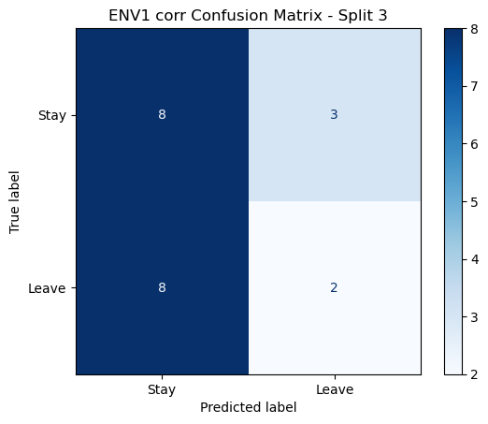

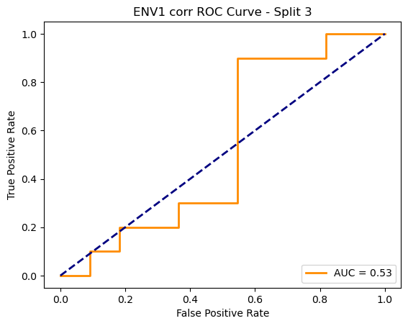

=== ENV1 Split 4/5 ===

After oversampling, class counts: Counter({1: 44, 0: 44})

C:\Users\sansk\miniconda3\Lib\site-packages\torch_geometric\deprecation.py:26: UserWarning: 'data.DataLoader' is deprecated, use 'loader.DataLoader' instead

warnings.warn(out)

Epoch 1/100 | Loss: 0.7297

Epoch 2/100 | Loss: 0.6978

Epoch 3/100 | Loss: 0.7497

Epoch 4/100 | Loss: 0.7167

Epoch 5/100 | Loss: 0.6797

Epoch 6/100 | Loss: 0.7019

Epoch 7/100 | Loss: 0.7186

Epoch 8/100 | Loss: 0.6399

Epoch 9/100 | Loss: 0.6915

Epoch 10/100 | Loss: 0.7252

Epoch 11/100 | Loss: 0.7326

Epoch 12/100 | Loss: 0.7100

Epoch 13/100 | Loss: 0.6888

Epoch 14/100 | Loss: 0.7463

Epoch 15/100 | Loss: 0.6740

Epoch 16/100 | Loss: 0.7791

Epoch 17/100 | Loss: 0.6269

Epoch 18/100 | Loss: 0.6660

Epoch 19/100 | Loss: 0.6477

Epoch 20/100 | Loss: 0.7331

Epoch 21/100 | Loss: 0.6484

Epoch 22/100 | Loss: 0.6759

Epoch 23/100 | Loss: 0.6785

Epoch 24/100 | Loss: 0.7188

Epoch 25/100 | Loss: 0.6890

Epoch 26/100 | Loss: 0.6631

Epoch 27/100 | Loss: 0.6743

Epoch 28/100 | Loss: 0.6608

Epoch 29/100 | Loss: 0.7411

Epoch 30/100 | Loss: 0.6788

Epoch 31/100 | Loss: 0.6791

Epoch 32/100 | Loss: 0.6993

Epoch 33/100 | Loss: 0.6796

Epoch 34/100 | Loss: 0.6553

Epoch 35/100 | Loss: 0.6875

Epoch 36/100 | Loss: 0.7123

Epoch 37/100 | Loss: 0.6911

Epoch 38/100 | Loss: 0.6964

Epoch 39/100 | Loss: 0.7046

Epoch 40/100 | Loss: 0.7057

Epoch 41/100 | Loss: 0.6824

Epoch 42/100 | Loss: 0.7189

Epoch 43/100 | Loss: 0.7643

Epoch 44/100 | Loss: 0.7049

Epoch 45/100 | Loss: 0.6611

Epoch 46/100 | Loss: 0.6495

Epoch 47/100 | Loss: 0.7025

Epoch 48/100 | Loss: 0.7352

Epoch 49/100 | Loss: 0.6567

Epoch 50/100 | Loss: 0.6738

Epoch 51/100 | Loss: 0.6761

Epoch 52/100 | Loss: 0.6740

Epoch 53/100 | Loss: 0.7397

Epoch 54/100 | Loss: 0.6875

Epoch 55/100 | Loss: 0.6344

Epoch 56/100 | Loss: 0.6985

Epoch 57/100 | Loss: 0.7081

Epoch 58/100 | Loss: 0.6744

Epoch 59/100 | Loss: 0.6848

Epoch 60/100 | Loss: 0.6552

Epoch 61/100 | Loss: 0.6670

Epoch 62/100 | Loss: 0.7056

Epoch 63/100 | Loss: 0.6656

Epoch 64/100 | Loss: 0.6976

Epoch 65/100 | Loss: 0.6621

Epoch 66/100 | Loss: 0.6602

Epoch 67/100 | Loss: 0.6551

Epoch 68/100 | Loss: 0.6558

Epoch 69/100 | Loss: 0.6835

Epoch 70/100 | Loss: 0.6547

Epoch 71/100 | Loss: 0.6310

Epoch 72/100 | Loss: 0.6229

Epoch 73/100 | Loss: 0.6438

Epoch 74/100 | Loss: 0.7031

Epoch 75/100 | Loss: 0.6850

Epoch 76/100 | Loss: 0.6129

Epoch 77/100 | Loss: 0.7079

Epoch 78/100 | Loss: 0.6361

Epoch 79/100 | Loss: 0.6334

Epoch 80/100 | Loss: 0.6515

Epoch 81/100 | Loss: 0.6603

Epoch 82/100 | Loss: 0.6097

Epoch 83/100 | Loss: 0.6674

Epoch 84/100 | Loss: 0.6704

Epoch 85/100 | Loss: 0.6287

Epoch 86/100 | Loss: 0.6729

Epoch 87/100 | Loss: 0.6839

Epoch 88/100 | Loss: 0.6186

Epoch 89/100 | Loss: 0.6923

Epoch 90/100 | Loss: 0.6384

Epoch 91/100 | Loss: 0.5961

Epoch 92/100 | Loss: 0.6319

Epoch 93/100 | Loss: 0.6214

Epoch 94/100 | Loss: 0.6301

Epoch 95/100 | Loss: 0.6200

Epoch 96/100 | Loss: 0.5891

Epoch 97/100 | Loss: 0.5698

Epoch 98/100 | Loss: 0.6135

Epoch 99/100 | Loss: 0.7127

Epoch 100/100 | Loss: 0.6361

Split 4 Accuracy: 0.6190

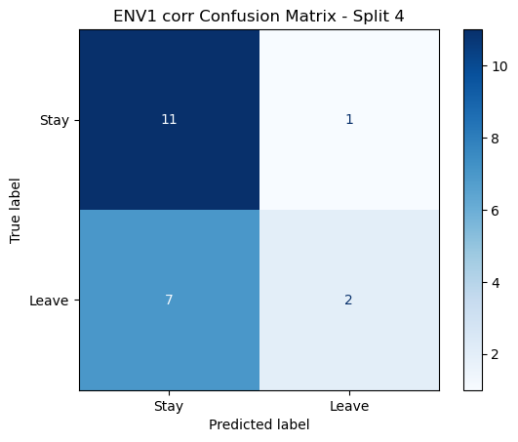

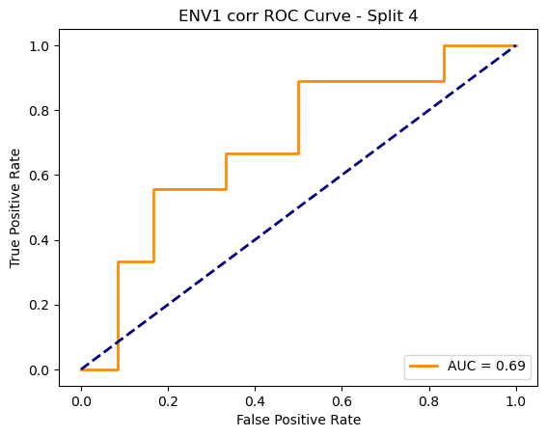

=== ENV1 Split 5/5 ===

After oversampling, class counts: Counter({1: 44, 0: 44})

C:\Users\sansk\miniconda3\Lib\site-packages\torch_geometric\deprecation.py:26: UserWarning: 'data.DataLoader' is deprecated, use 'loader.DataLoader' instead

warnings.warn(out)

Epoch 1/100 | Loss: 0.7536

Epoch 2/100 | Loss: 0.7802

Epoch 3/100 | Loss: 0.7462

Epoch 4/100 | Loss: 0.6641

Epoch 5/100 | Loss: 0.7666

Epoch 6/100 | Loss: 0.7337

Epoch 7/100 | Loss: 0.7147

Epoch 8/100 | Loss: 0.6769

Epoch 9/100 | Loss: 0.7326

Epoch 10/100 | Loss: 0.6936

Epoch 11/100 | Loss: 0.7047

Epoch 12/100 | Loss: 0.6585

Epoch 13/100 | Loss: 0.6746

Epoch 14/100 | Loss: 0.6884

Epoch 15/100 | Loss: 0.6279

Epoch 16/100 | Loss: 0.7354

Epoch 17/100 | Loss: 0.6674

Epoch 18/100 | Loss: 0.7260

Epoch 19/100 | Loss: 0.6867

Epoch 20/100 | Loss: 0.6155

Epoch 21/100 | Loss: 0.7403

Epoch 22/100 | Loss: 0.6676

Epoch 23/100 | Loss: 0.7235

Epoch 24/100 | Loss: 0.7247

Epoch 25/100 | Loss: 0.6814

Epoch 26/100 | Loss: 0.6995

Epoch 27/100 | Loss: 0.6875

Epoch 28/100 | Loss: 0.6714

Epoch 29/100 | Loss: 0.6795

Epoch 30/100 | Loss: 0.7009

Epoch 31/100 | Loss: 0.7071

Epoch 32/100 | Loss: 0.6758

Epoch 33/100 | Loss: 0.6355

Epoch 34/100 | Loss: 0.6940

Epoch 35/100 | Loss: 0.6541

Epoch 36/100 | Loss: 0.6748

Epoch 37/100 | Loss: 0.6523

Epoch 38/100 | Loss: 0.6770

Epoch 39/100 | Loss: 0.7066

Epoch 40/100 | Loss: 0.6759

Epoch 41/100 | Loss: 0.6827

Epoch 42/100 | Loss: 0.6008

Epoch 43/100 | Loss: 0.6559

Epoch 44/100 | Loss: 0.7048

Epoch 45/100 | Loss: 0.6477

Epoch 46/100 | Loss: 0.6466

Epoch 47/100 | Loss: 0.6710

Epoch 48/100 | Loss: 0.7149

Epoch 49/100 | Loss: 0.6568

Epoch 50/100 | Loss: 0.6115

Epoch 51/100 | Loss: 0.5869

Epoch 52/100 | Loss: 0.6763

Epoch 53/100 | Loss: 0.6789

Epoch 54/100 | Loss: 0.6482

Epoch 55/100 | Loss: 0.6822

Epoch 56/100 | Loss: 0.6119

Epoch 57/100 | Loss: 0.7138

Epoch 58/100 | Loss: 0.6710

Epoch 59/100 | Loss: 0.6533

Epoch 60/100 | Loss: 0.6594

Epoch 61/100 | Loss: 0.5816

Epoch 62/100 | Loss: 0.6263

Epoch 63/100 | Loss: 0.6601

Epoch 64/100 | Loss: 0.6240

Epoch 65/100 | Loss: 0.6075

Epoch 66/100 | Loss: 0.6687

Epoch 67/100 | Loss: 0.6353

Epoch 68/100 | Loss: 0.6673

Epoch 69/100 | Loss: 0.6362

Epoch 70/100 | Loss: 0.6764

Epoch 71/100 | Loss: 0.7124

Epoch 72/100 | Loss: 0.5738

Epoch 73/100 | Loss: 0.6482

Epoch 74/100 | Loss: 0.5322

Epoch 75/100 | Loss: 0.6262

Epoch 76/100 | Loss: 0.6321

Epoch 77/100 | Loss: 0.6294

Epoch 78/100 | Loss: 0.5603

Epoch 79/100 | Loss: 0.5869

Epoch 80/100 | Loss: 0.6191

Epoch 81/100 | Loss: 0.6562

Epoch 82/100 | Loss: 0.6460

Epoch 83/100 | Loss: 0.6983

Epoch 84/100 | Loss: 0.6351

Epoch 85/100 | Loss: 0.5851

Epoch 86/100 | Loss: 0.5721

Epoch 87/100 | Loss: 0.5949

Epoch 88/100 | Loss: 0.5746

Epoch 89/100 | Loss: 0.6290

Epoch 90/100 | Loss: 0.6601

Epoch 91/100 | Loss: 0.6926

Epoch 92/100 | Loss: 0.5732

Epoch 93/100 | Loss: 0.6253

Epoch 94/100 | Loss: 0.5646

Epoch 95/100 | Loss: 0.6154

Epoch 96/100 | Loss: 0.6017

Epoch 97/100 | Loss: 0.5948

Epoch 98/100 | Loss: 0.5800

Epoch 99/100 | Loss: 0.5647

Epoch 100/100 | Loss: 0.5471

Split 5 Accuracy: 0.6667

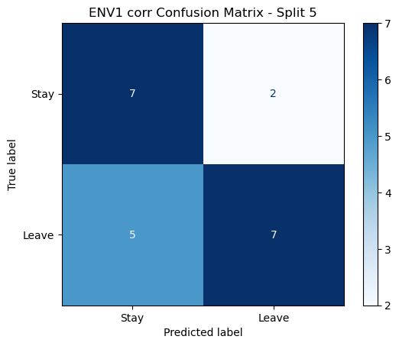

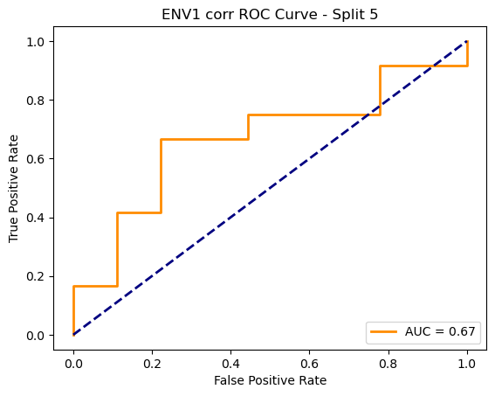

ENV1 corr Average Accuracy: 0.5294 ± 0.0970

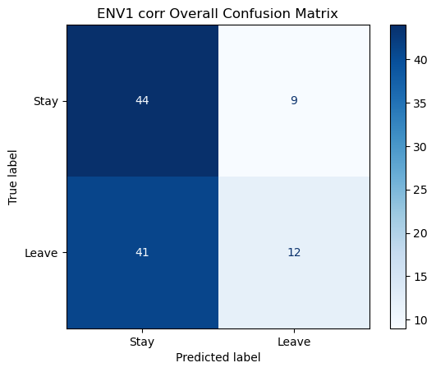

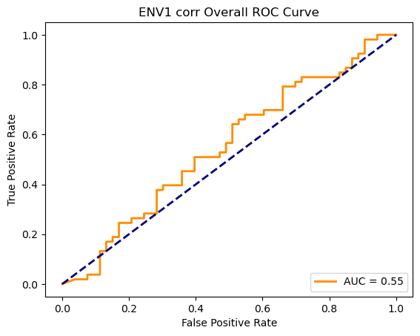

Running GNN with coh connectivity for ENV1...

==================================================

Training GNN for ENV1 with coh connectivity

==================================================

=== ENV1 Split 1/5 ===

C:\Users\sansk\miniconda3\Lib\site-packages\scipy\signal\_spectral_py.py:1668: RuntimeWarning: invalid value encountered in divide

Cxy = np.abs(Pxy)**2 / Pxx / Pyy

After oversampling, class counts: Counter({0: 43, 1: 43})

C:\Users\sansk\miniconda3\Lib\site-packages\torch_geometric\deprecation.py:26: UserWarning: 'data.DataLoader' is deprecated, use 'loader.DataLoader' instead

warnings.warn(out)

Epoch 1/100 | Loss: 0.7598

Epoch 2/100 | Loss: 0.7133

Epoch 3/100 | Loss: 0.7119

Epoch 4/100 | Loss: 0.7217

Epoch 5/100 | Loss: 0.7027

Epoch 6/100 | Loss: 0.7270

Epoch 7/100 | Loss: 0.7330

Epoch 8/100 | Loss: 0.7727

Epoch 9/100 | Loss: 0.6929

Epoch 10/100 | Loss: 0.7604

Epoch 11/100 | Loss: 0.7657

Epoch 12/100 | Loss: 0.6977

Epoch 13/100 | Loss: 0.7214

Epoch 14/100 | Loss: 0.7327

Epoch 15/100 | Loss: 0.7127

Epoch 16/100 | Loss: 0.7025

Epoch 17/100 | Loss: 0.7595

Epoch 18/100 | Loss: 0.6820

Epoch 19/100 | Loss: 0.7304

Epoch 20/100 | Loss: 0.6290

Epoch 21/100 | Loss: 0.7391

Epoch 22/100 | Loss: 0.6704

Epoch 23/100 | Loss: 0.7499

Epoch 24/100 | Loss: 0.7225

Epoch 25/100 | Loss: 0.6973

Epoch 26/100 | Loss: 0.7197

Epoch 27/100 | Loss: 0.6993

Epoch 28/100 | Loss: 0.7293

Epoch 29/100 | Loss: 0.7147

Epoch 30/100 | Loss: 0.7033

Epoch 31/100 | Loss: 0.7003

Epoch 32/100 | Loss: 0.6389

Epoch 33/100 | Loss: 0.7527

Epoch 34/100 | Loss: 0.6971

Epoch 35/100 | Loss: 0.7016

Epoch 36/100 | Loss: 0.6697

Epoch 37/100 | Loss: 0.7186

Epoch 38/100 | Loss: 0.6983

Epoch 39/100 | Loss: 0.7135

Epoch 40/100 | Loss: 0.6448

Epoch 41/100 | Loss: 0.6840

Epoch 42/100 | Loss: 0.7337

Epoch 43/100 | Loss: 0.6638

Epoch 44/100 | Loss: 0.7090

Epoch 45/100 | Loss: 0.7414

Epoch 46/100 | Loss: 0.6929

Epoch 47/100 | Loss: 0.7092

Epoch 48/100 | Loss: 0.6580

Epoch 49/100 | Loss: 0.7074

Epoch 50/100 | Loss: 0.6884

Epoch 51/100 | Loss: 0.6802

Epoch 52/100 | Loss: 0.6760

Epoch 53/100 | Loss: 0.7182

Epoch 54/100 | Loss: 0.7257

Epoch 55/100 | Loss: 0.7165

Epoch 56/100 | Loss: 0.6732

Epoch 57/100 | Loss: 0.7123

Epoch 58/100 | Loss: 0.6690

Epoch 59/100 | Loss: 0.6809

Epoch 60/100 | Loss: 0.6600

Epoch 61/100 | Loss: 0.6853

Epoch 62/100 | Loss: 0.7184

Epoch 63/100 | Loss: 0.7024

Epoch 64/100 | Loss: 0.7054

Epoch 65/100 | Loss: 0.7391

Epoch 66/100 | Loss: 0.7357

Epoch 67/100 | Loss: 0.6923

Epoch 68/100 | Loss: 0.6846

Epoch 69/100 | Loss: 0.6899

Epoch 70/100 | Loss: 0.6846

Epoch 71/100 | Loss: 0.6840

Epoch 72/100 | Loss: 0.7107

Epoch 73/100 | Loss: 0.6765

Epoch 74/100 | Loss: 0.6973

Epoch 75/100 | Loss: 0.7023

Epoch 76/100 | Loss: 0.6914

Epoch 77/100 | Loss: 0.7309

Epoch 78/100 | Loss: 0.7075

Epoch 79/100 | Loss: 0.7013

Epoch 80/100 | Loss: 0.7208

Epoch 81/100 | Loss: 0.7413

Epoch 82/100 | Loss: 0.7544

Epoch 83/100 | Loss: 0.7195

Epoch 84/100 | Loss: 0.6490

Epoch 85/100 | Loss: 0.7239

Epoch 86/100 | Loss: 0.6868

Epoch 87/100 | Loss: 0.6895

Epoch 88/100 | Loss: 0.7203

Epoch 89/100 | Loss: 0.6611

Epoch 90/100 | Loss: 0.6537

Epoch 91/100 | Loss: 0.6821

Epoch 92/100 | Loss: 0.6779

Epoch 93/100 | Loss: 0.7235

Epoch 94/100 | Loss: 0.6796

Epoch 95/100 | Loss: 0.7089

Epoch 96/100 | Loss: 0.7713

Epoch 97/100 | Loss: 0.7096

Epoch 98/100 | Loss: 0.7079

Epoch 99/100 | Loss: 0.6739

Epoch 100/100 | Loss: 0.6957

Split 1 Accuracy: 0.4545

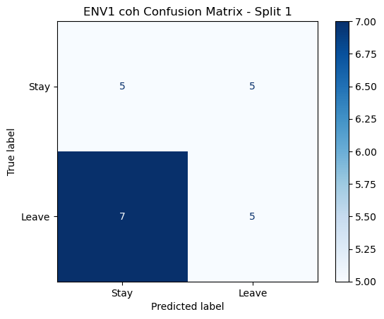

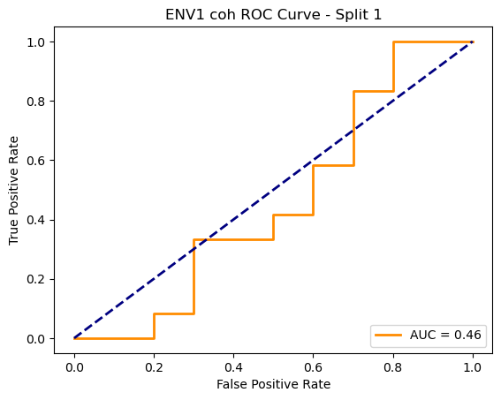

=== ENV1 Split 2/5 ===

C:\Users\sansk\miniconda3\Lib\site-packages\scipy\signal\_spectral_py.py:1668: RuntimeWarning: invalid value encountered in divide

Cxy = np.abs(Pxy)**2 / Pxx / Pyy

After oversampling, class counts: Counter({1: 43, 0: 43})

C:\Users\sansk\miniconda3\Lib\site-packages\torch_geometric\deprecation.py:26: UserWarning: 'data.DataLoader' is deprecated, use 'loader.DataLoader' instead

warnings.warn(out)

Epoch 1/100 | Loss: 0.7925

Epoch 2/100 | Loss: 0.7269

Epoch 3/100 | Loss: 0.8121

Epoch 4/100 | Loss: 0.6982

Epoch 5/100 | Loss: 0.6917

Epoch 6/100 | Loss: 0.7544

Epoch 7/100 | Loss: 0.7264

Epoch 8/100 | Loss: 0.8648

Epoch 9/100 | Loss: 0.6809

Epoch 10/100 | Loss: 0.7106

Epoch 11/100 | Loss: 0.7059

Epoch 12/100 | Loss: 0.7019

Epoch 13/100 | Loss: 0.7054

Epoch 14/100 | Loss: 0.7199

Epoch 15/100 | Loss: 0.7565

Epoch 16/100 | Loss: 0.7701

Epoch 17/100 | Loss: 0.7425

Epoch 18/100 | Loss: 0.6748

Epoch 19/100 | Loss: 0.7288

Epoch 20/100 | Loss: 0.7547

Epoch 21/100 | Loss: 0.6992

Epoch 22/100 | Loss: 0.7030

Epoch 23/100 | Loss: 0.7363

Epoch 24/100 | Loss: 0.7119

Epoch 25/100 | Loss: 0.6987

Epoch 26/100 | Loss: 0.7174

Epoch 27/100 | Loss: 0.7221

Epoch 28/100 | Loss: 0.6931

Epoch 29/100 | Loss: 0.7055

Epoch 30/100 | Loss: 0.6459

Epoch 31/100 | Loss: 0.7277

Epoch 32/100 | Loss: 0.7018

Epoch 33/100 | Loss: 0.6626

Epoch 34/100 | Loss: 0.6750

Epoch 35/100 | Loss: 0.6591

Epoch 36/100 | Loss: 0.6922

Epoch 37/100 | Loss: 0.6910

Epoch 38/100 | Loss: 0.6924

Epoch 39/100 | Loss: 0.6999

Epoch 40/100 | Loss: 0.7255

Epoch 41/100 | Loss: 0.6743

Epoch 42/100 | Loss: 0.7260

Epoch 43/100 | Loss: 0.6518

Epoch 44/100 | Loss: 0.7133

Epoch 45/100 | Loss: 0.6621

Epoch 46/100 | Loss: 0.7140

Epoch 47/100 | Loss: 0.6493

Epoch 48/100 | Loss: 0.7187

Epoch 49/100 | Loss: 0.7089

Epoch 50/100 | Loss: 0.7213

Epoch 51/100 | Loss: 0.7257

Epoch 52/100 | Loss: 0.6361

Epoch 53/100 | Loss: 0.6753

Epoch 54/100 | Loss: 0.6835

Epoch 55/100 | Loss: 0.6863

Epoch 56/100 | Loss: 0.6567

Epoch 57/100 | Loss: 0.7350

Epoch 58/100 | Loss: 0.6935

Epoch 59/100 | Loss: 0.6855

Epoch 60/100 | Loss: 0.7048

Epoch 61/100 | Loss: 0.6884

Epoch 62/100 | Loss: 0.6851

Epoch 63/100 | Loss: 0.6698

Epoch 64/100 | Loss: 0.6669

Epoch 65/100 | Loss: 0.7191

Epoch 66/100 | Loss: 0.6196

Epoch 67/100 | Loss: 0.6229

Epoch 68/100 | Loss: 0.7572

Epoch 69/100 | Loss: 0.6805

Epoch 70/100 | Loss: 0.7147

Epoch 71/100 | Loss: 0.6912

Epoch 72/100 | Loss: 0.6601

Epoch 73/100 | Loss: 0.6478

Epoch 74/100 | Loss: 0.7339

Epoch 75/100 | Loss: 0.6990

Epoch 76/100 | Loss: 0.6660

Epoch 77/100 | Loss: 0.7038

Epoch 78/100 | Loss: 0.6978

Epoch 79/100 | Loss: 0.6727

Epoch 80/100 | Loss: 0.7016

Epoch 81/100 | Loss: 0.7021

Epoch 82/100 | Loss: 0.6917

Epoch 83/100 | Loss: 0.6690

Epoch 84/100 | Loss: 0.7129

Epoch 85/100 | Loss: 0.6679

Epoch 86/100 | Loss: 0.6748

Epoch 87/100 | Loss: 0.7363

Epoch 88/100 | Loss: 0.6693

Epoch 89/100 | Loss: 0.6713

Epoch 90/100 | Loss: 0.6741

Epoch 91/100 | Loss: 0.6844

Epoch 92/100 | Loss: 0.6381

Epoch 93/100 | Loss: 0.7020

Epoch 94/100 | Loss: 0.6806

Epoch 95/100 | Loss: 0.6758

Epoch 96/100 | Loss: 0.7092

Epoch 97/100 | Loss: 0.6960

Epoch 98/100 | Loss: 0.6973

Epoch 99/100 | Loss: 0.7006

Epoch 100/100 | Loss: 0.7224

Split 2 Accuracy: 0.5238

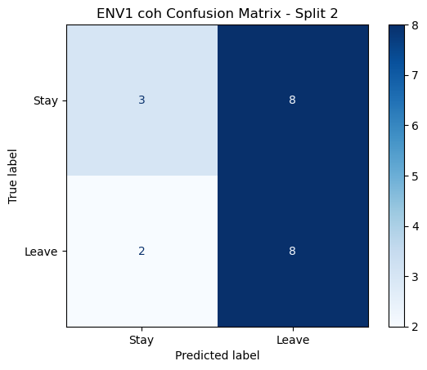

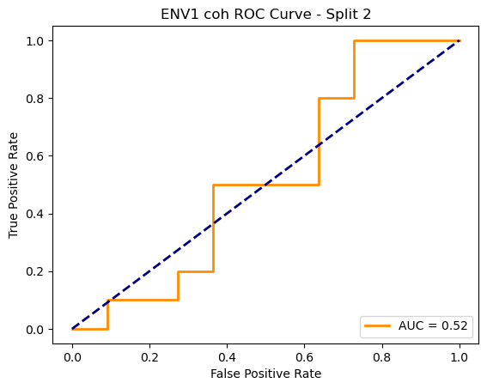

=== ENV1 Split 3/5 ===

C:\Users\sansk\miniconda3\Lib\site-packages\scipy\signal\_spectral_py.py:1668: RuntimeWarning: invalid value encountered in divide

Cxy = np.abs(Pxy)**2 / Pxx / Pyy

After oversampling, class counts: Counter({1: 43, 0: 43})

C:\Users\sansk\miniconda3\Lib\site-packages\torch_geometric\deprecation.py:26: UserWarning: 'data.DataLoader' is deprecated, use 'loader.DataLoader' instead

warnings.warn(out)

Epoch 1/100 | Loss: 0.8154

Epoch 2/100 | Loss: 0.7513

Epoch 3/100 | Loss: 0.7961

Epoch 4/100 | Loss: 0.7418

Epoch 5/100 | Loss: 0.7060

Epoch 6/100 | Loss: 0.8139

Epoch 7/100 | Loss: 0.7610

Epoch 8/100 | Loss: 0.7182

Epoch 9/100 | Loss: 0.7913

Epoch 10/100 | Loss: 0.7440

Epoch 11/100 | Loss: 0.7176

Epoch 12/100 | Loss: 0.7669

Epoch 13/100 | Loss: 0.7384

Epoch 14/100 | Loss: 0.7311

Epoch 15/100 | Loss: 0.7638

Epoch 16/100 | Loss: 0.7336

Epoch 17/100 | Loss: 0.7197

Epoch 18/100 | Loss: 0.7423

Epoch 19/100 | Loss: 0.7496

Epoch 20/100 | Loss: 0.7234

Epoch 21/100 | Loss: 0.7175

Epoch 22/100 | Loss: 0.7071

Epoch 23/100 | Loss: 0.7205

Epoch 24/100 | Loss: 0.7548

Epoch 25/100 | Loss: 0.7205

Epoch 26/100 | Loss: 0.7712

Epoch 27/100 | Loss: 0.6937

Epoch 28/100 | Loss: 0.7444

Epoch 29/100 | Loss: 0.7291

Epoch 30/100 | Loss: 0.7233

Epoch 31/100 | Loss: 0.6434

Epoch 32/100 | Loss: 0.6581

Epoch 33/100 | Loss: 0.6755

Epoch 34/100 | Loss: 0.7057

Epoch 35/100 | Loss: 0.7275

Epoch 36/100 | Loss: 0.6746

Epoch 37/100 | Loss: 0.7146

Epoch 38/100 | Loss: 0.7104

Epoch 39/100 | Loss: 0.6511

Epoch 40/100 | Loss: 0.7045

Epoch 41/100 | Loss: 0.7276

Epoch 42/100 | Loss: 0.7142

Epoch 43/100 | Loss: 0.7523

Epoch 44/100 | Loss: 0.6875

Epoch 45/100 | Loss: 0.6675

Epoch 46/100 | Loss: 0.7393

Epoch 47/100 | Loss: 0.7726

Epoch 48/100 | Loss: 0.7304

Epoch 49/100 | Loss: 0.6715

Epoch 50/100 | Loss: 0.7636

Epoch 51/100 | Loss: 0.7267

Epoch 52/100 | Loss: 0.6889

Epoch 53/100 | Loss: 0.7042

Epoch 54/100 | Loss: 0.7307

Epoch 55/100 | Loss: 0.7355

Epoch 56/100 | Loss: 0.6973

Epoch 57/100 | Loss: 0.6996

Epoch 58/100 | Loss: 0.7053

Epoch 59/100 | Loss: 0.6859

Epoch 60/100 | Loss: 0.6762

Epoch 61/100 | Loss: 0.7303

Epoch 62/100 | Loss: 0.7065

Epoch 63/100 | Loss: 0.7041

Epoch 64/100 | Loss: 0.7157

Epoch 65/100 | Loss: 0.7075

Epoch 66/100 | Loss: 0.7006

Epoch 67/100 | Loss: 0.7088

Epoch 68/100 | Loss: 0.6976

Epoch 69/100 | Loss: 0.7158

Epoch 70/100 | Loss: 0.7061

Epoch 71/100 | Loss: 0.6859

Epoch 72/100 | Loss: 0.7454

Epoch 73/100 | Loss: 0.7123

Epoch 74/100 | Loss: 0.7666

Epoch 75/100 | Loss: 0.6750

Epoch 76/100 | Loss: 0.6909

Epoch 77/100 | Loss: 0.6856

Epoch 78/100 | Loss: 0.6881

Epoch 79/100 | Loss: 0.7070

Epoch 80/100 | Loss: 0.7086

Epoch 81/100 | Loss: 0.6898

Epoch 82/100 | Loss: 0.7078

Epoch 83/100 | Loss: 0.6785

Epoch 84/100 | Loss: 0.7089

Epoch 85/100 | Loss: 0.6666

Epoch 86/100 | Loss: 0.7128

Epoch 87/100 | Loss: 0.7211

Epoch 88/100 | Loss: 0.6641

Epoch 89/100 | Loss: 0.7107

Epoch 90/100 | Loss: 0.6698

Epoch 91/100 | Loss: 0.6551

Epoch 92/100 | Loss: 0.7074

Epoch 93/100 | Loss: 0.7023

Epoch 94/100 | Loss: 0.6479

Epoch 95/100 | Loss: 0.7062

Epoch 96/100 | Loss: 0.6753

Epoch 97/100 | Loss: 0.6948

Epoch 98/100 | Loss: 0.7102

Epoch 99/100 | Loss: 0.6960

Epoch 100/100 | Loss: 0.7166

Split 3 Accuracy: 0.5238

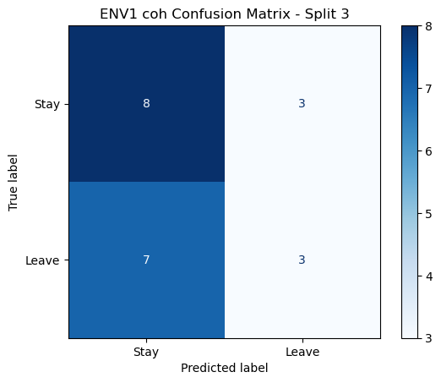

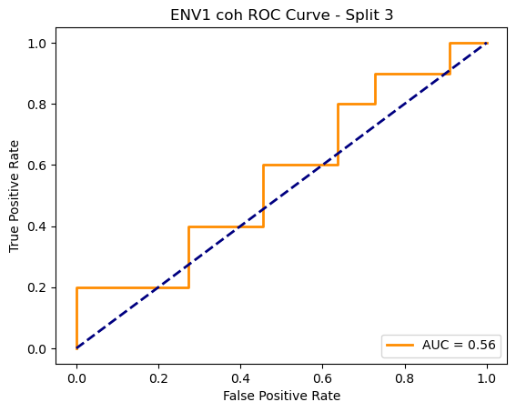

=== ENV1 Split 4/5 ===

C:\Users\sansk\miniconda3\Lib\site-packages\scipy\signal\_spectral_py.py:1668: RuntimeWarning: invalid value encountered in divide

Cxy = np.abs(Pxy)**2 / Pxx / Pyy

After oversampling, class counts: Counter({1: 44, 0: 44})

C:\Users\sansk\miniconda3\Lib\site-packages\torch_geometric\deprecation.py:26: UserWarning: 'data.DataLoader' is deprecated, use 'loader.DataLoader' instead

warnings.warn(out)

Epoch 1/100 | Loss: 0.7237

Epoch 2/100 | Loss: 0.7427

Epoch 3/100 | Loss: 0.7480

Epoch 4/100 | Loss: 0.7460

Epoch 5/100 | Loss: 0.7324

Epoch 6/100 | Loss: 0.7158

Epoch 7/100 | Loss: 0.7013

Epoch 8/100 | Loss: 0.7541

Epoch 9/100 | Loss: 0.7517

Epoch 10/100 | Loss: 0.7268

Epoch 11/100 | Loss: 0.7421

Epoch 12/100 | Loss: 0.7655

Epoch 13/100 | Loss: 0.7306

Epoch 14/100 | Loss: 0.7298

Epoch 15/100 | Loss: 0.7696

Epoch 16/100 | Loss: 0.7072

Epoch 17/100 | Loss: 0.7157

Epoch 18/100 | Loss: 0.6947

Epoch 19/100 | Loss: 0.7460

Epoch 20/100 | Loss: 0.7785

Epoch 21/100 | Loss: 0.7038

Epoch 22/100 | Loss: 0.7445

Epoch 23/100 | Loss: 0.7614

Epoch 24/100 | Loss: 0.7378

Epoch 25/100 | Loss: 0.7360

Epoch 26/100 | Loss: 0.7178

Epoch 27/100 | Loss: 0.7202

Epoch 28/100 | Loss: 0.7423

Epoch 29/100 | Loss: 0.7003

Epoch 30/100 | Loss: 0.6893

Epoch 31/100 | Loss: 0.7449

Epoch 32/100 | Loss: 0.7085

Epoch 33/100 | Loss: 0.7884

Epoch 34/100 | Loss: 0.7629

Epoch 35/100 | Loss: 0.6916

Epoch 36/100 | Loss: 0.6734

Epoch 37/100 | Loss: 0.7062

Epoch 38/100 | Loss: 0.6956

Epoch 39/100 | Loss: 0.7209

Epoch 40/100 | Loss: 0.7278

Epoch 41/100 | Loss: 0.6961

Epoch 42/100 | Loss: 0.7174

Epoch 43/100 | Loss: 0.7051

Epoch 44/100 | Loss: 0.7275

Epoch 45/100 | Loss: 0.6511

Epoch 46/100 | Loss: 0.6529

Epoch 47/100 | Loss: 0.6614

Epoch 48/100 | Loss: 0.7098

Epoch 49/100 | Loss: 0.6490

Epoch 50/100 | Loss: 0.7513

Epoch 51/100 | Loss: 0.7180

Epoch 52/100 | Loss: 0.6670

Epoch 53/100 | Loss: 0.6686

Epoch 54/100 | Loss: 0.6777

Epoch 55/100 | Loss: 0.6876

Epoch 56/100 | Loss: 0.6876

Epoch 57/100 | Loss: 0.6938

Epoch 58/100 | Loss: 0.7160

Epoch 59/100 | Loss: 0.6722

Epoch 60/100 | Loss: 0.6832

Epoch 61/100 | Loss: 0.6560

Epoch 62/100 | Loss: 0.7106

Epoch 63/100 | Loss: 0.7419

Epoch 64/100 | Loss: 0.6822

Epoch 65/100 | Loss: 0.6704

Epoch 66/100 | Loss: 0.7245

Epoch 67/100 | Loss: 0.6981

Epoch 68/100 | Loss: 0.6899

Epoch 69/100 | Loss: 0.6863

Epoch 70/100 | Loss: 0.6901

Epoch 71/100 | Loss: 0.6867

Epoch 72/100 | Loss: 0.6487

Epoch 73/100 | Loss: 0.6728

Epoch 74/100 | Loss: 0.6862

Epoch 75/100 | Loss: 0.7102

Epoch 76/100 | Loss: 0.6561

Epoch 77/100 | Loss: 0.7013

Epoch 78/100 | Loss: 0.6934

Epoch 79/100 | Loss: 0.6641

Epoch 80/100 | Loss: 0.6483

Epoch 81/100 | Loss: 0.7005

Epoch 82/100 | Loss: 0.6229

Epoch 83/100 | Loss: 0.6630

Epoch 84/100 | Loss: 0.6828

Epoch 85/100 | Loss: 0.6894

Epoch 86/100 | Loss: 0.6785

Epoch 87/100 | Loss: 0.7077

Epoch 88/100 | Loss: 0.7403

Epoch 89/100 | Loss: 0.6589

Epoch 90/100 | Loss: 0.6314

Epoch 91/100 | Loss: 0.6470

Epoch 92/100 | Loss: 0.6292

Epoch 93/100 | Loss: 0.6588

Epoch 94/100 | Loss: 0.6579

Epoch 95/100 | Loss: 0.6564

Epoch 96/100 | Loss: 0.6433

Epoch 97/100 | Loss: 0.7016

Epoch 98/100 | Loss: 0.6461

Epoch 99/100 | Loss: 0.6793

Epoch 100/100 | Loss: 0.6877

Split 4 Accuracy: 0.4762

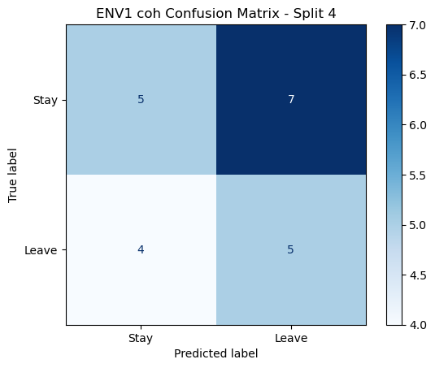

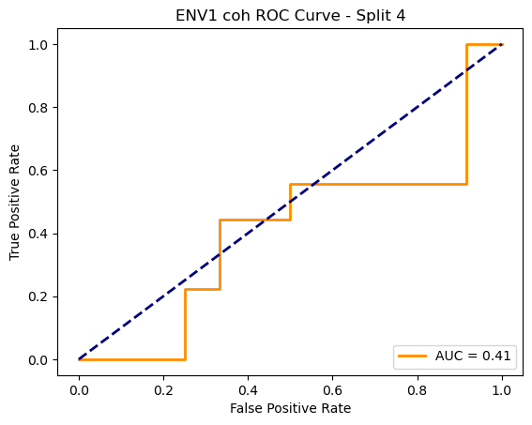

=== ENV1 Split 5/5 ===

C:\Users\sansk\miniconda3\Lib\site-packages\scipy\signal\_spectral_py.py:1668: RuntimeWarning: invalid value encountered in divide

Cxy = np.abs(Pxy)**2 / Pxx / Pyy

After oversampling, class counts: Counter({1: 44, 0: 44})

C:\Users\sansk\miniconda3\Lib\site-packages\torch_geometric\deprecation.py:26: UserWarning: 'data.DataLoader' is deprecated, use 'loader.DataLoader' instead

warnings.warn(out)

Epoch 1/100 | Loss: 0.7098

Epoch 2/100 | Loss: 0.7789

Epoch 3/100 | Loss: 0.7165

Epoch 4/100 | Loss: 0.7644

Epoch 5/100 | Loss: 0.7475

Epoch 6/100 | Loss: 0.7193

Epoch 7/100 | Loss: 0.8158

Epoch 8/100 | Loss: 0.7316

Epoch 9/100 | Loss: 0.7757

Epoch 10/100 | Loss: 0.6341

Epoch 11/100 | Loss: 0.6324

Epoch 12/100 | Loss: 0.7411

Epoch 13/100 | Loss: 0.7219

Epoch 14/100 | Loss: 0.7458

Epoch 15/100 | Loss: 0.7049

Epoch 16/100 | Loss: 0.6998

Epoch 17/100 | Loss: 0.7369

Epoch 18/100 | Loss: 0.7188

Epoch 19/100 | Loss: 0.7297

Epoch 20/100 | Loss: 0.6973

Epoch 21/100 | Loss: 0.7150

Epoch 22/100 | Loss: 0.6987

Epoch 23/100 | Loss: 0.7250

Epoch 24/100 | Loss: 0.6952

Epoch 25/100 | Loss: 0.7343

Epoch 26/100 | Loss: 0.7236

Epoch 27/100 | Loss: 0.7029

Epoch 28/100 | Loss: 0.7126

Epoch 29/100 | Loss: 0.7180

Epoch 30/100 | Loss: 0.6963

Epoch 31/100 | Loss: 0.6938

Epoch 32/100 | Loss: 0.6608

Epoch 33/100 | Loss: 0.6986

Epoch 34/100 | Loss: 0.6520

Epoch 35/100 | Loss: 0.6641

Epoch 36/100 | Loss: 0.6622

Epoch 37/100 | Loss: 0.6656

Epoch 38/100 | Loss: 0.7053

Epoch 39/100 | Loss: 0.6769

Epoch 40/100 | Loss: 0.7166

Epoch 41/100 | Loss: 0.6823

Epoch 42/100 | Loss: 0.6566

Epoch 43/100 | Loss: 0.6519

Epoch 44/100 | Loss: 0.6714

Epoch 45/100 | Loss: 0.6623

Epoch 46/100 | Loss: 0.6848

Epoch 47/100 | Loss: 0.6926

Epoch 48/100 | Loss: 0.7474

Epoch 49/100 | Loss: 0.7027

Epoch 50/100 | Loss: 0.6712

Epoch 51/100 | Loss: 0.7115

Epoch 52/100 | Loss: 0.6593

Epoch 53/100 | Loss: 0.7084

Epoch 54/100 | Loss: 0.7194

Epoch 55/100 | Loss: 0.7012

Epoch 56/100 | Loss: 0.6520

Epoch 57/100 | Loss: 0.6577

Epoch 58/100 | Loss: 0.6864

Epoch 59/100 | Loss: 0.7139

Epoch 60/100 | Loss: 0.6713

Epoch 61/100 | Loss: 0.6370

Epoch 62/100 | Loss: 0.6708

Epoch 63/100 | Loss: 0.7229

Epoch 64/100 | Loss: 0.6909

Epoch 65/100 | Loss: 0.6494

Epoch 66/100 | Loss: 0.6713

Epoch 67/100 | Loss: 0.6888

Epoch 68/100 | Loss: 0.6481

Epoch 69/100 | Loss: 0.6427

Epoch 70/100 | Loss: 0.6687

Epoch 71/100 | Loss: 0.6996

Epoch 72/100 | Loss: 0.7188

Epoch 73/100 | Loss: 0.6671

Epoch 74/100 | Loss: 0.6462

Epoch 75/100 | Loss: 0.6588

Epoch 76/100 | Loss: 0.7144

Epoch 77/100 | Loss: 0.6811

Epoch 78/100 | Loss: 0.6316

Epoch 79/100 | Loss: 0.7412

Epoch 80/100 | Loss: 0.6929

Epoch 81/100 | Loss: 0.6479

Epoch 82/100 | Loss: 0.6917

Epoch 83/100 | Loss: 0.6548

Epoch 84/100 | Loss: 0.6957

Epoch 85/100 | Loss: 0.6488

Epoch 86/100 | Loss: 0.6508

Epoch 87/100 | Loss: 0.6944

Epoch 88/100 | Loss: 0.6898

Epoch 89/100 | Loss: 0.6302

Epoch 90/100 | Loss: 0.6394

Epoch 91/100 | Loss: 0.6839

Epoch 92/100 | Loss: 0.6874

Epoch 93/100 | Loss: 0.6763

Epoch 94/100 | Loss: 0.6835

Epoch 95/100 | Loss: 0.6249

Epoch 96/100 | Loss: 0.6855

Epoch 97/100 | Loss: 0.6550

Epoch 98/100 | Loss: 0.6534

Epoch 99/100 | Loss: 0.6843

Epoch 100/100 | Loss: 0.6966

Split 5 Accuracy: 0.4286

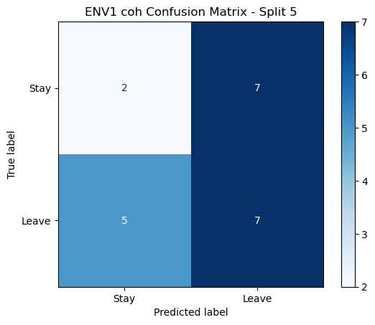

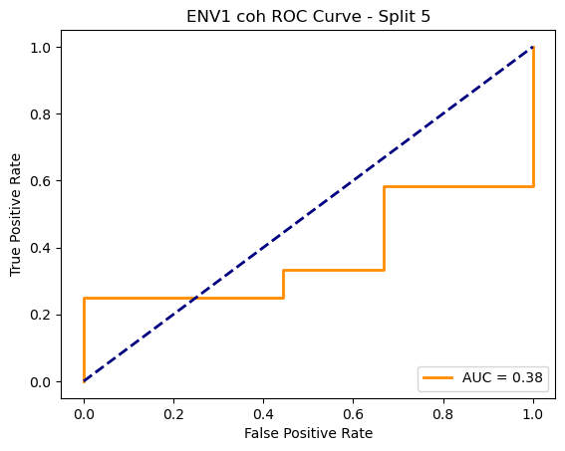

ENV1 coh Average Accuracy: 0.4814 ± 0.0378

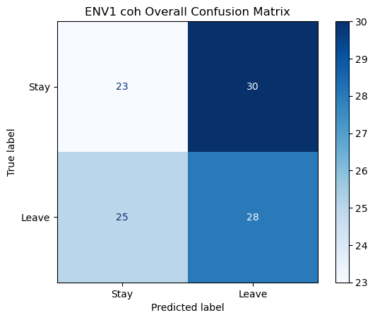

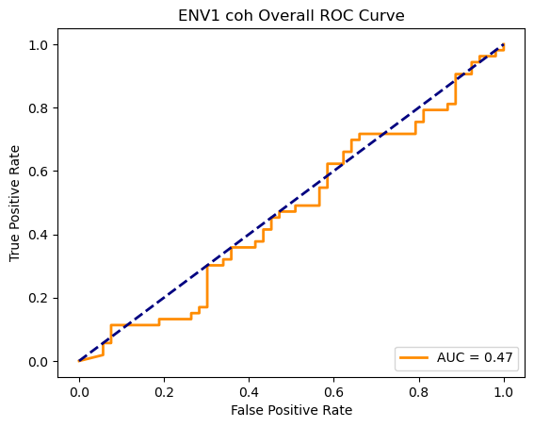

Running GNN with plv connectivity for ENV1...

==================================================

Training GNN for ENV1 with plv connectivity

==================================================

=== ENV1 Split 1/5 ===

After oversampling, class counts: Counter({0: 43, 1: 43})

C:\Users\sansk\miniconda3\Lib\site-packages\torch_geometric\deprecation.py:26: UserWarning: 'data.DataLoader' is deprecated, use 'loader.DataLoader' instead

warnings.warn(out)

Epoch 1/100 | Loss: 0.7696

Epoch 2/100 | Loss: 0.7853

Epoch 3/100 | Loss: 0.7522

Epoch 4/100 | Loss: 0.6992

Epoch 5/100 | Loss: 0.7941

Epoch 6/100 | Loss: 0.7946

Epoch 7/100 | Loss: 0.7149

Epoch 8/100 | Loss: 0.7158

Epoch 9/100 | Loss: 0.7577

Epoch 10/100 | Loss: 0.6724

Epoch 11/100 | Loss: 0.7174

Epoch 12/100 | Loss: 0.6921

Epoch 13/100 | Loss: 0.6856

Epoch 14/100 | Loss: 0.7593

Epoch 15/100 | Loss: 0.6702

Epoch 16/100 | Loss: 0.6883

Epoch 17/100 | Loss: 0.7631

Epoch 18/100 | Loss: 0.7268

Epoch 19/100 | Loss: 0.7111

Epoch 20/100 | Loss: 0.7101

Epoch 21/100 | Loss: 0.6214

Epoch 22/100 | Loss: 0.7121

Epoch 23/100 | Loss: 0.7046

Epoch 24/100 | Loss: 0.6728

Epoch 25/100 | Loss: 0.7036

Epoch 26/100 | Loss: 0.7136

Epoch 27/100 | Loss: 0.6938

Epoch 28/100 | Loss: 0.6675

Epoch 29/100 | Loss: 0.7659

Epoch 30/100 | Loss: 0.7335

Epoch 31/100 | Loss: 0.7244

Epoch 32/100 | Loss: 0.6716

Epoch 33/100 | Loss: 0.6866

Epoch 34/100 | Loss: 0.6398

Epoch 35/100 | Loss: 0.7191

Epoch 36/100 | Loss: 0.6966

Epoch 37/100 | Loss: 0.6784

Epoch 38/100 | Loss: 0.6758

Epoch 39/100 | Loss: 0.7200

Epoch 40/100 | Loss: 0.6786

Epoch 41/100 | Loss: 0.6279

Epoch 42/100 | Loss: 0.6714

Epoch 43/100 | Loss: 0.6326

Epoch 44/100 | Loss: 0.5837

Epoch 45/100 | Loss: 0.6457

Epoch 46/100 | Loss: 0.6388

Epoch 47/100 | Loss: 0.7117

Epoch 48/100 | Loss: 0.6856

Epoch 49/100 | Loss: 0.6647

Epoch 50/100 | Loss: 0.6797

Epoch 51/100 | Loss: 0.6889

Epoch 52/100 | Loss: 0.6872

Epoch 53/100 | Loss: 0.6161

Epoch 54/100 | Loss: 0.6551

Epoch 55/100 | Loss: 0.6367

Epoch 56/100 | Loss: 0.6523

Epoch 57/100 | Loss: 0.6366

Epoch 58/100 | Loss: 0.6469

Epoch 59/100 | Loss: 0.6449

Epoch 60/100 | Loss: 0.6522

Epoch 61/100 | Loss: 0.6539

Epoch 62/100 | Loss: 0.6154

Epoch 63/100 | Loss: 0.6896

Epoch 64/100 | Loss: 0.6614

Epoch 65/100 | Loss: 0.6394

Epoch 66/100 | Loss: 0.6260

Epoch 67/100 | Loss: 0.7035

Epoch 68/100 | Loss: 0.6723

Epoch 69/100 | Loss: 0.6935

Epoch 70/100 | Loss: 0.6235

Epoch 71/100 | Loss: 0.6317

Epoch 72/100 | Loss: 0.6271

Epoch 73/100 | Loss: 0.6657

Epoch 74/100 | Loss: 0.6298

Epoch 75/100 | Loss: 0.7075

Epoch 76/100 | Loss: 0.6282

Epoch 77/100 | Loss: 0.7128

Epoch 78/100 | Loss: 0.5790

Epoch 79/100 | Loss: 0.6671

Epoch 80/100 | Loss: 0.6166

Epoch 81/100 | Loss: 0.7088

Epoch 82/100 | Loss: 0.6684

Epoch 83/100 | Loss: 0.6198

Epoch 84/100 | Loss: 0.6744

Epoch 85/100 | Loss: 0.5979

Epoch 86/100 | Loss: 0.6503

Epoch 87/100 | Loss: 0.6073

Epoch 88/100 | Loss: 0.6027

Epoch 89/100 | Loss: 0.6128

Epoch 90/100 | Loss: 0.6909

Epoch 91/100 | Loss: 0.6542

Epoch 92/100 | Loss: 0.6941

Epoch 93/100 | Loss: 0.6037

Epoch 94/100 | Loss: 0.6701

Epoch 95/100 | Loss: 0.6274

Epoch 96/100 | Loss: 0.6822

Epoch 97/100 | Loss: 0.7176

Epoch 98/100 | Loss: 0.6145

Epoch 99/100 | Loss: 0.5887

Epoch 100/100 | Loss: 0.5976

Split 1 Accuracy: 0.4091

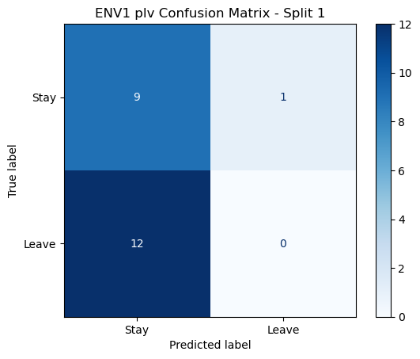

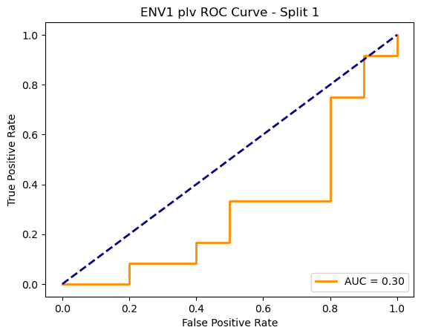

=== ENV1 Split 2/5 ===

After oversampling, class counts: Counter({1: 43, 0: 43})

C:\Users\sansk\miniconda3\Lib\site-packages\torch_geometric\deprecation.py:26: UserWarning: 'data.DataLoader' is deprecated, use 'loader.DataLoader' instead

warnings.warn(out)

Epoch 1/100 | Loss: 0.7879

Epoch 2/100 | Loss: 0.7114

Epoch 3/100 | Loss: 0.7423

Epoch 4/100 | Loss: 0.7496

Epoch 5/100 | Loss: 0.7178

Epoch 6/100 | Loss: 0.7258

Epoch 7/100 | Loss: 0.7392

Epoch 8/100 | Loss: 0.7247

Epoch 9/100 | Loss: 0.7302

Epoch 10/100 | Loss: 0.7312

Epoch 11/100 | Loss: 0.7167

Epoch 12/100 | Loss: 0.7204

Epoch 13/100 | Loss: 0.7177

Epoch 14/100 | Loss: 0.7069

Epoch 15/100 | Loss: 0.6646

Epoch 16/100 | Loss: 0.7528

Epoch 17/100 | Loss: 0.7391

Epoch 18/100 | Loss: 0.6585

Epoch 19/100 | Loss: 0.6803

Epoch 20/100 | Loss: 0.6908

Epoch 21/100 | Loss: 0.6966

Epoch 22/100 | Loss: 0.6715

Epoch 23/100 | Loss: 0.7332

Epoch 24/100 | Loss: 0.7023

Epoch 25/100 | Loss: 0.6900

Epoch 26/100 | Loss: 0.6766

Epoch 27/100 | Loss: 0.6606

Epoch 28/100 | Loss: 0.6791

Epoch 29/100 | Loss: 0.7157

Epoch 30/100 | Loss: 0.6519

Epoch 31/100 | Loss: 0.6568

Epoch 32/100 | Loss: 0.6646

Epoch 33/100 | Loss: 0.6470

Epoch 34/100 | Loss: 0.6876

Epoch 35/100 | Loss: 0.7128

Epoch 36/100 | Loss: 0.6827

Epoch 37/100 | Loss: 0.6952

Epoch 38/100 | Loss: 0.6481

Epoch 39/100 | Loss: 0.6754

Epoch 40/100 | Loss: 0.6605

Epoch 41/100 | Loss: 0.7147

Epoch 42/100 | Loss: 0.6321

Epoch 43/100 | Loss: 0.6443

Epoch 44/100 | Loss: 0.6656

Epoch 45/100 | Loss: 0.6041

Epoch 46/100 | Loss: 0.6695

Epoch 47/100 | Loss: 0.6559

Epoch 48/100 | Loss: 0.6714

Epoch 49/100 | Loss: 0.6909

Epoch 50/100 | Loss: 0.6811

Epoch 51/100 | Loss: 0.6193

Epoch 52/100 | Loss: 0.6517

Epoch 53/100 | Loss: 0.6087

Epoch 54/100 | Loss: 0.6865

Epoch 55/100 | Loss: 0.6745

Epoch 56/100 | Loss: 0.6808

Epoch 57/100 | Loss: 0.6681

Epoch 58/100 | Loss: 0.5730

Epoch 59/100 | Loss: 0.6645

Epoch 60/100 | Loss: 0.6487

Epoch 61/100 | Loss: 0.6786

Epoch 62/100 | Loss: 0.6547

Epoch 63/100 | Loss: 0.5924

Epoch 64/100 | Loss: 0.5828

Epoch 65/100 | Loss: 0.6161

Epoch 66/100 | Loss: 0.6073

Epoch 67/100 | Loss: 0.6271

Epoch 68/100 | Loss: 0.6363

Epoch 69/100 | Loss: 0.6560

Epoch 70/100 | Loss: 0.6209

Epoch 71/100 | Loss: 0.6505

Epoch 72/100 | Loss: 0.6294

Epoch 73/100 | Loss: 0.6349

Epoch 74/100 | Loss: 0.6545

Epoch 75/100 | Loss: 0.6537

Epoch 76/100 | Loss: 0.6129

Epoch 77/100 | Loss: 0.6206

Epoch 78/100 | Loss: 0.6144

Epoch 79/100 | Loss: 0.6874

Epoch 80/100 | Loss: 0.7141

Epoch 81/100 | Loss: 0.6257

Epoch 82/100 | Loss: 0.6376

Epoch 83/100 | Loss: 0.6122

Epoch 84/100 | Loss: 0.6413

Epoch 85/100 | Loss: 0.5275

Epoch 86/100 | Loss: 0.6973

Epoch 87/100 | Loss: 0.6125

Epoch 88/100 | Loss: 0.6422

Epoch 89/100 | Loss: 0.6165

Epoch 90/100 | Loss: 0.6171

Epoch 91/100 | Loss: 0.6061

Epoch 92/100 | Loss: 0.6053

Epoch 93/100 | Loss: 0.6091

Epoch 94/100 | Loss: 0.5914

Epoch 95/100 | Loss: 0.6070

Epoch 96/100 | Loss: 0.5804

Epoch 97/100 | Loss: 0.6193

Epoch 98/100 | Loss: 0.6411

Epoch 99/100 | Loss: 0.6155

Epoch 100/100 | Loss: 0.6434

Split 2 Accuracy: 0.3810

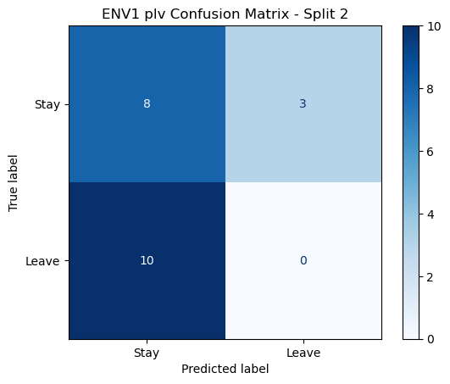

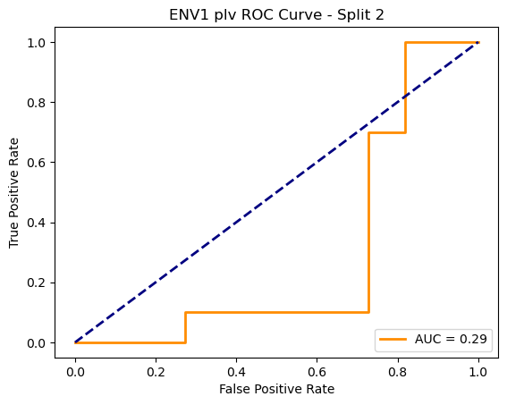

=== ENV1 Split 3/5 ===

After oversampling, class counts: Counter({1: 43, 0: 43})

C:\Users\sansk\miniconda3\Lib\site-packages\torch_geometric\deprecation.py:26: UserWarning: 'data.DataLoader' is deprecated, use 'loader.DataLoader' instead

warnings.warn(out)

Epoch 1/100 | Loss: 0.8520

Epoch 2/100 | Loss: 0.6974

Epoch 3/100 | Loss: 0.7474

Epoch 4/100 | Loss: 0.8048

Epoch 5/100 | Loss: 0.7265

Epoch 6/100 | Loss: 0.7578

Epoch 7/100 | Loss: 0.7087

Epoch 8/100 | Loss: 0.7221

Epoch 9/100 | Loss: 0.7600

Epoch 10/100 | Loss: 0.6913

Epoch 11/100 | Loss: 0.7343

Epoch 12/100 | Loss: 0.6987

Epoch 13/100 | Loss: 0.7512

Epoch 14/100 | Loss: 0.6143

Epoch 15/100 | Loss: 0.6963

Epoch 16/100 | Loss: 0.6842

Epoch 17/100 | Loss: 0.6724

Epoch 18/100 | Loss: 0.6773

Epoch 19/100 | Loss: 0.6687

Epoch 20/100 | Loss: 0.6994

Epoch 21/100 | Loss: 0.6807

Epoch 22/100 | Loss: 0.6342

Epoch 23/100 | Loss: 0.7084

Epoch 24/100 | Loss: 0.7346

Epoch 25/100 | Loss: 0.7044

Epoch 26/100 | Loss: 0.6738

Epoch 27/100 | Loss: 0.6616

Epoch 28/100 | Loss: 0.6889

Epoch 29/100 | Loss: 0.7238

Epoch 30/100 | Loss: 0.7677

Epoch 31/100 | Loss: 0.7290

Epoch 32/100 | Loss: 0.7114

Epoch 33/100 | Loss: 0.6656

Epoch 34/100 | Loss: 0.7304

Epoch 35/100 | Loss: 0.6412

Epoch 36/100 | Loss: 0.5936

Epoch 37/100 | Loss: 0.6786

Epoch 38/100 | Loss: 0.6602

Epoch 39/100 | Loss: 0.6463

Epoch 40/100 | Loss: 0.6357

Epoch 41/100 | Loss: 0.6663

Epoch 42/100 | Loss: 0.6444

Epoch 43/100 | Loss: 0.7196

Epoch 44/100 | Loss: 0.6460

Epoch 45/100 | Loss: 0.6359

Epoch 46/100 | Loss: 0.6920

Epoch 47/100 | Loss: 0.7082

Epoch 48/100 | Loss: 0.6685

Epoch 49/100 | Loss: 0.6043

Epoch 50/100 | Loss: 0.7005

Epoch 51/100 | Loss: 0.7020

Epoch 52/100 | Loss: 0.6515

Epoch 53/100 | Loss: 0.6987

Epoch 54/100 | Loss: 0.6753

Epoch 55/100 | Loss: 0.7083

Epoch 56/100 | Loss: 0.6072

Epoch 57/100 | Loss: 0.6469

Epoch 58/100 | Loss: 0.6197

Epoch 59/100 | Loss: 0.6572

Epoch 60/100 | Loss: 0.6095

Epoch 61/100 | Loss: 0.6814

Epoch 62/100 | Loss: 0.6514

Epoch 63/100 | Loss: 0.7060

Epoch 64/100 | Loss: 0.7139

Epoch 65/100 | Loss: 0.6483

Epoch 66/100 | Loss: 0.6833

Epoch 67/100 | Loss: 0.6243

Epoch 68/100 | Loss: 0.7025

Epoch 69/100 | Loss: 0.6423

Epoch 70/100 | Loss: 0.6418

Epoch 71/100 | Loss: 0.6506

Epoch 72/100 | Loss: 0.5830

Epoch 73/100 | Loss: 0.6028

Epoch 74/100 | Loss: 0.6032

Epoch 75/100 | Loss: 0.6296

Epoch 76/100 | Loss: 0.6086

Epoch 77/100 | Loss: 0.6404

Epoch 78/100 | Loss: 0.6138

Epoch 79/100 | Loss: 0.6575

Epoch 80/100 | Loss: 0.6557

Epoch 81/100 | Loss: 0.6158

Epoch 82/100 | Loss: 0.6159

Epoch 83/100 | Loss: 0.6429

Epoch 84/100 | Loss: 0.5568

Epoch 85/100 | Loss: 0.5618

Epoch 86/100 | Loss: 0.7260

Epoch 87/100 | Loss: 0.6164

Epoch 88/100 | Loss: 0.6514

Epoch 89/100 | Loss: 0.5566

Epoch 90/100 | Loss: 0.6017

Epoch 91/100 | Loss: 0.5958

Epoch 92/100 | Loss: 0.6309

Epoch 93/100 | Loss: 0.6066

Epoch 94/100 | Loss: 0.6485

Epoch 95/100 | Loss: 0.6179

Epoch 96/100 | Loss: 0.6608

Epoch 97/100 | Loss: 0.6344

Epoch 98/100 | Loss: 0.5457

Epoch 99/100 | Loss: 0.6630

Epoch 100/100 | Loss: 0.6184

Split 3 Accuracy: 0.5238

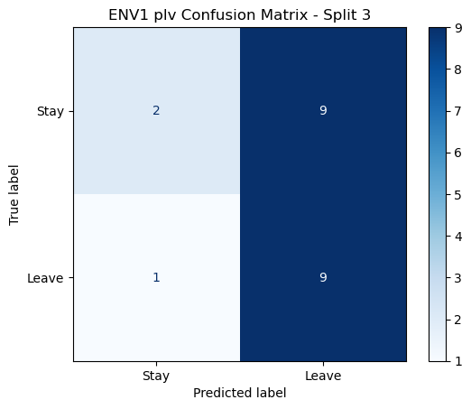

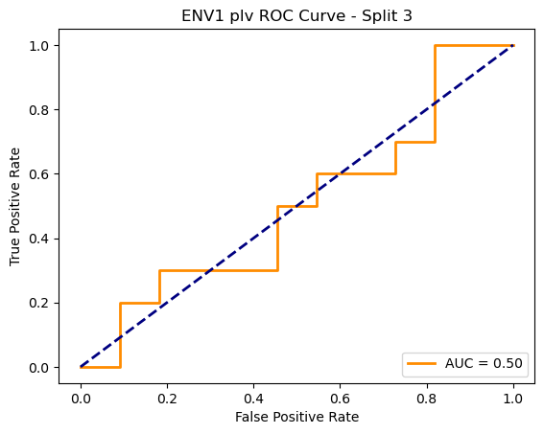

=== ENV1 Split 4/5 ===

After oversampling, class counts: Counter({1: 44, 0: 44})

C:\Users\sansk\miniconda3\Lib\site-packages\torch_geometric\deprecation.py:26: UserWarning: 'data.DataLoader' is deprecated, use 'loader.DataLoader' instead

warnings.warn(out)

Epoch 1/100 | Loss: 0.7616

Epoch 2/100 | Loss: 0.7724

Epoch 3/100 | Loss: 0.7591

Epoch 4/100 | Loss: 0.8000

Epoch 5/100 | Loss: 0.6526

Epoch 6/100 | Loss: 0.7592

Epoch 7/100 | Loss: 0.7284

Epoch 8/100 | Loss: 0.7599

Epoch 9/100 | Loss: 0.7603

Epoch 10/100 | Loss: 0.7300

Epoch 11/100 | Loss: 0.6774

Epoch 12/100 | Loss: 0.7028

Epoch 13/100 | Loss: 0.7587

Epoch 14/100 | Loss: 0.7710

Epoch 15/100 | Loss: 0.7258

Epoch 16/100 | Loss: 0.7302

Epoch 17/100 | Loss: 0.7462

Epoch 18/100 | Loss: 0.7018

Epoch 19/100 | Loss: 0.6878

Epoch 20/100 | Loss: 0.6718

Epoch 21/100 | Loss: 0.6953

Epoch 22/100 | Loss: 0.7513

Epoch 23/100 | Loss: 0.7476

Epoch 24/100 | Loss: 0.7186

Epoch 25/100 | Loss: 0.6972

Epoch 26/100 | Loss: 0.7716

Epoch 27/100 | Loss: 0.7051

Epoch 28/100 | Loss: 0.6952

Epoch 29/100 | Loss: 0.7106

Epoch 30/100 | Loss: 0.6399

Epoch 31/100 | Loss: 0.7582

Epoch 32/100 | Loss: 0.6910

Epoch 33/100 | Loss: 0.7284

Epoch 34/100 | Loss: 0.6954

Epoch 35/100 | Loss: 0.6596

Epoch 36/100 | Loss: 0.7032

Epoch 37/100 | Loss: 0.6893

Epoch 38/100 | Loss: 0.6473

Epoch 39/100 | Loss: 0.7041

Epoch 40/100 | Loss: 0.7032

Epoch 41/100 | Loss: 0.7262

Epoch 42/100 | Loss: 0.6585

Epoch 43/100 | Loss: 0.6847

Epoch 44/100 | Loss: 0.6712

Epoch 45/100 | Loss: 0.6640

Epoch 46/100 | Loss: 0.6523

Epoch 47/100 | Loss: 0.6523

Epoch 48/100 | Loss: 0.6443

Epoch 49/100 | Loss: 0.6683

Epoch 50/100 | Loss: 0.6796

Epoch 51/100 | Loss: 0.6740

Epoch 52/100 | Loss: 0.6639

Epoch 53/100 | Loss: 0.6715

Epoch 54/100 | Loss: 0.6680

Epoch 55/100 | Loss: 0.6437

Epoch 56/100 | Loss: 0.6742

Epoch 57/100 | Loss: 0.7014

Epoch 58/100 | Loss: 0.6842

Epoch 59/100 | Loss: 0.6562

Epoch 60/100 | Loss: 0.6954

Epoch 61/100 | Loss: 0.6662

Epoch 62/100 | Loss: 0.6760

Epoch 63/100 | Loss: 0.6318

Epoch 64/100 | Loss: 0.7143

Epoch 65/100 | Loss: 0.7157

Epoch 66/100 | Loss: 0.7062

Epoch 67/100 | Loss: 0.6450

Epoch 68/100 | Loss: 0.6649

Epoch 69/100 | Loss: 0.6176

Epoch 70/100 | Loss: 0.7311

Epoch 71/100 | Loss: 0.6457

Epoch 72/100 | Loss: 0.6480

Epoch 73/100 | Loss: 0.6785

Epoch 74/100 | Loss: 0.6423

Epoch 75/100 | Loss: 0.6308

Epoch 76/100 | Loss: 0.5965

Epoch 77/100 | Loss: 0.6884

Epoch 78/100 | Loss: 0.5858

Epoch 79/100 | Loss: 0.6468

Epoch 80/100 | Loss: 0.6504

Epoch 81/100 | Loss: 0.6748

Epoch 82/100 | Loss: 0.6852

Epoch 83/100 | Loss: 0.6363

Epoch 84/100 | Loss: 0.6434

Epoch 85/100 | Loss: 0.6362

Epoch 86/100 | Loss: 0.6320

Epoch 87/100 | Loss: 0.6728

Epoch 88/100 | Loss: 0.6741

Epoch 89/100 | Loss: 0.6536

Epoch 90/100 | Loss: 0.6036

Epoch 91/100 | Loss: 0.6467

Epoch 92/100 | Loss: 0.5995

Epoch 93/100 | Loss: 0.6680

Epoch 94/100 | Loss: 0.5811

Epoch 95/100 | Loss: 0.5739

Epoch 96/100 | Loss: 0.6185

Epoch 97/100 | Loss: 0.5700

Epoch 98/100 | Loss: 0.5431

Epoch 99/100 | Loss: 0.6317

Epoch 100/100 | Loss: 0.6153

Split 4 Accuracy: 0.4762

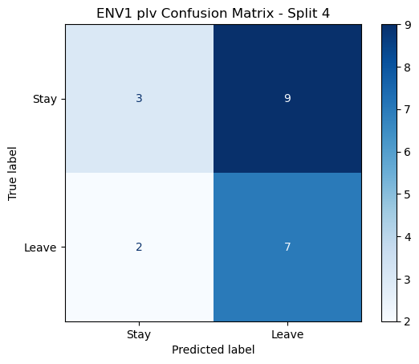

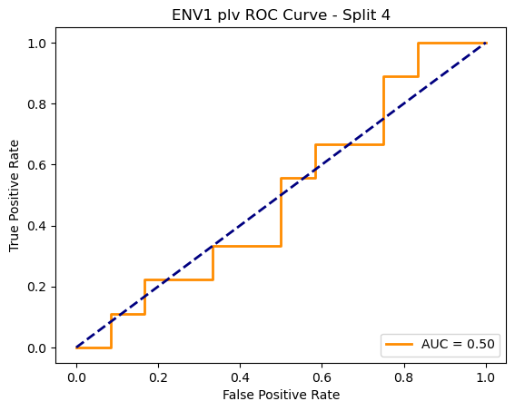

=== ENV1 Split 5/5 ===

After oversampling, class counts: Counter({1: 44, 0: 44})

C:\Users\sansk\miniconda3\Lib\site-packages\torch_geometric\deprecation.py:26: UserWarning: 'data.DataLoader' is deprecated, use 'loader.DataLoader' instead

warnings.warn(out)

Epoch 1/100 | Loss: 0.7388

Epoch 2/100 | Loss: 0.7233

Epoch 3/100 | Loss: 0.6744

Epoch 4/100 | Loss: 0.7382

Epoch 5/100 | Loss: 0.7333

Epoch 6/100 | Loss: 0.7450

Epoch 7/100 | Loss: 0.7314

Epoch 8/100 | Loss: 0.6716

Epoch 9/100 | Loss: 0.6475

Epoch 10/100 | Loss: 0.6809

Epoch 11/100 | Loss: 0.6802

Epoch 12/100 | Loss: 0.6762

Epoch 13/100 | Loss: 0.6562

Epoch 14/100 | Loss: 0.6554

Epoch 15/100 | Loss: 0.6422

Epoch 16/100 | Loss: 0.7024

Epoch 17/100 | Loss: 0.6565

Epoch 18/100 | Loss: 0.6751

Epoch 19/100 | Loss: 0.6771

Epoch 20/100 | Loss: 0.7081

Epoch 21/100 | Loss: 0.7106

Epoch 22/100 | Loss: 0.6621

Epoch 23/100 | Loss: 0.6611

Epoch 24/100 | Loss: 0.6274

Epoch 25/100 | Loss: 0.6450

Epoch 26/100 | Loss: 0.6484

Epoch 27/100 | Loss: 0.7186

Epoch 28/100 | Loss: 0.6242

Epoch 29/100 | Loss: 0.6961

Epoch 30/100 | Loss: 0.7285

Epoch 31/100 | Loss: 0.6139

Epoch 32/100 | Loss: 0.6499

Epoch 33/100 | Loss: 0.6603

Epoch 34/100 | Loss: 0.6640

Epoch 35/100 | Loss: 0.6508

Epoch 36/100 | Loss: 0.6445

Epoch 37/100 | Loss: 0.6255

Epoch 38/100 | Loss: 0.7185

Epoch 39/100 | Loss: 0.6359

Epoch 40/100 | Loss: 0.6149

Epoch 41/100 | Loss: 0.6096

Epoch 42/100 | Loss: 0.6704

Epoch 43/100 | Loss: 0.7087

Epoch 44/100 | Loss: 0.6316

Epoch 45/100 | Loss: 0.6443

Epoch 46/100 | Loss: 0.5924

Epoch 47/100 | Loss: 0.6610

Epoch 48/100 | Loss: 0.6257

Epoch 49/100 | Loss: 0.6413

Epoch 50/100 | Loss: 0.6392

Epoch 51/100 | Loss: 0.5886

Epoch 52/100 | Loss: 0.5736

Epoch 53/100 | Loss: 0.5819

Epoch 54/100 | Loss: 0.5975

Epoch 55/100 | Loss: 0.6227

Epoch 56/100 | Loss: 0.6081

Epoch 57/100 | Loss: 0.6694

Epoch 58/100 | Loss: 0.5877

Epoch 59/100 | Loss: 0.6850

Epoch 60/100 | Loss: 0.6505

Epoch 61/100 | Loss: 0.5643

Epoch 62/100 | Loss: 0.5976

Epoch 63/100 | Loss: 0.6488

Epoch 64/100 | Loss: 0.5986

Epoch 65/100 | Loss: 0.6356

Epoch 66/100 | Loss: 0.5080

Epoch 67/100 | Loss: 0.5384

Epoch 68/100 | Loss: 0.5550

Epoch 69/100 | Loss: 0.6190

Epoch 70/100 | Loss: 0.5861

Epoch 71/100 | Loss: 0.5526

Epoch 72/100 | Loss: 0.6384

Epoch 73/100 | Loss: 0.6122

Epoch 74/100 | Loss: 0.6354

Epoch 75/100 | Loss: 0.6205

Epoch 76/100 | Loss: 0.6228

Epoch 77/100 | Loss: 0.5413

Epoch 78/100 | Loss: 0.6127

Epoch 79/100 | Loss: 0.6027

Epoch 80/100 | Loss: 0.5794

Epoch 81/100 | Loss: 0.6539

Epoch 82/100 | Loss: 0.5466

Epoch 83/100 | Loss: 0.6297

Epoch 84/100 | Loss: 0.6444

Epoch 85/100 | Loss: 0.5799

Epoch 86/100 | Loss: 0.5917

Epoch 87/100 | Loss: 0.6037

Epoch 88/100 | Loss: 0.5694

Epoch 89/100 | Loss: 0.5243

Epoch 90/100 | Loss: 0.5740

Epoch 91/100 | Loss: 0.5714

Epoch 92/100 | Loss: 0.5944

Epoch 93/100 | Loss: 0.6333

Epoch 94/100 | Loss: 0.6161

Epoch 95/100 | Loss: 0.5951

Epoch 96/100 | Loss: 0.6094

Epoch 97/100 | Loss: 0.5476

Epoch 98/100 | Loss: 0.5641

Epoch 99/100 | Loss: 0.5611

Epoch 100/100 | Loss: 0.5515

Split 5 Accuracy: 0.4762

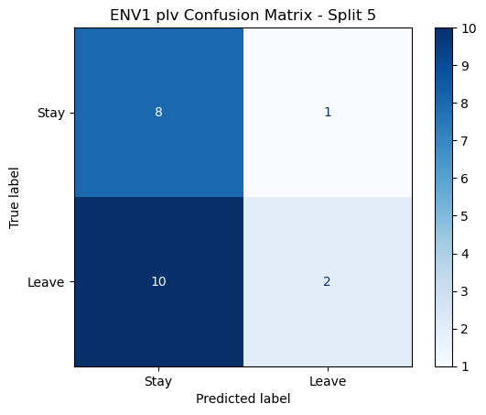

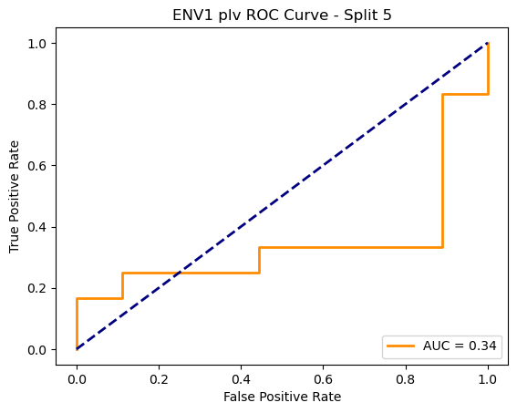

ENV1 plv Average Accuracy: 0.4532 ± 0.0514

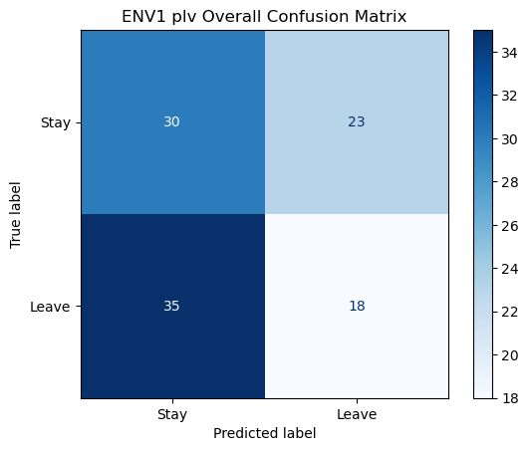

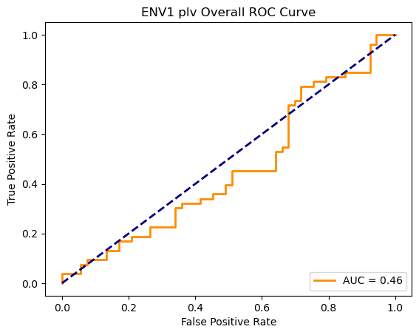

Loading ENV2 data...

ENV2: Loaded 106 trials (Stay: 53, Leave: 53)

Running GNN with corr connectivity for ENV2...

==================================================

Training GNN for ENV2 with corr connectivity

==================================================

=== ENV2 Split 1/5 ===

After oversampling, class counts: Counter({0: 43, 1: 43})

C:\Users\sansk\miniconda3\Lib\site-packages\torch_geometric\deprecation.py:26: UserWarning: 'data.DataLoader' is deprecated, use 'loader.DataLoader' instead

warnings.warn(out)

Epoch 1/100 | Loss: 0.8097

Epoch 2/100 | Loss: 0.8524

Epoch 3/100 | Loss: 0.7660

Epoch 4/100 | Loss: 0.7691

Epoch 5/100 | Loss: 0.7056

Epoch 6/100 | Loss: 0.6930

Epoch 7/100 | Loss: 0.7763

Epoch 8/100 | Loss: 0.6863

Epoch 9/100 | Loss: 0.7003

Epoch 10/100 | Loss: 0.7422

Epoch 11/100 | Loss: 0.7808

Epoch 12/100 | Loss: 0.6603

Epoch 13/100 | Loss: 0.7523

Epoch 14/100 | Loss: 0.7092

Epoch 15/100 | Loss: 0.7048

Epoch 16/100 | Loss: 0.7376

Epoch 17/100 | Loss: 0.7292

Epoch 18/100 | Loss: 0.6618

Epoch 19/100 | Loss: 0.6865

Epoch 20/100 | Loss: 0.6763

Epoch 21/100 | Loss: 0.7478

Epoch 22/100 | Loss: 0.6840

Epoch 23/100 | Loss: 0.7363

Epoch 24/100 | Loss: 0.7273

Epoch 25/100 | Loss: 0.7836

Epoch 26/100 | Loss: 0.7255

Epoch 27/100 | Loss: 0.6892

Epoch 28/100 | Loss: 0.6512

Epoch 29/100 | Loss: 0.6502

Epoch 30/100 | Loss: 0.6901

Epoch 31/100 | Loss: 0.6194

Epoch 32/100 | Loss: 0.6728

Epoch 33/100 | Loss: 0.7401

Epoch 34/100 | Loss: 0.6672

Epoch 35/100 | Loss: 0.6908

Epoch 36/100 | Loss: 0.6862

Epoch 37/100 | Loss: 0.7085

Epoch 38/100 | Loss: 0.7183

Epoch 39/100 | Loss: 0.7598

Epoch 40/100 | Loss: 0.7049

Epoch 41/100 | Loss: 0.6151

Epoch 42/100 | Loss: 0.6822

Epoch 43/100 | Loss: 0.7071

Epoch 44/100 | Loss: 0.6234

Epoch 45/100 | Loss: 0.7050

Epoch 46/100 | Loss: 0.7266

Epoch 47/100 | Loss: 0.6926

Epoch 48/100 | Loss: 0.6629

Epoch 49/100 | Loss: 0.7394

Epoch 50/100 | Loss: 0.6583

Epoch 51/100 | Loss: 0.7021

Epoch 52/100 | Loss: 0.7391

Epoch 53/100 | Loss: 0.6988

Epoch 54/100 | Loss: 0.6456

Epoch 55/100 | Loss: 0.6508

Epoch 56/100 | Loss: 0.6688

Epoch 57/100 | Loss: 0.6393

Epoch 58/100 | Loss: 0.7065

Epoch 59/100 | Loss: 0.6673

Epoch 60/100 | Loss: 0.5721

Epoch 61/100 | Loss: 0.6509

Epoch 62/100 | Loss: 0.6394

Epoch 63/100 | Loss: 0.7053

Epoch 64/100 | Loss: 0.7080

Epoch 65/100 | Loss: 0.6346

Epoch 66/100 | Loss: 0.6473

Epoch 67/100 | Loss: 0.6608

Epoch 68/100 | Loss: 0.6135

Epoch 69/100 | Loss: 0.6459

Epoch 70/100 | Loss: 0.6657

Epoch 71/100 | Loss: 0.6783

Epoch 72/100 | Loss: 0.6442

Epoch 73/100 | Loss: 0.6804

Epoch 74/100 | Loss: 0.6839

Epoch 75/100 | Loss: 0.6482

Epoch 76/100 | Loss: 0.6342

Epoch 77/100 | Loss: 0.6186

Epoch 78/100 | Loss: 0.6290

Epoch 79/100 | Loss: 0.6847

Epoch 80/100 | Loss: 0.6628

Epoch 81/100 | Loss: 0.6330

Epoch 82/100 | Loss: 0.6650

Epoch 83/100 | Loss: 0.6010

Epoch 84/100 | Loss: 0.6165

Epoch 85/100 | Loss: 0.6332

Epoch 86/100 | Loss: 0.6548

Epoch 87/100 | Loss: 0.6579

Epoch 88/100 | Loss: 0.6308

Epoch 89/100 | Loss: 0.7081

Epoch 90/100 | Loss: 0.6099

Epoch 91/100 | Loss: 0.6350

Epoch 92/100 | Loss: 0.6681

Epoch 93/100 | Loss: 0.6417

Epoch 94/100 | Loss: 0.6184

Epoch 95/100 | Loss: 0.6124

Epoch 96/100 | Loss: 0.7201

Epoch 97/100 | Loss: 0.6471

Epoch 98/100 | Loss: 0.6419

Epoch 99/100 | Loss: 0.6523

Epoch 100/100 | Loss: 0.6648

Split 1 Accuracy: 0.5455

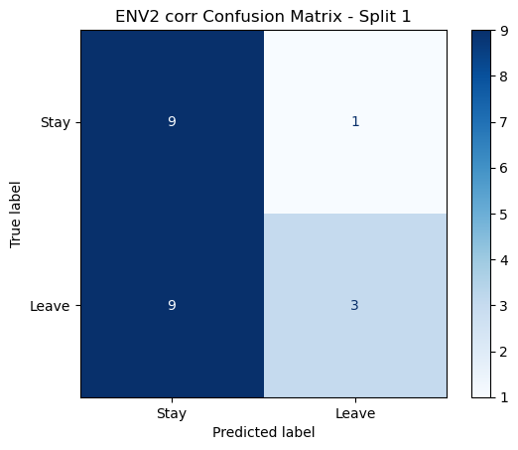

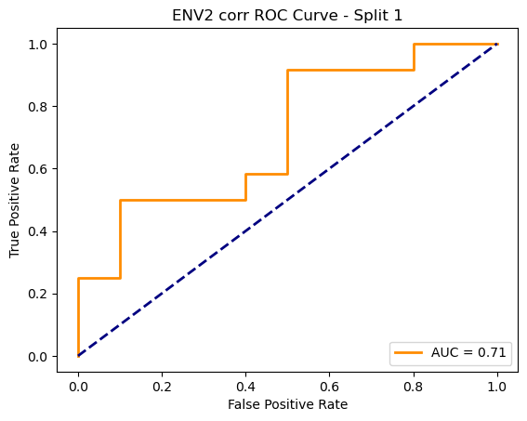

=== ENV2 Split 2/5 ===

After oversampling, class counts: Counter({1: 43, 0: 43})

C:\Users\sansk\miniconda3\Lib\site-packages\torch_geometric\deprecation.py:26: UserWarning: 'data.DataLoader' is deprecated, use 'loader.DataLoader' instead

warnings.warn(out)

Epoch 1/100 | Loss: 0.7610

Epoch 2/100 | Loss: 0.7939

Epoch 3/100 | Loss: 0.7574

Epoch 4/100 | Loss: 0.7988

Epoch 5/100 | Loss: 0.7209

Epoch 6/100 | Loss: 0.7352

Epoch 7/100 | Loss: 0.6957

Epoch 8/100 | Loss: 0.7760

Epoch 9/100 | Loss: 0.7168

Epoch 10/100 | Loss: 0.7102

Epoch 11/100 | Loss: 0.7011

Epoch 12/100 | Loss: 0.7148

Epoch 13/100 | Loss: 0.7464

Epoch 14/100 | Loss: 0.6161

Epoch 15/100 | Loss: 0.7797

Epoch 16/100 | Loss: 0.6861

Epoch 17/100 | Loss: 0.6979

Epoch 18/100 | Loss: 0.7094

Epoch 19/100 | Loss: 0.6601

Epoch 20/100 | Loss: 0.6664

Epoch 21/100 | Loss: 0.7204

Epoch 22/100 | Loss: 0.6598

Epoch 23/100 | Loss: 0.7094

Epoch 24/100 | Loss: 0.6777

Epoch 25/100 | Loss: 0.7071

Epoch 26/100 | Loss: 0.7179

Epoch 27/100 | Loss: 0.6682

Epoch 28/100 | Loss: 0.6245

Epoch 29/100 | Loss: 0.7072

Epoch 30/100 | Loss: 0.7239

Epoch 31/100 | Loss: 0.6926

Epoch 32/100 | Loss: 0.6883

Epoch 33/100 | Loss: 0.7095

Epoch 34/100 | Loss: 0.6862

Epoch 35/100 | Loss: 0.6799

Epoch 36/100 | Loss: 0.6471

Epoch 37/100 | Loss: 0.6959

Epoch 38/100 | Loss: 0.6235

Epoch 39/100 | Loss: 0.6958

Epoch 40/100 | Loss: 0.6673

Epoch 41/100 | Loss: 0.6887

Epoch 42/100 | Loss: 0.7405

Epoch 43/100 | Loss: 0.6521

Epoch 44/100 | Loss: 0.6657

Epoch 45/100 | Loss: 0.6696

Epoch 46/100 | Loss: 0.7012

Epoch 47/100 | Loss: 0.7297

Epoch 48/100 | Loss: 0.5849

Epoch 49/100 | Loss: 0.6279

Epoch 50/100 | Loss: 0.6622

Epoch 51/100 | Loss: 0.7101

Epoch 52/100 | Loss: 0.6612

Epoch 53/100 | Loss: 0.6715

Epoch 54/100 | Loss: 0.6036

Epoch 55/100 | Loss: 0.6408

Epoch 56/100 | Loss: 0.6202

Epoch 57/100 | Loss: 0.6682

Epoch 58/100 | Loss: 0.5959

Epoch 59/100 | Loss: 0.6845

Epoch 60/100 | Loss: 0.6736

Epoch 61/100 | Loss: 0.6297

Epoch 62/100 | Loss: 0.6456

Epoch 63/100 | Loss: 0.6246

Epoch 64/100 | Loss: 0.6391

Epoch 65/100 | Loss: 0.6685

Epoch 66/100 | Loss: 0.6680

Epoch 67/100 | Loss: 0.6310

Epoch 68/100 | Loss: 0.6232

Epoch 69/100 | Loss: 0.6671

Epoch 70/100 | Loss: 0.5930

Epoch 71/100 | Loss: 0.5859

Epoch 72/100 | Loss: 0.6984

Epoch 73/100 | Loss: 0.6443

Epoch 74/100 | Loss: 0.6144

Epoch 75/100 | Loss: 0.6482

Epoch 76/100 | Loss: 0.5791

Epoch 77/100 | Loss: 0.6862

Epoch 78/100 | Loss: 0.6432

Epoch 79/100 | Loss: 0.6718

Epoch 80/100 | Loss: 0.6505

Epoch 81/100 | Loss: 0.6024

Epoch 82/100 | Loss: 0.6669

Epoch 83/100 | Loss: 0.6232

Epoch 84/100 | Loss: 0.6395

Epoch 85/100 | Loss: 0.5961

Epoch 86/100 | Loss: 0.5726

Epoch 87/100 | Loss: 0.6179

Epoch 88/100 | Loss: 0.6277

Epoch 89/100 | Loss: 0.6289

Epoch 90/100 | Loss: 0.6489

Epoch 91/100 | Loss: 0.5781

Epoch 92/100 | Loss: 0.5936

Epoch 93/100 | Loss: 0.6351

Epoch 94/100 | Loss: 0.5860

Epoch 95/100 | Loss: 0.6074

Epoch 96/100 | Loss: 0.6367

Epoch 97/100 | Loss: 0.6592

Epoch 98/100 | Loss: 0.6005

Epoch 99/100 | Loss: 0.5354

Epoch 100/100 | Loss: 0.6378

Split 2 Accuracy: 0.4286

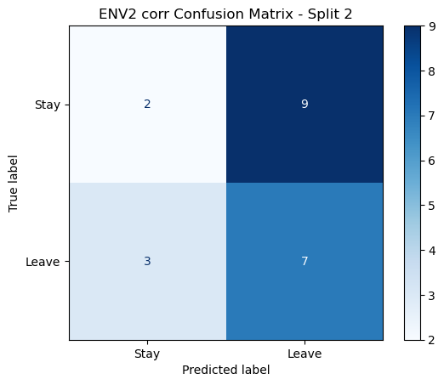

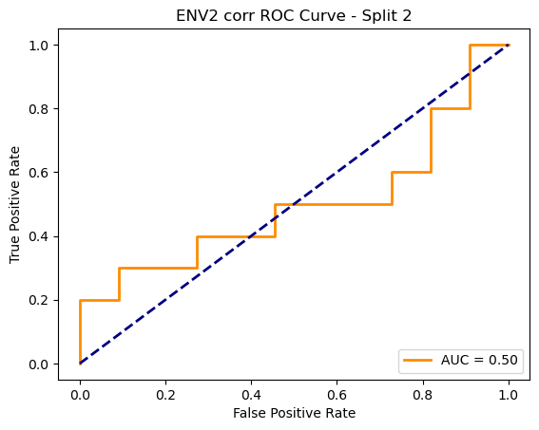

=== ENV2 Split 3/5 ===

After oversampling, class counts: Counter({1: 43, 0: 43})

C:\Users\sansk\miniconda3\Lib\site-packages\torch_geometric\deprecation.py:26: UserWarning: 'data.DataLoader' is deprecated, use 'loader.DataLoader' instead

warnings.warn(out)

Epoch 1/100 | Loss: 0.7972

Epoch 2/100 | Loss: 0.7671

Epoch 3/100 | Loss: 0.8395

Epoch 4/100 | Loss: 0.8084

Epoch 5/100 | Loss: 0.7921

Epoch 6/100 | Loss: 0.7964

Epoch 7/100 | Loss: 0.7226

Epoch 8/100 | Loss: 0.7342

Epoch 9/100 | Loss: 0.6812

Epoch 10/100 | Loss: 0.6576

Epoch 11/100 | Loss: 0.7406

Epoch 12/100 | Loss: 0.6938

Epoch 13/100 | Loss: 0.6740

Epoch 14/100 | Loss: 0.7347

Epoch 15/100 | Loss: 0.7836

Epoch 16/100 | Loss: 0.8198

Epoch 17/100 | Loss: 0.7702

Epoch 18/100 | Loss: 0.8055

Epoch 19/100 | Loss: 0.7670

Epoch 20/100 | Loss: 0.6682

Epoch 21/100 | Loss: 0.6410

Epoch 22/100 | Loss: 0.6785

Epoch 23/100 | Loss: 0.7052

Epoch 24/100 | Loss: 0.6714

Epoch 25/100 | Loss: 0.7124

Epoch 26/100 | Loss: 0.7602

Epoch 27/100 | Loss: 0.7053

Epoch 28/100 | Loss: 0.7285

Epoch 29/100 | Loss: 0.6400

Epoch 30/100 | Loss: 0.6754

Epoch 31/100 | Loss: 0.6733

Epoch 32/100 | Loss: 0.7470

Epoch 33/100 | Loss: 0.6068

Epoch 34/100 | Loss: 0.6776

Epoch 35/100 | Loss: 0.6695

Epoch 36/100 | Loss: 0.6417

Epoch 37/100 | Loss: 0.6885

Epoch 38/100 | Loss: 0.6959

Epoch 39/100 | Loss: 0.5719

Epoch 40/100 | Loss: 0.6680

Epoch 41/100 | Loss: 0.6765

Epoch 42/100 | Loss: 0.6150

Epoch 43/100 | Loss: 0.6268

Epoch 44/100 | Loss: 0.5708

Epoch 45/100 | Loss: 0.6686

Epoch 46/100 | Loss: 0.6061

Epoch 47/100 | Loss: 0.6117

Epoch 48/100 | Loss: 0.6953

Epoch 49/100 | Loss: 0.6325

Epoch 50/100 | Loss: 0.5646

Epoch 51/100 | Loss: 0.5967

Epoch 52/100 | Loss: 0.6012

Epoch 53/100 | Loss: 0.6274

Epoch 54/100 | Loss: 0.6328

Epoch 55/100 | Loss: 0.6764

Epoch 56/100 | Loss: 0.5817

Epoch 57/100 | Loss: 0.7002

Epoch 58/100 | Loss: 0.6228

Epoch 59/100 | Loss: 0.6773

Epoch 60/100 | Loss: 0.6173

Epoch 61/100 | Loss: 0.6635

Epoch 62/100 | Loss: 0.5534

Epoch 63/100 | Loss: 0.6472

Epoch 64/100 | Loss: 0.6290

Epoch 65/100 | Loss: 0.6438

Epoch 66/100 | Loss: 0.5868

Epoch 67/100 | Loss: 0.6194

Epoch 68/100 | Loss: 0.6480

Epoch 69/100 | Loss: 0.6689

Epoch 70/100 | Loss: 0.6214

Epoch 71/100 | Loss: 0.6172

Epoch 72/100 | Loss: 0.5773

Epoch 73/100 | Loss: 0.6213

Epoch 74/100 | Loss: 0.7128

Epoch 75/100 | Loss: 0.6178

Epoch 76/100 | Loss: 0.6955

Epoch 77/100 | Loss: 0.6107

Epoch 78/100 | Loss: 0.5831

Epoch 79/100 | Loss: 0.6302

Epoch 80/100 | Loss: 0.5823

Epoch 81/100 | Loss: 0.5637

Epoch 82/100 | Loss: 0.5630

Epoch 83/100 | Loss: 0.6214

Epoch 84/100 | Loss: 0.5997

Epoch 85/100 | Loss: 0.6400

Epoch 86/100 | Loss: 0.6185

Epoch 87/100 | Loss: 0.6268

Epoch 88/100 | Loss: 0.6168

Epoch 89/100 | Loss: 0.6237

Epoch 90/100 | Loss: 0.5941

Epoch 91/100 | Loss: 0.6548

Epoch 92/100 | Loss: 0.6071

Epoch 93/100 | Loss: 0.6284

Epoch 94/100 | Loss: 0.5604

Epoch 95/100 | Loss: 0.5442

Epoch 96/100 | Loss: 0.6438

Epoch 97/100 | Loss: 0.5891

Epoch 98/100 | Loss: 0.5973

Epoch 99/100 | Loss: 0.5687

Epoch 100/100 | Loss: 0.5595

Split 3 Accuracy: 0.4762

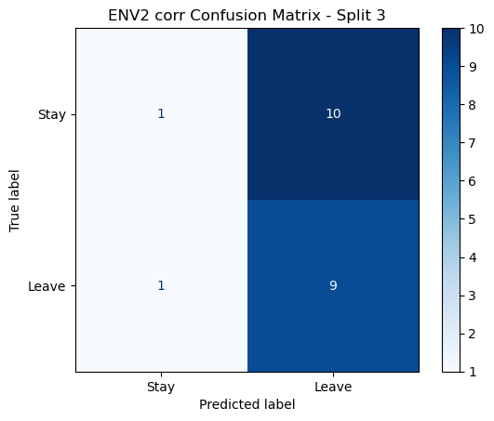

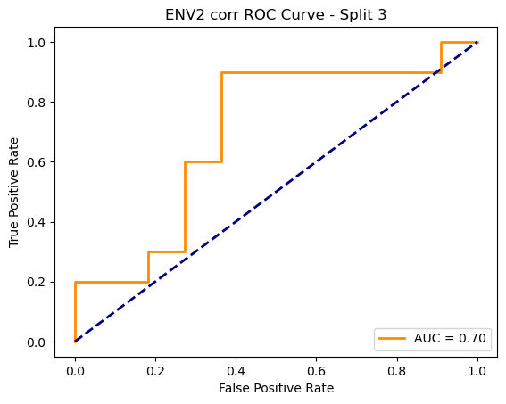

=== ENV2 Split 4/5 ===

After oversampling, class counts: Counter({1: 44, 0: 44})

C:\Users\sansk\miniconda3\Lib\site-packages\torch_geometric\deprecation.py:26: UserWarning: 'data.DataLoader' is deprecated, use 'loader.DataLoader' instead

warnings.warn(out)

Epoch 1/100 | Loss: 0.7967

Epoch 2/100 | Loss: 0.6692

Epoch 3/100 | Loss: 0.7847

Epoch 4/100 | Loss: 0.8108

Epoch 5/100 | Loss: 0.7926

Epoch 6/100 | Loss: 0.7521

Epoch 7/100 | Loss: 0.7557

Epoch 8/100 | Loss: 0.7475

Epoch 9/100 | Loss: 0.7583

Epoch 10/100 | Loss: 0.6974

Epoch 11/100 | Loss: 0.7537

Epoch 12/100 | Loss: 0.7316

Epoch 13/100 | Loss: 0.7330

Epoch 14/100 | Loss: 0.6945

Epoch 15/100 | Loss: 0.7082

Epoch 16/100 | Loss: 0.8208

Epoch 17/100 | Loss: 0.6777

Epoch 18/100 | Loss: 0.6943

Epoch 19/100 | Loss: 0.7209

Epoch 20/100 | Loss: 0.7213

Epoch 21/100 | Loss: 0.6911

Epoch 22/100 | Loss: 0.7042

Epoch 23/100 | Loss: 0.6769

Epoch 24/100 | Loss: 0.7111

Epoch 25/100 | Loss: 0.7355

Epoch 26/100 | Loss: 0.7564

Epoch 27/100 | Loss: 0.7156

Epoch 28/100 | Loss: 0.7431

Epoch 29/100 | Loss: 0.6791

Epoch 30/100 | Loss: 0.7181

Epoch 31/100 | Loss: 0.6503

Epoch 32/100 | Loss: 0.7017

Epoch 33/100 | Loss: 0.6982

Epoch 34/100 | Loss: 0.7119

Epoch 35/100 | Loss: 0.6628

Epoch 36/100 | Loss: 0.6888

Epoch 37/100 | Loss: 0.7474

Epoch 38/100 | Loss: 0.6260

Epoch 39/100 | Loss: 0.6573

Epoch 40/100 | Loss: 0.6736

Epoch 41/100 | Loss: 0.7072

Epoch 42/100 | Loss: 0.6859

Epoch 43/100 | Loss: 0.6620

Epoch 44/100 | Loss: 0.7021

Epoch 45/100 | Loss: 0.6759

Epoch 46/100 | Loss: 0.6853

Epoch 47/100 | Loss: 0.6612

Epoch 48/100 | Loss: 0.6980

Epoch 49/100 | Loss: 0.7160

Epoch 50/100 | Loss: 0.6196

Epoch 51/100 | Loss: 0.6526

Epoch 52/100 | Loss: 0.6929

Epoch 53/100 | Loss: 0.6565

Epoch 54/100 | Loss: 0.6884

Epoch 55/100 | Loss: 0.6302

Epoch 56/100 | Loss: 0.6360

Epoch 57/100 | Loss: 0.6401

Epoch 58/100 | Loss: 0.6106

Epoch 59/100 | Loss: 0.7304

Epoch 60/100 | Loss: 0.7136

Epoch 61/100 | Loss: 0.6704

Epoch 62/100 | Loss: 0.6490

Epoch 63/100 | Loss: 0.7016

Epoch 64/100 | Loss: 0.6365

Epoch 65/100 | Loss: 0.7158

Epoch 66/100 | Loss: 0.6134

Epoch 67/100 | Loss: 0.6300

Epoch 68/100 | Loss: 0.6257

Epoch 69/100 | Loss: 0.5736

Epoch 70/100 | Loss: 0.6441

Epoch 71/100 | Loss: 0.6779

Epoch 72/100 | Loss: 0.6972

Epoch 73/100 | Loss: 0.6229

Epoch 74/100 | Loss: 0.6998

Epoch 75/100 | Loss: 0.6557

Epoch 76/100 | Loss: 0.6572

Epoch 77/100 | Loss: 0.5939

Epoch 78/100 | Loss: 0.6968

Epoch 79/100 | Loss: 0.6328

Epoch 80/100 | Loss: 0.6496

Epoch 81/100 | Loss: 0.6272

Epoch 82/100 | Loss: 0.6438

Epoch 83/100 | Loss: 0.6313

Epoch 84/100 | Loss: 0.6769

Epoch 85/100 | Loss: 0.6880

Epoch 86/100 | Loss: 0.6012

Epoch 87/100 | Loss: 0.6392

Epoch 88/100 | Loss: 0.7056

Epoch 89/100 | Loss: 0.6924

Epoch 90/100 | Loss: 0.6455

Epoch 91/100 | Loss: 0.6425

Epoch 92/100 | Loss: 0.6714

Epoch 93/100 | Loss: 0.6137

Epoch 94/100 | Loss: 0.6328

Epoch 95/100 | Loss: 0.6085

Epoch 96/100 | Loss: 0.6286

Epoch 97/100 | Loss: 0.5974

Epoch 98/100 | Loss: 0.6519

Epoch 99/100 | Loss: 0.5829

Epoch 100/100 | Loss: 0.5700

Split 4 Accuracy: 0.5238

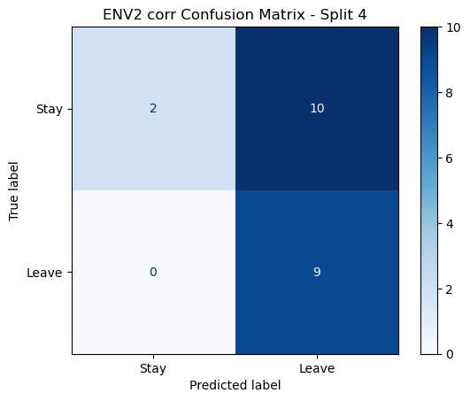

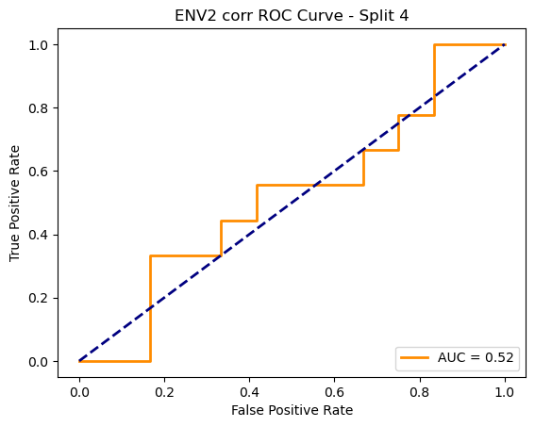

=== ENV2 Split 5/5 ===

After oversampling, class counts: Counter({1: 44, 0: 44})

C:\Users\sansk\miniconda3\Lib\site-packages\torch_geometric\deprecation.py:26: UserWarning: 'data.DataLoader' is deprecated, use 'loader.DataLoader' instead

warnings.warn(out)

Epoch 1/100 | Loss: 0.7103

Epoch 2/100 | Loss: 0.6929

Epoch 3/100 | Loss: 0.7731

Epoch 4/100 | Loss: 0.7508

Epoch 5/100 | Loss: 0.7694

Epoch 6/100 | Loss: 0.7584

Epoch 7/100 | Loss: 0.7526

Epoch 8/100 | Loss: 0.7270

Epoch 9/100 | Loss: 0.6754

Epoch 10/100 | Loss: 0.7251

Epoch 11/100 | Loss: 0.6974

Epoch 12/100 | Loss: 0.6871

Epoch 13/100 | Loss: 0.7144

Epoch 14/100 | Loss: 0.6430

Epoch 15/100 | Loss: 0.6708

Epoch 16/100 | Loss: 0.7025

Epoch 17/100 | Loss: 0.6702

Epoch 18/100 | Loss: 0.7541

Epoch 19/100 | Loss: 0.6541

Epoch 20/100 | Loss: 0.6291

Epoch 21/100 | Loss: 0.7187

Epoch 22/100 | Loss: 0.7470

Epoch 23/100 | Loss: 0.6873

Epoch 24/100 | Loss: 0.6587

Epoch 25/100 | Loss: 0.6839

Epoch 26/100 | Loss: 0.6648

Epoch 27/100 | Loss: 0.6374

Epoch 28/100 | Loss: 0.7194

Epoch 29/100 | Loss: 0.6878

Epoch 30/100 | Loss: 0.6257

Epoch 31/100 | Loss: 0.6064

Epoch 32/100 | Loss: 0.6122

Epoch 33/100 | Loss: 0.7023

Epoch 34/100 | Loss: 0.7332

Epoch 35/100 | Loss: 0.6153

Epoch 36/100 | Loss: 0.6227

Epoch 37/100 | Loss: 0.6745

Epoch 38/100 | Loss: 0.6296

Epoch 39/100 | Loss: 0.6638

Epoch 40/100 | Loss: 0.6350

Epoch 41/100 | Loss: 0.6869

Epoch 42/100 | Loss: 0.5843

Epoch 43/100 | Loss: 0.6366

Epoch 44/100 | Loss: 0.6120

Epoch 45/100 | Loss: 0.6539

Epoch 46/100 | Loss: 0.6089

Epoch 47/100 | Loss: 0.6215

Epoch 48/100 | Loss: 0.6433

Epoch 49/100 | Loss: 0.6297

Epoch 50/100 | Loss: 0.6686

Epoch 51/100 | Loss: 0.6918

Epoch 52/100 | Loss: 0.6099

Epoch 53/100 | Loss: 0.6447

Epoch 54/100 | Loss: 0.6282

Epoch 55/100 | Loss: 0.6655

Epoch 56/100 | Loss: 0.6732

Epoch 57/100 | Loss: 0.6024

Epoch 58/100 | Loss: 0.6003

Epoch 59/100 | Loss: 0.5953

Epoch 60/100 | Loss: 0.6291

Epoch 61/100 | Loss: 0.6380

Epoch 62/100 | Loss: 0.6843

Epoch 63/100 | Loss: 0.6015

Epoch 64/100 | Loss: 0.7070

Epoch 65/100 | Loss: 0.6456

Epoch 66/100 | Loss: 0.5322

Epoch 67/100 | Loss: 0.6069

Epoch 68/100 | Loss: 0.6762

Epoch 69/100 | Loss: 0.5595

Epoch 70/100 | Loss: 0.7014

Epoch 71/100 | Loss: 0.6900

Epoch 72/100 | Loss: 0.6179

Epoch 73/100 | Loss: 0.6762

Epoch 74/100 | Loss: 0.6489

Epoch 75/100 | Loss: 0.6326

Epoch 76/100 | Loss: 0.6299

Epoch 77/100 | Loss: 0.5336

Epoch 78/100 | Loss: 0.6504

Epoch 79/100 | Loss: 0.6729

Epoch 80/100 | Loss: 0.5578

Epoch 81/100 | Loss: 0.6190

Epoch 82/100 | Loss: 0.6319

Epoch 83/100 | Loss: 0.5961

Epoch 84/100 | Loss: 0.6812

Epoch 85/100 | Loss: 0.6449

Epoch 86/100 | Loss: 0.5882

Epoch 87/100 | Loss: 0.6081

Epoch 88/100 | Loss: 0.5845

Epoch 89/100 | Loss: 0.5434

Epoch 90/100 | Loss: 0.5884

Epoch 91/100 | Loss: 0.6544

Epoch 92/100 | Loss: 0.5450

Epoch 93/100 | Loss: 0.6097

Epoch 94/100 | Loss: 0.5560

Epoch 95/100 | Loss: 0.5934

Epoch 96/100 | Loss: 0.6211

Epoch 97/100 | Loss: 0.5507

Epoch 98/100 | Loss: 0.6014

Epoch 99/100 | Loss: 0.6100

Epoch 100/100 | Loss: 0.6154

Split 5 Accuracy: 0.4762

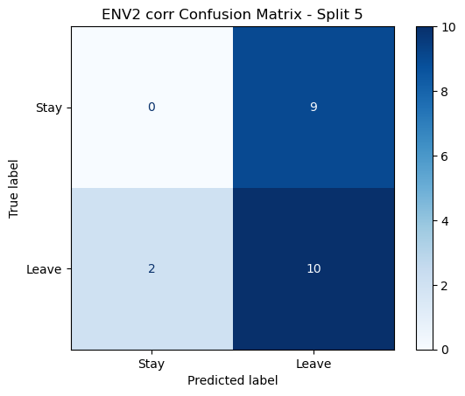

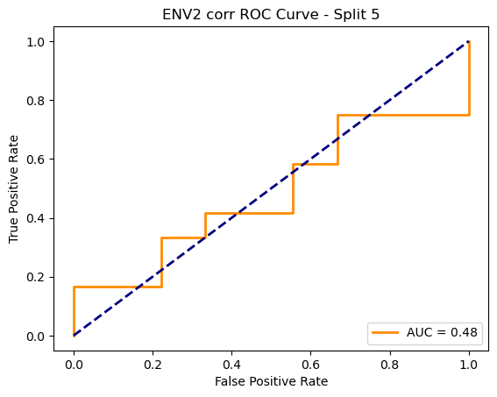

ENV2 corr Average Accuracy: 0.4900 ± 0.0409

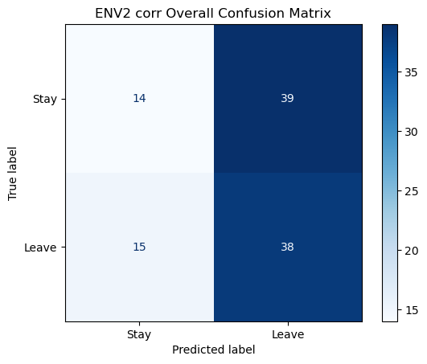

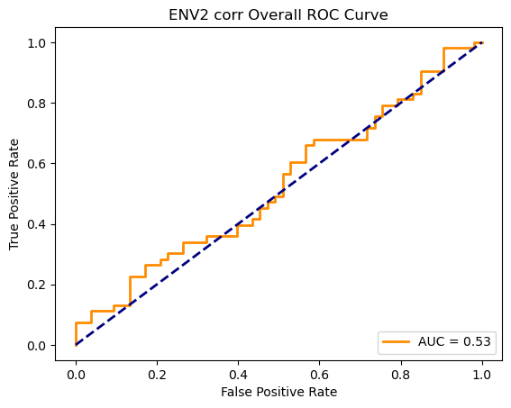

Running GNN with coh connectivity for ENV2...

==================================================

Training GNN for ENV2 with coh connectivity

==================================================

=== ENV2 Split 1/5 ===

C:\Users\sansk\miniconda3\Lib\site-packages\scipy\signal\_spectral_py.py:1668: RuntimeWarning: invalid value encountered in divide

Cxy = np.abs(Pxy)**2 / Pxx / Pyy

After oversampling, class counts: Counter({0: 43, 1: 43})

C:\Users\sansk\miniconda3\Lib\site-packages\torch_geometric\deprecation.py:26: UserWarning: 'data.DataLoader' is deprecated, use 'loader.DataLoader' instead

warnings.warn(out)

Epoch 1/100 | Loss: 0.6724

Epoch 2/100 | Loss: 0.7716

Epoch 3/100 | Loss: 0.7902

Epoch 4/100 | Loss: 0.8034

Epoch 5/100 | Loss: 0.6644

Epoch 6/100 | Loss: 0.8076

Epoch 7/100 | Loss: 0.7185

Epoch 8/100 | Loss: 0.7292

Epoch 9/100 | Loss: 0.7387

Epoch 10/100 | Loss: 0.6931

Epoch 11/100 | Loss: 0.6747

Epoch 12/100 | Loss: 0.7278

Epoch 13/100 | Loss: 0.7267

Epoch 14/100 | Loss: 0.7884

Epoch 15/100 | Loss: 0.7076

Epoch 16/100 | Loss: 0.7426

Epoch 17/100 | Loss: 0.6424

Epoch 18/100 | Loss: 0.7347

Epoch 19/100 | Loss: 0.7470

Epoch 20/100 | Loss: 0.6644

Epoch 21/100 | Loss: 0.7148

Epoch 22/100 | Loss: 0.7370

Epoch 23/100 | Loss: 0.7085

Epoch 24/100 | Loss: 0.7430

Epoch 25/100 | Loss: 0.7959

Epoch 26/100 | Loss: 0.7431

Epoch 27/100 | Loss: 0.7365

Epoch 28/100 | Loss: 0.6759

Epoch 29/100 | Loss: 0.7596

Epoch 30/100 | Loss: 0.7218

Epoch 31/100 | Loss: 0.7216

Epoch 32/100 | Loss: 0.7569

Epoch 33/100 | Loss: 0.7504

Epoch 34/100 | Loss: 0.6918

Epoch 35/100 | Loss: 0.6927

Epoch 36/100 | Loss: 0.7048

Epoch 37/100 | Loss: 0.6872

Epoch 38/100 | Loss: 0.7118

Epoch 39/100 | Loss: 0.7411

Epoch 40/100 | Loss: 0.7336

Epoch 41/100 | Loss: 0.7443

Epoch 42/100 | Loss: 0.7451

Epoch 43/100 | Loss: 0.6733

Epoch 44/100 | Loss: 0.7140

Epoch 45/100 | Loss: 0.7315

Epoch 46/100 | Loss: 0.7169

Epoch 47/100 | Loss: 0.6943

Epoch 48/100 | Loss: 0.6590

Epoch 49/100 | Loss: 0.6843

Epoch 50/100 | Loss: 0.7190

Epoch 51/100 | Loss: 0.7121

Epoch 52/100 | Loss: 0.7542

Epoch 53/100 | Loss: 0.6980

Epoch 54/100 | Loss: 0.6702

Epoch 55/100 | Loss: 0.7856

Epoch 56/100 | Loss: 0.6711

Epoch 57/100 | Loss: 0.6895

Epoch 58/100 | Loss: 0.7085

Epoch 59/100 | Loss: 0.6878

Epoch 60/100 | Loss: 0.7282

Epoch 61/100 | Loss: 0.7330

Epoch 62/100 | Loss: 0.7014

Epoch 63/100 | Loss: 0.7141

Epoch 64/100 | Loss: 0.7012

Epoch 65/100 | Loss: 0.7066

Epoch 66/100 | Loss: 0.6610

Epoch 67/100 | Loss: 0.6590

Epoch 68/100 | Loss: 0.7230

Epoch 69/100 | Loss: 0.7248

Epoch 70/100 | Loss: 0.6689

Epoch 71/100 | Loss: 0.6732

Epoch 72/100 | Loss: 0.6948

Epoch 73/100 | Loss: 0.6463

Epoch 74/100 | Loss: 0.7061

Epoch 75/100 | Loss: 0.6649

Epoch 76/100 | Loss: 0.7168

Epoch 77/100 | Loss: 0.7099

Epoch 78/100 | Loss: 0.6802

Epoch 79/100 | Loss: 0.6931

Epoch 80/100 | Loss: 0.6877

Epoch 81/100 | Loss: 0.6655

Epoch 82/100 | Loss: 0.7539

Epoch 83/100 | Loss: 0.6354

Epoch 84/100 | Loss: 0.6593

Epoch 85/100 | Loss: 0.6352

Epoch 86/100 | Loss: 0.6870

Epoch 87/100 | Loss: 0.7097

Epoch 88/100 | Loss: 0.7341

Epoch 89/100 | Loss: 0.7510

Epoch 90/100 | Loss: 0.6925

Epoch 91/100 | Loss: 0.6726

Epoch 92/100 | Loss: 0.6966

Epoch 93/100 | Loss: 0.6914

Epoch 94/100 | Loss: 0.7494

Epoch 95/100 | Loss: 0.7061

Epoch 96/100 | Loss: 0.7025

Epoch 97/100 | Loss: 0.7247

Epoch 98/100 | Loss: 0.7079

Epoch 99/100 | Loss: 0.7073

Epoch 100/100 | Loss: 0.6814

Split 1 Accuracy: 0.5909

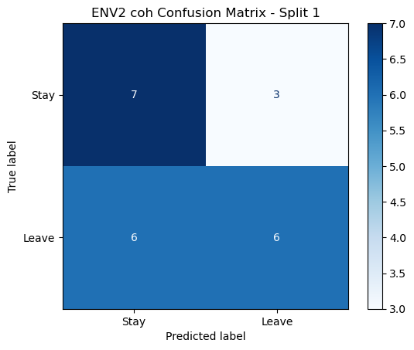

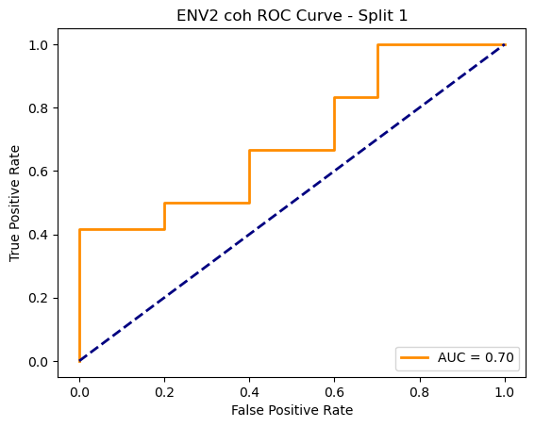

=== ENV2 Split 2/5 ===

C:\Users\sansk\miniconda3\Lib\site-packages\scipy\signal\_spectral_py.py:1668: RuntimeWarning: invalid value encountered in divide

Cxy = np.abs(Pxy)**2 / Pxx / Pyy

After oversampling, class counts: Counter({1: 43, 0: 43})

C:\Users\sansk\miniconda3\Lib\site-packages\torch_geometric\deprecation.py:26: UserWarning: 'data.DataLoader' is deprecated, use 'loader.DataLoader' instead

warnings.warn(out)

Epoch 1/100 | Loss: 0.7637

Epoch 2/100 | Loss: 0.7467

Epoch 3/100 | Loss: 0.7230

Epoch 4/100 | Loss: 0.7511

Epoch 5/100 | Loss: 0.7520

Epoch 6/100 | Loss: 0.7359

Epoch 7/100 | Loss: 0.7681

Epoch 8/100 | Loss: 0.6684

Epoch 9/100 | Loss: 0.6907

Epoch 10/100 | Loss: 0.6595

Epoch 11/100 | Loss: 0.7440

Epoch 12/100 | Loss: 0.6757

Epoch 13/100 | Loss: 0.6959

Epoch 14/100 | Loss: 0.7587

Epoch 15/100 | Loss: 0.7140

Epoch 16/100 | Loss: 0.6886

Epoch 17/100 | Loss: 0.8186

Epoch 18/100 | Loss: 0.7157

Epoch 19/100 | Loss: 0.7731

Epoch 20/100 | Loss: 0.7353

Epoch 21/100 | Loss: 0.7468

Epoch 22/100 | Loss: 0.7354

Epoch 23/100 | Loss: 0.6720

Epoch 24/100 | Loss: 0.7030

Epoch 25/100 | Loss: 0.7098

Epoch 26/100 | Loss: 0.7164

Epoch 27/100 | Loss: 0.7126

Epoch 28/100 | Loss: 0.6675

Epoch 29/100 | Loss: 0.6552

Epoch 30/100 | Loss: 0.7142

Epoch 31/100 | Loss: 0.7508

Epoch 32/100 | Loss: 0.7252

Epoch 33/100 | Loss: 0.6992

Epoch 34/100 | Loss: 0.7421

Epoch 35/100 | Loss: 0.6861

Epoch 36/100 | Loss: 0.6978

Epoch 37/100 | Loss: 0.6792

Epoch 38/100 | Loss: 0.6826

Epoch 39/100 | Loss: 0.7229

Epoch 40/100 | Loss: 0.6474

Epoch 41/100 | Loss: 0.6857

Epoch 42/100 | Loss: 0.7135

Epoch 43/100 | Loss: 0.7143

Epoch 44/100 | Loss: 0.6705

Epoch 45/100 | Loss: 0.7004

Epoch 46/100 | Loss: 0.7527

Epoch 47/100 | Loss: 0.6731

Epoch 48/100 | Loss: 0.7020

Epoch 49/100 | Loss: 0.7333

Epoch 50/100 | Loss: 0.6672

Epoch 51/100 | Loss: 0.7217

Epoch 52/100 | Loss: 0.7438

Epoch 53/100 | Loss: 0.6938

Epoch 54/100 | Loss: 0.6795

Epoch 55/100 | Loss: 0.6588

Epoch 56/100 | Loss: 0.6969

Epoch 57/100 | Loss: 0.6955

Epoch 58/100 | Loss: 0.7466

Epoch 59/100 | Loss: 0.6589

Epoch 60/100 | Loss: 0.6439

Epoch 61/100 | Loss: 0.7064

Epoch 62/100 | Loss: 0.6430

Epoch 63/100 | Loss: 0.6796

Epoch 64/100 | Loss: 0.6805

Epoch 65/100 | Loss: 0.6425

Epoch 66/100 | Loss: 0.6643

Epoch 67/100 | Loss: 0.6582

Epoch 68/100 | Loss: 0.6670

Epoch 69/100 | Loss: 0.6955

Epoch 70/100 | Loss: 0.7094

Epoch 71/100 | Loss: 0.7210

Epoch 72/100 | Loss: 0.6597

Epoch 73/100 | Loss: 0.6801

Epoch 74/100 | Loss: 0.7104

Epoch 75/100 | Loss: 0.6319

Epoch 76/100 | Loss: 0.6862

Epoch 77/100 | Loss: 0.6468

Epoch 78/100 | Loss: 0.6567

Epoch 79/100 | Loss: 0.6805

Epoch 80/100 | Loss: 0.6743

Epoch 81/100 | Loss: 0.6964

Epoch 82/100 | Loss: 0.6742

Epoch 83/100 | Loss: 0.6934

Epoch 84/100 | Loss: 0.6837

Epoch 85/100 | Loss: 0.6646

Epoch 86/100 | Loss: 0.6570

Epoch 87/100 | Loss: 0.6690

Epoch 88/100 | Loss: 0.6323

Epoch 89/100 | Loss: 0.6584

Epoch 90/100 | Loss: 0.7088

Epoch 91/100 | Loss: 0.7045

Epoch 92/100 | Loss: 0.6590

Epoch 93/100 | Loss: 0.6750

Epoch 94/100 | Loss: 0.7048

Epoch 95/100 | Loss: 0.6463

Epoch 96/100 | Loss: 0.6573

Epoch 97/100 | Loss: 0.6969

Epoch 98/100 | Loss: 0.6390

Epoch 99/100 | Loss: 0.6434

Epoch 100/100 | Loss: 0.6969

Split 2 Accuracy: 0.3810

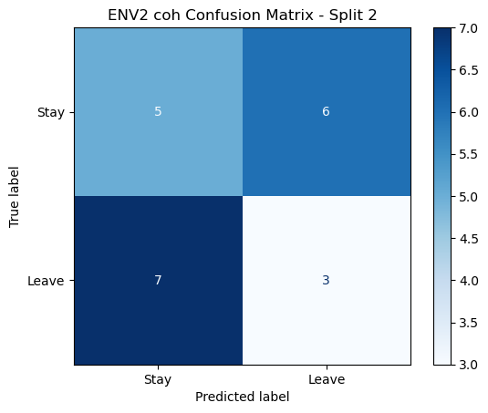

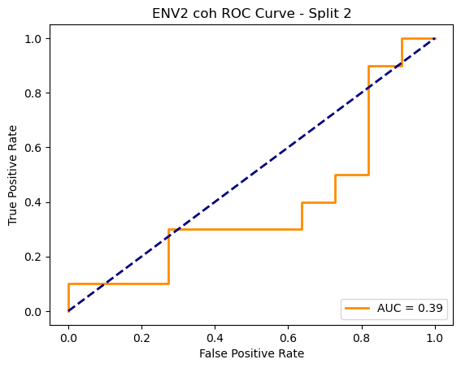

=== ENV2 Split 3/5 ===

C:\Users\sansk\miniconda3\Lib\site-packages\scipy\signal\_spectral_py.py:1668: RuntimeWarning: invalid value encountered in divide

Cxy = np.abs(Pxy)**2 / Pxx / Pyy

After oversampling, class counts: Counter({1: 43, 0: 43})

C:\Users\sansk\miniconda3\Lib\site-packages\torch_geometric\deprecation.py:26: UserWarning: 'data.DataLoader' is deprecated, use 'loader.DataLoader' instead

warnings.warn(out)

Epoch 1/100 | Loss: 0.8158

Epoch 2/100 | Loss: 0.6713

Epoch 3/100 | Loss: 0.8289

Epoch 4/100 | Loss: 0.7880

Epoch 5/100 | Loss: 0.7783

Epoch 6/100 | Loss: 0.7526

Epoch 7/100 | Loss: 0.7645

Epoch 8/100 | Loss: 0.7493

Epoch 9/100 | Loss: 0.7121

Epoch 10/100 | Loss: 0.7221

Epoch 11/100 | Loss: 0.7218

Epoch 12/100 | Loss: 0.7282

Epoch 13/100 | Loss: 0.7742

Epoch 14/100 | Loss: 0.7757

Epoch 15/100 | Loss: 0.7880

Epoch 16/100 | Loss: 0.7757

Epoch 17/100 | Loss: 0.7934

Epoch 18/100 | Loss: 0.7251

Epoch 19/100 | Loss: 0.7544

Epoch 20/100 | Loss: 0.6510

Epoch 21/100 | Loss: 0.7848

Epoch 22/100 | Loss: 0.7639

Epoch 23/100 | Loss: 0.7085

Epoch 24/100 | Loss: 0.7551

Epoch 25/100 | Loss: 0.7409

Epoch 26/100 | Loss: 0.7285

Epoch 27/100 | Loss: 0.7487

Epoch 28/100 | Loss: 0.7158

Epoch 29/100 | Loss: 0.7243

Epoch 30/100 | Loss: 0.7330

Epoch 31/100 | Loss: 0.7088

Epoch 32/100 | Loss: 0.7522

Epoch 33/100 | Loss: 0.7320

Epoch 34/100 | Loss: 0.6840

Epoch 35/100 | Loss: 0.7029

Epoch 36/100 | Loss: 0.7207

Epoch 37/100 | Loss: 0.6646

Epoch 38/100 | Loss: 0.7271

Epoch 39/100 | Loss: 0.6824

Epoch 40/100 | Loss: 0.7529

Epoch 41/100 | Loss: 0.6732

Epoch 42/100 | Loss: 0.6947

Epoch 43/100 | Loss: 0.7325

Epoch 44/100 | Loss: 0.7101

Epoch 45/100 | Loss: 0.7238

Epoch 46/100 | Loss: 0.7149

Epoch 47/100 | Loss: 0.6839

Epoch 48/100 | Loss: 0.7700

Epoch 49/100 | Loss: 0.7192

Epoch 50/100 | Loss: 0.7383

Epoch 51/100 | Loss: 0.7091

Epoch 52/100 | Loss: 0.7023

Epoch 53/100 | Loss: 0.7330

Epoch 54/100 | Loss: 0.6976

Epoch 55/100 | Loss: 0.7786

Epoch 56/100 | Loss: 0.6780

Epoch 57/100 | Loss: 0.7242

Epoch 58/100 | Loss: 0.6914

Epoch 59/100 | Loss: 0.6778

Epoch 60/100 | Loss: 0.7395

Epoch 61/100 | Loss: 0.6825

Epoch 62/100 | Loss: 0.7154

Epoch 63/100 | Loss: 0.6967

Epoch 64/100 | Loss: 0.6765

Epoch 65/100 | Loss: 0.7802

Epoch 66/100 | Loss: 0.7485

Epoch 67/100 | Loss: 0.7013

Epoch 68/100 | Loss: 0.7500

Epoch 69/100 | Loss: 0.7025

Epoch 70/100 | Loss: 0.7362

Epoch 71/100 | Loss: 0.6789

Epoch 72/100 | Loss: 0.6447

Epoch 73/100 | Loss: 0.6785

Epoch 74/100 | Loss: 0.7612

Epoch 75/100 | Loss: 0.6947

Epoch 76/100 | Loss: 0.6837

Epoch 77/100 | Loss: 0.7309

Epoch 78/100 | Loss: 0.7575

Epoch 79/100 | Loss: 0.7361

Epoch 80/100 | Loss: 0.7101

Epoch 81/100 | Loss: 0.7225

Epoch 82/100 | Loss: 0.6998

Epoch 83/100 | Loss: 0.6623

Epoch 84/100 | Loss: 0.7236

Epoch 85/100 | Loss: 0.7951

Epoch 86/100 | Loss: 0.7030

Epoch 87/100 | Loss: 0.7421

Epoch 88/100 | Loss: 0.6695

Epoch 89/100 | Loss: 0.7017

Epoch 90/100 | Loss: 0.7137

Epoch 91/100 | Loss: 0.7016

Epoch 92/100 | Loss: 0.7128

Epoch 93/100 | Loss: 0.7007

Epoch 94/100 | Loss: 0.6814

Epoch 95/100 | Loss: 0.6438

Epoch 96/100 | Loss: 0.7210

Epoch 97/100 | Loss: 0.6832

Epoch 98/100 | Loss: 0.6765

Epoch 99/100 | Loss: 0.6805

Epoch 100/100 | Loss: 0.6874

Split 3 Accuracy: 0.5238

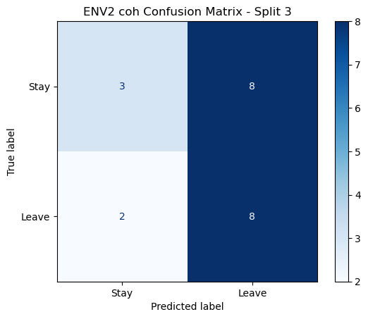

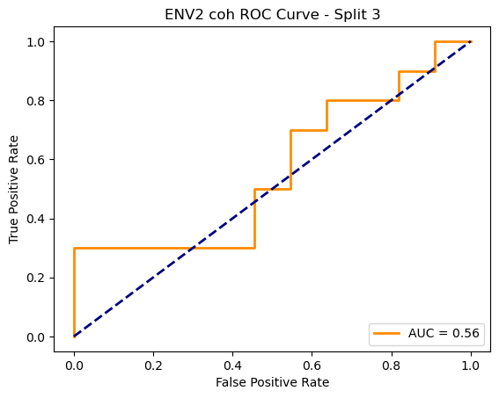

=== ENV2 Split 4/5 ===

C:\Users\sansk\miniconda3\Lib\site-packages\scipy\signal\_spectral_py.py:1668: RuntimeWarning: invalid value encountered in divide

Cxy = np.abs(Pxy)**2 / Pxx / Pyy

After oversampling, class counts: Counter({1: 44, 0: 44})

C:\Users\sansk\miniconda3\Lib\site-packages\torch_geometric\deprecation.py:26: UserWarning: 'data.DataLoader' is deprecated, use 'loader.DataLoader' instead

warnings.warn(out)

Epoch 1/100 | Loss: 0.7986

Epoch 2/100 | Loss: 0.7315

Epoch 3/100 | Loss: 0.7347

Epoch 4/100 | Loss: 0.6925

Epoch 5/100 | Loss: 0.7106

Epoch 6/100 | Loss: 0.7494

Epoch 7/100 | Loss: 0.6424

Epoch 8/100 | Loss: 0.7182

Epoch 9/100 | Loss: 0.7277

Epoch 10/100 | Loss: 0.7098

Epoch 11/100 | Loss: 0.7551

Epoch 12/100 | Loss: 0.7590

Epoch 13/100 | Loss: 0.7097

Epoch 14/100 | Loss: 0.6853

Epoch 15/100 | Loss: 0.7207

Epoch 16/100 | Loss: 0.7483

Epoch 17/100 | Loss: 0.7360

Epoch 18/100 | Loss: 0.7164

Epoch 19/100 | Loss: 0.7025

Epoch 20/100 | Loss: 0.7110

Epoch 21/100 | Loss: 0.6703

Epoch 22/100 | Loss: 0.6782

Epoch 23/100 | Loss: 0.6819

Epoch 24/100 | Loss: 0.6623

Epoch 25/100 | Loss: 0.8092

Epoch 26/100 | Loss: 0.7552

Epoch 27/100 | Loss: 0.7547

Epoch 28/100 | Loss: 0.7527

Epoch 29/100 | Loss: 0.7305

Epoch 30/100 | Loss: 0.7219

Epoch 31/100 | Loss: 0.7186

Epoch 32/100 | Loss: 0.6886

Epoch 33/100 | Loss: 0.6521

Epoch 34/100 | Loss: 0.6740

Epoch 35/100 | Loss: 0.7384

Epoch 36/100 | Loss: 0.6723

Epoch 37/100 | Loss: 0.7020

Epoch 38/100 | Loss: 0.7137

Epoch 39/100 | Loss: 0.6727

Epoch 40/100 | Loss: 0.7301

Epoch 41/100 | Loss: 0.6795

Epoch 42/100 | Loss: 0.6553

Epoch 43/100 | Loss: 0.7004

Epoch 44/100 | Loss: 0.7129

Epoch 45/100 | Loss: 0.6791

Epoch 46/100 | Loss: 0.6705

Epoch 47/100 | Loss: 0.7263

Epoch 48/100 | Loss: 0.6963

Epoch 49/100 | Loss: 0.7490

Epoch 50/100 | Loss: 0.7342

Epoch 51/100 | Loss: 0.7048

Epoch 52/100 | Loss: 0.7637

Epoch 53/100 | Loss: 0.7182

Epoch 54/100 | Loss: 0.7386

Epoch 55/100 | Loss: 0.6843

Epoch 56/100 | Loss: 0.6638

Epoch 57/100 | Loss: 0.7125

Epoch 58/100 | Loss: 0.6500

Epoch 59/100 | Loss: 0.6833

Epoch 60/100 | Loss: 0.6842

Epoch 61/100 | Loss: 0.7617

Epoch 62/100 | Loss: 0.6972

Epoch 63/100 | Loss: 0.6709

Epoch 64/100 | Loss: 0.6858

Epoch 65/100 | Loss: 0.7151

Epoch 66/100 | Loss: 0.7134

Epoch 67/100 | Loss: 0.6967

Epoch 68/100 | Loss: 0.6552

Epoch 69/100 | Loss: 0.7087

Epoch 70/100 | Loss: 0.6038

Epoch 71/100 | Loss: 0.6978

Epoch 72/100 | Loss: 0.7133

Epoch 73/100 | Loss: 0.6752

Epoch 74/100 | Loss: 0.6359

Epoch 75/100 | Loss: 0.6790

Epoch 76/100 | Loss: 0.6898

Epoch 77/100 | Loss: 0.6969

Epoch 78/100 | Loss: 0.7142

Epoch 79/100 | Loss: 0.6976

Epoch 80/100 | Loss: 0.6941

Epoch 81/100 | Loss: 0.6881

Epoch 82/100 | Loss: 0.6837

Epoch 83/100 | Loss: 0.6815

Epoch 84/100 | Loss: 0.6816

Epoch 85/100 | Loss: 0.6136

Epoch 86/100 | Loss: 0.7174

Epoch 87/100 | Loss: 0.7039

Epoch 88/100 | Loss: 0.7000

Epoch 89/100 | Loss: 0.7332

Epoch 90/100 | Loss: 0.7241

Epoch 91/100 | Loss: 0.6976

Epoch 92/100 | Loss: 0.6458

Epoch 93/100 | Loss: 0.6446

Epoch 94/100 | Loss: 0.7304

Epoch 95/100 | Loss: 0.6632

Epoch 96/100 | Loss: 0.7329

Epoch 97/100 | Loss: 0.7002

Epoch 98/100 | Loss: 0.6846

Epoch 99/100 | Loss: 0.6528

Epoch 100/100 | Loss: 0.7120

Split 4 Accuracy: 0.4762

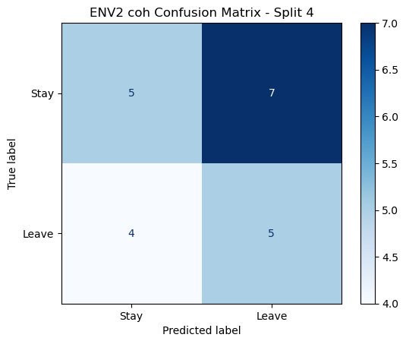

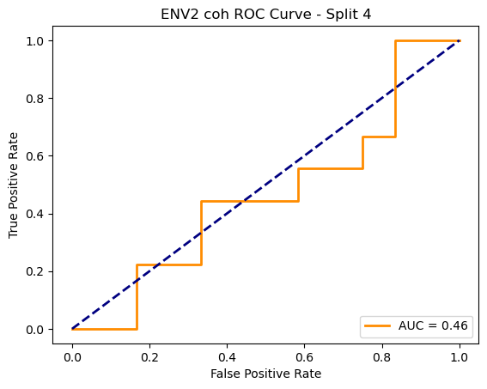

=== ENV2 Split 5/5 ===

C:\Users\sansk\miniconda3\Lib\site-packages\scipy\signal\_spectral_py.py:1668: RuntimeWarning: invalid value encountered in divide

Cxy = np.abs(Pxy)**2 / Pxx / Pyy

After oversampling, class counts: Counter({1: 44, 0: 44})

C:\Users\sansk\miniconda3\Lib\site-packages\torch_geometric\deprecation.py:26: UserWarning: 'data.DataLoader' is deprecated, use 'loader.DataLoader' instead

warnings.warn(out)

Epoch 1/100 | Loss: 0.8386

Epoch 2/100 | Loss: 0.8179

Epoch 3/100 | Loss: 0.7128

Epoch 4/100 | Loss: 0.7597

Epoch 5/100 | Loss: 0.7457

Epoch 6/100 | Loss: 0.7085

Epoch 7/100 | Loss: 0.6746

Epoch 8/100 | Loss: 0.7736

Epoch 9/100 | Loss: 0.7054

Epoch 10/100 | Loss: 0.6486

Epoch 11/100 | Loss: 0.6998

Epoch 12/100 | Loss: 0.7770

Epoch 13/100 | Loss: 0.7083

Epoch 14/100 | Loss: 0.7364

Epoch 15/100 | Loss: 0.7232

Epoch 16/100 | Loss: 0.7170

Epoch 17/100 | Loss: 0.7098

Epoch 18/100 | Loss: 0.7531

Epoch 19/100 | Loss: 0.7285

Epoch 20/100 | Loss: 0.7166

Epoch 21/100 | Loss: 0.7103

Epoch 22/100 | Loss: 0.7148

Epoch 23/100 | Loss: 0.7600

Epoch 24/100 | Loss: 0.7707

Epoch 25/100 | Loss: 0.7189

Epoch 26/100 | Loss: 0.7261

Epoch 27/100 | Loss: 0.7174

Epoch 28/100 | Loss: 0.7244

Epoch 29/100 | Loss: 0.7109

Epoch 30/100 | Loss: 0.7278

Epoch 31/100 | Loss: 0.7273

Epoch 32/100 | Loss: 0.7473

Epoch 33/100 | Loss: 0.7194

Epoch 34/100 | Loss: 0.6182

Epoch 35/100 | Loss: 0.7080

Epoch 36/100 | Loss: 0.6893

Epoch 37/100 | Loss: 0.7167

Epoch 38/100 | Loss: 0.6683

Epoch 39/100 | Loss: 0.6673

Epoch 40/100 | Loss: 0.6907

Epoch 41/100 | Loss: 0.6585

Epoch 42/100 | Loss: 0.7023

Epoch 43/100 | Loss: 0.7284

Epoch 44/100 | Loss: 0.7277

Epoch 45/100 | Loss: 0.6497

Epoch 46/100 | Loss: 0.7257

Epoch 47/100 | Loss: 0.7541

Epoch 48/100 | Loss: 0.7650

Epoch 49/100 | Loss: 0.6988

Epoch 50/100 | Loss: 0.6869

Epoch 51/100 | Loss: 0.7214

Epoch 52/100 | Loss: 0.7309

Epoch 53/100 | Loss: 0.6637

Epoch 54/100 | Loss: 0.7316

Epoch 55/100 | Loss: 0.6844

Epoch 56/100 | Loss: 0.7214

Epoch 57/100 | Loss: 0.6775

Epoch 58/100 | Loss: 0.6960

Epoch 59/100 | Loss: 0.6593

Epoch 60/100 | Loss: 0.6949

Epoch 61/100 | Loss: 0.7476

Epoch 62/100 | Loss: 0.6790

Epoch 63/100 | Loss: 0.7260

Epoch 64/100 | Loss: 0.6620

Epoch 65/100 | Loss: 0.7175

Epoch 66/100 | Loss: 0.6837

Epoch 67/100 | Loss: 0.6820

Epoch 68/100 | Loss: 0.7217

Epoch 69/100 | Loss: 0.7451

Epoch 70/100 | Loss: 0.6910

Epoch 71/100 | Loss: 0.6610

Epoch 72/100 | Loss: 0.7009

Epoch 73/100 | Loss: 0.7028

Epoch 74/100 | Loss: 0.7021

Epoch 75/100 | Loss: 0.7513

Epoch 76/100 | Loss: 0.6696

Epoch 77/100 | Loss: 0.6833

Epoch 78/100 | Loss: 0.7883

Epoch 79/100 | Loss: 0.7166

Epoch 80/100 | Loss: 0.7324

Epoch 81/100 | Loss: 0.6667

Epoch 82/100 | Loss: 0.7122

Epoch 83/100 | Loss: 0.7189

Epoch 84/100 | Loss: 0.6554

Epoch 85/100 | Loss: 0.6620

Epoch 86/100 | Loss: 0.6809

Epoch 87/100 | Loss: 0.7051

Epoch 88/100 | Loss: 0.7245

Epoch 89/100 | Loss: 0.6973

Epoch 90/100 | Loss: 0.6227

Epoch 91/100 | Loss: 0.6508

Epoch 92/100 | Loss: 0.7001

Epoch 93/100 | Loss: 0.7527

Epoch 94/100 | Loss: 0.7169

Epoch 95/100 | Loss: 0.7371

Epoch 96/100 | Loss: 0.7358

Epoch 97/100 | Loss: 0.6461

Epoch 98/100 | Loss: 0.6461

Epoch 99/100 | Loss: 0.6616

Epoch 100/100 | Loss: 0.6621

Split 5 Accuracy: 0.3333

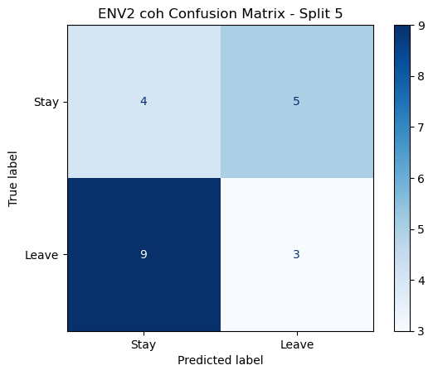

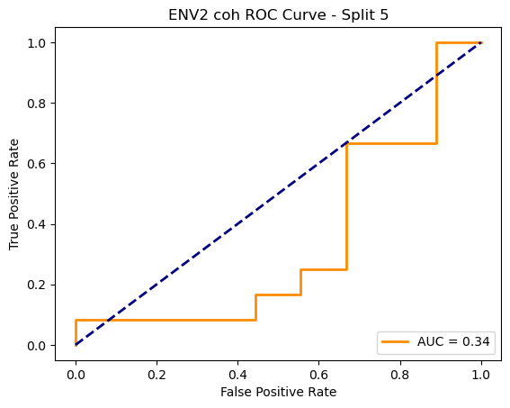

ENV2 coh Average Accuracy: 0.4610 ± 0.0936

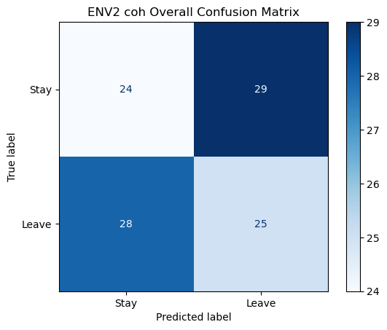

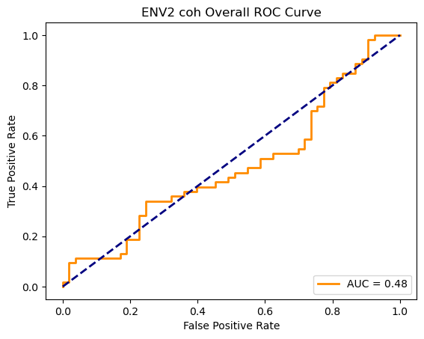

Running GNN with plv connectivity for ENV2...

==================================================

Training GNN for ENV2 with plv connectivity

==================================================

=== ENV2 Split 1/5 ===

After oversampling, class counts: Counter({0: 43, 1: 43})

C:\Users\sansk\miniconda3\Lib\site-packages\torch_geometric\deprecation.py:26: UserWarning: 'data.DataLoader' is deprecated, use 'loader.DataLoader' instead

warnings.warn(out)

Epoch 1/100 | Loss: 0.7304

Epoch 2/100 | Loss: 0.7651

Epoch 3/100 | Loss: 0.7425

Epoch 4/100 | Loss: 0.8042

Epoch 5/100 | Loss: 0.7630

Epoch 6/100 | Loss: 0.7256

Epoch 7/100 | Loss: 0.7339

Epoch 8/100 | Loss: 0.6974

Epoch 9/100 | Loss: 0.7243

Epoch 10/100 | Loss: 0.7024

Epoch 11/100 | Loss: 0.7262

Epoch 12/100 | Loss: 0.7643

Epoch 13/100 | Loss: 0.6774

Epoch 14/100 | Loss: 0.7305

Epoch 15/100 | Loss: 0.6826

Epoch 16/100 | Loss: 0.7132

Epoch 17/100 | Loss: 0.6677

Epoch 18/100 | Loss: 0.6451

Epoch 19/100 | Loss: 0.7270

Epoch 20/100 | Loss: 0.6755

Epoch 21/100 | Loss: 0.5992

Epoch 22/100 | Loss: 0.6790

Epoch 23/100 | Loss: 0.6822

Epoch 24/100 | Loss: 0.6920

Epoch 25/100 | Loss: 0.5897

Epoch 26/100 | Loss: 0.6632

Epoch 27/100 | Loss: 0.6813

Epoch 28/100 | Loss: 0.7209

Epoch 29/100 | Loss: 0.7275

Epoch 30/100 | Loss: 0.7397

Epoch 31/100 | Loss: 0.6920

Epoch 32/100 | Loss: 0.6795

Epoch 33/100 | Loss: 0.6706

Epoch 34/100 | Loss: 0.6974

Epoch 35/100 | Loss: 0.7042

Epoch 36/100 | Loss: 0.6818

Epoch 37/100 | Loss: 0.6618

Epoch 38/100 | Loss: 0.6721

Epoch 39/100 | Loss: 0.6626

Epoch 40/100 | Loss: 0.6632

Epoch 41/100 | Loss: 0.6609

Epoch 42/100 | Loss: 0.6793

Epoch 43/100 | Loss: 0.6831

Epoch 44/100 | Loss: 0.7207

Epoch 45/100 | Loss: 0.7102

Epoch 46/100 | Loss: 0.6477

Epoch 47/100 | Loss: 0.6779

Epoch 48/100 | Loss: 0.6795

Epoch 49/100 | Loss: 0.7122

Epoch 50/100 | Loss: 0.6443

Epoch 51/100 | Loss: 0.6546

Epoch 52/100 | Loss: 0.6559

Epoch 53/100 | Loss: 0.6359

Epoch 54/100 | Loss: 0.6908

Epoch 55/100 | Loss: 0.6622

Epoch 56/100 | Loss: 0.6538

Epoch 57/100 | Loss: 0.6781

Epoch 58/100 | Loss: 0.6348

Epoch 59/100 | Loss: 0.6020

Epoch 60/100 | Loss: 0.6517

Epoch 61/100 | Loss: 0.6509

Epoch 62/100 | Loss: 0.6551

Epoch 63/100 | Loss: 0.6304

Epoch 64/100 | Loss: 0.5843

Epoch 65/100 | Loss: 0.6107

Epoch 66/100 | Loss: 0.5430

Epoch 67/100 | Loss: 0.6336

Epoch 68/100 | Loss: 0.5725

Epoch 69/100 | Loss: 0.5852

Epoch 70/100 | Loss: 0.6301

Epoch 71/100 | Loss: 0.6582

Epoch 72/100 | Loss: 0.5616

Epoch 73/100 | Loss: 0.6501

Epoch 74/100 | Loss: 0.6262

Epoch 75/100 | Loss: 0.5877

Epoch 76/100 | Loss: 0.6385

Epoch 77/100 | Loss: 0.6303

Epoch 78/100 | Loss: 0.6145

Epoch 79/100 | Loss: 0.5744

Epoch 80/100 | Loss: 0.6202

Epoch 81/100 | Loss: 0.5909

Epoch 82/100 | Loss: 0.6301

Epoch 83/100 | Loss: 0.5362

Epoch 84/100 | Loss: 0.6188

Epoch 85/100 | Loss: 0.6085

Epoch 86/100 | Loss: 0.6550

Epoch 87/100 | Loss: 0.5993

Epoch 88/100 | Loss: 0.5571

Epoch 89/100 | Loss: 0.6764

Epoch 90/100 | Loss: 0.5590

Epoch 91/100 | Loss: 0.6814

Epoch 92/100 | Loss: 0.5954

Epoch 93/100 | Loss: 0.5918

Epoch 94/100 | Loss: 0.6514

Epoch 95/100 | Loss: 0.6622

Epoch 96/100 | Loss: 0.5748

Epoch 97/100 | Loss: 0.6164

Epoch 98/100 | Loss: 0.6452

Epoch 99/100 | Loss: 0.6069

Epoch 100/100 | Loss: 0.6301

Split 1 Accuracy: 0.5000

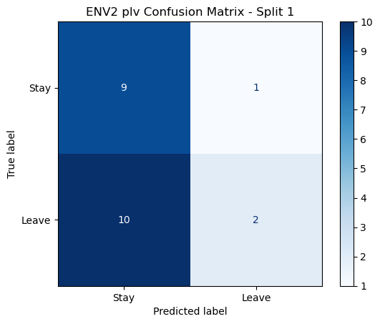

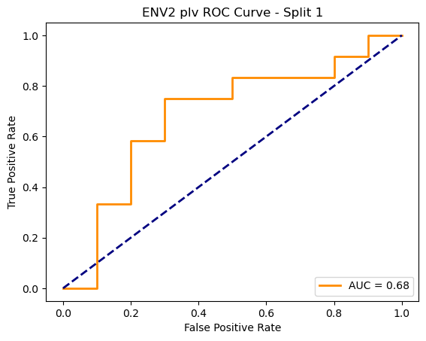

=== ENV2 Split 2/5 ===

After oversampling, class counts: Counter({1: 43, 0: 43})

C:\Users\sansk\miniconda3\Lib\site-packages\torch_geometric\deprecation.py:26: UserWarning: 'data.DataLoader' is deprecated, use 'loader.DataLoader' instead

warnings.warn(out)

Epoch 1/100 | Loss: 0.7575

Epoch 2/100 | Loss: 0.8282

Epoch 3/100 | Loss: 0.7311

Epoch 4/100 | Loss: 0.7300

Epoch 5/100 | Loss: 0.7088

Epoch 6/100 | Loss: 0.7793

Epoch 7/100 | Loss: 0.7223

Epoch 8/100 | Loss: 0.7500

Epoch 9/100 | Loss: 0.7435

Epoch 10/100 | Loss: 0.6676

Epoch 11/100 | Loss: 0.6763

Epoch 12/100 | Loss: 0.7509

Epoch 13/100 | Loss: 0.7381

Epoch 14/100 | Loss: 0.6532

Epoch 15/100 | Loss: 0.7160

Epoch 16/100 | Loss: 0.7018

Epoch 17/100 | Loss: 0.6902

Epoch 18/100 | Loss: 0.7705

Epoch 19/100 | Loss: 0.6801

Epoch 20/100 | Loss: 0.6775

Epoch 21/100 | Loss: 0.7431

Epoch 22/100 | Loss: 0.7414

Epoch 23/100 | Loss: 0.7149

Epoch 24/100 | Loss: 0.7029

Epoch 25/100 | Loss: 0.7115

Epoch 26/100 | Loss: 0.6749

Epoch 27/100 | Loss: 0.6764

Epoch 28/100 | Loss: 0.6180

Epoch 29/100 | Loss: 0.6862

Epoch 30/100 | Loss: 0.6398

Epoch 31/100 | Loss: 0.6538

Epoch 32/100 | Loss: 0.6121

Epoch 33/100 | Loss: 0.6575

Epoch 34/100 | Loss: 0.6984

Epoch 35/100 | Loss: 0.6039

Epoch 36/100 | Loss: 0.6700

Epoch 37/100 | Loss: 0.7081

Epoch 38/100 | Loss: 0.6806

Epoch 39/100 | Loss: 0.6457

Epoch 40/100 | Loss: 0.6922

Epoch 41/100 | Loss: 0.6389

Epoch 42/100 | Loss: 0.7025

Epoch 43/100 | Loss: 0.6210

Epoch 44/100 | Loss: 0.6539

Epoch 45/100 | Loss: 0.6562

Epoch 46/100 | Loss: 0.6350

Epoch 47/100 | Loss: 0.6859

Epoch 48/100 | Loss: 0.6750

Epoch 49/100 | Loss: 0.6063

Epoch 50/100 | Loss: 0.7056

Epoch 51/100 | Loss: 0.6802

Epoch 52/100 | Loss: 0.6647

Epoch 53/100 | Loss: 0.6443

Epoch 54/100 | Loss: 0.6807

Epoch 55/100 | Loss: 0.6549

Epoch 56/100 | Loss: 0.6760

Epoch 57/100 | Loss: 0.6807

Epoch 58/100 | Loss: 0.6102

Epoch 59/100 | Loss: 0.6385

Epoch 60/100 | Loss: 0.6576

Epoch 61/100 | Loss: 0.6137

Epoch 62/100 | Loss: 0.6720

Epoch 63/100 | Loss: 0.6827

Epoch 64/100 | Loss: 0.6748

Epoch 65/100 | Loss: 0.6171

Epoch 66/100 | Loss: 0.6347

Epoch 67/100 | Loss: 0.6562

Epoch 68/100 | Loss: 0.6047

Epoch 69/100 | Loss: 0.6419

Epoch 70/100 | Loss: 0.6077

Epoch 71/100 | Loss: 0.6473

Epoch 72/100 | Loss: 0.6750

Epoch 73/100 | Loss: 0.6203

Epoch 74/100 | Loss: 0.7023

Epoch 75/100 | Loss: 0.6576

Epoch 76/100 | Loss: 0.6658

Epoch 77/100 | Loss: 0.6149

Epoch 78/100 | Loss: 0.5562

Epoch 79/100 | Loss: 0.6634

Epoch 80/100 | Loss: 0.5789

Epoch 81/100 | Loss: 0.6216

Epoch 82/100 | Loss: 0.5876

Epoch 83/100 | Loss: 0.5652

Epoch 84/100 | Loss: 0.6930

Epoch 85/100 | Loss: 0.5776

Epoch 86/100 | Loss: 0.5523

Epoch 87/100 | Loss: 0.6517

Epoch 88/100 | Loss: 0.6137

Epoch 89/100 | Loss: 0.5716

Epoch 90/100 | Loss: 0.6010

Epoch 91/100 | Loss: 0.6420

Epoch 92/100 | Loss: 0.6158

Epoch 93/100 | Loss: 0.5831

Epoch 94/100 | Loss: 0.6125

Epoch 95/100 | Loss: 0.6034

Epoch 96/100 | Loss: 0.6569

Epoch 97/100 | Loss: 0.6470

Epoch 98/100 | Loss: 0.6641

Epoch 99/100 | Loss: 0.5268

Epoch 100/100 | Loss: 0.6508

Split 2 Accuracy: 0.5238

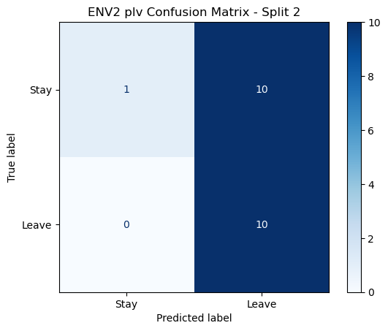

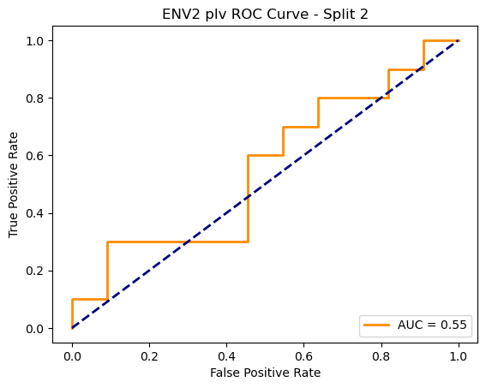

=== ENV2 Split 3/5 ===

After oversampling, class counts: Counter({1: 43, 0: 43})

C:\Users\sansk\miniconda3\Lib\site-packages\torch_geometric\deprecation.py:26: UserWarning: 'data.DataLoader' is deprecated, use 'loader.DataLoader' instead

warnings.warn(out)

Epoch 1/100 | Loss: 0.8257

Epoch 2/100 | Loss: 0.7505

Epoch 3/100 | Loss: 0.7576

Epoch 4/100 | Loss: 0.7306

Epoch 5/100 | Loss: 0.6913

Epoch 6/100 | Loss: 0.7439

Epoch 7/100 | Loss: 0.6669

Epoch 8/100 | Loss: 0.7201

Epoch 9/100 | Loss: 0.6949

Epoch 10/100 | Loss: 0.7434

Epoch 11/100 | Loss: 0.7161

Epoch 12/100 | Loss: 0.7147

Epoch 13/100 | Loss: 0.7336

Epoch 14/100 | Loss: 0.7150

Epoch 15/100 | Loss: 0.6675

Epoch 16/100 | Loss: 0.7251

Epoch 17/100 | Loss: 0.6423

Epoch 18/100 | Loss: 0.7430

Epoch 19/100 | Loss: 0.6948

Epoch 20/100 | Loss: 0.7105

Epoch 21/100 | Loss: 0.7175

Epoch 22/100 | Loss: 0.7191

Epoch 23/100 | Loss: 0.7204

Epoch 24/100 | Loss: 0.6790

Epoch 25/100 | Loss: 0.6873

Epoch 26/100 | Loss: 0.6972

Epoch 27/100 | Loss: 0.6718

Epoch 28/100 | Loss: 0.6514

Epoch 29/100 | Loss: 0.7089

Epoch 30/100 | Loss: 0.7246

Epoch 31/100 | Loss: 0.6812

Epoch 32/100 | Loss: 0.6705

Epoch 33/100 | Loss: 0.6918

Epoch 34/100 | Loss: 0.7202

Epoch 35/100 | Loss: 0.6446

Epoch 36/100 | Loss: 0.6666

Epoch 37/100 | Loss: 0.6325

Epoch 38/100 | Loss: 0.7315

Epoch 39/100 | Loss: 0.6419

Epoch 40/100 | Loss: 0.6643

Epoch 41/100 | Loss: 0.6506

Epoch 42/100 | Loss: 0.6667

Epoch 43/100 | Loss: 0.6141

Epoch 44/100 | Loss: 0.6062

Epoch 45/100 | Loss: 0.6870

Epoch 46/100 | Loss: 0.7216

Epoch 47/100 | Loss: 0.6801

Epoch 48/100 | Loss: 0.6714

Epoch 49/100 | Loss: 0.6843

Epoch 50/100 | Loss: 0.7142

Epoch 51/100 | Loss: 0.6451

Epoch 52/100 | Loss: 0.7083

Epoch 53/100 | Loss: 0.6731

Epoch 54/100 | Loss: 0.6641

Epoch 55/100 | Loss: 0.6709

Epoch 56/100 | Loss: 0.6480

Epoch 57/100 | Loss: 0.6416

Epoch 58/100 | Loss: 0.6697

Epoch 59/100 | Loss: 0.6784

Epoch 60/100 | Loss: 0.6778

Epoch 61/100 | Loss: 0.6424

Epoch 62/100 | Loss: 0.6935

Epoch 63/100 | Loss: 0.7018

Epoch 64/100 | Loss: 0.6057

Epoch 65/100 | Loss: 0.7457

Epoch 66/100 | Loss: 0.6532

Epoch 67/100 | Loss: 0.6414

Epoch 68/100 | Loss: 0.6681

Epoch 69/100 | Loss: 0.6409

Epoch 70/100 | Loss: 0.7099

Epoch 71/100 | Loss: 0.5601

Epoch 72/100 | Loss: 0.6236

Epoch 73/100 | Loss: 0.6623

Epoch 74/100 | Loss: 0.6792

Epoch 75/100 | Loss: 0.6342

Epoch 76/100 | Loss: 0.6779

Epoch 77/100 | Loss: 0.7134

Epoch 78/100 | Loss: 0.6158

Epoch 79/100 | Loss: 0.7119

Epoch 80/100 | Loss: 0.6352

Epoch 81/100 | Loss: 0.6463

Epoch 82/100 | Loss: 0.6512

Epoch 83/100 | Loss: 0.6315

Epoch 84/100 | Loss: 0.6696

Epoch 85/100 | Loss: 0.6357

Epoch 86/100 | Loss: 0.6734

Epoch 87/100 | Loss: 0.6107

Epoch 88/100 | Loss: 0.6007

Epoch 89/100 | Loss: 0.6117

Epoch 90/100 | Loss: 0.6413

Epoch 91/100 | Loss: 0.6676

Epoch 92/100 | Loss: 0.6224

Epoch 93/100 | Loss: 0.6365

Epoch 94/100 | Loss: 0.5323

Epoch 95/100 | Loss: 0.6429

Epoch 96/100 | Loss: 0.5638

Epoch 97/100 | Loss: 0.6434

Epoch 98/100 | Loss: 0.5923

Epoch 99/100 | Loss: 0.6212

Epoch 100/100 | Loss: 0.5914

Split 3 Accuracy: 0.5238

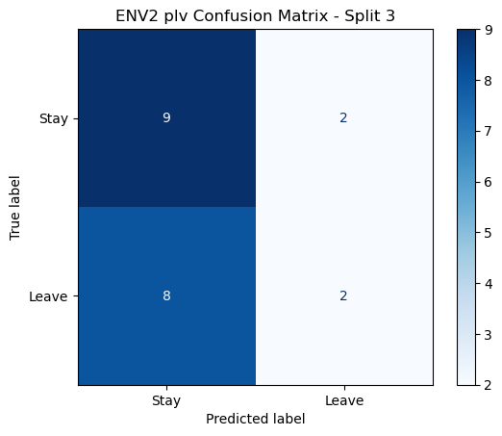

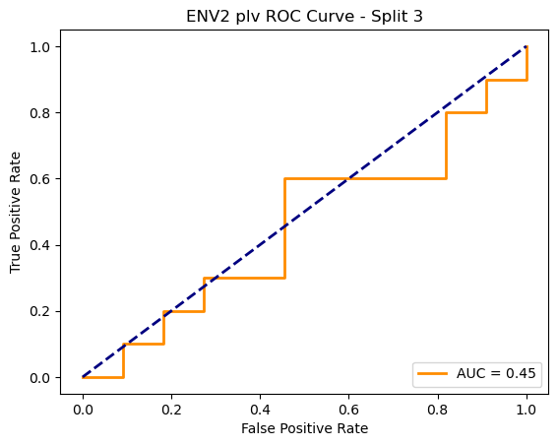

=== ENV2 Split 4/5 ===

After oversampling, class counts: Counter({1: 44, 0: 44})

C:\Users\sansk\miniconda3\Lib\site-packages\torch_geometric\deprecation.py:26: UserWarning: 'data.DataLoader' is deprecated, use 'loader.DataLoader' instead

warnings.warn(out)

Epoch 1/100 | Loss: 0.7273

Epoch 2/100 | Loss: 0.8157

Epoch 3/100 | Loss: 0.7607

Epoch 4/100 | Loss: 0.7910

Epoch 5/100 | Loss: 0.8346

Epoch 6/100 | Loss: 0.6628

Epoch 7/100 | Loss: 0.7815

Epoch 8/100 | Loss: 0.6797

Epoch 9/100 | Loss: 0.7327

Epoch 10/100 | Loss: 0.7141

Epoch 11/100 | Loss: 0.7210

Epoch 12/100 | Loss: 0.7251

Epoch 13/100 | Loss: 0.6710

Epoch 14/100 | Loss: 0.6891

Epoch 15/100 | Loss: 0.7173

Epoch 16/100 | Loss: 0.7073

Epoch 17/100 | Loss: 0.6709

Epoch 18/100 | Loss: 0.7288

Epoch 19/100 | Loss: 0.7310

Epoch 20/100 | Loss: 0.6304

Epoch 21/100 | Loss: 0.6908

Epoch 22/100 | Loss: 0.8119

Epoch 23/100 | Loss: 0.7194

Epoch 24/100 | Loss: 0.7364

Epoch 25/100 | Loss: 0.7191

Epoch 26/100 | Loss: 0.6481

Epoch 27/100 | Loss: 0.6661

Epoch 28/100 | Loss: 0.6481

Epoch 29/100 | Loss: 0.6647

Epoch 30/100 | Loss: 0.6497

Epoch 31/100 | Loss: 0.6199

Epoch 32/100 | Loss: 0.6917

Epoch 33/100 | Loss: 0.6939

Epoch 34/100 | Loss: 0.6311

Epoch 35/100 | Loss: 0.7252

Epoch 36/100 | Loss: 0.6800

Epoch 37/100 | Loss: 0.5805

Epoch 38/100 | Loss: 0.6971

Epoch 39/100 | Loss: 0.6602

Epoch 40/100 | Loss: 0.7289

Epoch 41/100 | Loss: 0.6595

Epoch 42/100 | Loss: 0.7038

Epoch 43/100 | Loss: 0.5918

Epoch 44/100 | Loss: 0.6441

Epoch 45/100 | Loss: 0.6837

Epoch 46/100 | Loss: 0.6335

Epoch 47/100 | Loss: 0.6533

Epoch 48/100 | Loss: 0.6249

Epoch 49/100 | Loss: 0.6453

Epoch 50/100 | Loss: 0.6502

Epoch 51/100 | Loss: 0.7101

Epoch 52/100 | Loss: 0.6480

Epoch 53/100 | Loss: 0.6070

Epoch 54/100 | Loss: 0.6722

Epoch 55/100 | Loss: 0.6395

Epoch 56/100 | Loss: 0.6285

Epoch 57/100 | Loss: 0.6562

Epoch 58/100 | Loss: 0.5681

Epoch 59/100 | Loss: 0.6555

Epoch 60/100 | Loss: 0.6434

Epoch 61/100 | Loss: 0.7272

Epoch 62/100 | Loss: 0.5921

Epoch 63/100 | Loss: 0.6172

Epoch 64/100 | Loss: 0.6461

Epoch 65/100 | Loss: 0.6623

Epoch 66/100 | Loss: 0.7118

Epoch 67/100 | Loss: 0.6905

Epoch 68/100 | Loss: 0.6863

Epoch 69/100 | Loss: 0.6018

Epoch 70/100 | Loss: 0.6545

Epoch 71/100 | Loss: 0.6565

Epoch 72/100 | Loss: 0.6801

Epoch 73/100 | Loss: 0.5869

Epoch 74/100 | Loss: 0.6733

Epoch 75/100 | Loss: 0.6772

Epoch 76/100 | Loss: 0.6444

Epoch 77/100 | Loss: 0.5635

Epoch 78/100 | Loss: 0.6565

Epoch 79/100 | Loss: 0.6431

Epoch 80/100 | Loss: 0.6219

Epoch 81/100 | Loss: 0.5711

Epoch 82/100 | Loss: 0.5597

Epoch 83/100 | Loss: 0.6722

Epoch 84/100 | Loss: 0.5873

Epoch 85/100 | Loss: 0.6766

Epoch 86/100 | Loss: 0.6940

Epoch 87/100 | Loss: 0.5721

Epoch 88/100 | Loss: 0.6628

Epoch 89/100 | Loss: 0.6515

Epoch 90/100 | Loss: 0.5857

Epoch 91/100 | Loss: 0.5597

Epoch 92/100 | Loss: 0.6010

Epoch 93/100 | Loss: 0.6486

Epoch 94/100 | Loss: 0.6387

Epoch 95/100 | Loss: 0.5755

Epoch 96/100 | Loss: 0.5948

Epoch 97/100 | Loss: 0.5239

Epoch 98/100 | Loss: 0.5977

Epoch 99/100 | Loss: 0.5781

Epoch 100/100 | Loss: 0.5748

Split 4 Accuracy: 0.4762

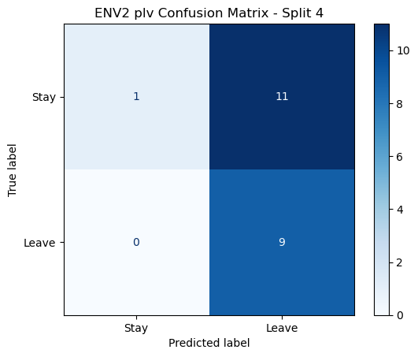

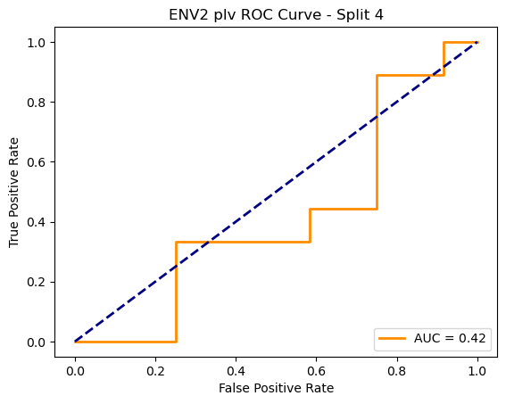

=== ENV2 Split 5/5 ===

After oversampling, class counts: Counter({1: 44, 0: 44})

C:\Users\sansk\miniconda3\Lib\site-packages\torch_geometric\deprecation.py:26: UserWarning: 'data.DataLoader' is deprecated, use 'loader.DataLoader' instead

warnings.warn(out)

Epoch 1/100 | Loss: 0.6794

Epoch 2/100 | Loss: 0.7713

Epoch 3/100 | Loss: 0.7232

Epoch 4/100 | Loss: 0.7291

Epoch 5/100 | Loss: 0.7080

Epoch 6/100 | Loss: 0.6897

Epoch 7/100 | Loss: 0.7634

Epoch 8/100 | Loss: 0.7241

Epoch 9/100 | Loss: 0.6929

Epoch 10/100 | Loss: 0.7365

Epoch 11/100 | Loss: 0.7232

Epoch 12/100 | Loss: 0.7618

Epoch 13/100 | Loss: 0.7398

Epoch 14/100 | Loss: 0.7451

Epoch 15/100 | Loss: 0.7866

Epoch 16/100 | Loss: 0.7121

Epoch 17/100 | Loss: 0.7223

Epoch 18/100 | Loss: 0.7199

Epoch 19/100 | Loss: 0.7426

Epoch 20/100 | Loss: 0.7214

Epoch 21/100 | Loss: 0.7353

Epoch 22/100 | Loss: 0.6588

Epoch 23/100 | Loss: 0.7196

Epoch 24/100 | Loss: 0.6937

Epoch 25/100 | Loss: 0.7211

Epoch 26/100 | Loss: 0.6723

Epoch 27/100 | Loss: 0.7123

Epoch 28/100 | Loss: 0.7457

Epoch 29/100 | Loss: 0.7282

Epoch 30/100 | Loss: 0.7585

Epoch 31/100 | Loss: 0.6777

Epoch 32/100 | Loss: 0.7605

Epoch 33/100 | Loss: 0.6774

Epoch 34/100 | Loss: 0.6928

Epoch 35/100 | Loss: 0.6988

Epoch 36/100 | Loss: 0.6805

Epoch 37/100 | Loss: 0.6612

Epoch 38/100 | Loss: 0.6912

Epoch 39/100 | Loss: 0.6469

Epoch 40/100 | Loss: 0.6904

Epoch 41/100 | Loss: 0.6768

Epoch 42/100 | Loss: 0.6676

Epoch 43/100 | Loss: 0.7011

Epoch 44/100 | Loss: 0.6915

Epoch 45/100 | Loss: 0.6553

Epoch 46/100 | Loss: 0.6273

Epoch 47/100 | Loss: 0.7250

Epoch 48/100 | Loss: 0.7126

Epoch 49/100 | Loss: 0.6517

Epoch 50/100 | Loss: 0.6398

Epoch 51/100 | Loss: 0.6822

Epoch 52/100 | Loss: 0.6561

Epoch 53/100 | Loss: 0.6815

Epoch 54/100 | Loss: 0.6837

Epoch 55/100 | Loss: 0.6543

Epoch 56/100 | Loss: 0.6024

Epoch 57/100 | Loss: 0.6947

Epoch 58/100 | Loss: 0.6860

Epoch 59/100 | Loss: 0.6750

Epoch 60/100 | Loss: 0.6724

Epoch 61/100 | Loss: 0.7308

Epoch 62/100 | Loss: 0.6542

Epoch 63/100 | Loss: 0.6587

Epoch 64/100 | Loss: 0.7146

Epoch 65/100 | Loss: 0.6859

Epoch 66/100 | Loss: 0.6561

Epoch 67/100 | Loss: 0.6120

Epoch 68/100 | Loss: 0.7191

Epoch 69/100 | Loss: 0.6998

Epoch 70/100 | Loss: 0.6089

Epoch 71/100 | Loss: 0.6064

Epoch 72/100 | Loss: 0.5832

Epoch 73/100 | Loss: 0.6260

Epoch 74/100 | Loss: 0.6311

Epoch 75/100 | Loss: 0.5981

Epoch 76/100 | Loss: 0.6173

Epoch 77/100 | Loss: 0.6422

Epoch 78/100 | Loss: 0.6087

Epoch 79/100 | Loss: 0.5581

Epoch 80/100 | Loss: 0.5915

Epoch 81/100 | Loss: 0.6431

Epoch 82/100 | Loss: 0.5874

Epoch 83/100 | Loss: 0.6822

Epoch 84/100 | Loss: 0.6625

Epoch 85/100 | Loss: 0.5912

Epoch 86/100 | Loss: 0.5695

Epoch 87/100 | Loss: 0.6307

Epoch 88/100 | Loss: 0.6674

Epoch 89/100 | Loss: 0.5788

Epoch 90/100 | Loss: 0.6541

Epoch 91/100 | Loss: 0.6701

Epoch 92/100 | Loss: 0.6309

Epoch 93/100 | Loss: 0.5628

Epoch 94/100 | Loss: 0.6486

Epoch 95/100 | Loss: 0.6081

Epoch 96/100 | Loss: 0.6094

Epoch 97/100 | Loss: 0.6448

Epoch 98/100 | Loss: 0.6089

Epoch 99/100 | Loss: 0.6114

Epoch 100/100 | Loss: 0.5534

Split 5 Accuracy: 0.4762

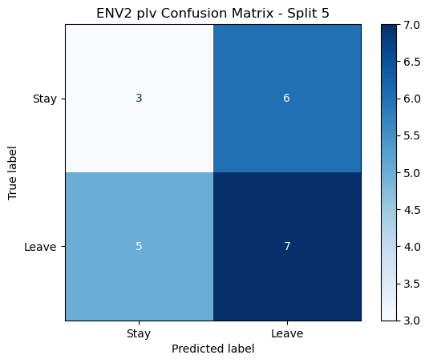

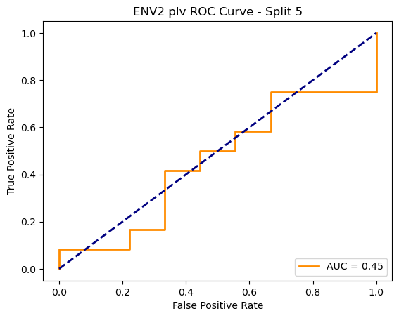

ENV2 plv Average Accuracy: 0.5000 ± 0.0213

