=== Processing Split 1/10 ===

C:\Users\sansk\miniconda3\Lib\site-packages\torch_geometric\deprecation.py:26: UserWarning: 'data.DataLoader' is deprecated, use 'loader.DataLoader' instead

warnings.warn(out)

Epoch 1/20 | Loss: 2.3016

Epoch 2/20 | Loss: 2.1102

Epoch 3/20 | Loss: 1.0946

Epoch 4/20 | Loss: 0.2182

Epoch 5/20 | Loss: 0.0192

Epoch 6/20 | Loss: 0.0118

Epoch 7/20 | Loss: 0.0104

Epoch 8/20 | Loss: 0.0099

Epoch 9/20 | Loss: 0.0094

Epoch 10/20 | Loss: 0.0090

Epoch 11/20 | Loss: 0.0087

Epoch 12/20 | Loss: 0.0089

Epoch 13/20 | Loss: 0.0098

Epoch 14/20 | Loss: 0.0134

Epoch 15/20 | Loss: 0.0064

Epoch 16/20 | Loss: 0.0057

Epoch 17/20 | Loss: 0.0052

Epoch 18/20 | Loss: 0.0048

Epoch 19/20 | Loss: 0.0045

Epoch 20/20 | Loss: 0.0043

Accuracy: 0.8889

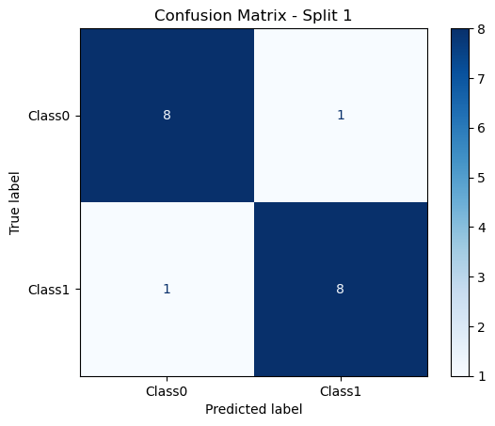

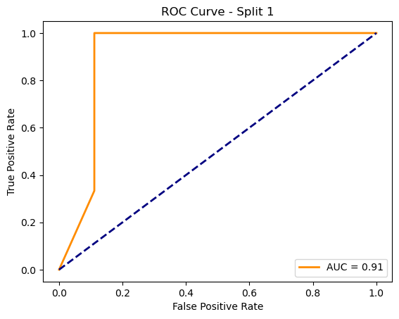

=== Processing Split 2/10 ===

C:\Users\sansk\miniconda3\Lib\site-packages\torch_geometric\deprecation.py:26: UserWarning: 'data.DataLoader' is deprecated, use 'loader.DataLoader' instead

warnings.warn(out)

Epoch 1/20 | Loss: 8.4074

Epoch 2/20 | Loss: 3.9417

Epoch 3/20 | Loss: nan

Epoch 4/20 | Loss: nan

Epoch 5/20 | Loss: nan

Epoch 6/20 | Loss: nan

Epoch 7/20 | Loss: nan

Epoch 8/20 | Loss: nan

Epoch 9/20 | Loss: nan

Epoch 10/20 | Loss: nan

Epoch 11/20 | Loss: nan

Epoch 12/20 | Loss: nan

Epoch 13/20 | Loss: nan

Epoch 14/20 | Loss: nan

Epoch 15/20 | Loss: nan

Epoch 16/20 | Loss: nan

Epoch 17/20 | Loss: nan

Epoch 18/20 | Loss: nan

Epoch 19/20 | Loss: nan

Epoch 20/20 | Loss: nan

Accuracy: 0.6875

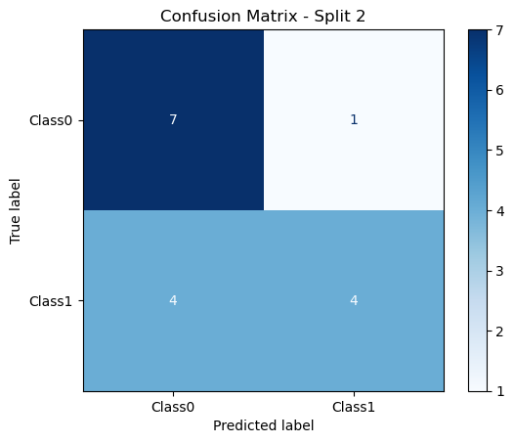

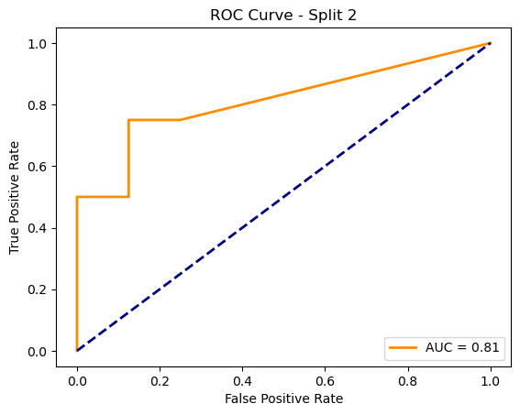

=== Processing Split 3/10 ===

C:\Users\sansk\miniconda3\Lib\site-packages\torch_geometric\deprecation.py:26: UserWarning: 'data.DataLoader' is deprecated, use 'loader.DataLoader' instead

warnings.warn(out)

Epoch 1/20 | Loss: 3.6844

Epoch 2/20 | Loss: 1.7424

Epoch 3/20 | Loss: nan

Epoch 4/20 | Loss: nan

Epoch 5/20 | Loss: nan

Epoch 6/20 | Loss: nan

Epoch 7/20 | Loss: nan

Epoch 8/20 | Loss: nan

Epoch 9/20 | Loss: nan

Epoch 10/20 | Loss: nan

Epoch 11/20 | Loss: nan

Epoch 12/20 | Loss: nan

Epoch 13/20 | Loss: nan

Epoch 14/20 | Loss: nan

Epoch 15/20 | Loss: nan

Epoch 16/20 | Loss: nan

Epoch 17/20 | Loss: nan

Epoch 18/20 | Loss: nan

Epoch 19/20 | Loss: nan

Epoch 20/20 | Loss: nan

Accuracy: 0.7500

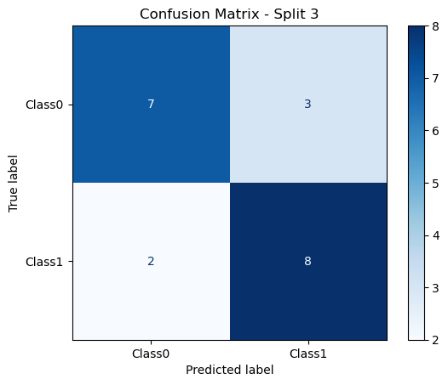

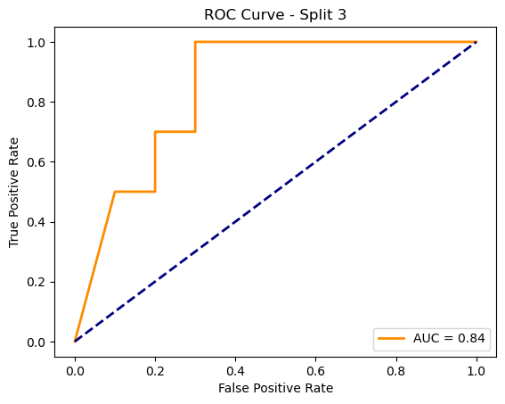

=== Processing Split 4/10 ===

C:\Users\sansk\miniconda3\Lib\site-packages\torch_geometric\deprecation.py:26: UserWarning: 'data.DataLoader' is deprecated, use 'loader.DataLoader' instead

warnings.warn(out)

Epoch 1/20 | Loss: 5.0880

Epoch 2/20 | Loss: 1.9350

Epoch 3/20 | Loss: nan

Epoch 4/20 | Loss: nan

Epoch 5/20 | Loss: nan

Epoch 6/20 | Loss: nan

Epoch 7/20 | Loss: nan

Epoch 8/20 | Loss: nan

Epoch 9/20 | Loss: nan

Epoch 10/20 | Loss: nan

Epoch 11/20 | Loss: nan

Epoch 12/20 | Loss: nan

Epoch 13/20 | Loss: nan

Epoch 14/20 | Loss: nan

Epoch 15/20 | Loss: nan

Epoch 16/20 | Loss: nan

Epoch 17/20 | Loss: nan

Epoch 18/20 | Loss: nan

Epoch 19/20 | Loss: nan

Epoch 20/20 | Loss: nan

Accuracy: 0.7778

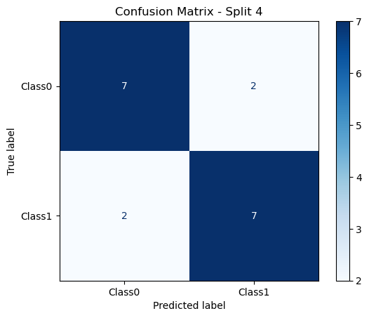

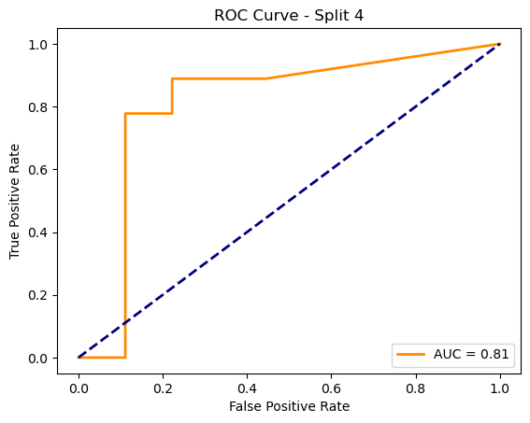

=== Processing Split 5/10 ===

C:\Users\sansk\miniconda3\Lib\site-packages\torch_geometric\deprecation.py:26: UserWarning: 'data.DataLoader' is deprecated, use 'loader.DataLoader' instead

warnings.warn(out)

Epoch 1/20 | Loss: 2.6362

Epoch 2/20 | Loss: nan

Epoch 3/20 | Loss: nan

Epoch 4/20 | Loss: nan

Epoch 5/20 | Loss: nan

Epoch 6/20 | Loss: nan

Epoch 7/20 | Loss: nan

Epoch 8/20 | Loss: nan

Epoch 9/20 | Loss: nan

Epoch 10/20 | Loss: nan

Epoch 11/20 | Loss: nan

Epoch 12/20 | Loss: nan

Epoch 13/20 | Loss: nan

Epoch 14/20 | Loss: nan

Epoch 15/20 | Loss: nan

Epoch 16/20 | Loss: nan

Epoch 17/20 | Loss: nan

Epoch 18/20 | Loss: nan

Epoch 19/20 | Loss: nan

Epoch 20/20 | Loss: nan

Accuracy: 0.7500

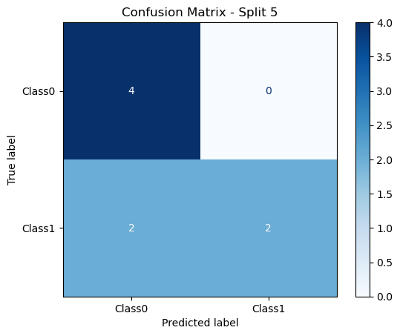

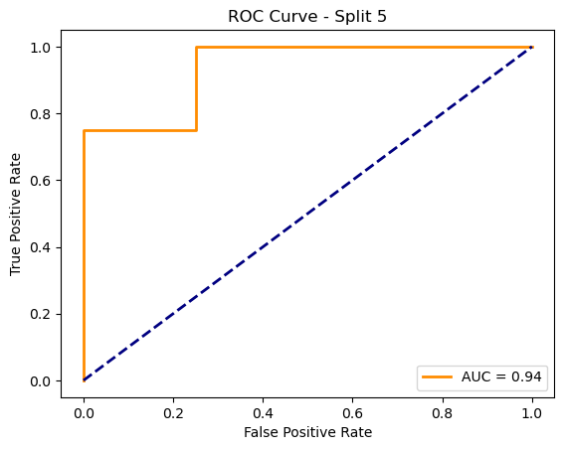

=== Processing Split 6/10 ===

C:\Users\sansk\miniconda3\Lib\site-packages\torch_geometric\deprecation.py:26: UserWarning: 'data.DataLoader' is deprecated, use 'loader.DataLoader' instead

warnings.warn(out)

Epoch 1/20 | Loss: 3.2487

Epoch 2/20 | Loss: 2.5252

Epoch 3/20 | Loss: 0.1916

Epoch 4/20 | Loss: nan

Epoch 5/20 | Loss: nan

Epoch 6/20 | Loss: nan

Epoch 7/20 | Loss: nan

Epoch 8/20 | Loss: nan

Epoch 9/20 | Loss: nan

Epoch 10/20 | Loss: nan

Epoch 11/20 | Loss: nan

Epoch 12/20 | Loss: nan

Epoch 13/20 | Loss: nan

Epoch 14/20 | Loss: nan

Epoch 15/20 | Loss: nan

Epoch 16/20 | Loss: nan

Epoch 17/20 | Loss: nan

Epoch 18/20 | Loss: nan

Epoch 19/20 | Loss: nan

Epoch 20/20 | Loss: nan

Accuracy: 0.7500

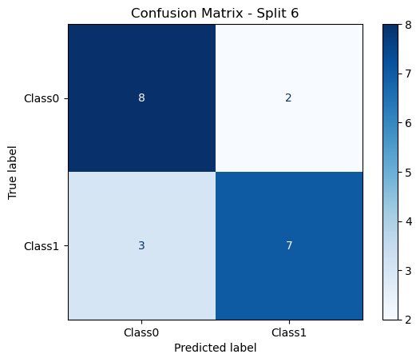

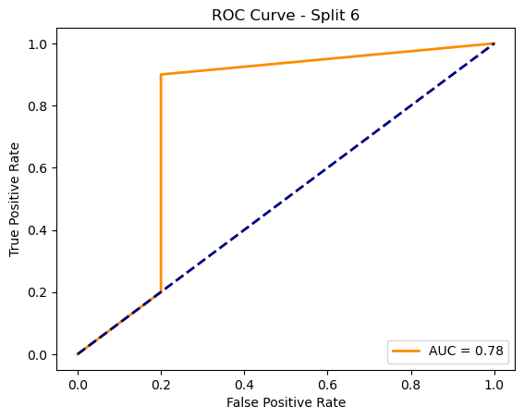

=== Processing Split 7/10 ===

C:\Users\sansk\miniconda3\Lib\site-packages\torch_geometric\deprecation.py:26: UserWarning: 'data.DataLoader' is deprecated, use 'loader.DataLoader' instead

warnings.warn(out)

Epoch 1/20 | Loss: 10.6109

Epoch 2/20 | Loss: nan

Epoch 3/20 | Loss: nan

Epoch 4/20 | Loss: nan

Epoch 5/20 | Loss: nan

Epoch 6/20 | Loss: nan

Epoch 7/20 | Loss: nan

Epoch 8/20 | Loss: nan

Epoch 9/20 | Loss: nan

Epoch 10/20 | Loss: nan

Epoch 11/20 | Loss: nan

Epoch 12/20 | Loss: nan

Epoch 13/20 | Loss: nan

Epoch 14/20 | Loss: nan

Epoch 15/20 | Loss: nan

Epoch 16/20 | Loss: nan

Epoch 17/20 | Loss: nan

Epoch 18/20 | Loss: nan

Epoch 19/20 | Loss: nan

Epoch 20/20 | Loss: nan

Accuracy: 0.8000

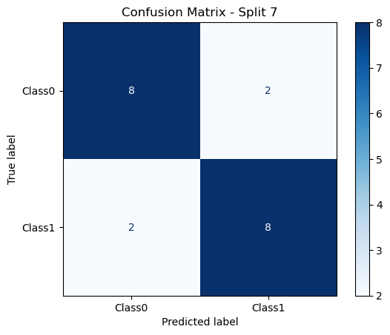

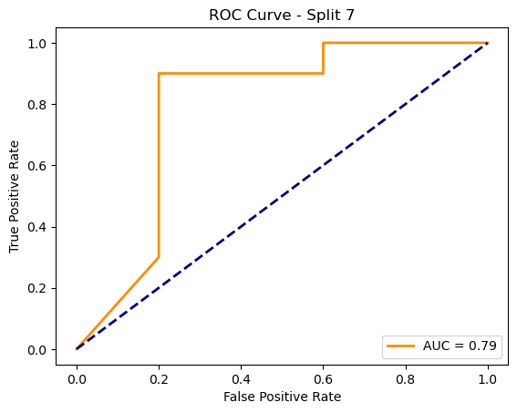

=== Processing Split 8/10 ===

C:\Users\sansk\miniconda3\Lib\site-packages\torch_geometric\deprecation.py:26: UserWarning: 'data.DataLoader' is deprecated, use 'loader.DataLoader' instead

warnings.warn(out)

Epoch 1/20 | Loss: 4.2494

Epoch 2/20 | Loss: nan

Epoch 3/20 | Loss: nan

Epoch 4/20 | Loss: nan

Epoch 5/20 | Loss: nan

Epoch 6/20 | Loss: nan

Epoch 7/20 | Loss: nan

Epoch 8/20 | Loss: nan

Epoch 9/20 | Loss: nan

Epoch 10/20 | Loss: nan

Epoch 11/20 | Loss: nan

Epoch 12/20 | Loss: nan

Epoch 13/20 | Loss: nan

Epoch 14/20 | Loss: nan

Epoch 15/20 | Loss: nan

Epoch 16/20 | Loss: nan

Epoch 17/20 | Loss: nan

Epoch 18/20 | Loss: nan

Epoch 19/20 | Loss: nan

Epoch 20/20 | Loss: nan

Accuracy: 0.9000

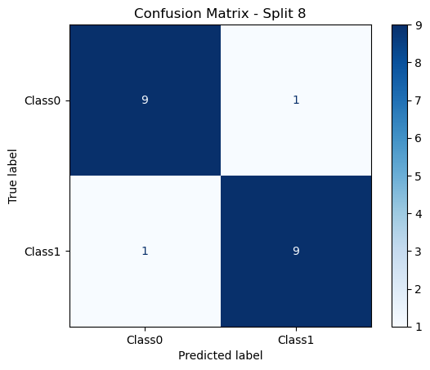

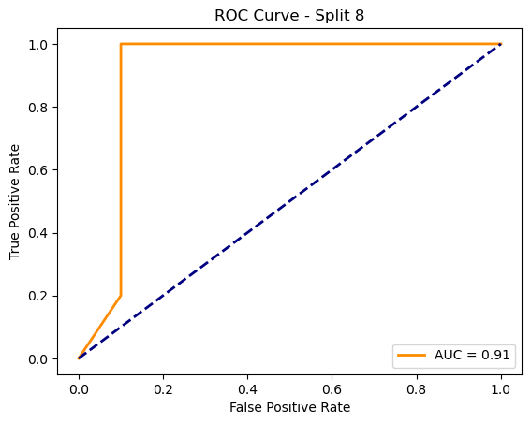

=== Processing Split 9/10 ===

C:\Users\sansk\miniconda3\Lib\site-packages\torch_geometric\deprecation.py:26: UserWarning: 'data.DataLoader' is deprecated, use 'loader.DataLoader' instead

warnings.warn(out)

Epoch 1/20 | Loss: 2.2626

Epoch 2/20 | Loss: 2.0814

Epoch 3/20 | Loss: 5.4428

Epoch 4/20 | Loss: nan

Epoch 5/20 | Loss: nan

Epoch 6/20 | Loss: nan

Epoch 7/20 | Loss: nan

Epoch 8/20 | Loss: nan

Epoch 9/20 | Loss: nan

Epoch 10/20 | Loss: nan

Epoch 11/20 | Loss: nan

Epoch 12/20 | Loss: nan

Epoch 13/20 | Loss: nan

Epoch 14/20 | Loss: nan

Epoch 15/20 | Loss: nan

Epoch 16/20 | Loss: nan

Epoch 17/20 | Loss: nan

Epoch 18/20 | Loss: nan

Epoch 19/20 | Loss: nan

Epoch 20/20 | Loss: nan

Accuracy: 0.8000

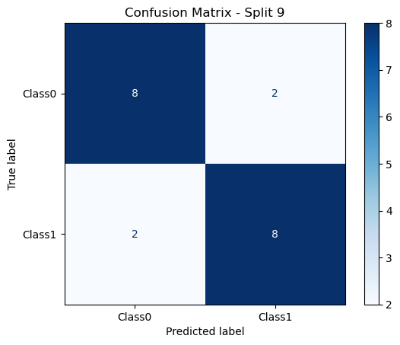

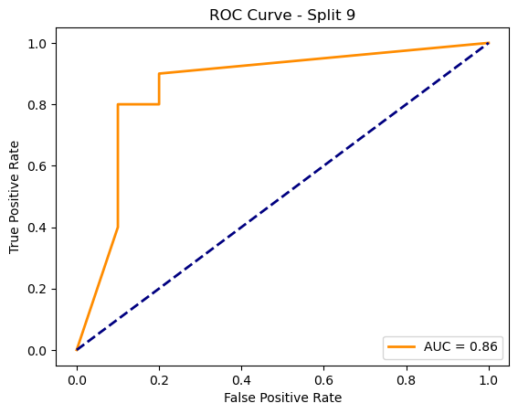

=== Processing Split 10/10 ===

C:\Users\sansk\miniconda3\Lib\site-packages\torch_geometric\deprecation.py:26: UserWarning: 'data.DataLoader' is deprecated, use 'loader.DataLoader' instead

warnings.warn(out)

Epoch 1/20 | Loss: 1.1783

Epoch 2/20 | Loss: 1.9057

Epoch 3/20 | Loss: 0.4755

Epoch 4/20 | Loss: 0.1641

Epoch 5/20 | Loss: 0.0608

Epoch 6/20 | Loss: 0.0540

Epoch 7/20 | Loss: nan

Epoch 8/20 | Loss: nan

Epoch 9/20 | Loss: nan

Epoch 10/20 | Loss: nan

Epoch 11/20 | Loss: nan

Epoch 12/20 | Loss: nan

Epoch 13/20 | Loss: nan

Epoch 14/20 | Loss: nan

Epoch 15/20 | Loss: nan

Epoch 16/20 | Loss: nan

Epoch 17/20 | Loss: nan

Epoch 18/20 | Loss: nan

Epoch 19/20 | Loss: nan

Epoch 20/20 | Loss: nan

Accuracy: 0.7000

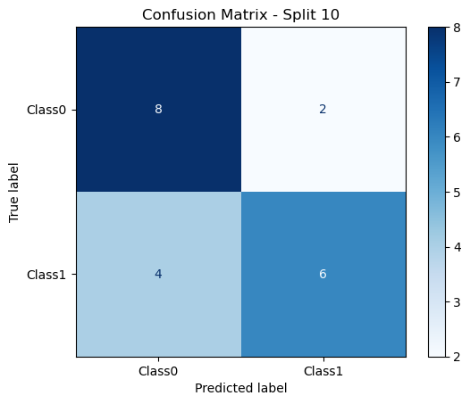

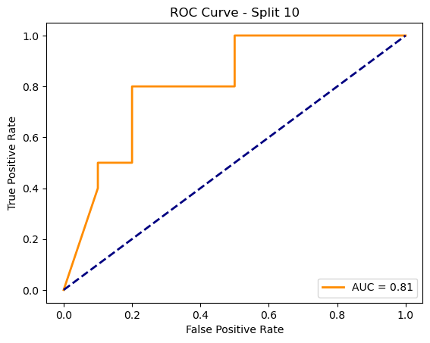

Average Test Accuracy: 0.7804 ± 0.0669