Loaded 53 leave files.

Stay shape: (6830, 32, 251), Leave shape: (1389, 32, 251)

Oversampled shapes: Stay=(6830, 32, 251), Leave=(6830, 32, 251)

Final dataset shape: (13660, 1, 32, 251), Class balance: (6830, 6830)

Using device: cuda

Fold 1/5

Epoch 1: Train loss 0.6927, acc 0.5194 | Val loss 0.7051, acc 0.5015

Epoch 2: Train loss 0.6882, acc 0.5410 | Val loss 0.8007, acc 0.4996

Epoch 3: Train loss 0.6839, acc 0.5530 | Val loss 0.8743, acc 0.5007

Epoch 4: Train loss 0.6802, acc 0.5605 | Val loss 0.8939, acc 0.4989

Epoch 5: Train loss 0.6796, acc 0.5603 | Val loss 1.1368, acc 0.5048

Epoch 6: Train loss 0.6762, acc 0.5658 | Val loss 0.7129, acc 0.5095

Epoch 7: Train loss 0.6727, acc 0.5693 | Val loss 0.6837, acc 0.5586

Epoch 8: Train loss 0.6718, acc 0.5685 | Val loss 0.9617, acc 0.5007

Epoch 9: Train loss 0.6687, acc 0.5697 | Val loss 0.7189, acc 0.5187

Epoch 10: Train loss 0.6667, acc 0.5717 | Val loss 0.7016, acc 0.5377

Fold 2/5

Epoch 1: Train loss 0.6929, acc 0.5187 | Val loss 0.6910, acc 0.5176

Epoch 2: Train loss 0.6880, acc 0.5381 | Val loss 0.6906, acc 0.5275

Epoch 3: Train loss 0.6838, acc 0.5516 | Val loss 0.8032, acc 0.5015

Epoch 4: Train loss 0.6802, acc 0.5572 | Val loss 0.7226, acc 0.5077

Epoch 5: Train loss 0.6787, acc 0.5593 | Val loss 0.8152, acc 0.5095

Epoch 6: Train loss 0.6757, acc 0.5641 | Val loss 1.2680, acc 0.5015

Epoch 7: Train loss 0.6725, acc 0.5708 | Val loss 1.4398, acc 0.5004

Epoch 8: Train loss 0.6696, acc 0.5749 | Val loss 1.0527, acc 0.5015

Epoch 9: Train loss 0.6674, acc 0.5794 | Val loss 1.5823, acc 0.5011

Epoch 10: Train loss 0.6660, acc 0.5794 | Val loss 0.8167, acc 0.5117

Fold 3/5

Epoch 1: Train loss 0.6924, acc 0.5145 | Val loss 0.7222, acc 0.5022

Epoch 2: Train loss 0.6875, acc 0.5426 | Val loss 0.6997, acc 0.5150

Epoch 3: Train loss 0.6835, acc 0.5500 | Val loss 0.7388, acc 0.5011

Epoch 4: Train loss 0.6806, acc 0.5605 | Val loss 0.7438, acc 0.5033

Epoch 5: Train loss 0.6774, acc 0.5669 | Val loss 1.7485, acc 0.5000

Epoch 6: Train loss 0.6754, acc 0.5690 | Val loss 0.8163, acc 0.5084

Epoch 7: Train loss 0.6728, acc 0.5708 | Val loss 0.8682, acc 0.5029

Epoch 8: Train loss 0.6711, acc 0.5733 | Val loss 0.7192, acc 0.5132

Epoch 9: Train loss 0.6692, acc 0.5701 | Val loss 1.0599, acc 0.5037

Epoch 10: Train loss 0.6676, acc 0.5745 | Val loss 0.7301, acc 0.5187

Fold 4/5

Epoch 1: Train loss 0.6925, acc 0.5176 | Val loss 0.6959, acc 0.5033

Epoch 2: Train loss 0.6880, acc 0.5507 | Val loss 0.7141, acc 0.5077

Epoch 3: Train loss 0.6837, acc 0.5520 | Val loss 0.7813, acc 0.5026

Epoch 4: Train loss 0.6811, acc 0.5544 | Val loss 0.7045, acc 0.5062

Epoch 5: Train loss 0.6784, acc 0.5602 | Val loss 0.7670, acc 0.5073

Epoch 6: Train loss 0.6757, acc 0.5626 | Val loss 0.8110, acc 0.5029

Epoch 7: Train loss 0.6734, acc 0.5683 | Val loss 0.7095, acc 0.5081

Epoch 8: Train loss 0.6729, acc 0.5710 | Val loss 1.0517, acc 0.5022

Epoch 9: Train loss 0.6694, acc 0.5735 | Val loss 0.8787, acc 0.5059

Epoch 10: Train loss 0.6673, acc 0.5799 | Val loss 0.6965, acc 0.5692

Fold 5/5

Epoch 1: Train loss 0.6931, acc 0.5149 | Val loss 0.6935, acc 0.4996

Epoch 2: Train loss 0.6891, acc 0.5372 | Val loss 0.8976, acc 0.5004

Epoch 3: Train loss 0.6846, acc 0.5526 | Val loss 0.7202, acc 0.5037

Epoch 4: Train loss 0.6817, acc 0.5555 | Val loss 0.7462, acc 0.5095

Epoch 5: Train loss 0.6788, acc 0.5615 | Val loss 0.6771, acc 0.5556

Epoch 6: Train loss 0.6771, acc 0.5696 | Val loss 0.6895, acc 0.5242

Epoch 7: Train loss 0.6740, acc 0.5734 | Val loss 0.6904, acc 0.5216

Epoch 8: Train loss 0.6715, acc 0.5770 | Val loss 0.7265, acc 0.5183

Epoch 9: Train loss 0.6691, acc 0.5740 | Val loss 0.9101, acc 0.5077

Epoch 10: Train loss 0.6675, acc 0.5787 | Val loss 0.7123, acc 0.5264

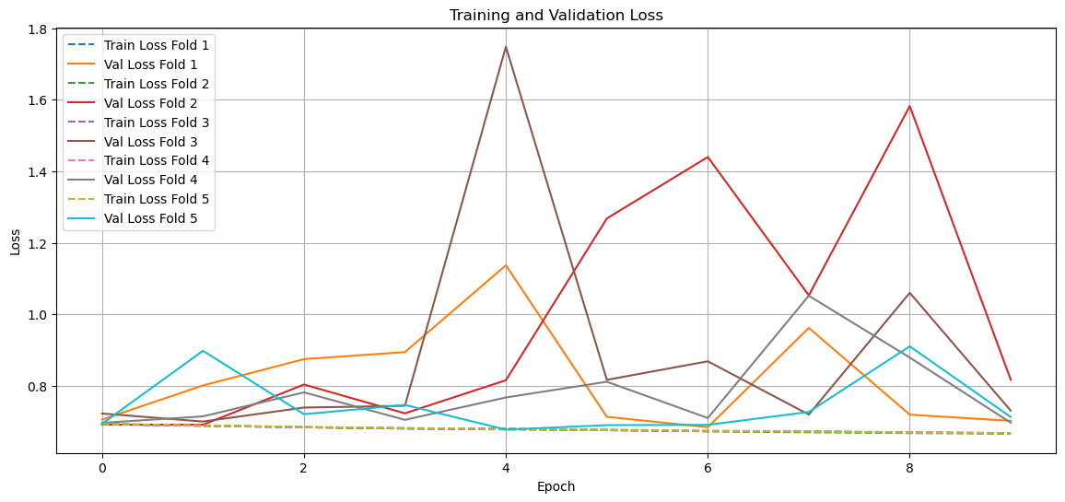

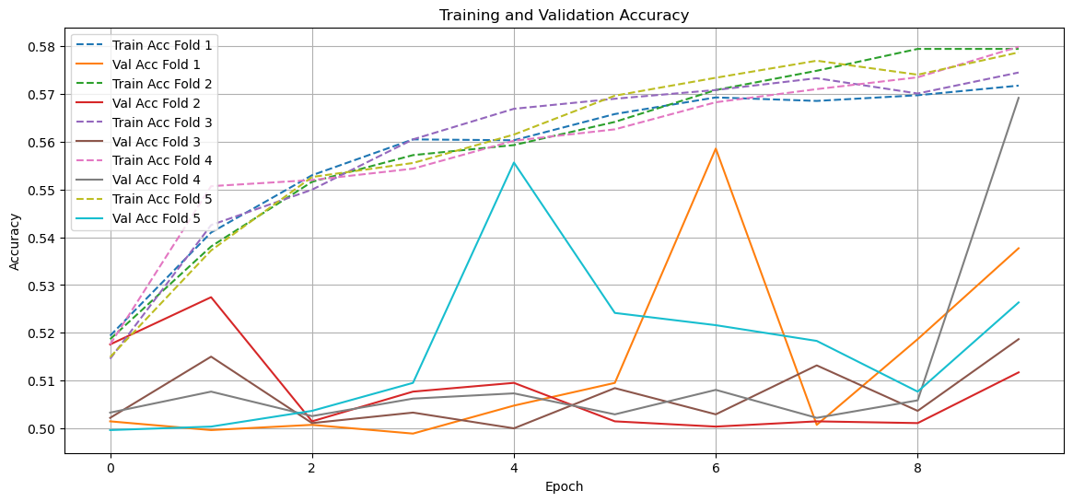

Evaluating Fold 1...

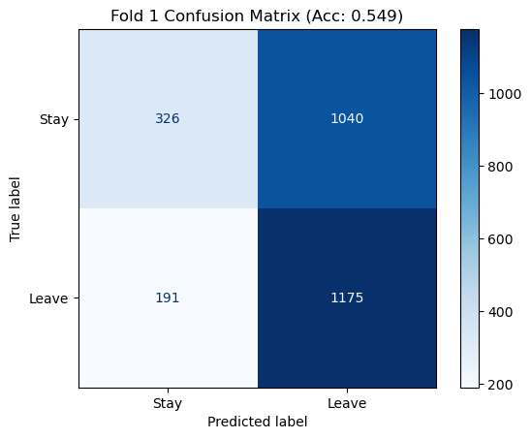

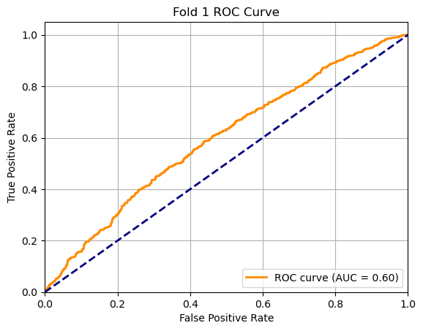

Fold 1 Accuracy: 0.549, AUC: 0.596

Evaluating Fold 2...

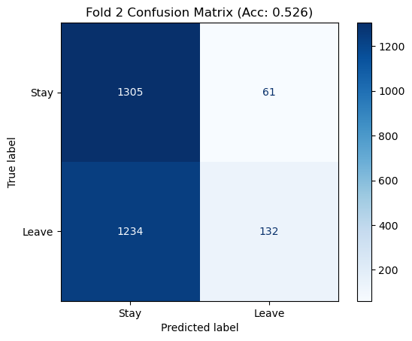

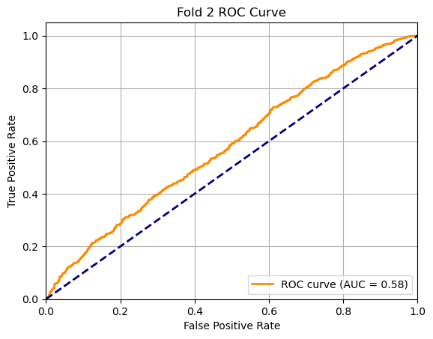

Fold 2 Accuracy: 0.526, AUC: 0.579

Evaluating Fold 3...

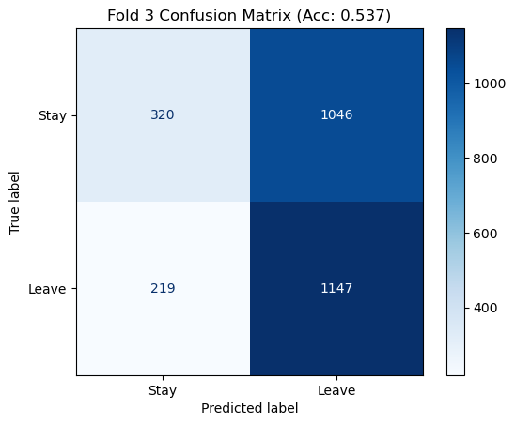

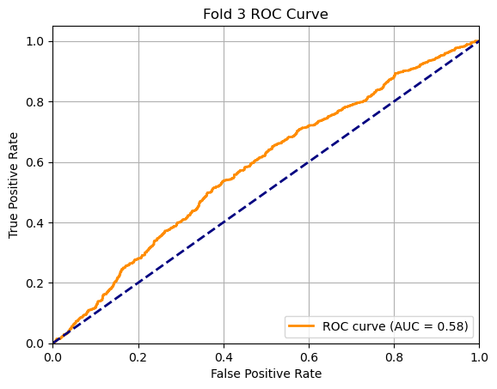

Fold 3 Accuracy: 0.537, AUC: 0.581

Evaluating Fold 4...

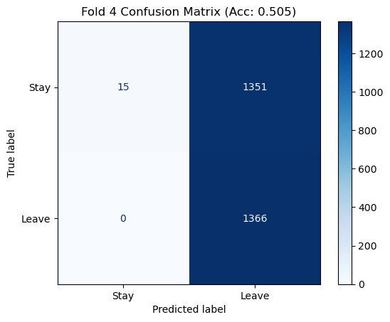

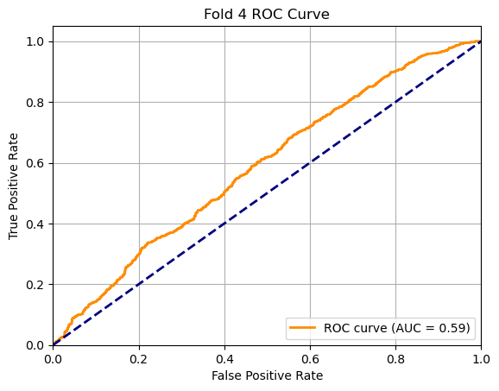

Fold 4 Accuracy: 0.505, AUC: 0.588

Evaluating Fold 5...

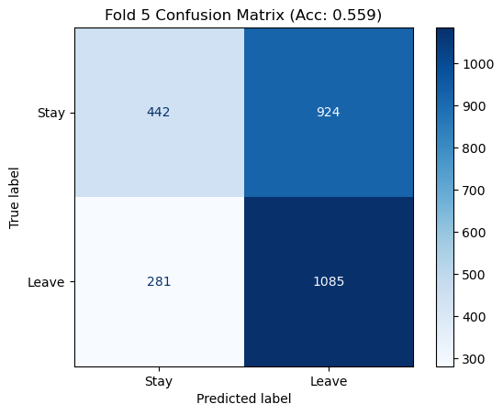

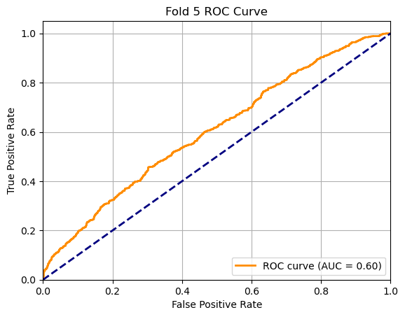

Fold 5 Accuracy: 0.559, AUC: 0.604

Average accuracy across folds: 0.535 ± 0.019

Average AUC across folds: 0.590 ± 0.009

