Loaded 53 leave files.

Original shapes - Stay: (6830, 32, 251), Leave: (1389, 32, 251)

Undersampled shapes - Stay: (1389, 32, 251), Leave: (1389, 32, 251)

Final dataset shape: (2778, 1, 32, 251), Class balance: (array([0., 1.], dtype=float32), array([1389, 1389], dtype=int64))

Using device: cuda

Fold 1/5

Epoch 1/10: Train Loss: 0.6946, Acc: 0.4986 | Val Loss: 0.6937, Acc: 0.5000

Epoch 2/10: Train Loss: 0.6930, Acc: 0.5027 | Val Loss: 0.7138, Acc: 0.5000

Epoch 3/10: Train Loss: 0.6914, Acc: 0.5189 | Val Loss: 0.7037, Acc: 0.5000

Epoch 4/10: Train Loss: 0.6907, Acc: 0.5468 | Val Loss: 0.6927, Acc: 0.5036

Epoch 5/10: Train Loss: 0.6887, Acc: 0.5504 | Val Loss: 0.9668, Acc: 0.5000

Epoch 6/10: Train Loss: 0.6871, Acc: 0.5464 | Val Loss: 0.9078, Acc: 0.5000

Epoch 7/10: Train Loss: 0.6851, Acc: 0.5455 | Val Loss: 0.7904, Acc: 0.5018

Epoch 8/10: Train Loss: 0.6845, Acc: 0.5540 | Val Loss: 0.8839, Acc: 0.5000

Epoch 9/10: Train Loss: 0.6816, Acc: 0.5576 | Val Loss: 0.6983, Acc: 0.5144

Epoch 10/10: Train Loss: 0.6803, Acc: 0.5590 | Val Loss: 0.7206, Acc: 0.5036

Fold 2/5

Epoch 1/10: Train Loss: 0.6940, Acc: 0.4982 | Val Loss: 0.6931, Acc: 0.5018

Epoch 2/10: Train Loss: 0.6926, Acc: 0.5180 | Val Loss: 0.6936, Acc: 0.5000

Epoch 3/10: Train Loss: 0.6917, Acc: 0.5423 | Val Loss: 0.7020, Acc: 0.4982

Epoch 4/10: Train Loss: 0.6901, Acc: 0.5608 | Val Loss: 0.7773, Acc: 0.5000

Epoch 5/10: Train Loss: 0.6887, Acc: 0.5549 | Val Loss: 0.7193, Acc: 0.4982

Epoch 6/10: Train Loss: 0.6881, Acc: 0.5513 | Val Loss: 0.6902, Acc: 0.5234

Epoch 7/10: Train Loss: 0.6849, Acc: 0.5536 | Val Loss: 0.7080, Acc: 0.5018

Epoch 8/10: Train Loss: 0.6826, Acc: 0.5675 | Val Loss: 1.0098, Acc: 0.5000

Epoch 9/10: Train Loss: 0.6808, Acc: 0.5599 | Val Loss: 1.3233, Acc: 0.5000

Epoch 10/10: Train Loss: 0.6785, Acc: 0.5707 | Val Loss: 1.3349, Acc: 0.5000

Fold 3/5

Epoch 1/10: Train Loss: 0.6943, Acc: 0.4991 | Val Loss: 0.6935, Acc: 0.5000

Epoch 2/10: Train Loss: 0.6923, Acc: 0.5036 | Val Loss: 0.6935, Acc: 0.4982

Epoch 3/10: Train Loss: 0.6919, Acc: 0.5360 | Val Loss: 0.6943, Acc: 0.5018

Epoch 4/10: Train Loss: 0.6902, Acc: 0.5441 | Val Loss: 0.6929, Acc: 0.5018

Epoch 5/10: Train Loss: 0.6890, Acc: 0.5500 | Val Loss: 0.6936, Acc: 0.5108

Epoch 6/10: Train Loss: 0.6873, Acc: 0.5545 | Val Loss: 0.8170, Acc: 0.5000

Epoch 7/10: Train Loss: 0.6853, Acc: 0.5554 | Val Loss: 0.6925, Acc: 0.5198

Epoch 8/10: Train Loss: 0.6835, Acc: 0.5630 | Val Loss: 0.8010, Acc: 0.5000

Epoch 9/10: Train Loss: 0.6822, Acc: 0.5545 | Val Loss: 1.4742, Acc: 0.5000

Epoch 10/10: Train Loss: 0.6792, Acc: 0.5675 | Val Loss: 0.7016, Acc: 0.5144

Fold 4/5

Epoch 1/10: Train Loss: 0.6938, Acc: 0.5097 | Val Loss: 0.6933, Acc: 0.4991

Epoch 2/10: Train Loss: 0.6922, Acc: 0.5488 | Val Loss: 0.6965, Acc: 0.4955

Epoch 3/10: Train Loss: 0.6906, Acc: 0.5470 | Val Loss: 0.7257, Acc: 0.4973

Epoch 4/10: Train Loss: 0.6882, Acc: 0.5538 | Val Loss: 0.7275, Acc: 0.4937

Epoch 5/10: Train Loss: 0.6855, Acc: 0.5511 | Val Loss: 0.9187, Acc: 0.4973

Epoch 6/10: Train Loss: 0.6832, Acc: 0.5502 | Val Loss: 0.8149, Acc: 0.4973

Epoch 7/10: Train Loss: 0.6811, Acc: 0.5515 | Val Loss: 1.1303, Acc: 0.4973

Epoch 8/10: Train Loss: 0.6792, Acc: 0.5587 | Val Loss: 0.8958, Acc: 0.4937

Epoch 9/10: Train Loss: 0.6779, Acc: 0.5646 | Val Loss: 0.9456, Acc: 0.4973

Epoch 10/10: Train Loss: 0.6760, Acc: 0.5583 | Val Loss: 1.1958, Acc: 0.4973

Fold 5/5

Epoch 1/10: Train Loss: 0.6933, Acc: 0.5002 | Val Loss: 0.6934, Acc: 0.5009

Epoch 2/10: Train Loss: 0.6916, Acc: 0.5119 | Val Loss: 0.7030, Acc: 0.5568

Epoch 3/10: Train Loss: 0.6898, Acc: 0.5277 | Val Loss: 0.7225, Acc: 0.5027

Epoch 4/10: Train Loss: 0.6879, Acc: 0.5416 | Val Loss: 0.8551, Acc: 0.5009

Epoch 5/10: Train Loss: 0.6863, Acc: 0.5461 | Val Loss: 0.7719, Acc: 0.5009

Epoch 6/10: Train Loss: 0.6847, Acc: 0.5511 | Val Loss: 0.7726, Acc: 0.4991

Epoch 7/10: Train Loss: 0.6826, Acc: 0.5542 | Val Loss: 0.7275, Acc: 0.5099

Epoch 8/10: Train Loss: 0.6813, Acc: 0.5506 | Val Loss: 0.7334, Acc: 0.5027

Epoch 9/10: Train Loss: 0.6793, Acc: 0.5493 | Val Loss: 1.0575, Acc: 0.4991

Epoch 10/10: Train Loss: 0.6778, Acc: 0.5641 | Val Loss: 0.9122, Acc: 0.5063

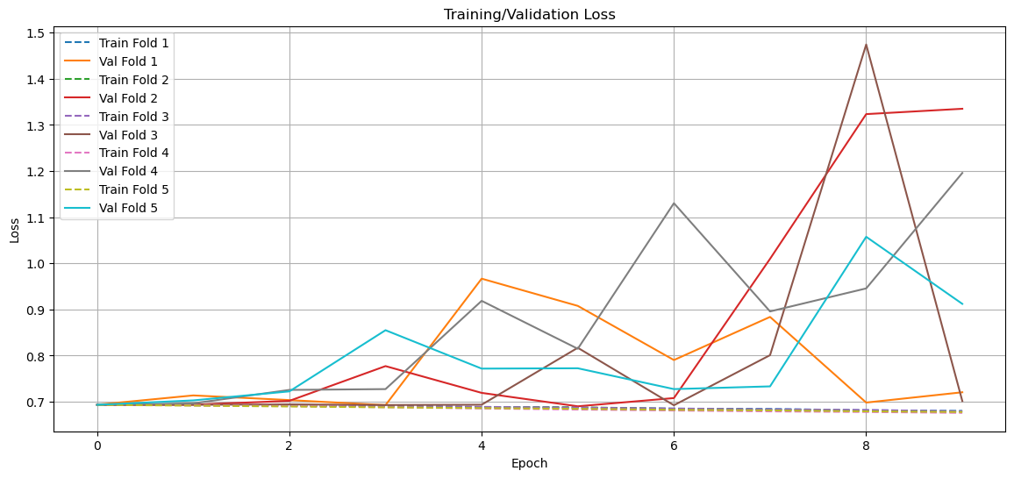

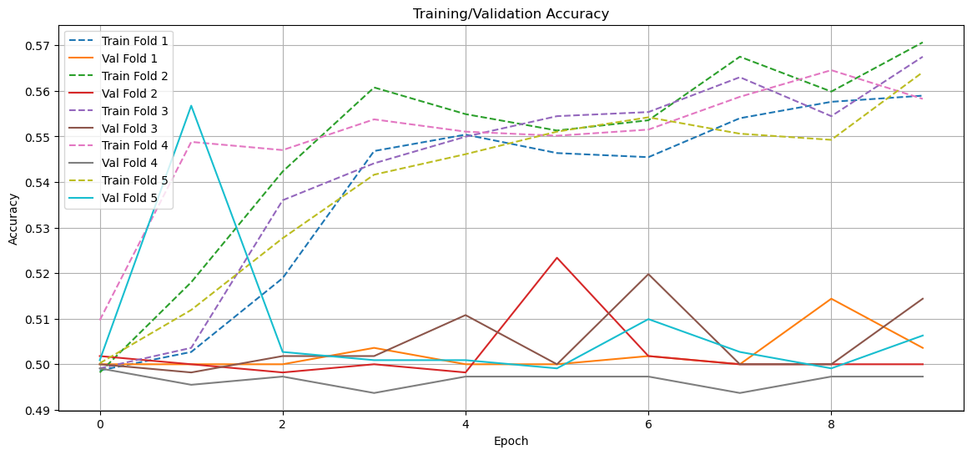

=== Fold 1 Analysis ===

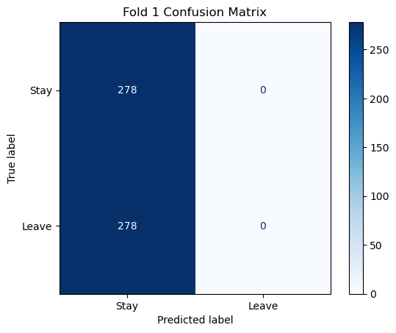

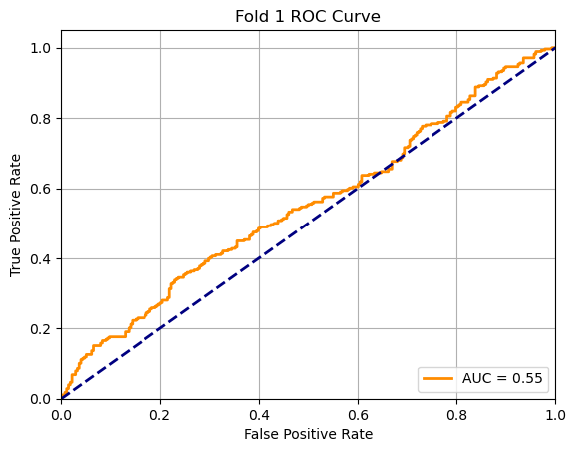

Accuracy: 0.500

AUC: 0.549

=== Fold 2 Analysis ===

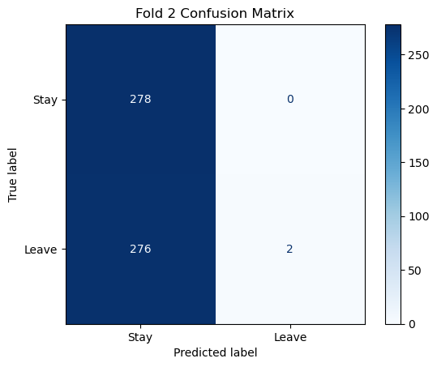

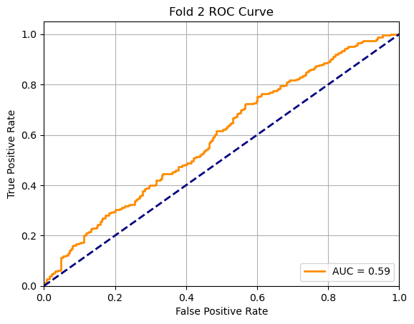

Accuracy: 0.504

AUC: 0.590

=== Fold 3 Analysis ===

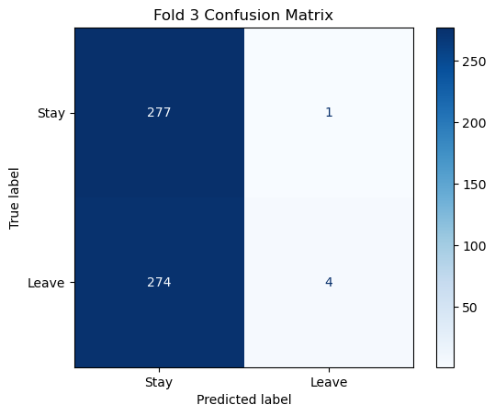

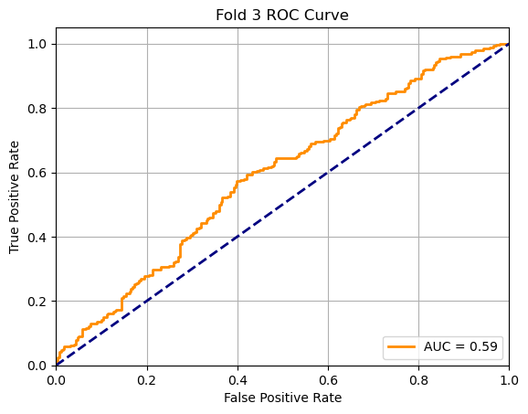

Accuracy: 0.505

AUC: 0.592

=== Fold 4 Analysis ===

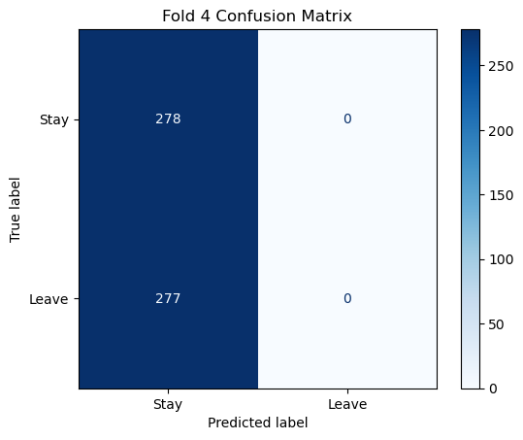

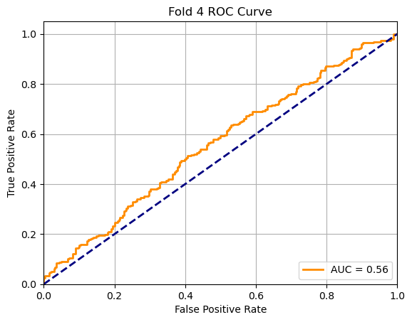

Accuracy: 0.501

AUC: 0.559

=== Fold 5 Analysis ===

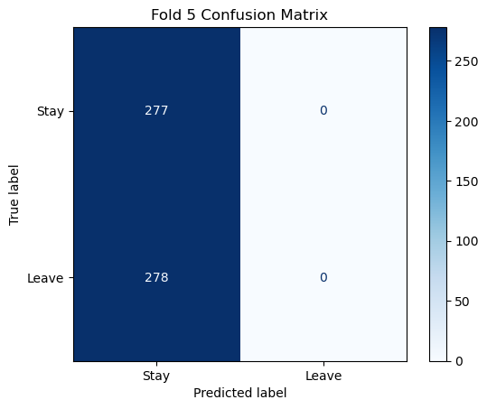

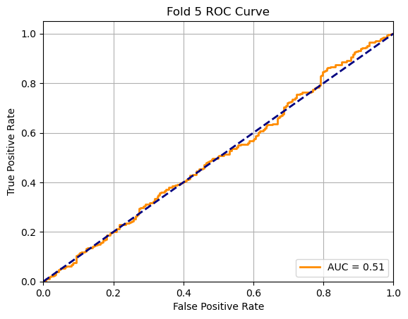

Accuracy: 0.499

AUC: 0.506

=== Final Summary ===

Average Accuracy: 0.502 ± 0.002

Average AUC: 0.559 ± 0.032

