Frequency resolution: 0.0028 Hz
Using 17969 frequency bins to cover 0-50 Hz
Data shape: (212, 28, 17969)
Frequency bins from 0 to 50 Hz: 17969

Training EEGNet...
EEGNet Results:
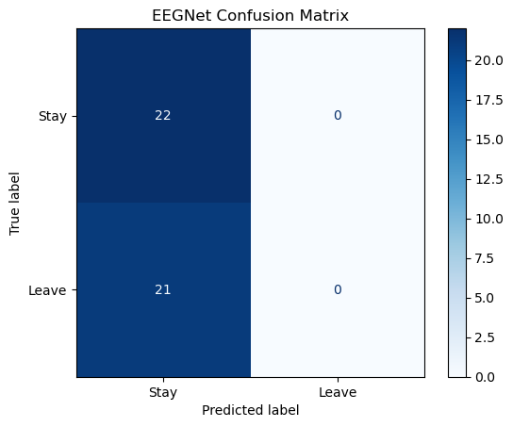
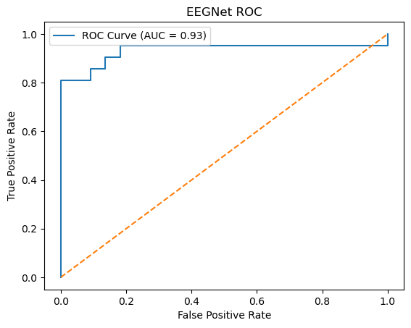
EEGNet ROC AUC: 0.9329

Training LMDA...
LMDA Results:
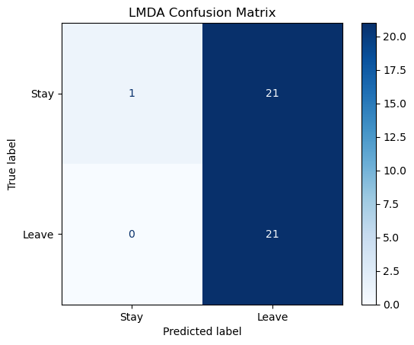
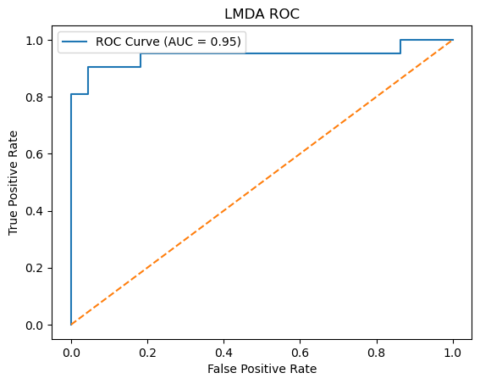
LMDA ROC AUC: 0.9459

Training GCN...
C:\Users\sansk\miniconda3\Lib\site-packages\torch_geometric\deprecation.py:26: UserWarning: 'data.DataLoader' is deprecated, use 'loader.DataLoader' instead
warnings.warn(out)
GCN Results:
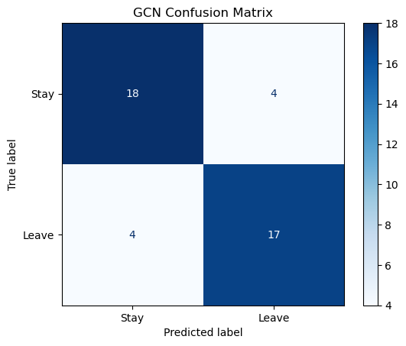
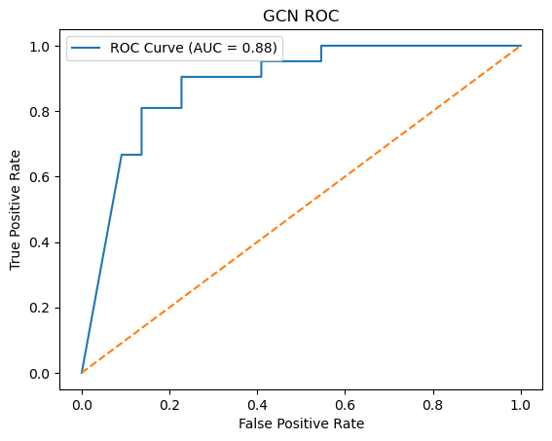
GCN ROC AUC: 0.8831

