Finding max time length...
Loading EEG data...
Data shape: (212, 28, 9201), Stay: 106, Leave: 106

======================================================================
K-FOLD CROSS-VALIDATION WITH FIGURE 3 & 4 METRICS
======================================================================
Device: cuda

Fold 1/5

Fold 2/5

Fold 3/5

Fold 4/5

Fold 5/5

Computing coverage and localization metrics...

Generating Figure 3: Occlusion Maps...
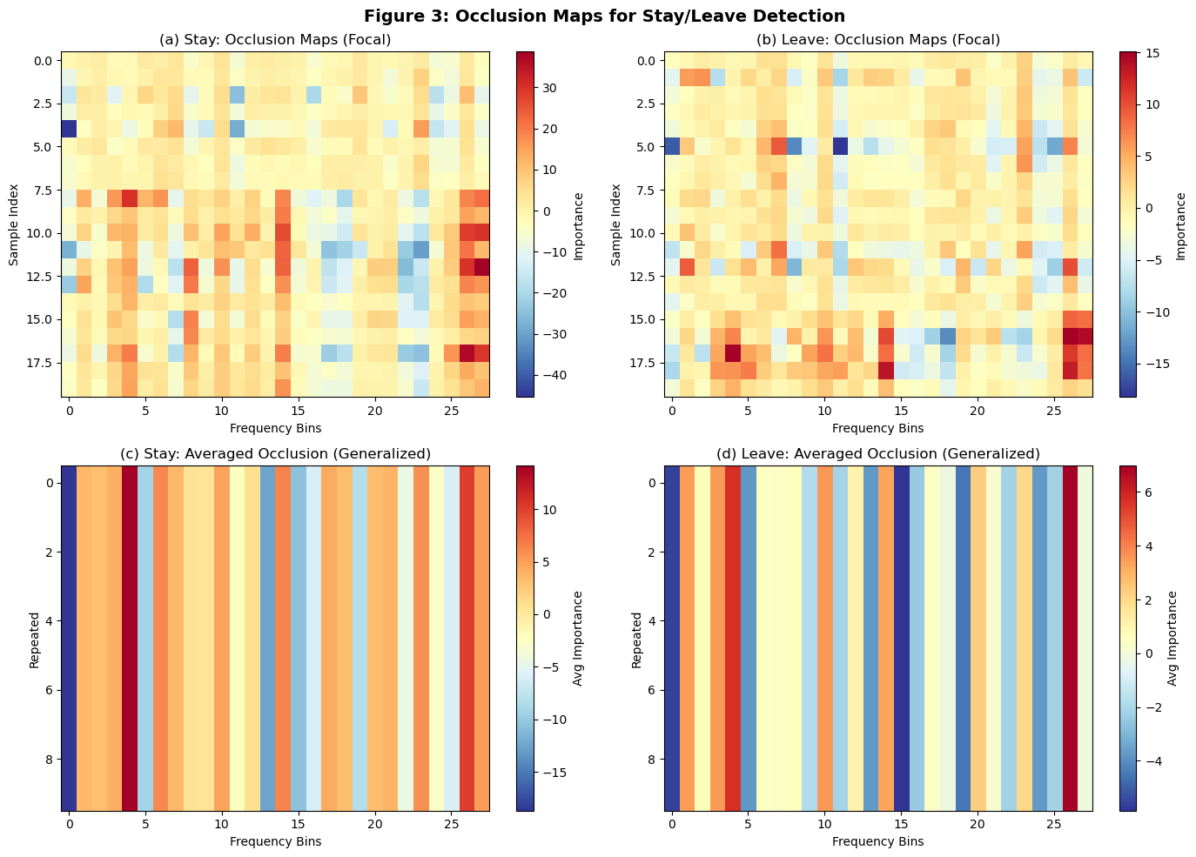
✓ Saved: figure3_occlusion_maps.png

Generating Figure 4: Coverage & Localization Metrics...
C:\Users\sansk\AppData\Local\Temp\ipykernel_31068\2727225039.py:327: MatplotlibDeprecationWarning: The 'labels' parameter of boxplot() has been renamed 'tick_labels' since Matplotlib 3.9; support for the old name will be dropped in 3.11.
bp1 = ax.boxplot(coverage_data, labels=labels_coverage, patch_artist=True)
C:\Users\sansk\AppData\Local\Temp\ipykernel_31068\2727225039.py:337: MatplotlibDeprecationWarning: The 'labels' parameter of boxplot() has been renamed 'tick_labels' since Matplotlib 3.9; support for the old name will be dropped in 3.11.
bp2 = ax.boxplot(coverage_data, labels=labels_coverage, patch_artist=True)
C:\Users\sansk\AppData\Local\Temp\ipykernel_31068\2727225039.py:348: MatplotlibDeprecationWarning: The 'labels' parameter of boxplot() has been renamed 'tick_labels' since Matplotlib 3.9; support for the old name will be dropped in 3.11.
bp3 = ax.boxplot(localization_data, labels=labels_coverage, patch_artist=True)
C:\Users\sansk\AppData\Local\Temp\ipykernel_31068\2727225039.py:358: MatplotlibDeprecationWarning: The 'labels' parameter of boxplot() has been renamed 'tick_labels' since Matplotlib 3.9; support for the old name will be dropped in 3.11.
bp4 = ax.boxplot(localization_data, labels=labels_coverage, patch_artist=True)
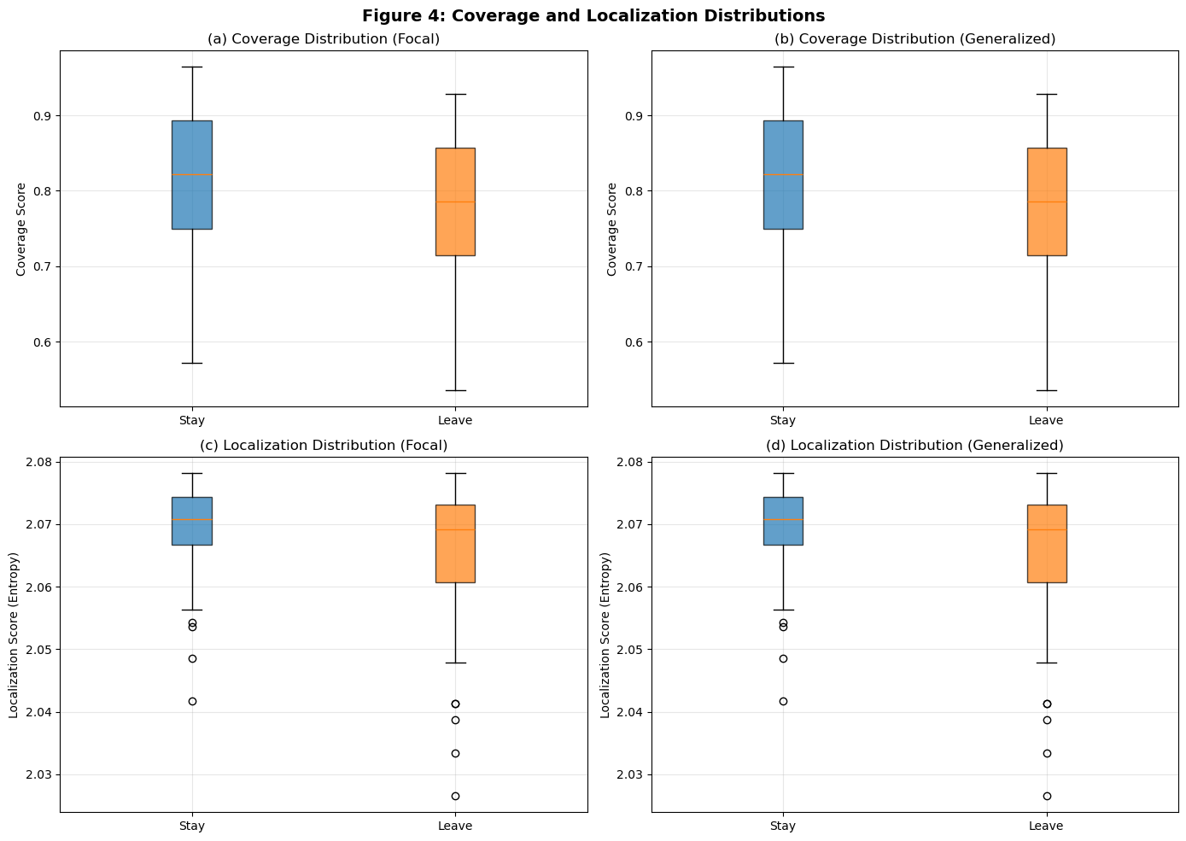
✓ Saved: figure4_coverage_localization.png

Generating channel-wise heatmaps...
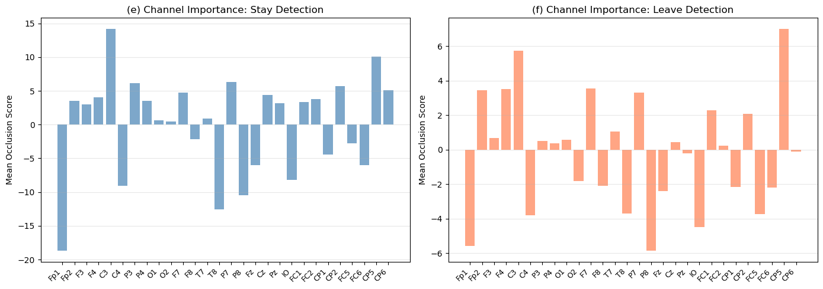
✓ Saved: figure4_channel_importance.png

======================================================================
SUMMARY STATISTICS
======================================================================

Stay Samples (Correct Predictions): 74
Leave Samples (Correct Predictions): 73

Coverage (Stay): 0.809 ± 0.093
Coverage (Leave): 0.783 ± 0.100

Localization (Stay): 2.069 ± 0.007
Localization (Leave): 2.066 ± 0.011

✓ ALL FIGURES GENERATED!
- figure3_occlusion_maps.png
- figure4_coverage_localization.png
- figure4_channel_importance.png

