Loaded 7243 frequency-domain epochs

Training EEGNet on Frequency Features...
Epoch 1: Loss 0.8221
Epoch 2: Loss 0.5652
Epoch 3: Loss 0.4433
Epoch 4: Loss 0.3923
Epoch 5: Loss 0.3195
Epoch 6: Loss 0.2830
Epoch 7: Loss 0.2389
Epoch 8: Loss 0.2112
Epoch 9: Loss 0.1951
Epoch 10: Loss 0.1684
Epoch 11: Loss 0.1716
Epoch 12: Loss 0.1584
Epoch 13: Loss 0.1519
Epoch 14: Loss 0.1719
Epoch 15: Loss 0.1329
Epoch 16: Loss 0.1240
Epoch 17: Loss 0.1111
Epoch 18: Loss 0.1316
Epoch 19: Loss 0.1393
Epoch 20: Loss 0.1187
EEGNet Results:
precision recall f1-score support

Low(25-39) 0.49 0.96 0.65 585
Medium(40-49) 0.72 0.42 0.53 512
High(50-74) 1.00 0.03 0.07 352

accuracy 0.54 1449
macro avg 0.74 0.47 0.42 1449
weighted avg 0.70 0.54 0.47 1449

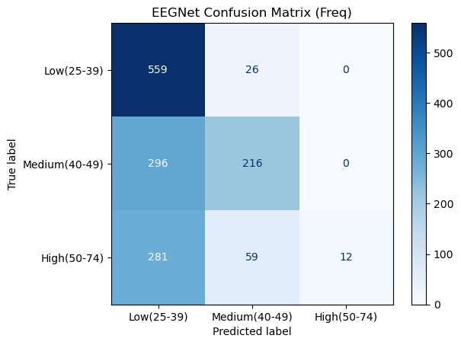

Training LMDA on Frequency Features...
Epoch 1: Loss 0.8568
Epoch 2: Loss 0.5854
Epoch 3: Loss 0.4355
Epoch 4: Loss 0.3429
Epoch 5: Loss 0.2852
Epoch 6: Loss 0.2542
Epoch 7: Loss 0.2188
Epoch 8: Loss 0.1783
Epoch 9: Loss 0.1723
Epoch 10: Loss 0.1532
Epoch 11: Loss 0.1389
Epoch 12: Loss 0.1379
Epoch 13: Loss 0.1234
Epoch 14: Loss 0.1217
Epoch 15: Loss 0.1022
Epoch 16: Loss 0.0992
Epoch 17: Loss 0.0857
Epoch 18: Loss 0.0936
Epoch 19: Loss 0.1003
Epoch 20: Loss 0.0794
LMDA Results:
precision recall f1-score support

Low(25-39) 0.98 0.99 0.98 585
Medium(40-49) 0.99 0.97 0.98 512
High(50-74) 0.99 0.99 0.99 352

accuracy 0.98 1449
macro avg 0.99 0.98 0.98 1449
weighted avg 0.98 0.98 0.98 1449

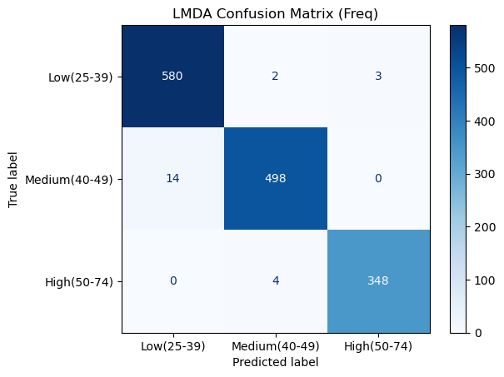

Training GCN on Frequency Features...
Epoch 1: Loss 20.1519
Epoch 2: Loss 4.2939
Epoch 3: Loss 2.8862
Epoch 4: Loss 2.1383
Epoch 5: Loss 1.7313
Epoch 6: Loss 1.7486
Epoch 7: Loss 1.2989
Epoch 8: Loss 1.2207
Epoch 9: Loss 1.1743
Epoch 10: Loss 1.0735
Epoch 11: Loss 1.0519
Epoch 12: Loss 1.0545
Epoch 13: Loss 0.9762
Epoch 14: Loss 1.0396
Epoch 15: Loss 0.9898
Epoch 16: Loss 0.9198
Epoch 17: Loss 0.9388
Epoch 18: Loss 0.8769
Epoch 19: Loss 0.8724
Epoch 20: Loss 0.8300
GCN Results:
precision recall f1-score support

Low(25-39) 0.53 0.76 0.62 585
Medium(40-49) 0.59 0.33 0.42 512
High(50-74) 0.63 0.58 0.60 352

accuracy 0.56 1449
macro avg 0.58 0.55 0.55 1449
weighted avg 0.57 0.56 0.55 1449

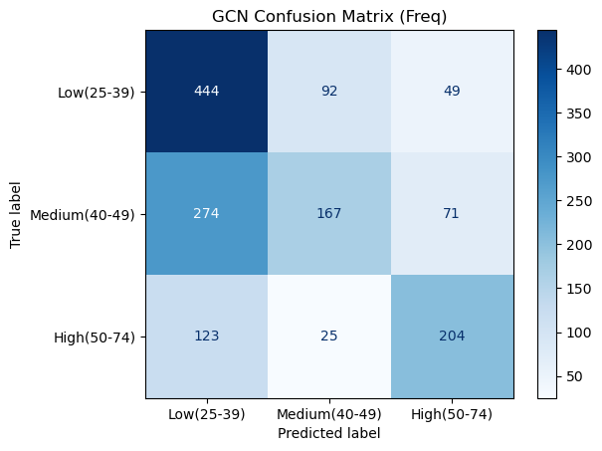
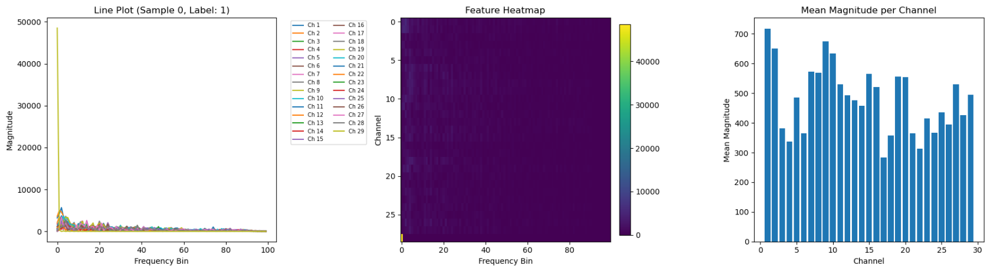
EEGNet conv1: torch.Size([1, 16, 29, 100])
EEGNet bn1 + elu: torch.Size([1, 16, 29, 100])
EEGNet depthwise + bn2 + elu: torch.Size([1, 32, 8, 100])
EEGNet conv2 + bn3 + elu: torch.Size([1, 32, 8, 100])
EEGNet adaptive_pool: torch.Size([1, 32, 1, 1])
EEGNet flatten: torch.Size([1, 32])
EEGNet classifier: torch.Size([1, 3])
EEGNet Model Structure:

EEGNet(
(conv1): Conv2d(1, 16, kernel_size=(1, 64), stride=(1, 1), padding=same)
(bn1): BatchNorm2d(16, eps=1e-05, momentum=0.1, affine=True, track_running_stats=True)
(depthwise): Conv2d(16, 32, kernel_size=(22, 1), stride=(1, 1), groups=16)
(bn2): BatchNorm2d(32, eps=1e-05, momentum=0.1, affine=True, track_running_stats=True)
(conv2): Conv2d(32, 32, kernel_size=(1, 16), stride=(1, 1), padding=same)
(bn3): BatchNorm2d(32, eps=1e-05, momentum=0.1, affine=True, track_running_stats=True)
(adaptive_pool): AdaptiveAvgPool2d(output_size=(1, 1))
(classifier): Linear(in_features=32, out_features=3, bias=True)
)

========================================

Input shape: torch.Size([1, 1, 29, 100])
After conv1: torch.Size([1, 16, 29, 100])
After bn1: torch.Size([1, 16, 29, 100])
After ELU 1: torch.Size([1, 16, 29, 100])
After depthwise: torch.Size([1, 32, 8, 100])
After bn2: torch.Size([1, 32, 8, 100])
After ELU 2: torch.Size([1, 32, 8, 100])
After conv2: torch.Size([1, 32, 8, 100])
After bn3: torch.Size([1, 32, 8, 100])
After ELU 3: torch.Size([1, 32, 8, 100])
After adaptive_pool: torch.Size([1, 32, 1, 1])
After flatten: torch.Size([1, 32])
After classifier (output): torch.Size([1, 3])
LMDA Model Structure:

LMDA(
(time_conv): Sequential(
(0): Conv2d(9, 24, kernel_size=(1, 75), stride=(1, 1), padding=(0, 37))
(1): BatchNorm2d(24, eps=1e-05, momentum=0.1, affine=True, track_running_stats=True)
(2): GELU(approximate='none')
)
(chanel_conv): Sequential(
(0): Conv2d(24, 24, kernel_size=(29, 1), stride=(1, 1), groups=24)
(1): BatchNorm2d(24, eps=1e-05, momentum=0.1, affine=True, track_running_stats=True)
(2): GELU(approximate='none')
)
(adaptive_pool): AdaptiveAvgPool2d(output_size=(1, 1))
(classifier): Linear(in_features=24, out_features=3, bias=True)
)

========================================

LMDA Input shape: torch.Size([1, 9, 29, 100])
After squeeze(2): torch.Size([1, 9, 29, 100])
After channel_weight einsum: torch.Size([1, 9, 29, 100])
After time_conv: torch.Size([1, 24, 29, 100])
After chanel_conv: torch.Size([1, 24, 1, 100])
After adaptive_pool: torch.Size([1, 24, 1, 1])
After flatten: torch.Size([1, 24])
After classifier (output): torch.Size([1, 3])

============================================================

GCN Model Structure:

GCN(
(conv1): GCNConv(100, 32)
(conv2): GCNConv(32, 32)
(classifier): Linear(in_features=32, out_features=3, bias=True)
)

========================================

GCN layer-wise output shapes:
Input node features: torch.Size([29, 100])
Edge index shape: torch.Size([2, 192])
After conv1: torch.Size([29, 32])
After ReLU 1: torch.Size([29, 32])
After conv2: torch.Size([29, 32])
After ReLU 2: torch.Size([29, 32])
After global_mean_pool: torch.Size([1, 32])
After classifier (output): torch.Size([1, 3])

