Loaded 8447 frequency-domain epochs

Training EEGNet on Frequency Features...
Epoch 1: Loss 0.7725
Epoch 2: Loss 0.4992
Epoch 3: Loss 0.3769
Epoch 4: Loss 0.3061
Epoch 5: Loss 0.2438
Epoch 6: Loss 0.2209
Epoch 7: Loss 0.1844
Epoch 8: Loss 0.1689
Epoch 9: Loss 0.1508
Epoch 10: Loss 0.1367
Epoch 11: Loss 0.1365
Epoch 12: Loss 0.1210
Epoch 13: Loss 0.1079
Epoch 14: Loss 0.1042
Epoch 15: Loss 0.1041
Epoch 16: Loss 0.0962
Epoch 17: Loss 0.0853
Epoch 18: Loss 0.0780
Epoch 19: Loss 0.0744
Epoch 20: Loss 0.0987
EEGNet Results:
precision recall f1-score support

Low(25-39) 0.97 0.94 0.96 682
Medium(40-49) 0.92 0.99 0.96 597
High(50-74) 0.98 0.94 0.96 411

accuracy 0.96 1690
macro avg 0.96 0.96 0.96 1690
weighted avg 0.96 0.96 0.96 1690

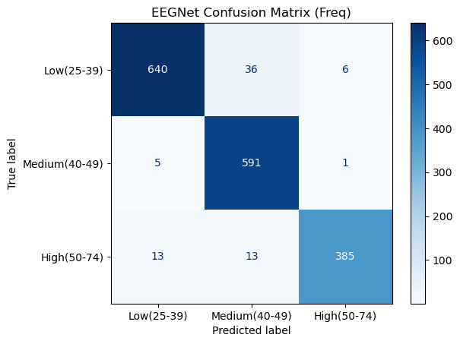

Training LMDA on Frequency Features...
Epoch 1: Loss 0.8175
Epoch 2: Loss 0.5518
Epoch 3: Loss 0.4123
Epoch 4: Loss 0.3296
Epoch 5: Loss 0.2814
Epoch 6: Loss 0.2396
Epoch 7: Loss 0.2128
Epoch 8: Loss 0.1956
Epoch 9: Loss 0.1771
Epoch 10: Loss 0.1579
Epoch 11: Loss 0.1528
Epoch 12: Loss 0.1414
Epoch 13: Loss 0.1295
Epoch 14: Loss 0.1288
Epoch 15: Loss 0.1150
Epoch 16: Loss 0.1259
Epoch 17: Loss 0.0985
Epoch 18: Loss 0.1011
Epoch 19: Loss 0.0978
Epoch 20: Loss 0.0992
LMDA Results:
precision recall f1-score support

Low(25-39) 1.00 0.90 0.95 682
Medium(40-49) 0.97 0.98 0.98 597
High(50-74) 0.88 1.00 0.93 411

accuracy 0.95 1690
macro avg 0.95 0.96 0.95 1690
weighted avg 0.96 0.95 0.95 1690

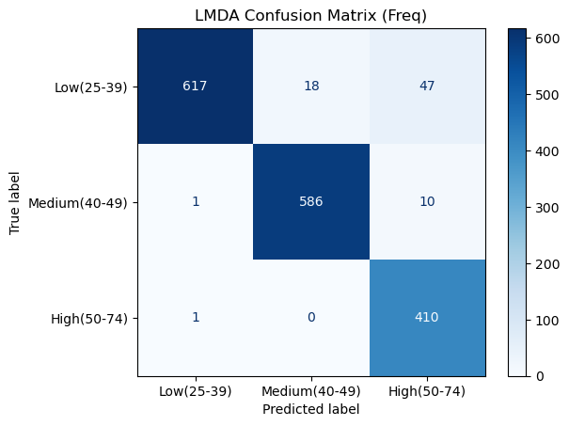

Training GCN on Frequency Features...
Epoch 1: Loss 9.0177
Epoch 2: Loss 2.0118
Epoch 3: Loss 1.8125
Epoch 4: Loss 1.3767
Epoch 5: Loss 1.2873
Epoch 6: Loss 1.1631
Epoch 7: Loss 1.1276
Epoch 8: Loss 1.1431
Epoch 9: Loss 1.0923
Epoch 10: Loss 1.0412
Epoch 11: Loss 1.0158
Epoch 12: Loss 1.0061
Epoch 13: Loss 1.0056
Epoch 14: Loss 0.9873
Epoch 15: Loss 1.0217
Epoch 16: Loss 0.9494
Epoch 17: Loss 0.9396
Epoch 18: Loss 0.9280
Epoch 19: Loss 0.9216
Epoch 20: Loss 0.9102
GCN Results:
precision recall f1-score support

Low(25-39) 0.59 0.51 0.55 682
Medium(40-49) 0.49 0.62 0.55 597
High(50-74) 0.52 0.44 0.47 411

accuracy 0.53 1690
macro avg 0.53 0.52 0.52 1690
weighted avg 0.54 0.53 0.53 1690

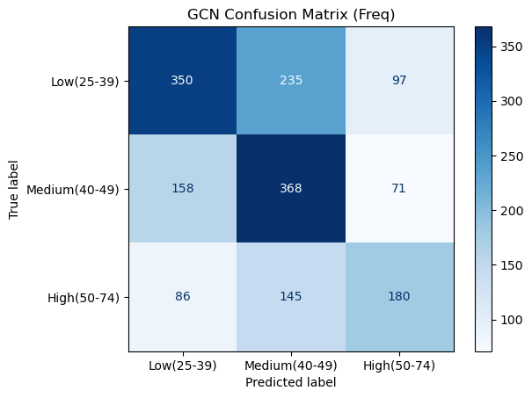
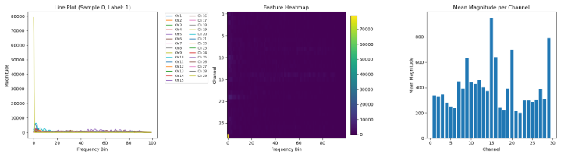
EEGNet conv1: torch.Size([1, 16, 29, 100])
EEGNet bn1 + elu: torch.Size([1, 16, 29, 100])
EEGNet depthwise + bn2 + elu: torch.Size([1, 32, 8, 100])
EEGNet conv2 + bn3 + elu: torch.Size([1, 32, 8, 100])
EEGNet adaptive_pool: torch.Size([1, 32, 1, 1])
EEGNet flatten: torch.Size([1, 32])
EEGNet classifier: torch.Size([1, 3])
EEGNet Model Structure:

EEGNet(
(conv1): Conv2d(1, 16, kernel_size=(1, 64), stride=(1, 1), padding=same)
(bn1): BatchNorm2d(16, eps=1e-05, momentum=0.1, affine=True, track_running_stats=True)
(depthwise): Conv2d(16, 32, kernel_size=(22, 1), stride=(1, 1), groups=16)
(bn2): BatchNorm2d(32, eps=1e-05, momentum=0.1, affine=True, track_running_stats=True)
(conv2): Conv2d(32, 32, kernel_size=(1, 16), stride=(1, 1), padding=same)
(bn3): BatchNorm2d(32, eps=1e-05, momentum=0.1, affine=True, track_running_stats=True)
(adaptive_pool): AdaptiveAvgPool2d(output_size=(1, 1))
(classifier): Linear(in_features=32, out_features=3, bias=True)
)

========================================

Input shape: torch.Size([1, 1, 29, 100])
After conv1: torch.Size([1, 16, 29, 100])
After bn1: torch.Size([1, 16, 29, 100])
After ELU 1: torch.Size([1, 16, 29, 100])
After depthwise: torch.Size([1, 32, 8, 100])
After bn2: torch.Size([1, 32, 8, 100])
After ELU 2: torch.Size([1, 32, 8, 100])
After conv2: torch.Size([1, 32, 8, 100])
After bn3: torch.Size([1, 32, 8, 100])
After ELU 3: torch.Size([1, 32, 8, 100])
After adaptive_pool: torch.Size([1, 32, 1, 1])
After flatten: torch.Size([1, 32])
After classifier (output): torch.Size([1, 3])
LMDA Model Structure:

LMDA(
(time_conv): Sequential(
(0): Conv2d(9, 24, kernel_size=(1, 75), stride=(1, 1), padding=(0, 37))
(1): BatchNorm2d(24, eps=1e-05, momentum=0.1, affine=True, track_running_stats=True)
(2): GELU(approximate='none')
)
(chanel_conv): Sequential(
(0): Conv2d(24, 24, kernel_size=(29, 1), stride=(1, 1), groups=24)
(1): BatchNorm2d(24, eps=1e-05, momentum=0.1, affine=True, track_running_stats=True)
(2): GELU(approximate='none')
)
(adaptive_pool): AdaptiveAvgPool2d(output_size=(1, 1))
(classifier): Linear(in_features=24, out_features=3, bias=True)
)

========================================

LMDA Input shape: torch.Size([1, 9, 29, 100])
After squeeze(2): torch.Size([1, 9, 29, 100])
After channel_weight einsum: torch.Size([1, 9, 29, 100])
After time_conv: torch.Size([1, 24, 29, 100])
After chanel_conv: torch.Size([1, 24, 1, 100])
After adaptive_pool: torch.Size([1, 24, 1, 1])
After flatten: torch.Size([1, 24])
After classifier (output): torch.Size([1, 3])

============================================================

GCN Model Structure:

GCN(
(conv1): GCNConv(100, 32)
(conv2): GCNConv(32, 32)
(classifier): Linear(in_features=32, out_features=3, bias=True)
)

========================================

GCN layer-wise output shapes:
Input node features: torch.Size([29, 100])
Edge index shape: torch.Size([2, 120])
After conv1: torch.Size([29, 32])
After ReLU 1: torch.Size([29, 32])
After conv2: torch.Size([29, 32])
After ReLU 2: torch.Size([29, 32])
After global_mean_pool: torch.Size([1, 32])
After classifier (output): torch.Size([1, 3])

