Frequency resolution: 0.0054 Hz
Using 9201 frequency bins to cover 0-50 Hz
Data shape: (212, 28, 9201)

============================================================
Starting K-Fold Cross-Validation
============================================================

Fold 1/5
----------------------------------------
Training EEGNet...
C:\Users\sansk\miniconda3\Lib\site-packages\torch\nn\modules\conv.py:456: UserWarning: Using padding='same' with even kernel lengths and odd dilation may require a zero-padded copy of the input be created (Triggered internally at ..\aten\src\ATen\native\Convolution.cpp:1041.)
return F.conv2d(input, weight, bias, self.stride,
EEGNet - Acc: 0.8140, AUC: 0.9091, F1: 0.7895
Training GCN...
C:\Users\sansk\miniconda3\Lib\site-packages\torch_geometric\deprecation.py:26: UserWarning: 'data.DataLoader' is deprecated, use 'loader.DataLoader' instead
warnings.warn(out)
GCN - Acc: 0.6977, AUC: 0.7532, F1: 0.7111

Fold 2/5
----------------------------------------
Training EEGNet...
EEGNet - Acc: 0.8837, AUC: 0.9545, F1: 0.8889
Training GCN...
C:\Users\sansk\miniconda3\Lib\site-packages\torch_geometric\deprecation.py:26: UserWarning: 'data.DataLoader' is deprecated, use 'loader.DataLoader' instead
warnings.warn(out)
GCN - Acc: 0.6977, AUC: 0.9405, F1: 0.5806

Fold 3/5
----------------------------------------
Training EEGNet...
EEGNet - Acc: 0.9286, AUC: 0.9388, F1: 0.9302
Training GCN...
C:\Users\sansk\miniconda3\Lib\site-packages\torch_geometric\deprecation.py:26: UserWarning: 'data.DataLoader' is deprecated, use 'loader.DataLoader' instead
warnings.warn(out)
GCN - Acc: 0.6905, AUC: 0.7993, F1: 0.6286

Fold 4/5
----------------------------------------
Training EEGNet...
EEGNet - Acc: 0.5476, AUC: 0.9932, F1: 0.1739
Training GCN...
C:\Users\sansk\miniconda3\Lib\site-packages\torch_geometric\deprecation.py:26: UserWarning: 'data.DataLoader' is deprecated, use 'loader.DataLoader' instead
warnings.warn(out)
GCN - Acc: 0.8333, AUC: 0.8605, F1: 0.8293

Fold 5/5
----------------------------------------
Training EEGNet...
EEGNet - Acc: 0.9762, AUC: 1.0000, F1: 0.9767
Training GCN...
C:\Users\sansk\miniconda3\Lib\site-packages\torch_geometric\deprecation.py:26: UserWarning: 'data.DataLoader' is deprecated, use 'loader.DataLoader' instead
warnings.warn(out)
GCN - Acc: 0.6667, AUC: 0.8288, F1: 0.6111
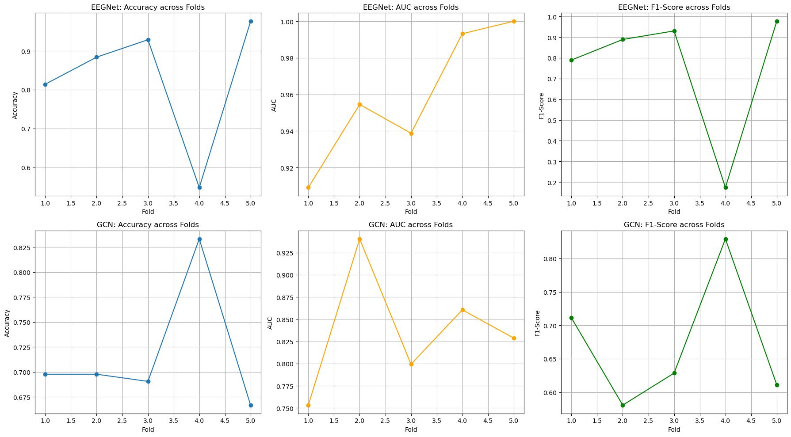
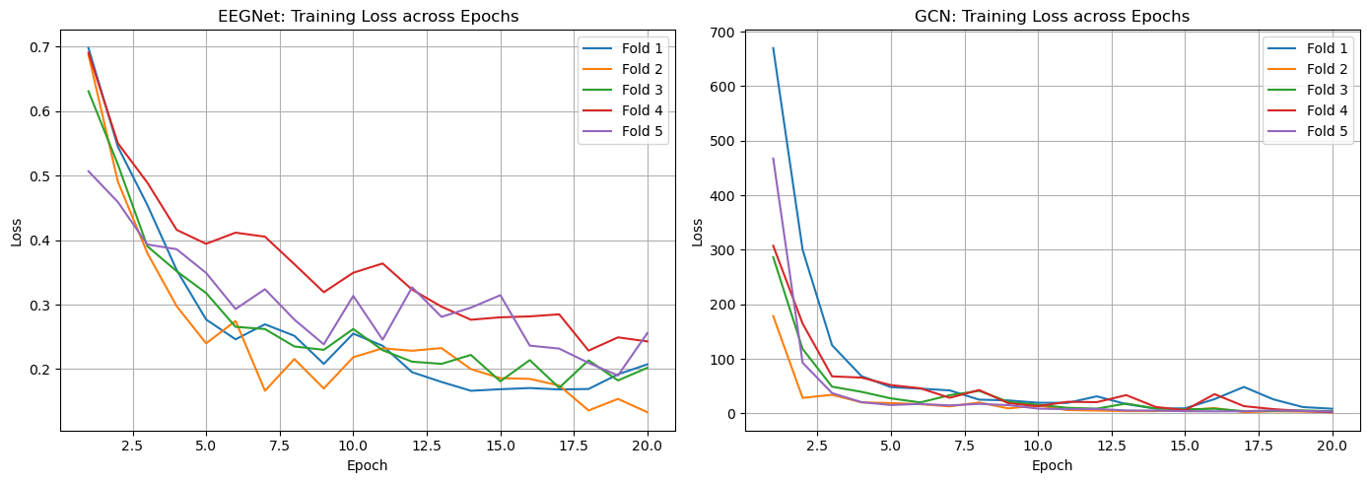

============================================================
Summary Statistics
============================================================
EEGNet - Mean Accuracy: 0.8300 ± 0.1510
EEGNet - Mean AUC: 0.9591 ± 0.0340
EEGNet - Mean F1: 0.7519 ± 0.2955

GCN - Mean Accuracy: 0.7172 ± 0.0592
GCN - Mean AUC: 0.8365 ± 0.0629
GCN - Mean F1: 0.6721 ± 0.0897

============================================================
Visualizing Layer-wise Features
============================================================
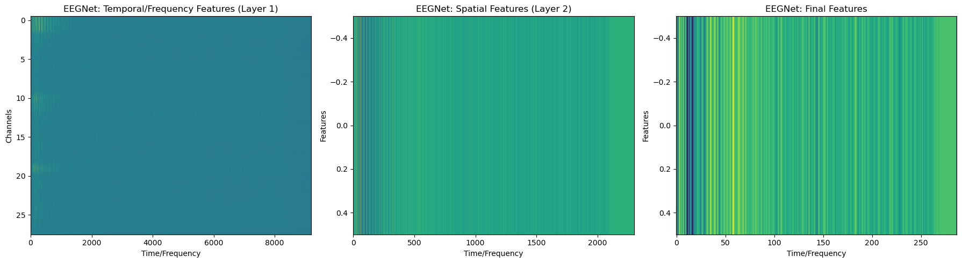
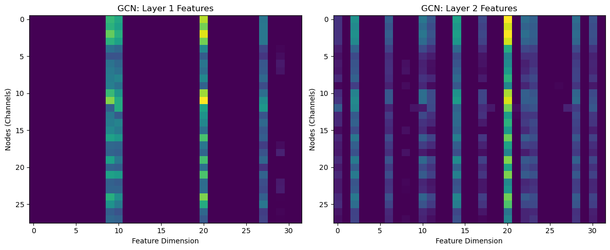

All visualizations saved!

