Number of epochs: 8447
(8447, 1000, 29) (8447,)
Epoch 1/20
212/212 ━━━━━━━━━━━━━━━━━━━━ 200s 907ms/step - accuracy: 0.5100 - loss: 0.7134 - val_accuracy: 0.5521 - val_loss: 0.6786
Epoch 2/20
212/212 ━━━━━━━━━━━━━━━━━━━━ 193s 912ms/step - accuracy: 0.5523 - loss: 0.6829 - val_accuracy: 0.5675 - val_loss: 0.6715
Epoch 3/20
212/212 ━━━━━━━━━━━━━━━━━━━━ 196s 924ms/step - accuracy: 0.5971 - loss: 0.6610 - val_accuracy: 0.5917 - val_loss: 0.6617
Epoch 4/20
212/212 ━━━━━━━━━━━━━━━━━━━━ 196s 924ms/step - accuracy: 0.6048 - loss: 0.6532 - val_accuracy: 0.5917 - val_loss: 0.6616
Epoch 5/20
212/212 ━━━━━━━━━━━━━━━━━━━━ 194s 914ms/step - accuracy: 0.6406 - loss: 0.6256 - val_accuracy: 0.6059 - val_loss: 0.6686
Epoch 6/20
212/212 ━━━━━━━━━━━━━━━━━━━━ 95s 445ms/step - accuracy: 0.6642 - loss: 0.6196 - val_accuracy: 0.6325 - val_loss: 0.6405
Epoch 7/20
212/212 ━━━━━━━━━━━━━━━━━━━━ 87s 409ms/step - accuracy: 0.6614 - loss: 0.6158 - val_accuracy: 0.6018 - val_loss: 0.6480
Epoch 8/20
212/212 ━━━━━━━━━━━━━━━━━━━━ 87s 409ms/step - accuracy: 0.6713 - loss: 0.6017 - val_accuracy: 0.6479 - val_loss: 0.6314
Epoch 9/20
212/212 ━━━━━━━━━━━━━━━━━━━━ 86s 405ms/step - accuracy: 0.6885 - loss: 0.5872 - val_accuracy: 0.6828 - val_loss: 0.6043
Epoch 10/20
212/212 ━━━━━━━━━━━━━━━━━━━━ 86s 405ms/step - accuracy: 0.6928 - loss: 0.5801 - val_accuracy: 0.6515 - val_loss: 0.6291
Epoch 11/20
212/212 ━━━━━━━━━━━━━━━━━━━━ 87s 409ms/step - accuracy: 0.6821 - loss: 0.5949 - val_accuracy: 0.6479 - val_loss: 0.6436
Epoch 12/20
212/212 ━━━━━━━━━━━━━━━━━━━━ 142s 408ms/step - accuracy: 0.6491 - loss: 0.6407 - val_accuracy: 0.5852 - val_loss: 0.6651
Epoch 13/20
212/212 ━━━━━━━━━━━━━━━━━━━━ 86s 408ms/step - accuracy: 0.6373 - loss: 0.6330 - val_accuracy: 0.6124 - val_loss: 0.6555
Epoch 14/20
212/212 ━━━━━━━━━━━━━━━━━━━━ 141s 402ms/step - accuracy: 0.6347 - loss: 0.6324 - val_accuracy: 0.6497 - val_loss: 0.6265
Epoch 15/20
212/212 ━━━━━━━━━━━━━━━━━━━━ 250s 903ms/step - accuracy: 0.6795 - loss: 0.5956 - val_accuracy: 0.6515 - val_loss: 0.6588
Epoch 16/20
212/212 ━━━━━━━━━━━━━━━━━━━━ 195s 922ms/step - accuracy: 0.6468 - loss: 0.6509 - val_accuracy: 0.5533 - val_loss: 0.6790
Epoch 17/20
212/212 ━━━━━━━━━━━━━━━━━━━━ 197s 929ms/step - accuracy: 0.5644 - loss: 0.6721 - val_accuracy: 0.5686 - val_loss: 0.6740
Epoch 18/20
212/212 ━━━━━━━━━━━━━━━━━━━━ 196s 926ms/step - accuracy: 0.5692 - loss: 0.6659 - val_accuracy: 0.5793 - val_loss: 0.6653
Epoch 19/20
212/212 ━━━━━━━━━━━━━━━━━━━━ 196s 925ms/step - accuracy: 0.5842 - loss: 0.6583 - val_accuracy: 0.5864 - val_loss: 0.6554
Epoch 20/20
212/212 ━━━━━━━━━━━━━━━━━━━━ 198s 936ms/step - accuracy: 0.6238 - loss: 0.6332 - val_accuracy: 0.6089 - val_loss: 0.6461
53/53 ━━━━━━━━━━━━━━━━━━━━ 20s 364ms/step
LSTM Classification Report:
precision recall f1-score support

0 0.63 0.61 0.62 885
1 0.59 0.60 0.60 805

accuracy 0.61 1690
macro avg 0.61 0.61 0.61 1690
weighted avg 0.61 0.61 0.61 1690

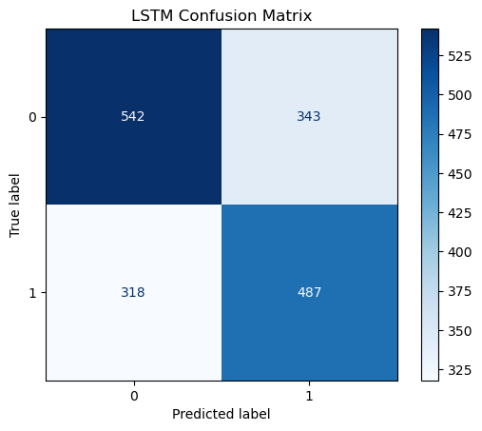
Epoch 1/20
212/212 ━━━━━━━━━━━━━━━━━━━━ 323s 1s/step - accuracy: 0.5230 - loss: 0.7176 - val_accuracy: 0.5621 - val_loss: 0.6707
Epoch 2/20
212/212 ━━━━━━━━━━━━━━━━━━━━ 305s 1s/step - accuracy: 0.5784 - loss: 0.6697 - val_accuracy: 0.6047 - val_loss: 0.6517
Epoch 3/20
212/212 ━━━━━━━━━━━━━━━━━━━━ 304s 1s/step - accuracy: 0.6244 - loss: 0.6407 - val_accuracy: 0.6290 - val_loss: 0.6363
Epoch 4/20
212/212 ━━━━━━━━━━━━━━━━━━━━ 306s 1s/step - accuracy: 0.6486 - loss: 0.6264 - val_accuracy: 0.6296 - val_loss: 0.6218
Epoch 5/20
212/212 ━━━━━━━━━━━━━━━━━━━━ 251s 1s/step - accuracy: 0.6922 - loss: 0.5688 - val_accuracy: 0.6556 - val_loss: 0.6082
Epoch 8/20
212/212 ━━━━━━━━━━━━━━━━━━━━ 146s 690ms/step - accuracy: 0.7235 - loss: 0.5400 - val_accuracy: 0.6864 - val_loss: 0.5868
Epoch 9/20
212/212 ━━━━━━━━━━━━━━━━━━━━ 144s 677ms/step - accuracy: 0.7518 - loss: 0.5027 - val_accuracy: 0.6976 - val_loss: 0.5579
Epoch 10/20
212/212 ━━━━━━━━━━━━━━━━━━━━ 144s 678ms/step - accuracy: 0.7555 - loss: 0.4951 - val_accuracy: 0.6828 - val_loss: 0.5913
Epoch 11/20
212/212 ━━━━━━━━━━━━━━━━━━━━ 142s 670ms/step - accuracy: 0.7271 - loss: 0.5373 - val_accuracy: 0.6751 - val_loss: 0.5950
Epoch 12/20
212/212 ━━━━━━━━━━━━━━━━━━━━ 130s 615ms/step - accuracy: 0.7460 - loss: 0.5079 - val_accuracy: 0.6959 - val_loss: 0.5650
Epoch 13/20
212/212 ━━━━━━━━━━━━━━━━━━━━ 69s 323ms/step - accuracy: 0.7490 - loss: 0.5036 - val_accuracy: 0.7024 - val_loss: 0.5688
Epoch 14/20
212/212 ━━━━━━━━━━━━━━━━━━━━ 68s 319ms/step - accuracy: 0.7459 - loss: 0.5031 - val_accuracy: 0.6686 - val_loss: 0.5977
Epoch 15/20
212/212 ━━━━━━━━━━━━━━━━━━━━ 67s 314ms/step - accuracy: 0.7658 - loss: 0.4778 - val_accuracy: 0.7166 - val_loss: 0.5482
Epoch 16/20
212/212 ━━━━━━━━━━━━━━━━━━━━ 67s 314ms/step - accuracy: 0.7837 - loss: 0.4501 - val_accuracy: 0.7118 - val_loss: 0.5727
Epoch 17/20
212/212 ━━━━━━━━━━━━━━━━━━━━ 66s 313ms/step - accuracy: 0.7889 - loss: 0.4473 - val_accuracy: 0.7237 - val_loss: 0.5649
Epoch 18/20
212/212 ━━━━━━━━━━━━━━━━━━━━ 65s 308ms/step - accuracy: 0.7886 - loss: 0.4333 - val_accuracy: 0.7260 - val_loss: 0.5399
Epoch 19/20
212/212 ━━━━━━━━━━━━━━━━━━━━ 65s 307ms/step - accuracy: 0.8172 - loss: 0.4106 - val_accuracy: 0.7095 - val_loss: 0.5818
Epoch 20/20
212/212 ━━━━━━━━━━━━━━━━━━━━ 65s 308ms/step - accuracy: 0.7996 - loss: 0.4259 - val_accuracy: 0.6858 - val_loss: 0.5926
53/53 ━━━━━━━━━━━━━━━━━━━━ 6s 112ms/step
Bi-LSTM Classification Report:
precision recall f1-score support

0 0.70 0.70 0.70 885
1 0.67 0.67 0.67 805

accuracy 0.69 1690
macro avg 0.69 0.69 0.69 1690
weighted avg 0.69 0.69 0.69 1690

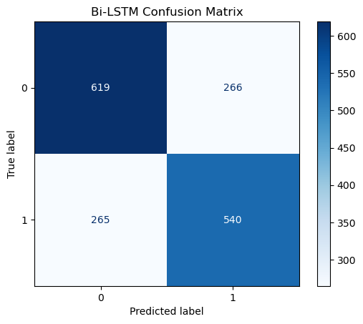
| Model | Test Accuracy | Test Loss |
|:--------|----------------:|:-----------------------------------------|
| LSTM | 0.608876 | [0.646052360534668, 0.6088757514953613] |
| Bi-LSTM | 0.685799 | [0.5925546288490295, 0.6857988238334656] |

