Training EEGNet...
EEGNet Results:
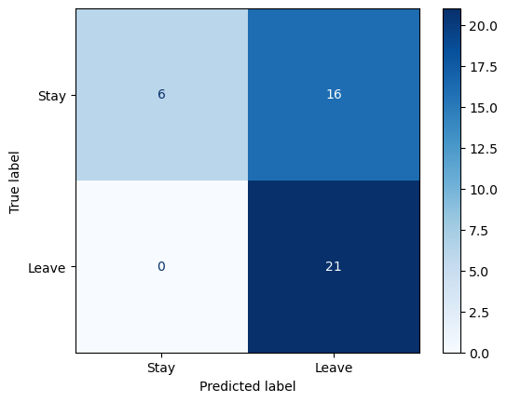
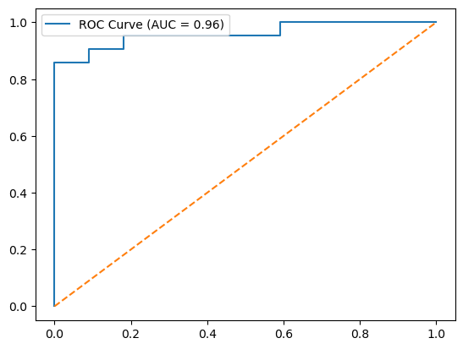

Training LMDA...
LMDA Results:
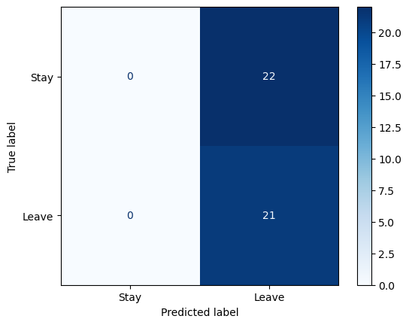
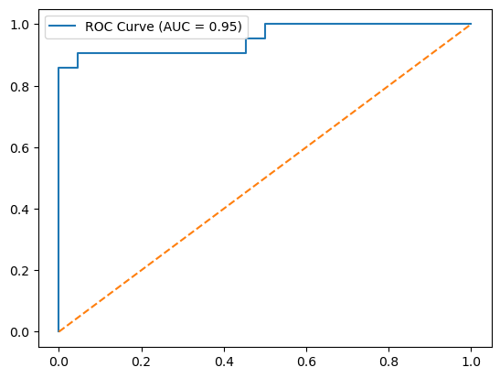

Training GCN...
C:\Users\sansk\miniconda3\Lib\site-packages\torch_geometric\deprecation.py:26: UserWarning: 'data.DataLoader' is deprecated, use 'loader.DataLoader' instead
warnings.warn(out)
GCN Results:
