Finding max time length...
Frequency resolution: 0.0054 Hz, Freq bins: 9201
Loading EEG data...
Data shape: (212, 28, 9201), Stay: 106, Leave: 106

======================================================================
K-FOLD CROSS-VALIDATION WITH FEATURE EXTRACTION
======================================================================
Device: cuda

Fold 1/5
----------------------------------------------------------------------
Training GCN...
Evaluating and extracting features...
AUROC: 0.6299, F1: 0.6454

Fold 2/5
----------------------------------------------------------------------
Training GCN...
Evaluating and extracting features...
AUROC: 0.7121, F1: 0.5740

Fold 3/5
----------------------------------------------------------------------
Training GCN...
Evaluating and extracting features...
AUROC: 0.7517, F1: 0.7117

Fold 4/5
----------------------------------------------------------------------
Training GCN...
Evaluating and extracting features...
AUROC: 0.8685, F1: 0.5714

Fold 5/5
----------------------------------------------------------------------
Training GCN...
Evaluating and extracting features...
AUROC: 0.8934, F1: 0.8809

======================================================================
VISUALIZING LAYER-WISE FEATURES
======================================================================
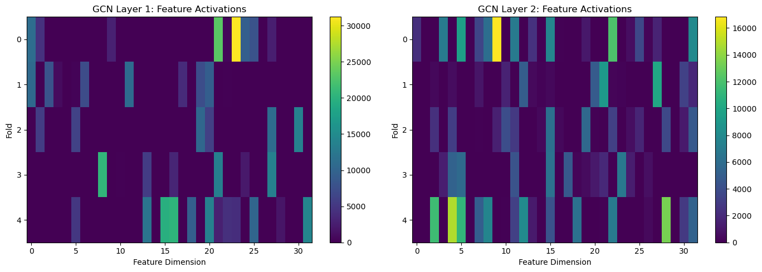
✓ Saved: gcn_layer_features.png
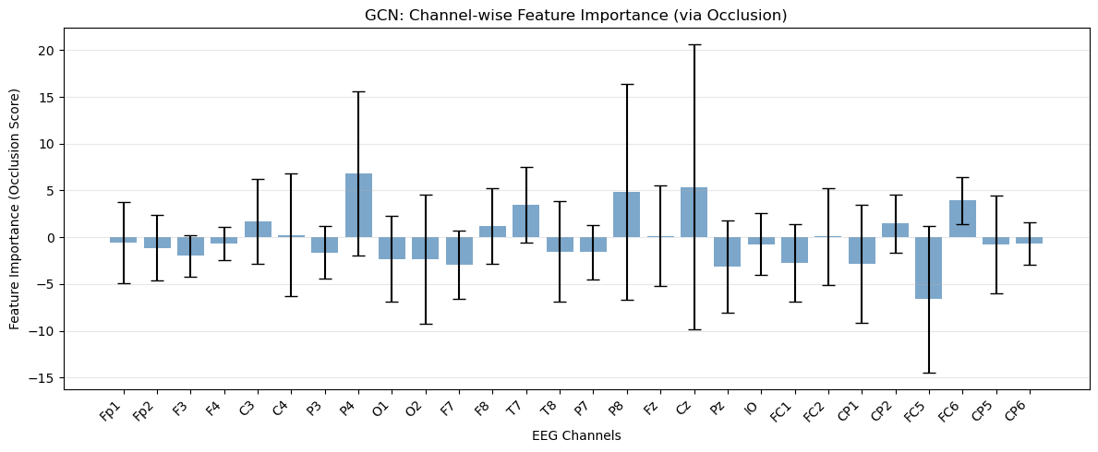
✓ Saved: gcn_occlusion_map.png

======================================================================
FINAL RESULTS
======================================================================
AUROC: 0.771 ± 0.098
Weighted F1: 0.677 ± 0.114
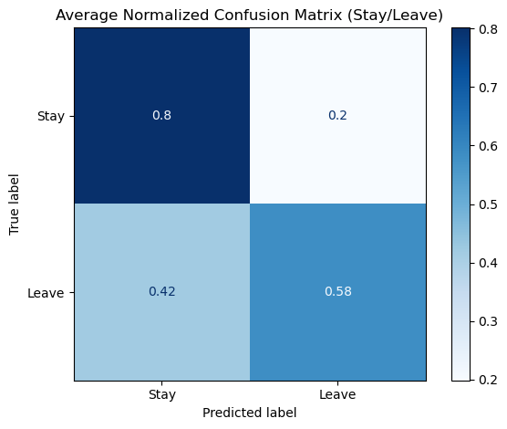
✓ Saved: confusion_matrix_weighted.png
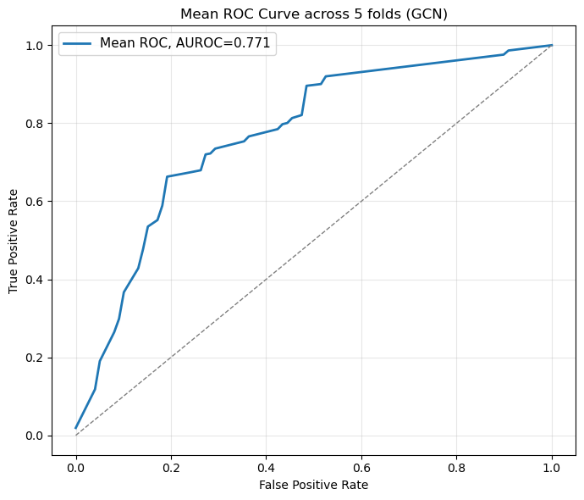
✓ Saved: roc_curve_weighted.png
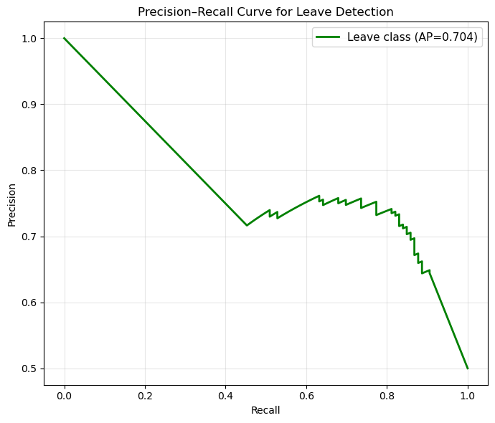
✓ Saved: precision_recall_weighted.png

