Finding max time length...
Frequency resolution: 0.0054 Hz
Frequency bins (0-50 Hz): 9201
Max time samples: 92000

Loading EEG data...
Data shape: (212, 28, 9201)
Labels shape: (212,)
Stay samples: 106, Leave samples: 106

============================================================
PLOTTING GRAPH STRUCTURES
============================================================

Stay epoch index: 1
Leave epoch index: 0

--- Plotting with correlation threshold 0.7 ---
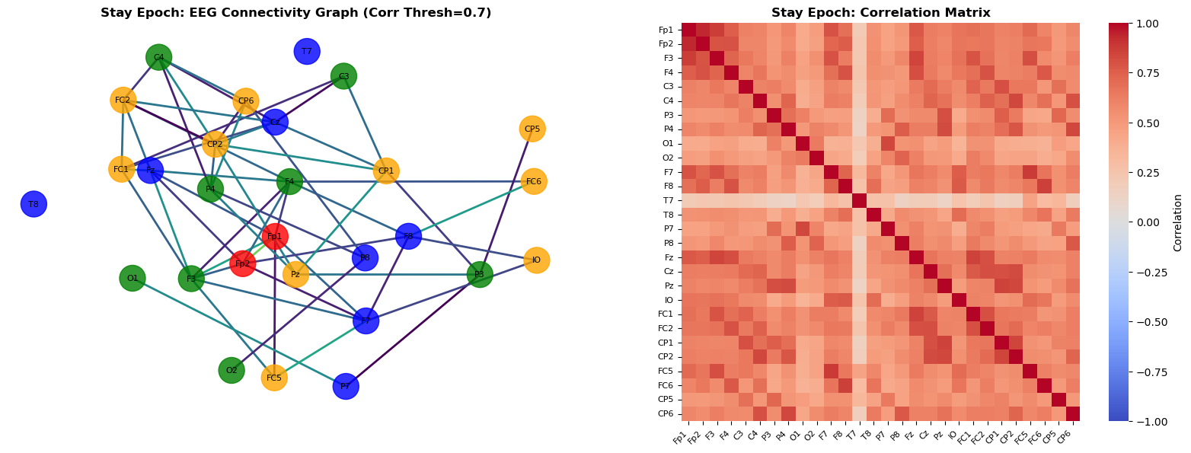

Stay Epoch Statistics:
Number of nodes: 28
Number of edges: 56
Average degree: 4.00
Network density: 0.1481
Largest connected component size: 26
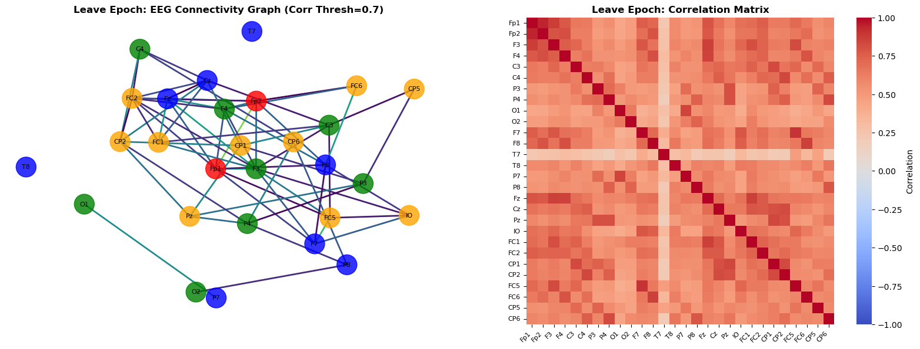

Leave Epoch Statistics:
Number of nodes: 28
Number of edges: 64
Average degree: 4.57
Network density: 0.1693
Largest connected component size: 24

============================================================
CONSTRUCTING GRAPHS FOR GNN TRAINING
============================================================

============================================================
K-FOLD CROSS-VALIDATION WITH SPATIO-TEMPORAL GNN
============================================================
Device: cuda

Fold 1/5
----------------------------------------
Acc: 0.4884, AUC: 0.3344, F1: 0.0000

Fold 2/5
----------------------------------------
Acc: 0.4884, AUC: 0.5238, F1: 0.6562

Fold 3/5
----------------------------------------
Acc: 0.5000, AUC: 0.6633, F1: 0.0000

Fold 4/5
----------------------------------------
Acc: 0.4286, AUC: 0.4138, F1: 0.5862

Fold 5/5
----------------------------------------
Acc: 0.5000, AUC: 0.3878, F1: 0.6667

============================================================
PLOTTING RESULTS
============================================================
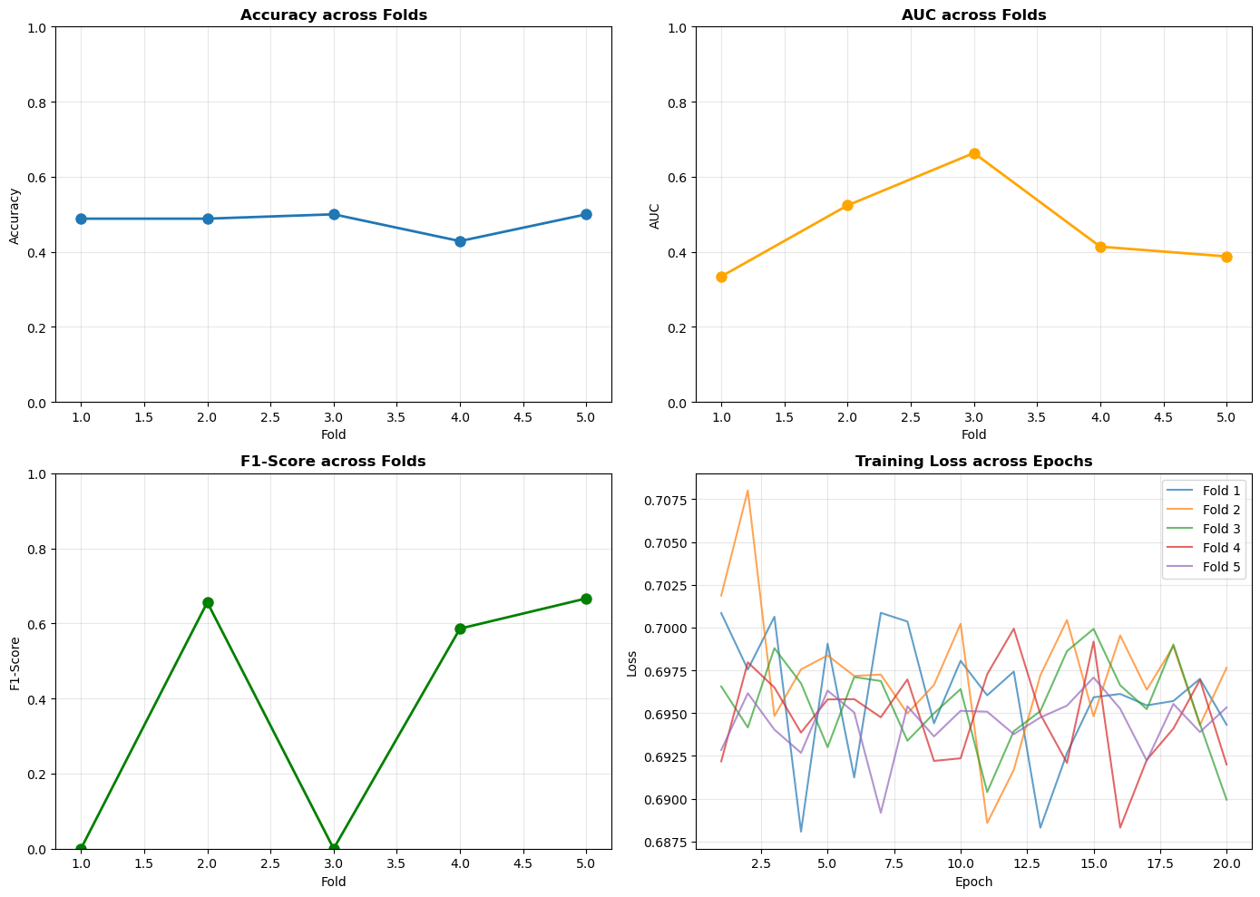

============================================================
SUMMARY STATISTICS
============================================================
Mean Accuracy: 0.4811 ± 0.0268
Mean AUC: 0.4646 ± 0.1170
Mean F1: 0.3818 ± 0.3130

All visualizations and results saved!

