X shape: (212, 28, 9201) y shape: (212,)
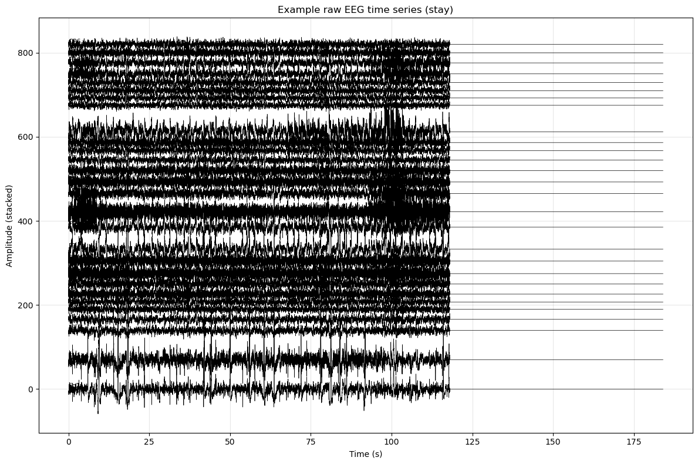
Saved: example_stay_timeseries.png
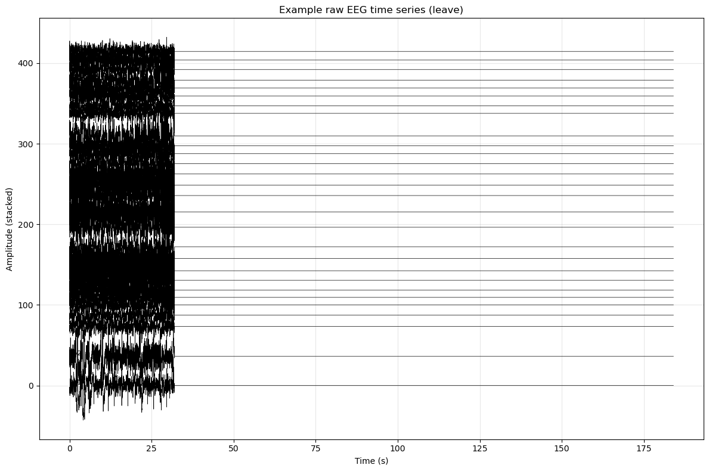
Saved: example_leave_timeseries.png
C:\Users\sansk\AppData\Local\Temp\ipykernel_15164\4057022834.py:119: UserWarning: This figure includes Axes that are not compatible with tight_layout, so results might be incorrect.
plt.tight_layout()
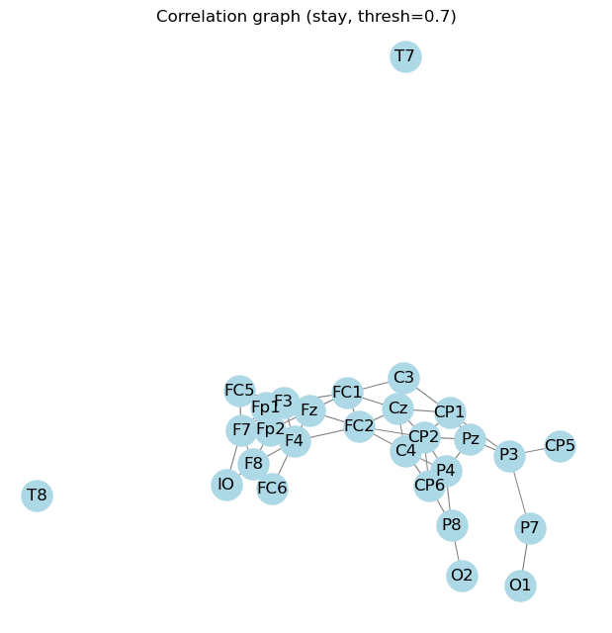
Saved: example_stay_graph.png
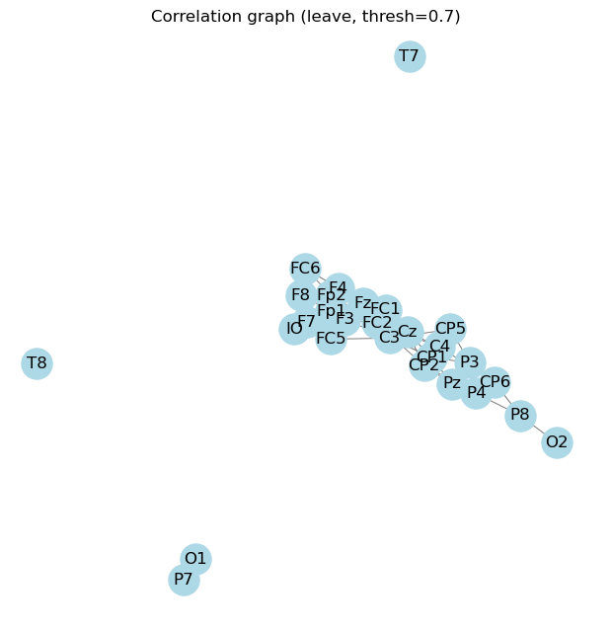
Saved: example_leave_graph.png
Device: cuda

Fold 1/5
Epoch 20/100 - Loss: 12.1168
Epoch 40/100 - Loss: 0.0212
Epoch 60/100 - Loss: 0.9607
Epoch 80/100 - Loss: 0.0000
Epoch 100/100 - Loss: 0.0000
Fold 1 AUROC: 0.7240, Weighted F1: 0.7163

Fold 2/5
Epoch 20/100 - Loss: 3.1011
Epoch 40/100 - Loss: 2.9752
Epoch 60/100 - Loss: 0.0000
Epoch 80/100 - Loss: 0.0000
Epoch 100/100 - Loss: 0.0000
Fold 2 AUROC: 0.8030, Weighted F1: 0.7439

Fold 3/5
Epoch 20/100 - Loss: 2.1645
Epoch 40/100 - Loss: 0.2876
Epoch 60/100 - Loss: 0.0000
Epoch 80/100 - Loss: 0.0000
Epoch 100/100 - Loss: 0.0000
Fold 3 AUROC: 0.8753, Weighted F1: 0.8095

Fold 4/5
Epoch 20/100 - Loss: 7.3530
Epoch 40/100 - Loss: 0.5113
Epoch 60/100 - Loss: 0.0000
Epoch 80/100 - Loss: 0.0000
Epoch 100/100 - Loss: 0.0000
Fold 4 AUROC: 0.7506, Weighted F1: 0.6889

Fold 5/5
Epoch 20/100 - Loss: 14.3857
Epoch 40/100 - Loss: 4.1479
Epoch 60/100 - Loss: 0.2179
Epoch 80/100 - Loss: 0.0000
Epoch 100/100 - Loss: 0.0000
Fold 5 AUROC: 0.7075, Weighted F1: 0.6659

Mean AUROC: 0.7720779220779221 ± 0.06091576003638316
Mean Weighted F1: 0.7249141600025262 ± 0.04974438029519365
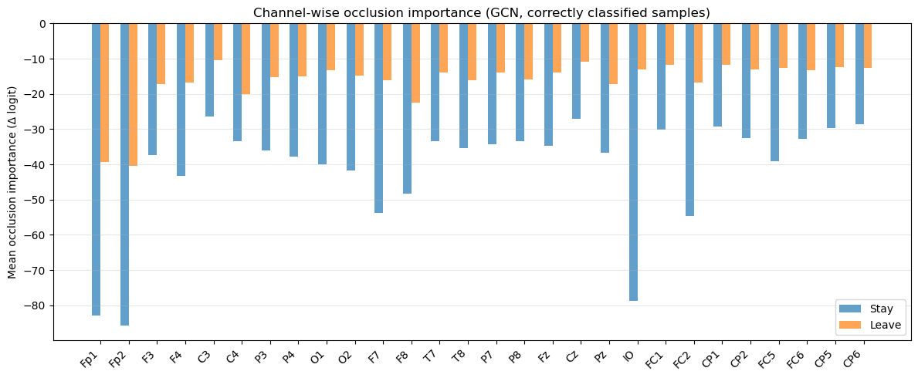
Saved: gcn_channel_occlusion_importance.png

