X shape: (212, 28, 9201) y shape: (212,)
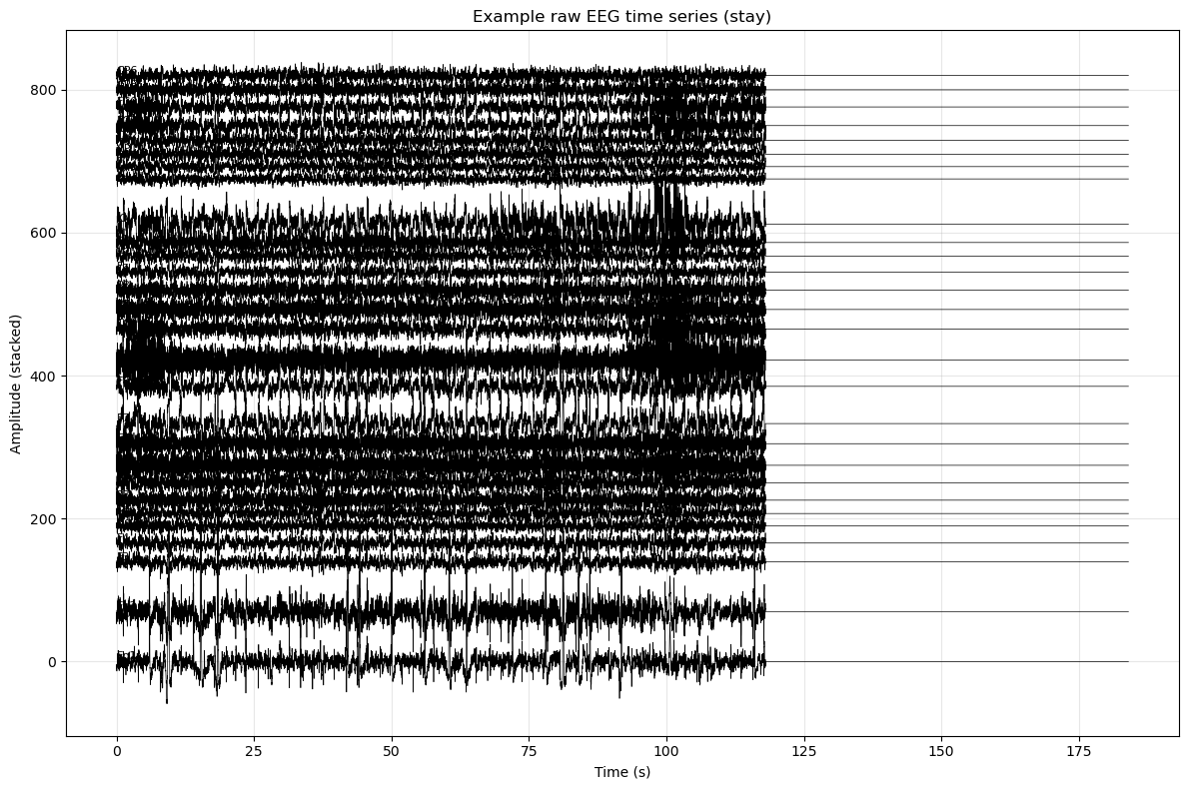
Saved: example_stay_timeseries.png
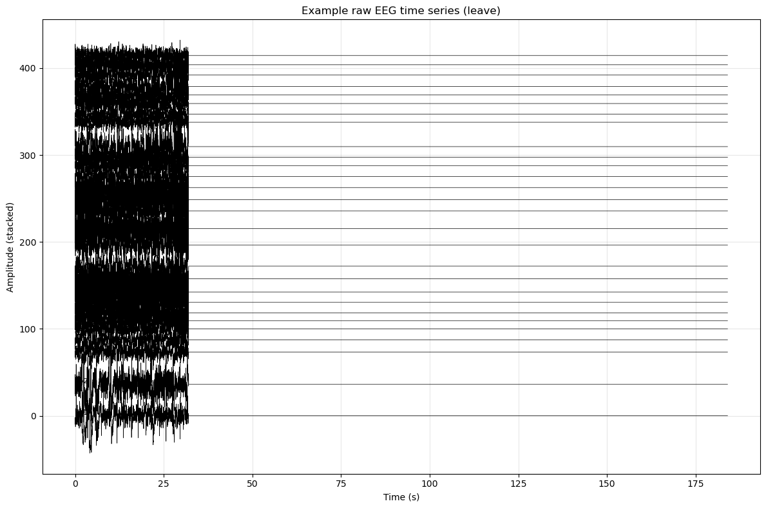
Saved: example_leave_timeseries.png
C:\Users\sansk\AppData\Local\Temp\ipykernel_15164\3726610292.py:121: UserWarning: This figure includes Axes that are not compatible with tight_layout, so results might be incorrect.
plt.tight_layout()
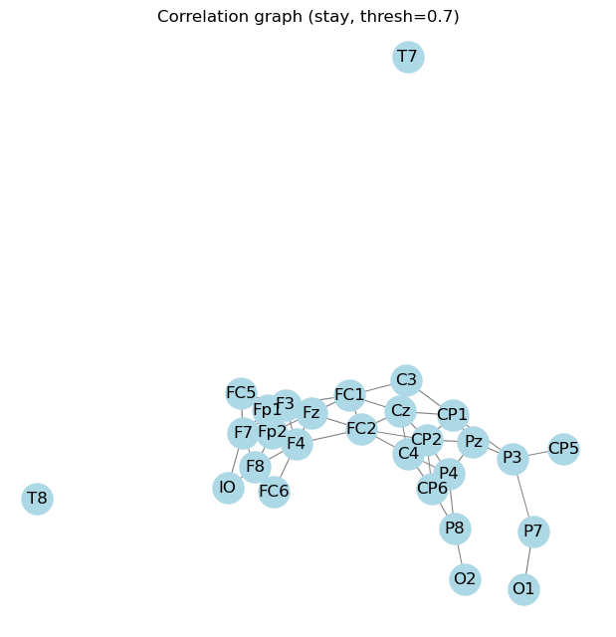
Saved: example_stay_graph.png
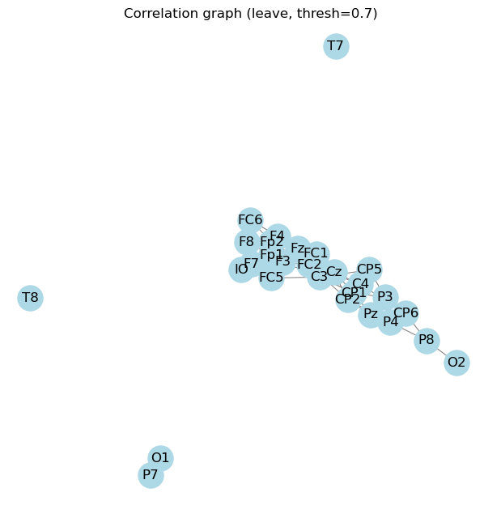
Saved: example_leave_graph.png
Device: cuda

Fold 1/5
Epoch 20/100 - Loss: 4.7711
Epoch 40/100 - Loss: 0.5065
Epoch 60/100 - Loss: 0.0001
Epoch 80/100 - Loss: 0.0000
Epoch 100/100 - Loss: 0.0000
Fold 1 AUROC: 0.8983, Weighted F1: 0.8600

Fold 2/5
Epoch 20/100 - Loss: 31.0218
Epoch 40/100 - Loss: 2.4072
Epoch 60/100 - Loss: 1.8321
Epoch 80/100 - Loss: 0.0000
Epoch 100/100 - Loss: 0.0000
Fold 2 AUROC: 0.8258, Weighted F1: 0.8109

Fold 3/5
Epoch 20/100 - Loss: 1.5185
Epoch 40/100 - Loss: 4.4599
Epoch 60/100 - Loss: 0.0428
Epoch 80/100 - Loss: 0.0000
Epoch 100/100 - Loss: 0.0000
Fold 3 AUROC: 0.7959, Weighted F1: 0.7826

Fold 4/5
Epoch 20/100 - Loss: 9.2992
Epoch 40/100 - Loss: 0.3005
Epoch 60/100 - Loss: 0.0000
Epoch 80/100 - Loss: 0.0000
Epoch 100/100 - Loss: 0.0000
Fold 4 AUROC: 0.8118, Weighted F1: 0.8325

Fold 5/5
Epoch 20/100 - Loss: 5.5697
Epoch 40/100 - Loss: 0.3538
Epoch 60/100 - Loss: 0.0017
Epoch 80/100 - Loss: 0.0002
Epoch 100/100 - Loss: 0.0001
Fold 5 AUROC: 0.7755, Weighted F1: 0.6903

Mean AUROC: 0.8214491857349 ± 0.04189329185244397
Mean Weighted F1: 0.7952633156035548 ± 0.058306267783028
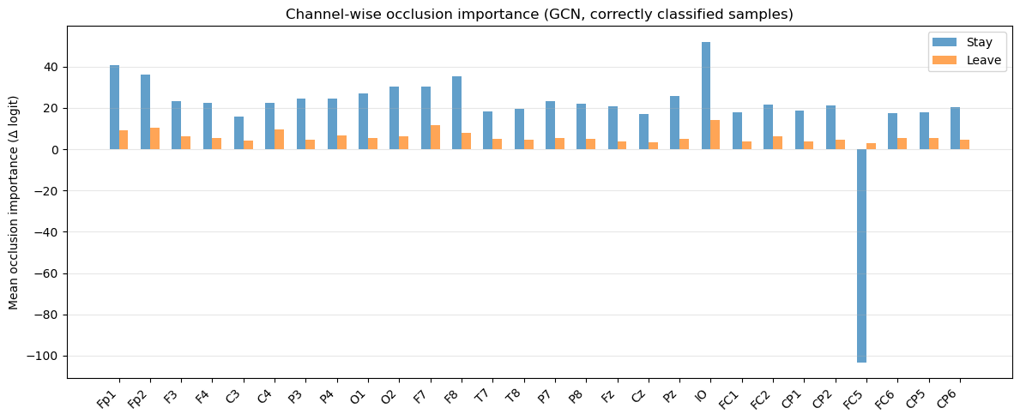
Saved: gcn_channel_occlusion_importance.png
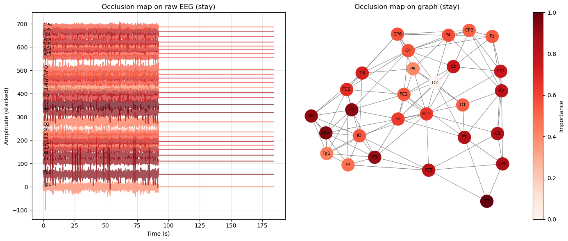
Saved: example_stay_occlusion_map.png
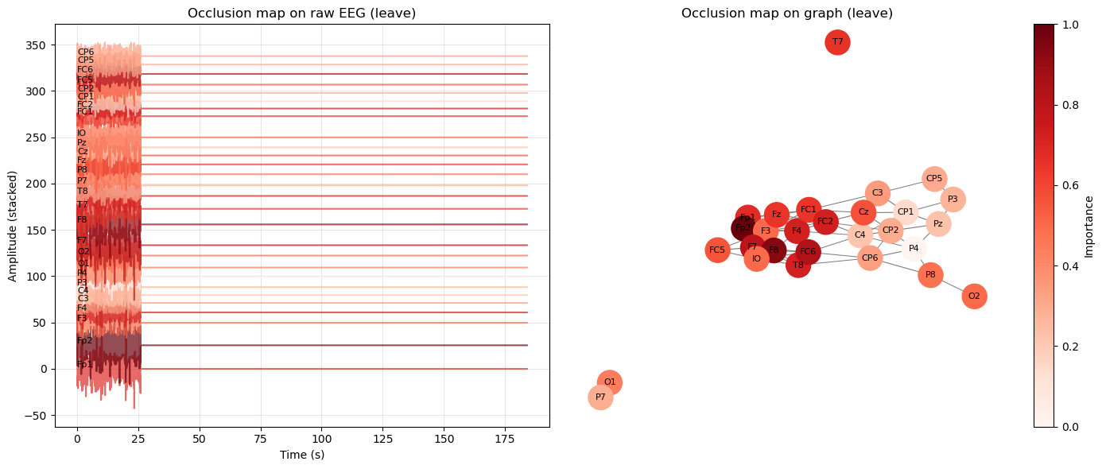
Saved: example_leave_occlusion_map.png
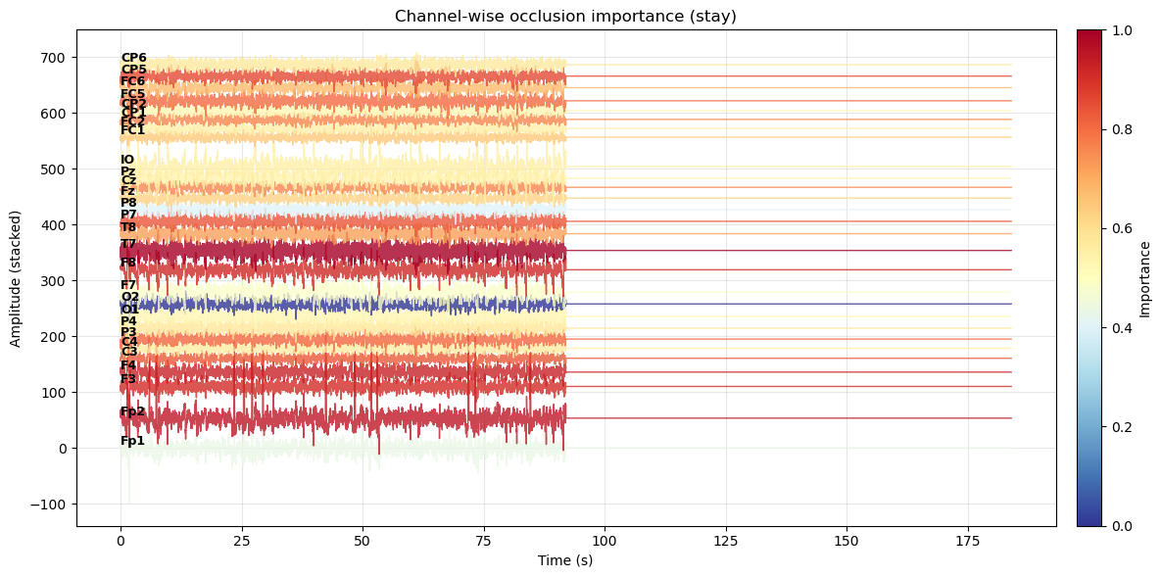
Saved: example_stay_classification_importance.png
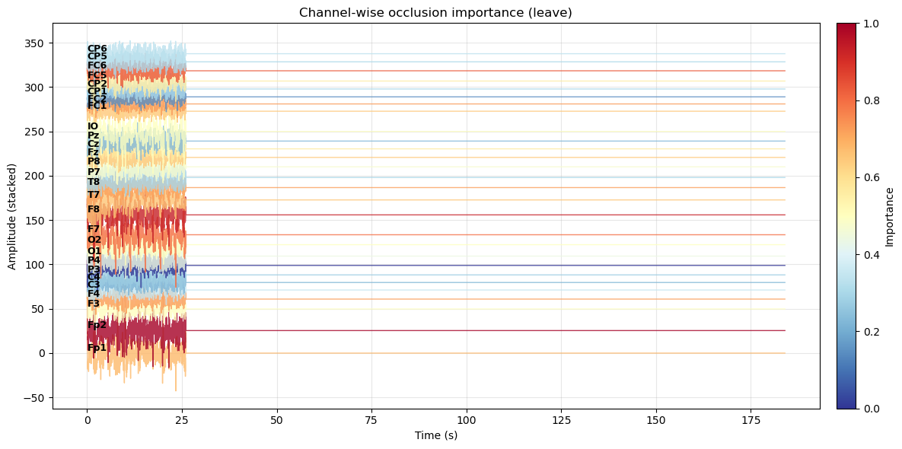
Saved: example_leave_classification_importance.png

