Number of epochs: 7243
(7243, 1000, 29) (7243,)
Epoch 1/20
182/182 ━━━━━━━━━━━━━━━━━━━━ 79s 412ms/step - accuracy: 0.5192 - loss: 0.7198 - val_accuracy: 0.5707 - val_loss: 0.6765
Epoch 2/20
182/182 ━━━━━━━━━━━━━━━━━━━━ 85s 432ms/step - accuracy: 0.5619 - loss: 0.6808 - val_accuracy: 0.5673 - val_loss: 0.6704
Epoch 3/20
182/182 ━━━━━━━━━━━━━━━━━━━━ 79s 432ms/step - accuracy: 0.5943 - loss: 0.6562 - val_accuracy: 0.6066 - val_loss: 0.6462
Epoch 4/20
182/182 ━━━━━━━━━━━━━━━━━━━━ 82s 452ms/step - accuracy: 0.6347 - loss: 0.6326 - val_accuracy: 0.6232 - val_loss: 0.6371
Epoch 5/20
182/182 ━━━━━━━━━━━━━━━━━━━━ 132s 398ms/step - accuracy: 0.6502 - loss: 0.6193 - val_accuracy: 0.6349 - val_loss: 0.6386
Epoch 6/20
182/182 ━━━━━━━━━━━━━━━━━━━━ 75s 410ms/step - accuracy: 0.6576 - loss: 0.6135 - val_accuracy: 0.6266 - val_loss: 0.6355
Epoch 7/20
182/182 ━━━━━━━━━━━━━━━━━━━━ 76s 416ms/step - accuracy: 0.6737 - loss: 0.6059 - val_accuracy: 0.6453 - val_loss: 0.6235
Epoch 8/20
182/182 ━━━━━━━━━━━━━━━━━━━━ 82s 414ms/step - accuracy: 0.6756 - loss: 0.5934 - val_accuracy: 0.6625 - val_loss: 0.6174
Epoch 9/20
182/182 ━━━━━━━━━━━━━━━━━━━━ 79s 396ms/step - accuracy: 0.7159 - loss: 0.5594 - val_accuracy: 0.6384 - val_loss: 0.6308
Epoch 10/20
182/182 ━━━━━━━━━━━━━━━━━━━━ 73s 404ms/step - accuracy: 0.7108 - loss: 0.5726 - val_accuracy: 0.6674 - val_loss: 0.6424
Epoch 11/20
182/182 ━━━━━━━━━━━━━━━━━━━━ 80s 390ms/step - accuracy: 0.7136 - loss: 0.5647 - val_accuracy: 0.6570 - val_loss: 0.6176
Epoch 12/20
182/182 ━━━━━━━━━━━━━━━━━━━━ 69s 377ms/step - accuracy: 0.7187 - loss: 0.5574 - val_accuracy: 0.6646 - val_loss: 0.6151
Epoch 13/20
182/182 ━━━━━━━━━━━━━━━━━━━━ 69s 379ms/step - accuracy: 0.7395 - loss: 0.5376 - val_accuracy: 0.5680 - val_loss: 0.7254
Epoch 14/20
182/182 ━━━━━━━━━━━━━━━━━━━━ 70s 386ms/step - accuracy: 0.5958 - loss: 0.6557 - val_accuracy: 0.6287 - val_loss: 0.6301
Epoch 15/20
182/182 ━━━━━━━━━━━━━━━━━━━━ 71s 388ms/step - accuracy: 0.6669 - loss: 0.5957 - val_accuracy: 0.6563 - val_loss: 0.6136
Epoch 16/20
182/182 ━━━━━━━━━━━━━━━━━━━━ 81s 382ms/step - accuracy: 0.7101 - loss: 0.5506 - val_accuracy: 0.6867 - val_loss: 0.5958
Epoch 17/20
182/182 ━━━━━━━━━━━━━━━━━━━━ 83s 389ms/step - accuracy: 0.7212 - loss: 0.5482 - val_accuracy: 0.6211 - val_loss: 0.6384
Epoch 18/20
182/182 ━━━━━━━━━━━━━━━━━━━━ 72s 393ms/step - accuracy: 0.6970 - loss: 0.5735 - val_accuracy: 0.6522 - val_loss: 0.6214
Epoch 19/20
182/182 ━━━━━━━━━━━━━━━━━━━━ 72s 394ms/step - accuracy: 0.7300 - loss: 0.5505 - val_accuracy: 0.6653 - val_loss: 0.6188
Epoch 20/20
182/182 ━━━━━━━━━━━━━━━━━━━━ 71s 390ms/step - accuracy: 0.7246 - loss: 0.5514 - val_accuracy: 0.6901 - val_loss: 0.5819
46/46 ━━━━━━━━━━━━━━━━━━━━ 8s 162ms/step
LSTM Classification Report:
precision recall f1-score support

0 0.69 0.74 0.71 757
1 0.69 0.64 0.66 692

accuracy 0.69 1449
macro avg 0.69 0.69 0.69 1449
weighted avg 0.69 0.69 0.69 1449

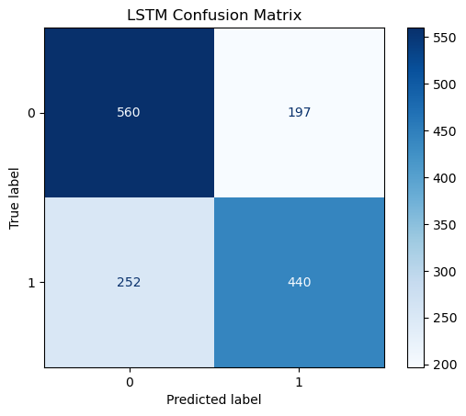
Epoch 1/20
182/182 ━━━━━━━━━━━━━━━━━━━━ 103s 523ms/step - accuracy: 0.5133 - loss: 0.7227 - val_accuracy: 0.5839 - val_loss: 0.6587
Epoch 2/20
182/182 ━━━━━━━━━━━━━━━━━━━━ 96s 528ms/step - accuracy: 0.5784 - loss: 0.6670 - val_accuracy: 0.6225 - val_loss: 0.6396
Epoch 3/20
182/182 ━━━━━━━━━━━━━━━━━━━━ 93s 510ms/step - accuracy: 0.6201 - loss: 0.6416 - val_accuracy: 0.6391 - val_loss: 0.6254
Epoch 4/20
182/182 ━━━━━━━━━━━━━━━━━━━━ 143s 513ms/step - accuracy: 0.6613 - loss: 0.6014 - val_accuracy: 0.6473 - val_loss: 0.6169
Epoch 5/20
182/182 ━━━━━━━━━━━━━━━━━━━━ 93s 510ms/step - accuracy: 0.6848 - loss: 0.5820 - val_accuracy: 0.6660 - val_loss: 0.6014
Epoch 6/20
182/182 ━━━━━━━━━━━━━━━━━━━━ 94s 515ms/step - accuracy: 0.7056 - loss: 0.5531 - val_accuracy: 0.6729 - val_loss: 0.5995
Epoch 7/20
182/182 ━━━━━━━━━━━━━━━━━━━━ 94s 515ms/step - accuracy: 0.7351 - loss: 0.5203 - val_accuracy: 0.6970 - val_loss: 0.5769
Epoch 8/20
182/182 ━━━━━━━━━━━━━━━━━━━━ 94s 517ms/step - accuracy: 0.7392 - loss: 0.5253 - val_accuracy: 0.7046 - val_loss: 0.5683
Epoch 9/20
182/182 ━━━━━━━━━━━━━━━━━━━━ 93s 514ms/step - accuracy: 0.7421 - loss: 0.5122 - val_accuracy: 0.6984 - val_loss: 0.5665
Epoch 10/20
182/182 ━━━━━━━━━━━━━━━━━━━━ 266s 1s/step - accuracy: 0.7346 - loss: 0.5405 - val_accuracy: 0.6977 - val_loss: 0.5865
Epoch 11/20
182/182 ━━━━━━━━━━━━━━━━━━━━ 248s 1s/step - accuracy: 0.7208 - loss: 0.5317 - val_accuracy: 0.7032 - val_loss: 0.5679
Epoch 12/20
182/182 ━━━━━━━━━━━━━━━━━━━━ 243s 1s/step - accuracy: 0.7595 - loss: 0.4985 - val_accuracy: 0.7143 - val_loss: 0.5570
Epoch 13/20
182/182 ━━━━━━━━━━━━━━━━━━━━ 243s 1s/step - accuracy: 0.7820 - loss: 0.4600 - val_accuracy: 0.7267 - val_loss: 0.5546
Epoch 14/20
182/182 ━━━━━━━━━━━━━━━━━━━━ 247s 1s/step - accuracy: 0.7647 - loss: 0.4822 - val_accuracy: 0.7150 - val_loss: 0.5497
Epoch 15/20
182/182 ━━━━━━━━━━━━━━━━━━━━ 244s 1s/step - accuracy: 0.8006 - loss: 0.4356 - val_accuracy: 0.7246 - val_loss: 0.5703
Epoch 16/20
182/182 ━━━━━━━━━━━━━━━━━━━━ 254s 1s/step - accuracy: 0.8242 - loss: 0.3907 - val_accuracy: 0.7164 - val_loss: 0.5937
Epoch 17/20
182/182 ━━━━━━━━━━━━━━━━━━━━ 249s 1s/step - accuracy: 0.8094 - loss: 0.4221 - val_accuracy: 0.7405 - val_loss: 0.5497
Epoch 18/20
182/182 ━━━━━━━━━━━━━━━━━━━━ 270s 1s/step - accuracy: 0.8237 - loss: 0.3878 - val_accuracy: 0.6805 - val_loss: 0.6530
Epoch 19/20
182/182 ━━━━━━━━━━━━━━━━━━━━ 255s 1s/step - accuracy: 0.8413 - loss: 0.3789 - val_accuracy: 0.6770 - val_loss: 0.5983
46/46 ━━━━━━━━━━━━━━━━━━━━ 25s 508ms/step
Bi-LSTM Classification Report:
precision recall f1-score support

0 0.67 0.75 0.71 757
1 0.68 0.60 0.64 692

accuracy 0.68 1449
macro avg 0.68 0.67 0.67 1449
weighted avg 0.68 0.68 0.67 1449

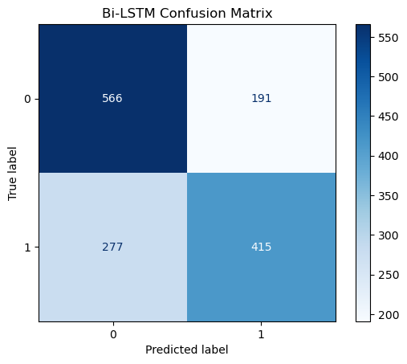
| Model | Test Accuracy | Test Loss |
|:--------|----------------:|:-----------------------------------------|
| LSTM | 0.690131 | [0.5819476842880249, 0.6901311278343201] |
| Bi-LSTM | 0.677019 | [0.5983206629753113, 0.6770186424255371] |

