Frequency resolution: 0.0028 Hz
Using 35938 frequency bins to cover 0-100 Hz
Data shape: (212, 28, 35938)
Frequency bins from 0 to 100 Hz: 35938

Training EEGNet...
EEGNet Results:
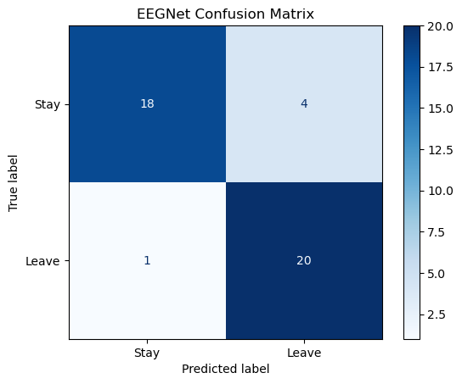
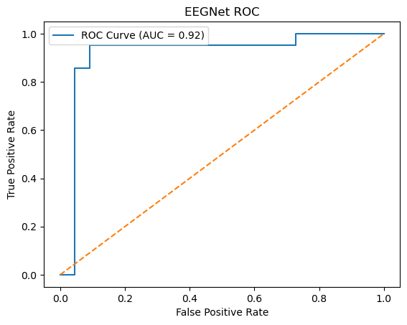
EEGNet ROC AUC: 0.9177

Training LMDA...
LMDA Results:
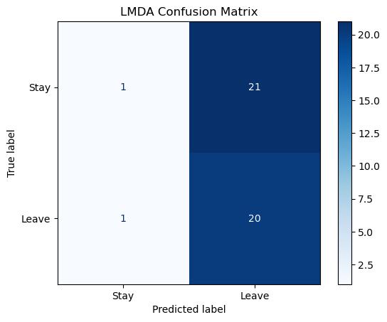
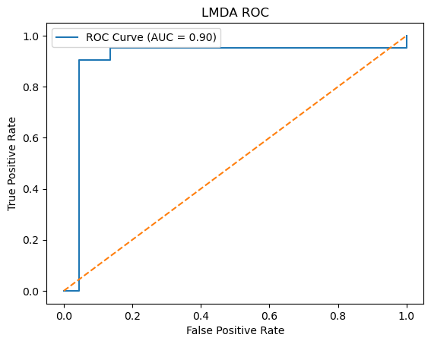
LMDA ROC AUC: 0.9048

Training GCN...
C:\Users\sansk\miniconda3\Lib\site-packages\torch_geometric\deprecation.py:26: UserWarning: 'data.DataLoader' is deprecated, use 'loader.DataLoader' instead
warnings.warn(out)
GCN Results:
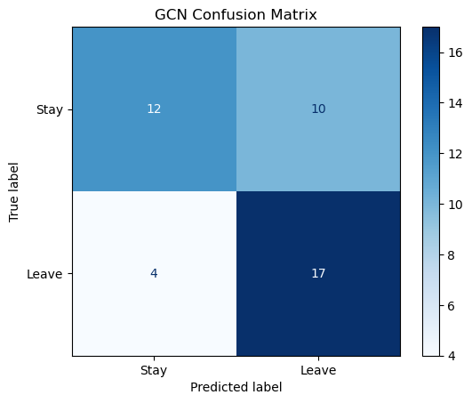
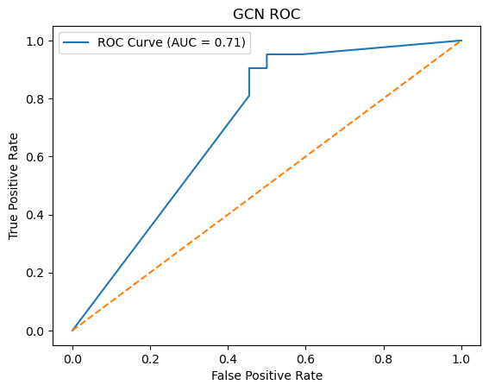
GCN ROC AUC: 0.7110

