Finding max time length...
Frequency resolution: 0.0054 Hz
Frequency bins: 9201
Loading EEG data...
Data shape: (212, 28, 9201)
Stay samples: 106, Leave samples: 106
Class weights - Stay: 1.000, Leave: 1.000

============================================================
K-FOLD CROSS-VALIDATION WITH CLASS WEIGHTING
============================================================
Device: cuda

Fold 1/5
----------------------------------------
AUROC: 0.9026, Weighted F1: 0.8603

Fold 2/5
----------------------------------------
AUROC: 0.8312, Weighted F1: 0.7425

Fold 3/5
----------------------------------------
AUROC: 0.7914, Weighted F1: 0.7619

Fold 4/5
----------------------------------------
AUROC: 0.7653, Weighted F1: 0.6889

Fold 5/5
----------------------------------------
AUROC: 0.8163, Weighted F1: 0.7379

============================================================
FINAL RESULTS
============================================================
AUROC: 0.821 ± 0.046
Weighted F1: 0.758 ± 0.056

| Model | AUROC | Weighted F1 |
|-------|-------|-------------|
| GCN | 0.821 ± 0.046 | 0.758 ± 0.056 |
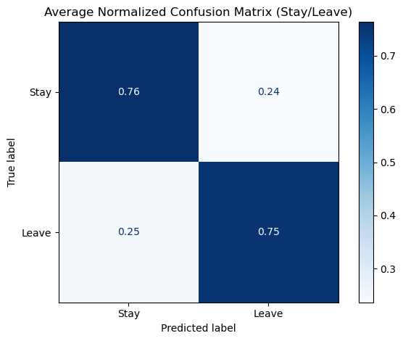
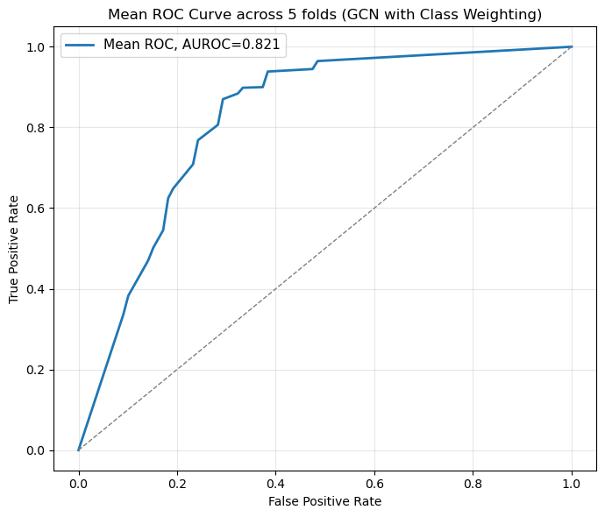
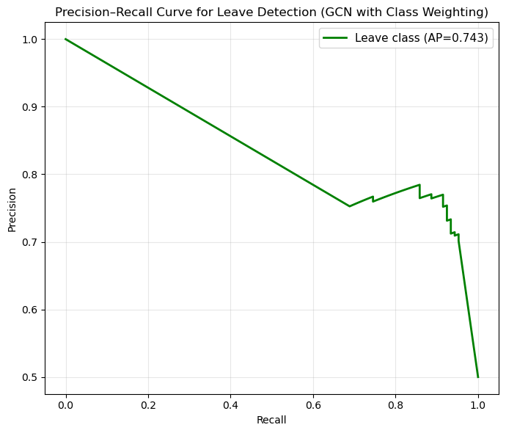

Best threshold for Leave: 0.10
F1_leave at best threshold: 0.7642
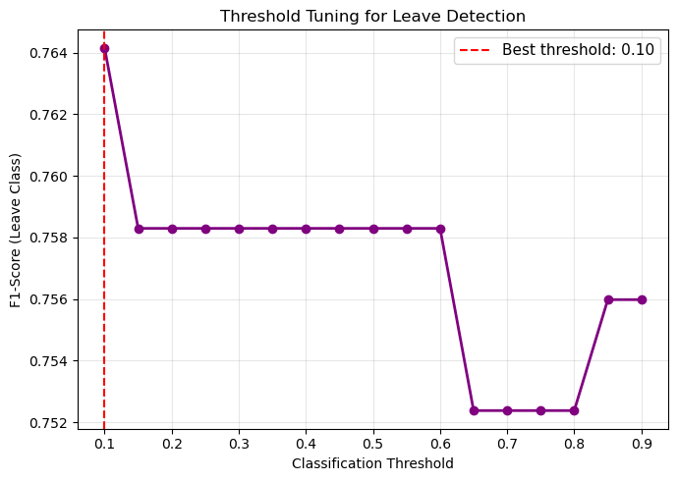

Per-class metrics at threshold 0.10:
Leave Sensitivity (Recall): 0.7642
Leave Specificity: 0.7642
Leave Precision: 0.7642
Leave F1-Score: 0.7642

============================================================
SUMMARY STATISTICS
============================================================
Mean AUROC: 0.8214 ± 0.0464
Mean Weighted F1: 0.7583 ± 0.0564
Mean Confusion Matrix (row-normalized):
[[0.76363636 0.23636364]
[0.24588745 0.75411255]]

Average Precision (Leave): 0.7435
Best Threshold: 0.10
Leave F1 @ Best Threshold: 0.7642

✓ All results saved as PNG files!

