**Using device: cuda**

**--- Fold 1/5 ---**

**Fold 1 Accuracy: 0.8792**

**--- Fold 2/5 ---**

**Fold 2 Accuracy: 0.8949**

**--- Fold 3/5 ---**

**Fold 3 Accuracy: 0.8438**

**--- Fold 4/5 ---**

**Fold 4 Accuracy: 0.8860**

**--- Fold 5/5 ---**

**Fold 5 Accuracy: 0.8839**

**Average Cross-Validation Accuracy: 0.8775 (±0.0176)**

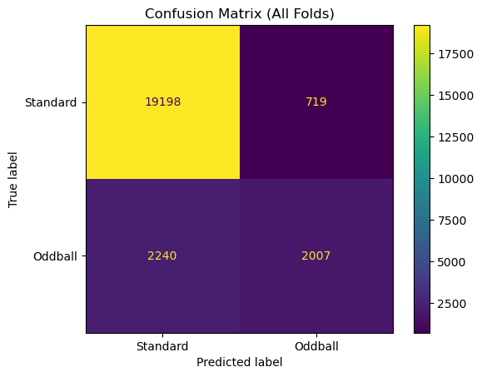

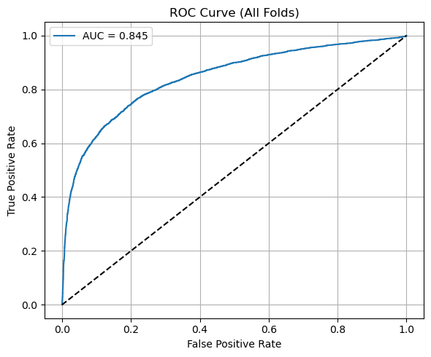

=== Fold-by-Fold Detailed Analysis ===

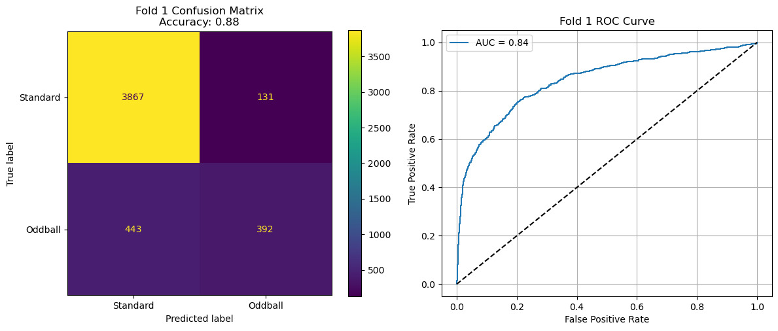

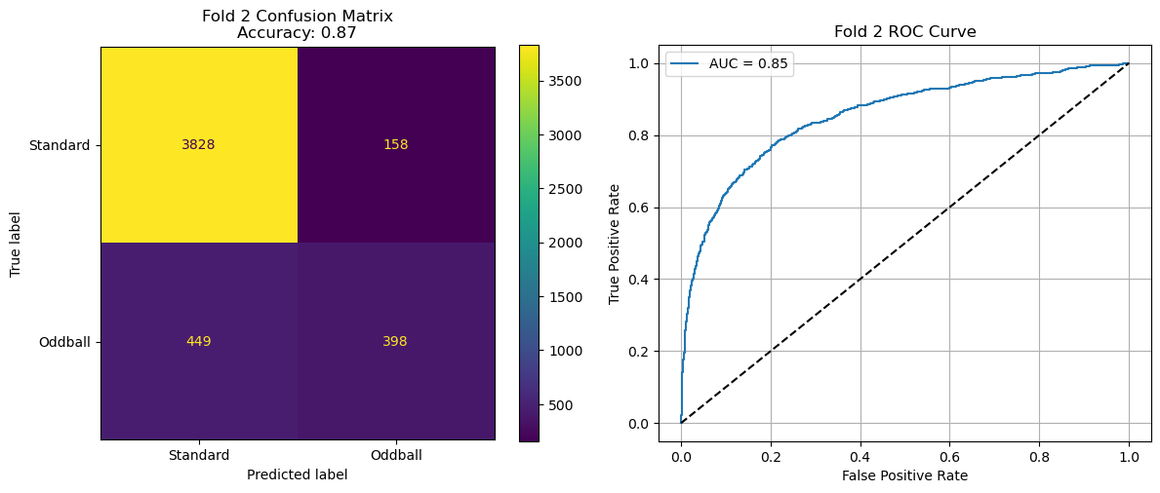

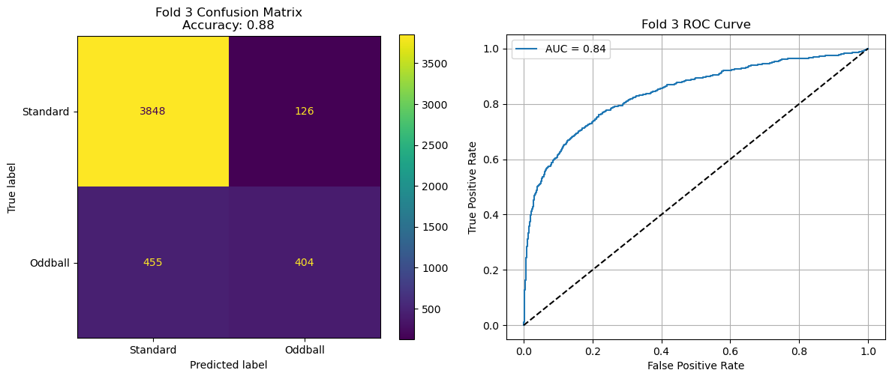

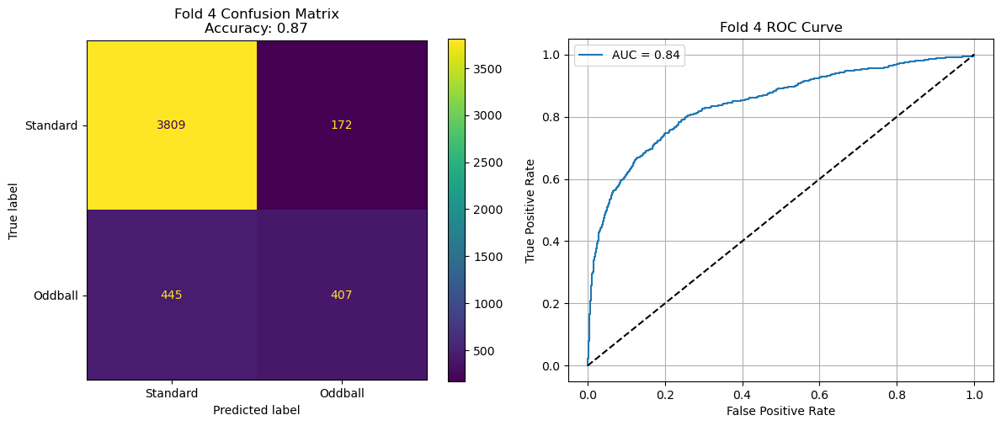

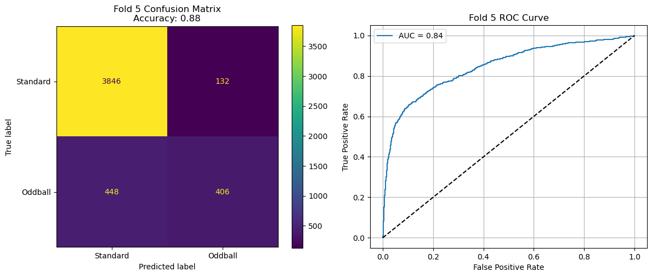

=== Cross-Validation Performance Summary ===

Fold | Accuracy | AUC

-----------------------------------

Fold 1 | 0.8812 | 0.8425

Fold 2 | 0.8744 | 0.8543

Fold 3 | 0.8798 | 0.8402

Fold 4 | 0.8723 | 0.8420

Fold 5 | 0.8800 | 0.8450

-----------------------------------

Mean | 0.8775 | 0.8448

Std | ±0.0035 | ±0.0050