Streamlit for Information Discovery and Big Data Analysis: A Review Using Student Performance Data

[Student Name]
[Department], [University]
Query Design & Analysis
[Instructor Name]
[Due Date]

Streamlit for Information Discovery and Big Data Analysis: A Review Using Student Performance Data
Organizations collect more data than static reports can summarize, so the value of analysis depends on how quickly decision makers can ask and answer their own questions. Streamlit is an open-source Python framework that converts ordinary data scripts into interactive web applications without front-end development (Khorasani et al., 2022). This review examines Streamlit's features, data integration, dashboard design, and support for exploration, and illustrates each point with a working grade-prediction dashboard built on the UCI Student Performance dataset, which contains 1,044 records and 33 attributes describing secondary-school students in Math and Portuguese (Cortez, 2008).
Streamlit and Its Key Features
Streamlit's defining idea is its execution model: the script runs from top to bottom, and whenever a user moves a slider or selects a value, the script runs again with the new input. Each widget simply returns a Python value, so the developer writes no callbacks, HTML, or JavaScript. Around this model, Streamlit provides a widget library (sliders, select boxes, file uploaders, and forms), layout elements (sidebar, columns, tabs, and expanders), native rendering of DataFrames and charts, and two caching decorators, st.cache_data and st.cache_resource, which stop expensive data loading and model training from repeating on every rerun.
How Streamlit Differs From Other Data Analysis Tools
Business intelligence tools such as Tableau and Power BI offer drag-and-drop reporting but limit custom logic and machine learning. Jupyter notebooks support deep exploration, but their output is a document for programmers rather than an application for end users. Dash and Shiny provide fine-grained control through callback functions at the cost of more code. Streamlit sits between these options: it exposes the entire Python ecosystem, including pandas, scikit-learn, and SQL engines, through an interface that a data scientist can build in hours. Its trade-offs are less precise layout control and reruns that require careful caching when data or computation is heavy.
Data Loading and Integration
Streamlit does not impose its own data layer; any source that Python can read can feed an application. In practice, the pandas DataFrame is the common format between sources and widgets (McKinney, 2010). Data may come from flat files, Parquet, REST APIs, cloud storage, or databases through st.connection, which manages credentials and caches query results. The sample dashboard offers three sources in its sidebar (the bundled dataset, an uploaded CSV, or a CSV URL), and all three pass through one preparation function. Figure 1 shows how the two subject files are combined and cached.
Figure 1
Cached Data Loading and Integration in the Dashboard
@st.cache_data # runs once; later reruns reuse the result
def load_sample() -> pd.DataFrame:
frames = []
for subject, file in FILES.items(): # Math and Portuguese CSV files
df = pd.read_csv(DATA_DIR / file, sep=";")
df["subject"] = subject # integrate both files into one table
frames.append(df)
return prepare(pd.concat(frames, ignore_index=True))
con = duckdb.connect()
con.register("students", df) # filtered DataFrame becomes a SQL table
result = con.execute(sql).df()

For query-based analysis, the filtered DataFrame is registered as a table in DuckDB, an embedded columnar database that runs inside the Python process and executes analytical SQL without a separate server (Raasveldt & Mühleisen, 2019). Users can therefore query exactly the subset they have filtered (Figure 4, left).
Creating and Customizing Dashboards and Visualizations
Dashboards are assembled from layout primitives rather than designed on a canvas. The sample application uses a sidebar for data source and filters, a row of four st.metric tiles for key indicators, and four tabs (Overview, Explore, SQL Query, and Predict) that keep the interface uncluttered. Streamlit offers quick built-in charts and also renders Matplotlib, Plotly, and Altair figures. The dashboard uses Altair, a declarative grammar in which charts are specified by mapping columns to visual encodings (VanderPlas et al., 2018). Appearance is customized through a theme file that sets colors and fonts, and the same encoding (blue for pass, red for fail) is applied to every chart. Figure 2 shows that the overall pass rate is 78.0%, that 53 students received a final grade of zero, and that Portuguese pass rates exceed Math pass rates at both schools (84.6% compared with 67.1% overall).
Figure 2
Overview Tab With Key Indicators and Summary Charts
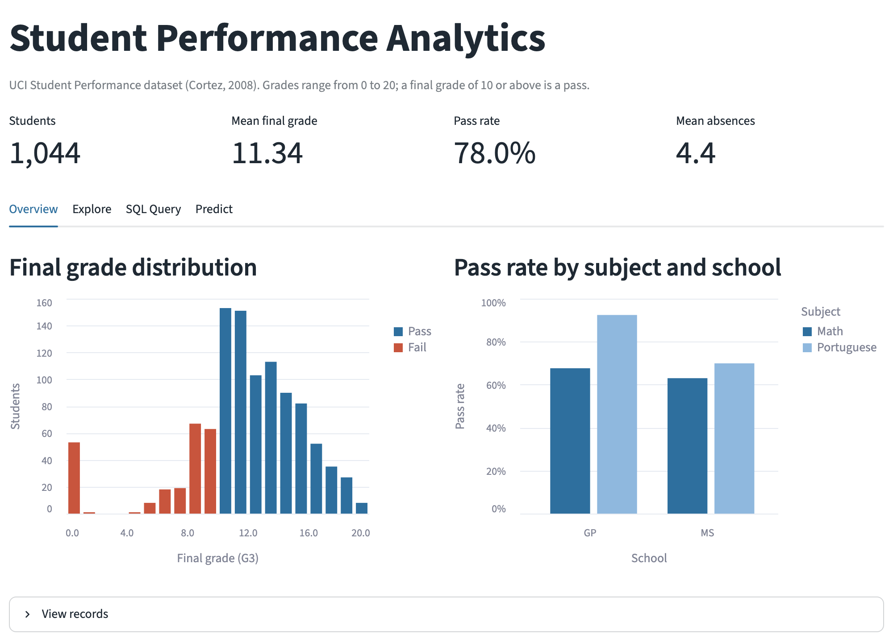
Data Exploration and Interaction
Shneiderman's (1996) guideline for information-seeking interfaces, "overview first, zoom and filter, then details-on-demand," maps directly onto Streamlit. The metric tiles and histograms provide the overview. Sidebar filters for subject, school, sex, and age apply to every metric, chart, query, and table because the script reruns with the new values. Tooltips, a brushable scatter plot, and an expandable record table supply details on demand. In the Explore tab (Figure 3), the user selects which factor to compare. The median final grade rises from 11 for students studying under 2 hours per week to 13 for those studying 5 to 10 hours, the second-period grade correlates strongly with the final grade (r = .91), and past failures are the strongest non-grade risk factor: the pass rate falls from 85.0% with no failures to 30.0% with three.
Figure 3
Explore Tab With User-Selected Factor and Interactive Scatter Plot
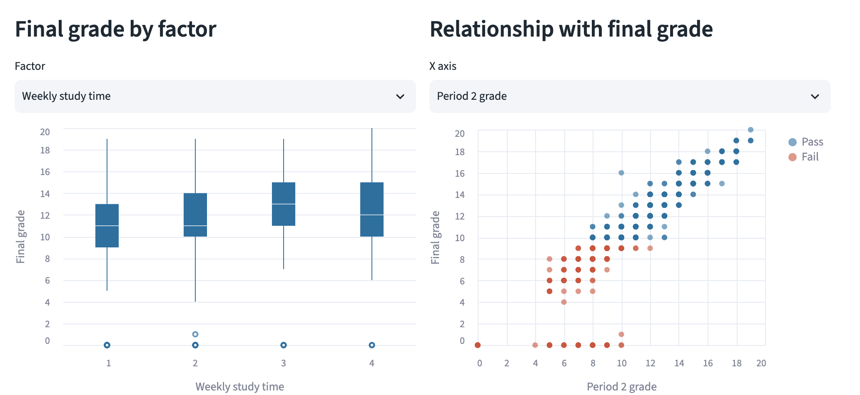
The Predict tab extends exploration into modeling. A random forest regressor, cached with st.cache_resource, achieves R² = .82 and a mean absolute error of 0.94 grade points on a 20% test set, and a form lets users enter a student's profile to obtain a predicted grade (Figure 4). When the period grades are removed, R² falls to .23, which shows that early prediction from background factors alone is much harder.
Figure 4
SQL Query Tab (Left) and Grade Prediction Tab (Right)
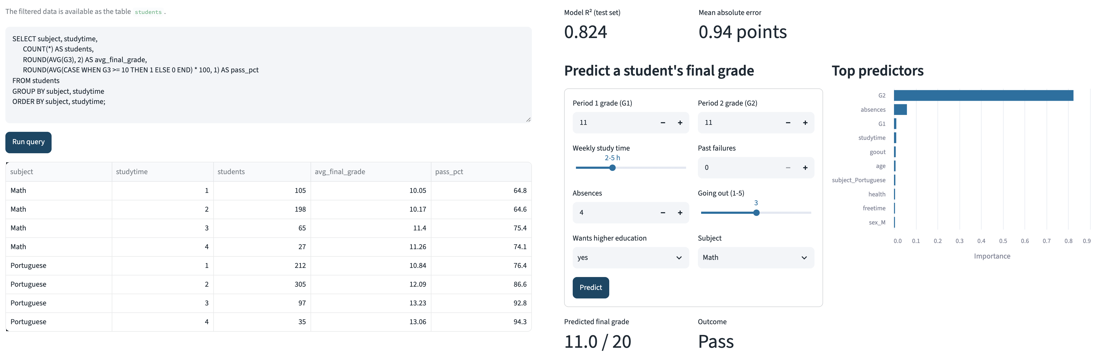
Hypothetical Scenario: A National Early-Warning Dashboard
Consider a ministry of education that holds records for two million students across 3,000 schools, plus billions of learning-platform events each term. Streamlit cannot process this volume in memory, so the heavy work is pushed to Apache Spark, a distributed engine for large-scale data processing (Zaharia et al., 2016). Nightly Spark jobs aggregate attendance, assessment, and engagement logs into per-student feature tables and school summaries stored as Parquet files, and score every student with a model similar to the one above. A Streamlit application then queries only these compact tables through DuckDB or a warehouse connection, with time-limited caching. Regional officers filter by district and grade level, drill down to schools with rising risk. Streamlit is especially useful here because the data science team that builds the model can also deliver the interface in Python and update it weekly as stakeholders respond, without a separate web development cycle.
Conclusion
Streamlit's contribution to information discovery is that it closes the gap between analysis and application: one Python script can integrate data, run SQL, render interactive charts, and serve predictions. It is not a big data engine itself, but as the interactive layer above engines such as Spark and DuckDB, it lets decision makers explore large datasets directly.
References
Cortez, P. (2008). Student performance [Data set]. UCI Machine Learning Repository. https://doi.org/10.24432/C5TG7T
Khorasani, M., Abdou, M., & Hernández Fernández, J. (2022). Web application development with Streamlit: Develop and deploy secure and scalable web applications to the cloud using a pure Python framework. Apress. https://doi.org/10.1007/978-1-4842-8111-6
McKinney, W. (2010). Data structures for statistical computing in Python. In S. van der Walt & J. Millman (Eds.), Proceedings of the 9th Python in Science Conference (pp. 56–61). https://doi.org/10.25080/Majora-92bf1922-00a
Raasveldt, M., & Mühleisen, H. (2019). DuckDB: An embeddable analytical database. In Proceedings of the 2019 International Conference on Management of Data (pp. 1981–1984). Association for Computing Machinery. https://doi.org/10.1145/3299869.3320212
Shneiderman, B. (1996). The eyes have it: A task by data type taxonomy for information visualizations. In Proceedings 1996 IEEE Symposium on Visual Languages (pp. 336–343). IEEE. https://doi.org/10.1109/VL.1996.545307
VanderPlas, J., Granger, B. E., Heer, J., Moritz, D., Wongsuphasawat, K., Satyanarayan, A., Lees, E., Timofeev, I., Welsh, B., & Sievert, S. (2018). Altair: Interactive statistical visualizations for Python. Journal of Open Source Software, 3(32), Article 1057. https://doi.org/10.21105/joss.01057
Zaharia, M., Xin, R. S., Wendell, P., Das, T., Armbrust, M., Dave, A., Meng, X., Rosen, J., Venkataraman, S., Franklin, M. J., Ghodsi, A., Gonzalez, J., Shenker, S., & Stoica, I. (2016). Apache Spark: A unified engine for big data processing. Communications of the ACM, 59(11), 56–65. https://doi.org/10.1145/2934664

