DATASET BRIEFING
BRCA Illumina Methylation
Dataset
Dataset description, file inventory, analytical framework, and visual summaries
TCGA-BRCA tumor versus tumor-adjacent normal tissue
Samples | Tumor | Adjacent normal | CpG sites tested
888 | 791 | 97 | 486,427

The study compares methylation at fixed Illumina HM450 CpG locations across primary breast tumors and adjacent-normal tissue.
Executive summary This report describes an Illumina HumanMethylation450 study of 888 TCGA-BRCA tissue samples. It documents the beta-value data structure, the tumor-versus-adjacent-normal comparison, the downloadable analysis files, and the principal visual summaries.
This report intentionally excludes the separate validation report and focuses on the array dataset, file structure, analytical outputs, and interpretation.

1. Dataset overview
The project uses the Illumina HumanMethylation450 (HM450) array. The array does not sequence the whole genome. It measures methylation at a fixed catalogue of CpG sites, concentrated in promoters, gene bodies, CpG islands, shores, shelves, and open-sea regions.
The primary comparison is tumor versus adjacent-normal tissue from TCGA-BRCA. The word normal is important: these are solid-tissue-normal samples collected next to tumors, not guaranteed disease-free donor controls.
What a beta value means A beta value is between 0 and 1. Near 0 means little methylation at a CpG site; near 1 means high methylation. Beta values are not direct gene-expression measurements.

Study summary
Source: TCGA-BRCA, accessed through the TCGA/UCSC Xena data route described in the project report.
Array: Illumina HumanMethylation450 (HM450), approximately 485,000 fixed CpG locations.
Samples: 888 total: 791 primary tumor and 97 solid-tissue-normal samples.
Main question: Which CpG sites have different methylation levels in tumor compared with adjacent-normal tissue?
Primary output: A per-CpG tumor mean, normal mean, delta beta, p-value, FDR, genomic context, and predicted direction.

What is actually being compared?
For each CpG site, the pipeline calculates a tumor-group mean and a normal-group mean, then computes delta beta as tumor minus normal. Positive delta beta means the tumor group is more methylated at that site; negative delta beta means the tumor group is less methylated.
The analysis then corrects the many per-site p-values using FDR. The project calls a site strong when FDR is below 0.05 and the absolute methylation difference is at least 0.20, or 20 percentage points.

2. What comes with the download
The downloadable deliverables package is organized for review and reuse: reports and screenshots for orientation, curated data tables for common questions, full per-site result lists for complete analysis access, and Excel workbooks for exploration.
Important distinction The current BRCA_Methylation_Deliverables.zip does not contain the original 888-sample beta-value matrix. It contains the complete per-CpG derived result table and the analysis outputs. The raw beta matrix, sample metadata, and array manifest should be distributed separately when the goal is to reproduce the upstream preprocessing.
File or folder | What it is for
00_START_HERE.txt | A short map of the package, how to open it, and the main caveats.
index.html / Website_v2/ | Interactive single-page and multi-page explanations of the study and findings.
Reports/PDF/ | Three printable reports: dataset overview, pipeline/validation, and gene/site findings.
Reports/Word/ | Editable Word versions of the reports.
Excel/BRCA_Methylation_Master_Workbook.xlsx | Workbook with cohort, differential sites, panel, marker, atlas, and interpretation sheets.
Data_Tables/1_Differential_Methylation/ | Cohort manifest, PCA sample coordinates, ranked markers, panel, and summaries.
Data_Tables/3_Site_Annotation/ | Array-site genomic context and annotation coverage summaries.
Data_Tables/4_Biomarker_Panel_and_Sites/ | Balanced panel, site maps, and methylation direction mechanics.
Data_Tables/5_Pathway_and_GSEA/ | Exploratory pathway tables and the project’s pathway caveats.
Data_Tables/6_Healthy_Baseline_Atlas/ | Healthy-tissue methylation atlas tables for the longevity-gene exploration.
Full_Site_Lists/ALL_486427_sites_full_mechanics.tsv | Complete derived per-CpG result table: every site measured, with means, delta beta, p-value/FDR, annotation, and predicted effect.
Full_Site_Lists/SIGNIFICANT_321823_sites_mechanics_fdr0.05.tsv | Subset containing sites passing FDR < 0.05.

The inventory above is the practical map of the downloadable deliverables package. Full-size raw source matrices are intentionally kept separate from this reading package.

3. How the Illumina array data is represented
A raw methylation matrix is conceptually simple: rows are CpG probes and columns are samples. A second table describes the samples, and a third table describes the probes. The analysis joins those pieces by sample ID and probe ID.

Required raw input files
Input | Key | What it contributes
Beta-value matrix | Probe ID x sample ID | One beta value per probe/sample pair; usually stored as a large TSV/CSV or compressed matrix.
Sample metadata | Sample ID -> tissue label | Tumor/normal class, TCGA barcode, tissue type, clinical fields, and optional subtype.
HM450 probe manifest | Probe ID -> genomic context | Chromosome, coordinate, gene, promoter/TSS region, CpG island relation, and strand.
Optional clinical/subtype table | Sample ID -> phenotype | Stage, PAM50 subtype, age, and other clinical fields used for stratified questions.

Current package status The raw beta matrix and original manifest are not present in the current deliverables ZIP. The project does retain the downstream site-level table and the sample manifest used for the tumor-versus-normal analysis.

Preview: complete derived site-level table
CpG probe | Tumor beta | Normal beta | Delta beta | FDR | Gene | Change
cg20843277 | 0.838 | 0.153 | +0.685 | not retained | SHANK2 | hyper
cg26081875 | 0.277 | 0.944 | -0.667 | not retained | LINC00243 | hypo
cg13851368 | 0.852 | 0.190 | +0.662 | not retained | (intergenic) | hyper
cg17326769 | 0.827 | 0.167 | +0.660 | 1.84e-09 | HCK | hyper
cg03161803 | 0.768 | 0.135 | +0.633 | 4.06e-196 | AL009179.2 | hyper

This is a derived result preview, not a raw beta-matrix preview. The full 486,427-site table contains the same kinds of fields for every tested CpG site.

4. Sample metadata and probe annotation

Preview: sample metadata
Sample barcode | Sample type | Tissue | Sex | Age | Class
TCGA-A7-A0CE-11A | Solid Tissue Normal | Normal | female | 57.0 | normal
TCGA-A7-A0CH-11A | Solid Tissue Normal | Normal | female | 79.0 | normal
TCGA-A7-A0D9-11A | Solid Tissue Normal | Normal | female | 37.0 | normal
TCGA-A7-A0DB-11A | Solid Tissue Normal | Normal | female | 56.0 | normal
TCGA-A7-A0DC-11A | Solid Tissue Normal | Normal | female | 63.0 | normal

The sample manifest supplies the labels needed to form the tumor and adjacent-normal groups. The first rows happen to begin with normal samples because the manifest is barcode-sorted.

Preview: probe annotation
CpG probe | Gene | Chrom | Start | Region | CpG context | Promoter
cg08104202 | CCDC181 | chr1 | 169427473.0 | 5UTR_1stExon | Island | True
cg15584221 | HHAT | chr1 | 210373557.0 | gene_body | OpenSea | False
cg26765743 | MIR646HG | chr20 | 60472429.0 | gene_body | OpenSea | False
cg11785980 | RIMBP2 | chr12 | 130638433.0 | gene_body | N_Shelf | False

Annotation turns a probe ID into interpretable genomic context. Some probes are intergenic or outside promoters; those should not be described as direct gene switches.

How the files connect
Sample ID connects a beta-matrix column to the sample manifest. Probe ID connects a beta-matrix row to the HM450 annotation. After those joins, the analysis can compare groups, attach coordinates and gene context, and produce a site-level result table.
Data linkage summary Sample ID -> tumor/normal label; probe ID -> chromosome/gene/context; beta values -> methylation level; statistics -> evidence for a tumor-normal difference.

5. Analytical framework

Analysis workflow
1 Load and label Read the methylation values, match sample IDs, and assign tumor or adjacent-normal class.
2 Summarize each CpG Calculate group means and the difference between tumor and normal beta values.
3 Measure evidence Compute a per-site test and FDR-adjusted significance so thousands of sites can be assessed together.
4 Add context Join each CpG to chromosome, coordinate, gene, promoter/TSS region, CpG island relation, and predicted direction.
5 Show the pattern Use PCA, volcano plots, marker tables, heatmaps, and site maps to make the result understandable.

Key measures
Beta: The methylation level at one probe in one sample, from 0 to 1.
Delta beta: Tumor mean beta minus normal mean beta. Positive means tumor is more methylated; negative means less methylated.
FDR: A multiple-testing-adjusted measure of evidence. It helps control false discoveries when hundreds of thousands of probes are tested.

PCA interpretation
PCA compresses the many-probe matrix into a few axes so a learner can ask whether tumor and adjacent-normal samples occupy different regions of the data space. It is a visualization of overall methylation structure, not proof that every single probe separates the groups.

PCA visualization
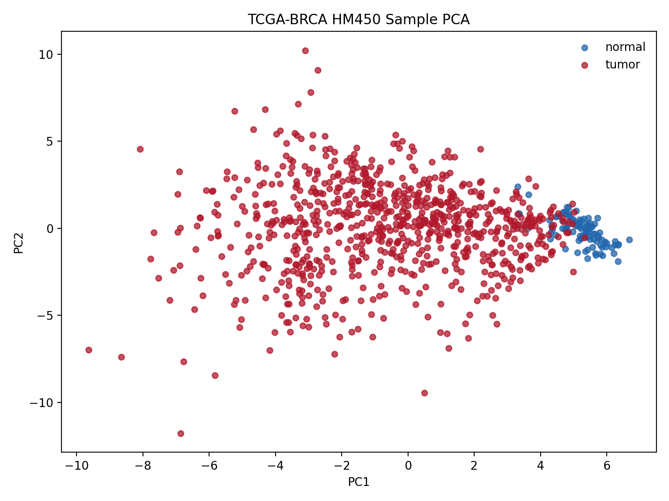
PCA of the TCGA-BRCA methylation samples from the project figures.

6. Primary visual outputs

Volcano plot
The x-axis shows delta beta, defined as the tumor mean minus the adjacent-normal mean. Positive values indicate higher tumor methylation; negative values indicate lower tumor methylation. The y-axis shows -log10(FDR), so higher points have stronger multiple-testing-adjusted evidence. The figure uses the published TCGA-BRCA plotting data: 4,500 background sites and all 1,536 high-change sites retained for the report.
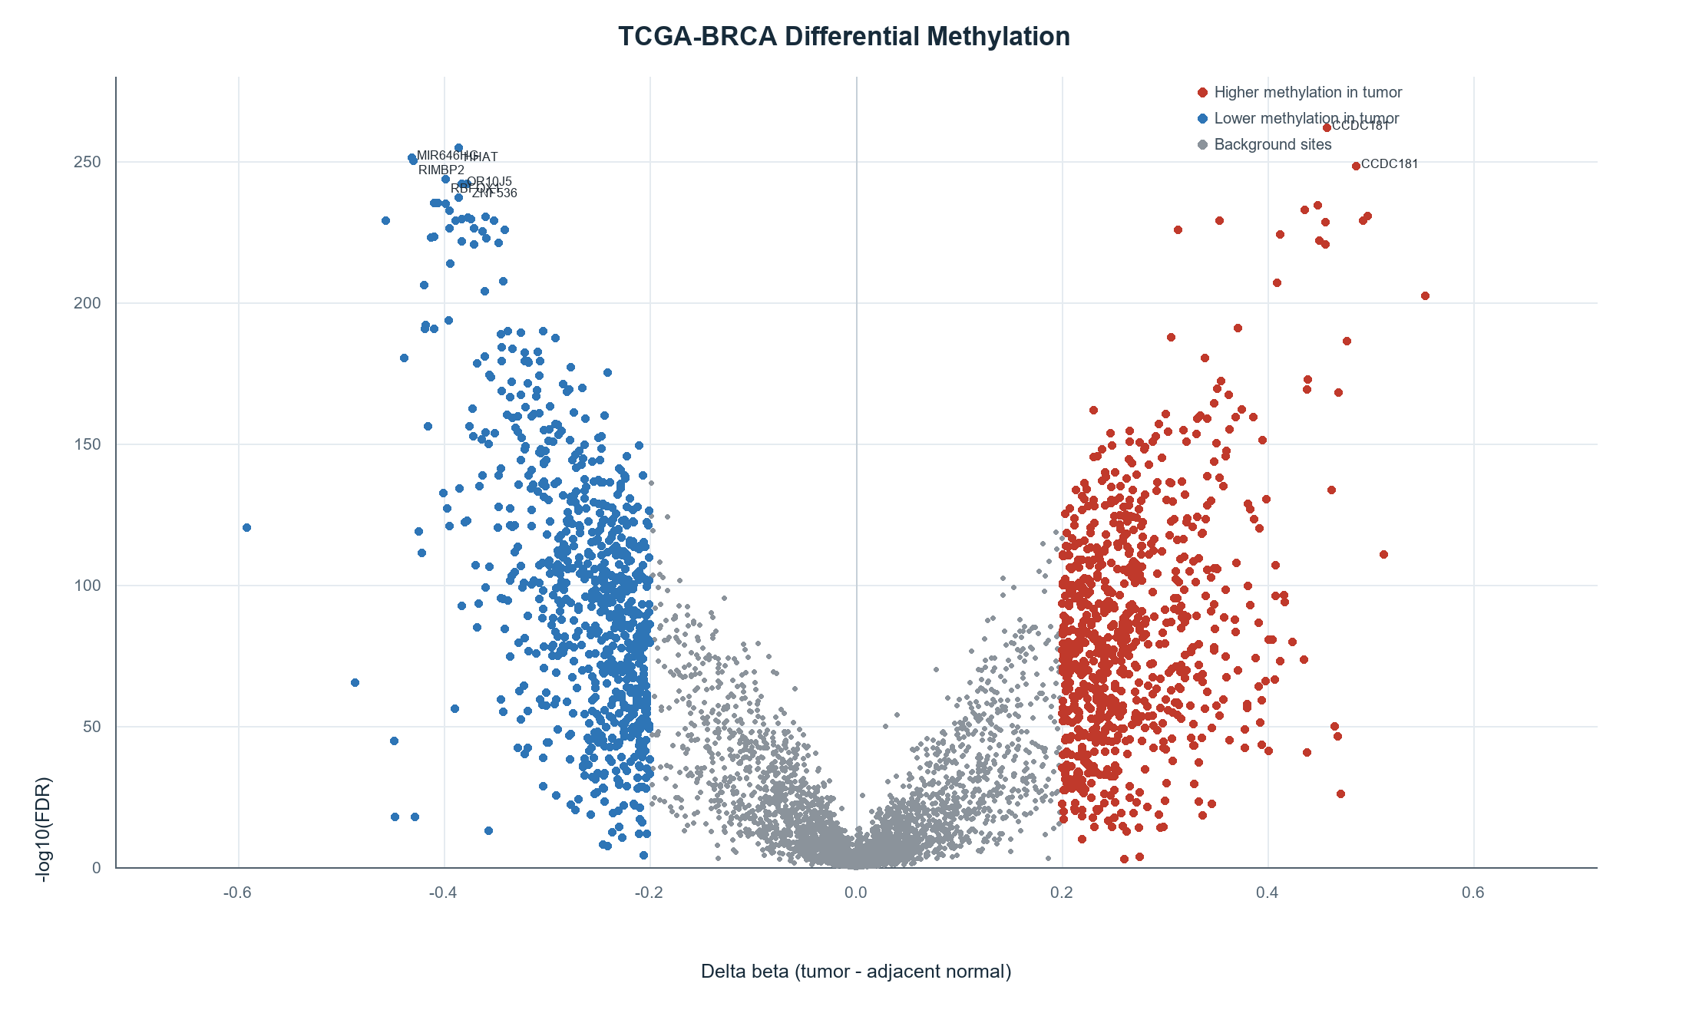
Published TCGA-BRCA tumor-versus-adjacent-normal differential methylation. Red and blue points identify the direction of the methylation difference; gray points provide the background distribution.

Heatmap: a compact view of selected sites
A heatmap is best used for a selected marker panel, not as a substitute for the complete 486,427-site matrix. It shows how a small set of probes varies across samples and makes sample grouping easier to discuss.
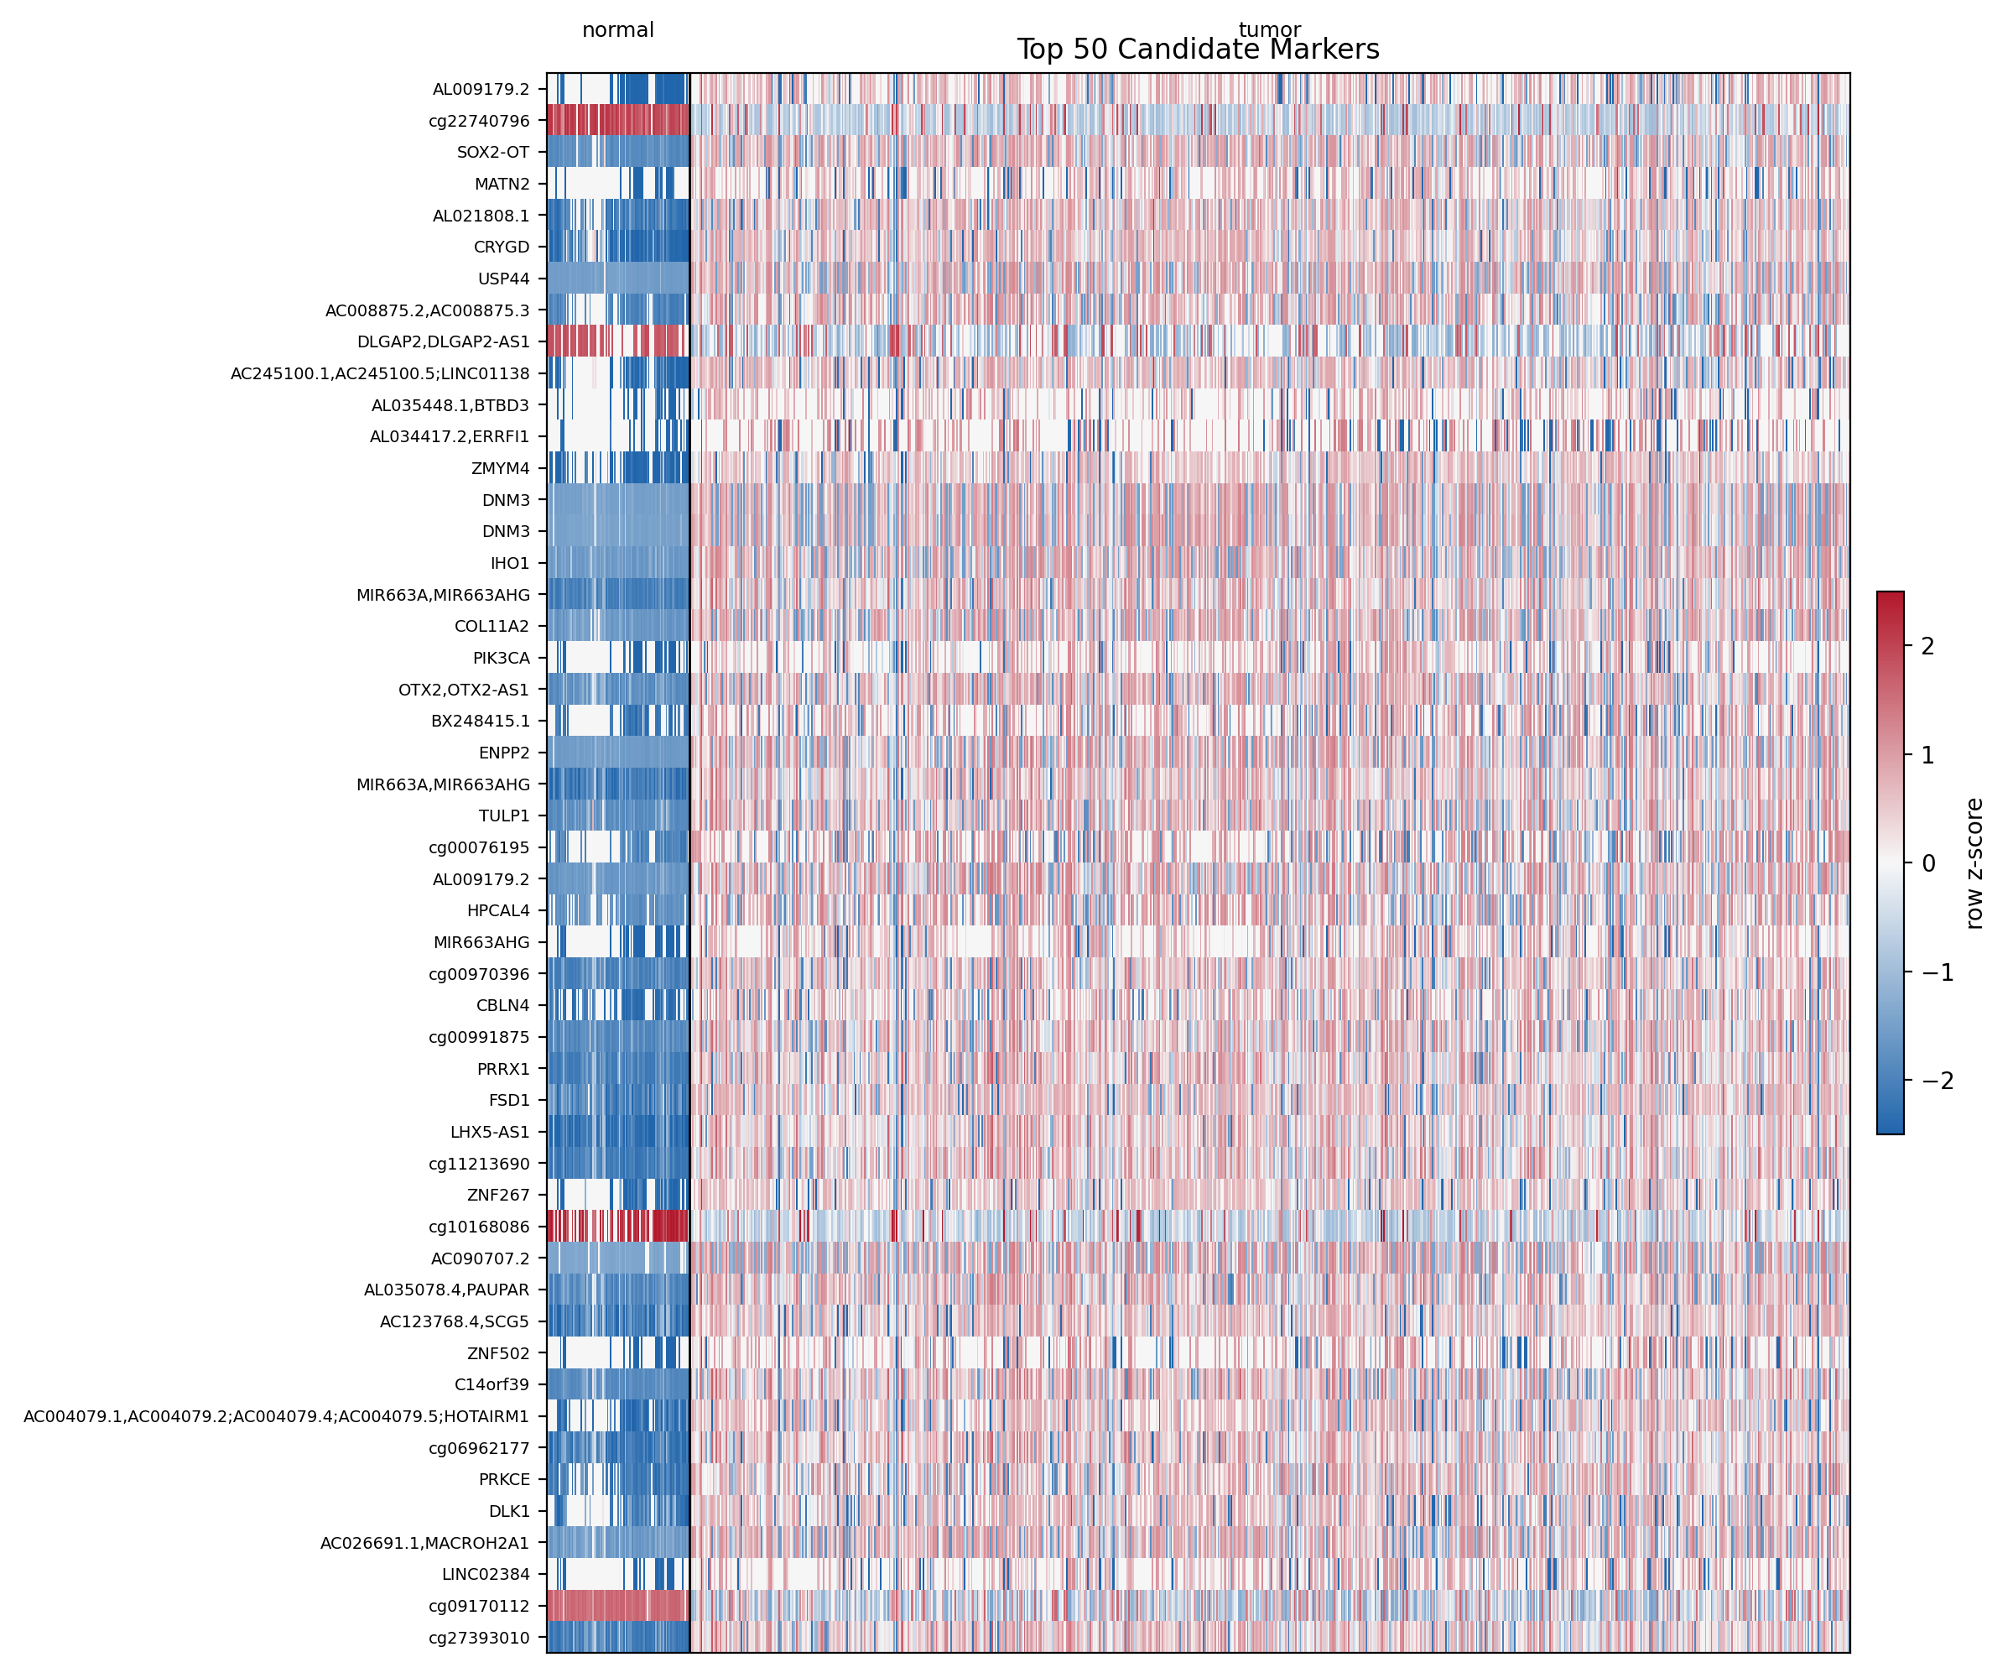
Project heatmap figure for selected marker sites; the full site list remains the source for complete per-CpG inspection.

7. Recommended presentation sequence
For a clear dataset walkthrough, move from a sample record to an individual CpG site, then to the cohort-level structure, and finally to the complete result files. This sequence establishes the meaning of each data object before introducing the full scale of the array.
Context: Begin with the study question: which methylation sites differ between breast tumor and tumor-adjacent normal tissue?
Sample record: Open the sample manifest and identify a tumor and a normal barcode. The class label is assigned in the metadata.
Individual CpG: Find a probe such as cg08104202 in the full site table. Review its tumor mean, normal mean, delta beta, FDR, gene, chromosome, and predicted effect.
Cohort structure: Use PCA to examine whether the combined methylation profile forms distinct tumor and adjacent-normal patterns across the 888 samples.
Array-wide result: Use the volcano plot to compare effect magnitude on the x-axis with statistical evidence on the y-axis.
Follow-up analysis: Use the curated marker table, annotation, and Excel workbook to select sites for detailed inspection.
Interpretation: Methylation results support hypotheses about regulatory effects; they do not directly measure RNA expression, protein abundance, or clinical outcome.

Recommended materials sequence
Provide this report first, followed by the deliverables ZIP and the interactive Version 7 site. Readers can keep the report open while inspecting one row from the complete site list and one sample from the manifest.
Recommended demonstration Open the Version 7 BRCA Results tab, select a colored volcano point to display its probe and gene, and then open the corresponding row in the complete site list. This links the interactive visualization to the downloadable evidence.

8. Limitations and interpretation
Array, not sequencing: The HM450 platform measures a fixed set of CpG locations. It does not discover every methylated base in the genome.
Adjacent normal is not donor normal: The normal group is tumor-adjacent tissue and may contain field effects or early changes.
Methylation is not expression: Promoter methylation can support a prediction about gene regulation, but direct expression data is needed to claim that a gene is switched off or on.
Large sample size affects FDR: With 888 samples, very small p-values can occur. Interpret the shape, effect size, and biological context together.
Derived output versus raw input: The complete site list is a finished analysis table. Reproducing preprocessing requires the original beta matrix, sample metadata, and HM450 manifest.

Plain-language summary
Plain-language script We measured DNA methylation at about 486,000 fixed locations in 888 breast samples. We compared 791 tumors with 97 tumor-adjacent normal tissues. For each location, we asked how different the average methylation was and how strong the evidence was. The downloadable files let you trace a result from a sample label, to a CpG probe, to a gene or genomic location, and then to the plots.

Recommended digital companion
Keep the full deliverables ZIP available for inspection, and use the hosted Version 7 site as the guided front door. The website is for orientation and interaction; the complete site list and workbook are for auditing, filtering, and follow-up.
This briefing intentionally leaves out the separate validation report. It is designed to explain the Illumina array data and the files that come with the analysis package.

