ASSEMBLER-INTERFACE

CS322 MINI-PROJECT

If we run the welcome.py file, our **Welcome window** will be opened.

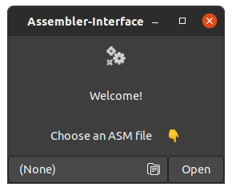

* **File chooser** - Choose file from the system
* **Open button** - if a **file is chosen** then clicking it will open the **Editor-Console window** Otherwise, when **no file chosen**, clicking it will open a **warning dialogue box**

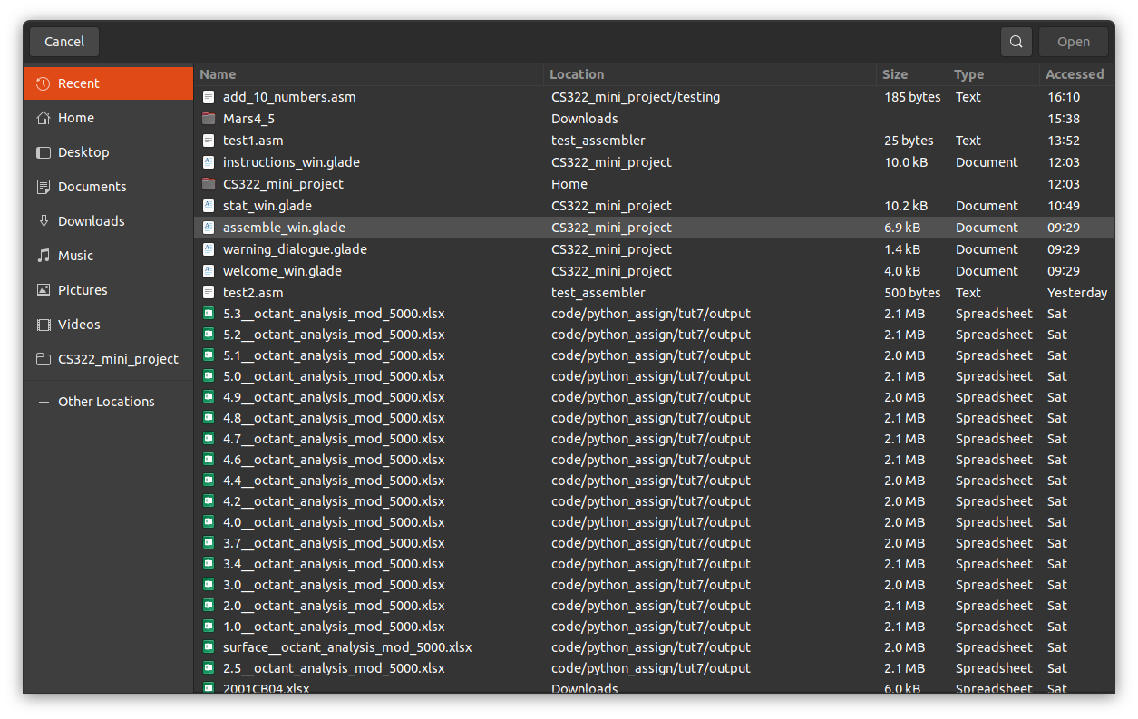

This is the open file box

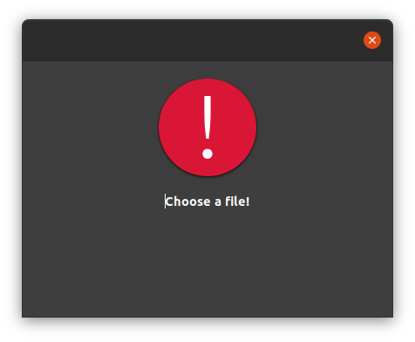

This if the file not chosen warning dialogue box

After choosing a file and clicking open button **Editor-Console window** will open

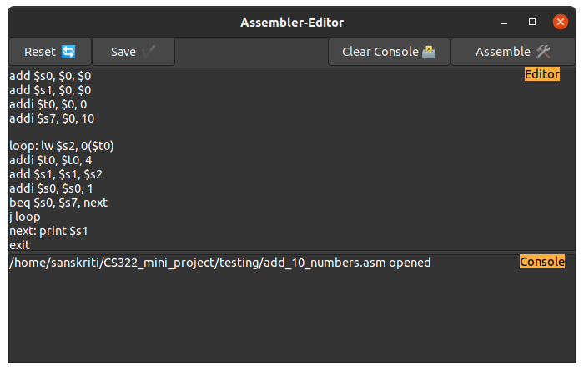

This is the assembler-editor window

* **Reset button** - on clicking this, unsaved changes will revert back to previous stage
* **Save button** - it will save the changes to the file
* **Editor screen** - an editable text editing area where we can edit asm code
* **Console** - a non-editable text area where information of current status and changes are shown
* **Clear console button** - it clears the console area’s text
* **Assemble button** - it will convert MIPS to machine codes. Assembler’s status will be shown in the console. **If there is no error,** then then **Instructions output window will open** and results will be shown there

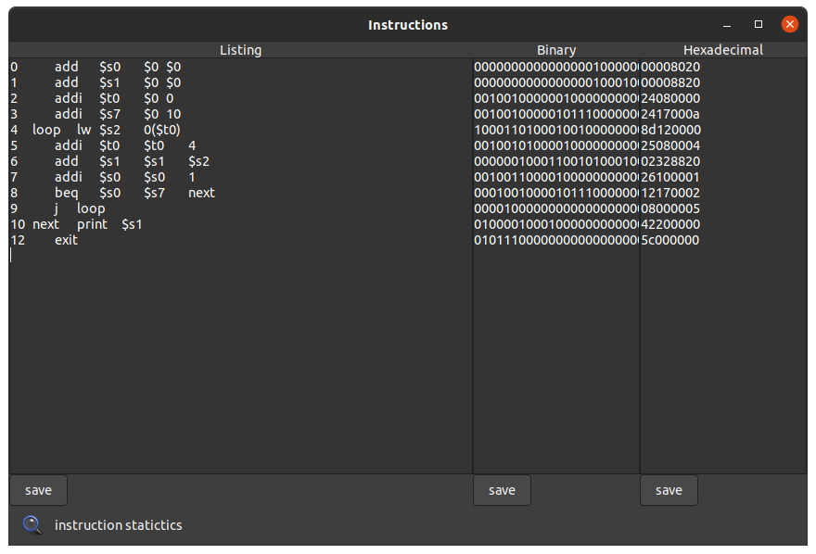

This is the instructions output window

**Display area** - the three text areas display listing, binary and hexadecimal forms of machine code

**Save button** - we can save them into the system

**Instruction statistic button** - on clicking it, an **instruction statistic window will appear**

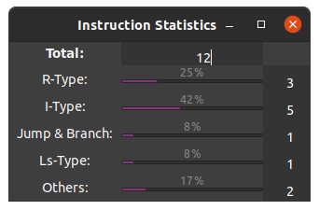

This is the instruction statistic window

It shows the number of and the percentage of different types of MIPS operations used